**Synopsis**

Elize Kupce 10/05/1998

Multimedia Design, INT

Online Portfolio: <http://ekmedia.one/Portfolio_1/index.html>

GIT: <https://github.com/eliiziite/Portfolio_1st.git>

**Idea development:**

How do I want to approach ’’making my portfolio website”? How do I want to structure my project weeks?

Mapping out and noting things that describe me and things that interest me

Thinking about what I want to communicate with my portfolio and why.

Want to continue learning: graphics, motion design, animation, Web design

My process started with mapping blocks for the journey of my design process. The day before I collected inspiration and was going through the things I want to learn and my interests. Afterward, I was looking through some images and design principles from which I made the first mood board, except the typography. Now I want to go through typography and do some research on which fonts for playfulness and which for seriousness.

**Target group:**

**Local, sustainable, products**

**Location:** Denmark

**Size of company**: SME – Small and medium enterprises

**Focus:**sustainable recycle fashion brands – sustainable fashion brands Denmark, sustainable zero-waste cafes, local ecological skincare

**What do I want to research?**

· Fears

· Needs

· Which criteria play a role when hiring people

· What services are they looking for in their future worker

What kinds of communication tools are they using

*Rest of the research and other notes are on Appendices

**Moodboards**

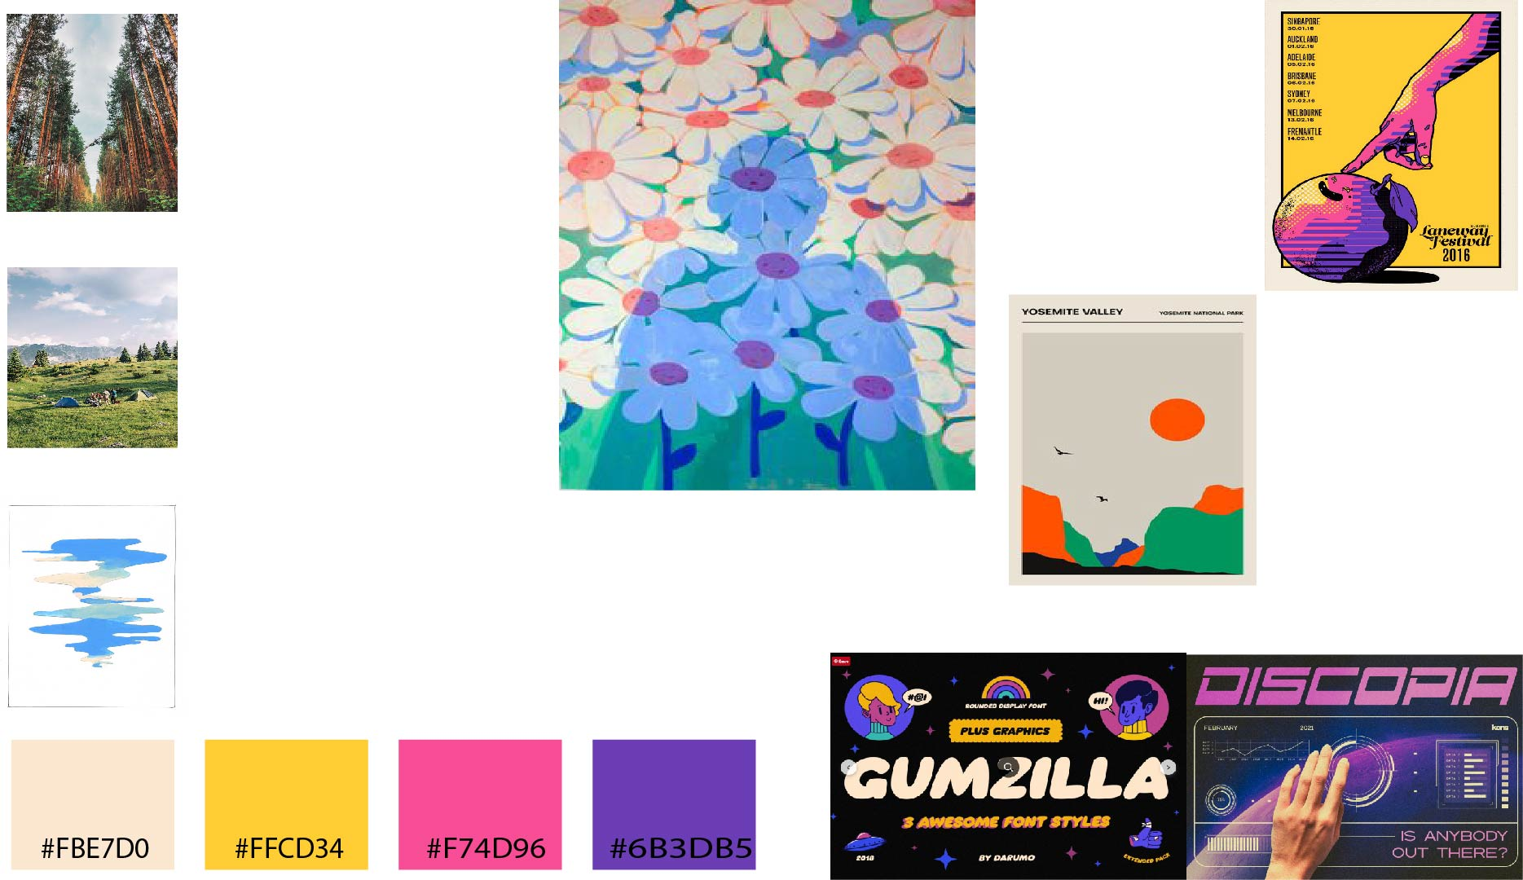

After creating a mood board with my favorite colors, pictures representing me and my interests, I went on researching fonts. For the headings, I first was excited about the cartoon or futuristic fonts, with a 90s vibe. Later on, I choose to go with default fonts instead of downloading fonts just for the headings. I ended up making a logo with the **Chee Font.**For the headings I went with **Verdana Bold** Font, a san serif that is easy to read, meaning it’s perfect for a computer screen. For the Subheadings, I went for **Verdana Regular.**I decided to keep one font, with different font weights, to keep it as simple as possible and let the colors speak for themselves.

After creating a mood board I asked some friends of mine for their opinion. Particularly the color combination pink and yellow.

*Rest of the research and other notes are on Appendices

**Marketing Strategy**

Throughout this process, I wanted to have a clear vision of what my values are and how I want to position myself. My marketing strategy included: My needs, why I want to attract sustainable businesses, why multimedia, the core of my concept, my story, value proposition, objectives, presentation, positioning, and visual identity.

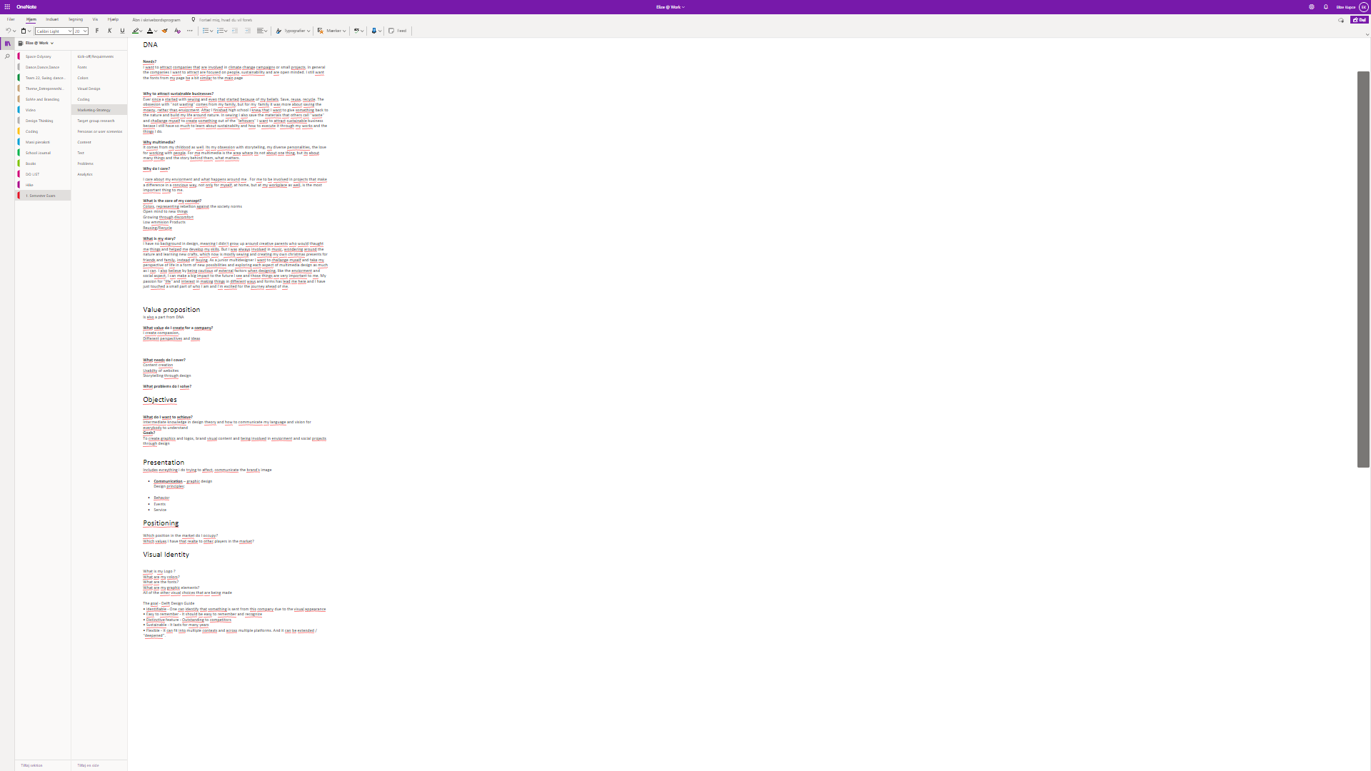

*Rest of the research and other notes are on Appendices

**Mockup**

After deciding on colors and fonts I want to use. Also understanding my concept for the web page I went on putting together a mockup that would align with my intentions.

With the website, I want to tell a story about how I work and who I am.

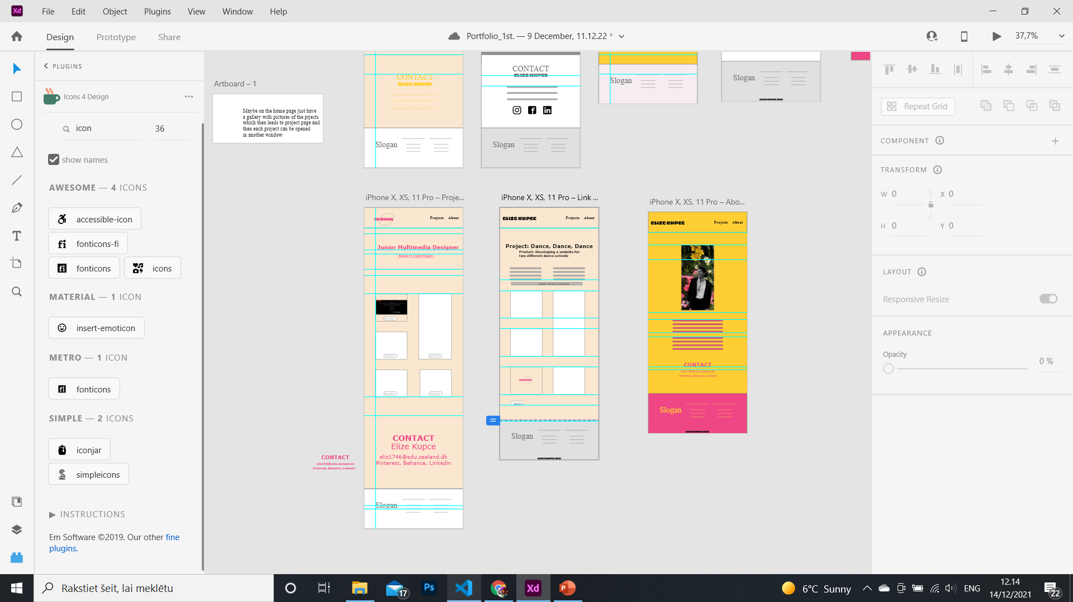

*Rest of the research and other notes are on Appendices

**Tests**

**Nr. 1 Gangster Test**

Firstly evaluated the overall structure. I was doing the evaluation by myself and reflecting of what i have made. I addressed the issues bothering me about the design.

The biggest problem with the website is the main page. The ''hero'' part of the website is not inviting the viewer. It is clear, but it's not saying anything about me. Then the second part is the different heading pictures making the page look messy and a user can't really understand what the projects are about and what I'm even working on. At this moment I'm very unsatisfied with the main page, as it is also not communicating me as a designer

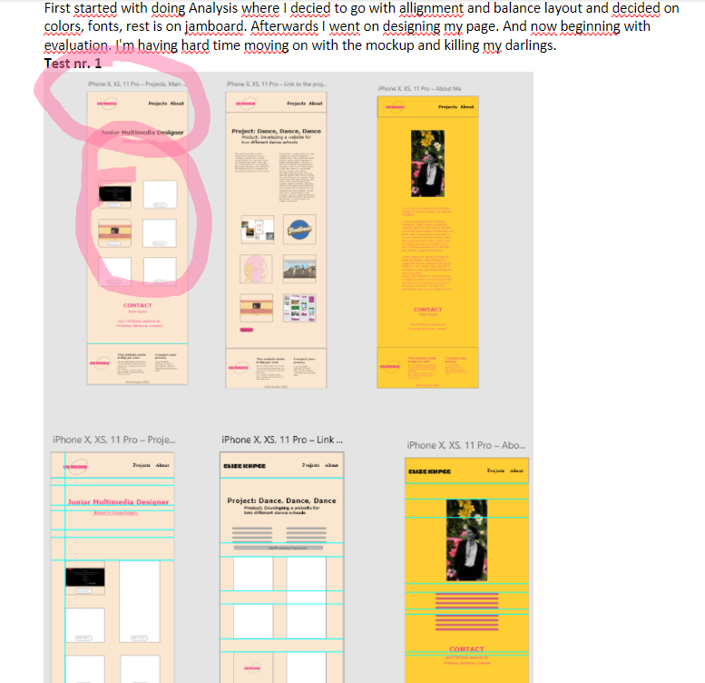

**Nr. 2 Expert review**

With this test, I want to analyze the layout and design of the website. The message itself and the structure. The way I'm executing this test is by asking a person I know, working as a graphic designer to evaluate her experience on the web page. I want to ask her questions about layout and design and watch her scroll through the pages, to understand the overall interaction with the page.

**Information structure:**

Is it clear on what page you're on?

Is it clear how to get on a particular project?

---> When opening the project page, it's not clear that you're on a different page, because the layout of the pictures is the same.

**Interaction design:**

Can you read the product description?

Is the purpose of link ''open project" clear?

---> The heading text on the main page don't have a proper alignment with the pictures and logo

---> The ''open project'' buttons are covering the project page and are not easy to read. Could be put somewhere else, for better usability of the page and button

---> The About page colors work very well but the other projects of the main pages are not working well, need different accent color instead of black font color.

Final Mockup

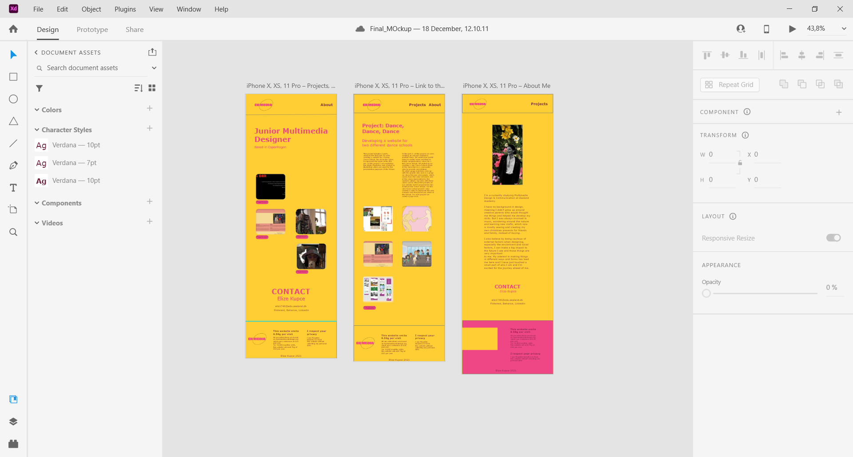

**The following pages are appendices with more detailed notes and extra material. The following pages are not a part of the Synopsis.**

**Idea development**

Structure:

Overall I structured my project content on Windows one note. I made sections for Idea development, fonts, colors, Target group research. For the rest of the deadlines and weekly schedule, I was using Google calendar but didn’t hold on deadline strictly.

Did research online on the companies I would like to work with in the future. From the research, I wanted to understand the tone and colors, fonts used in sustainable brand websites. These are the brands I was researching about.

My favorites from example portfolios:

<https://heylow.world/>

<https://sussmanprejza.com/projects/>

<https://www.brucemaudesign.com/>

<https://www.curroclaret.com/en/amor_shoeslaces_lamparas.html>

<https://kellauren.design/contact>

Measuring website emissions:

<https://www.websitecarbon.com/>

<https://ecoping.earth/>

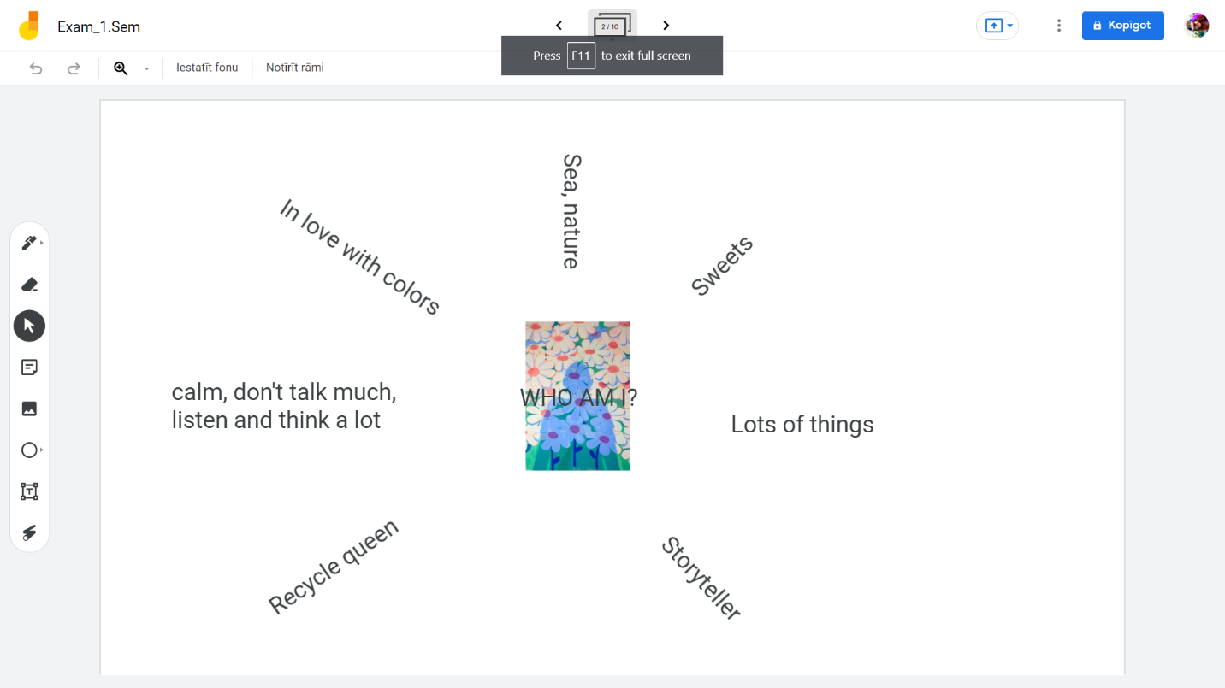

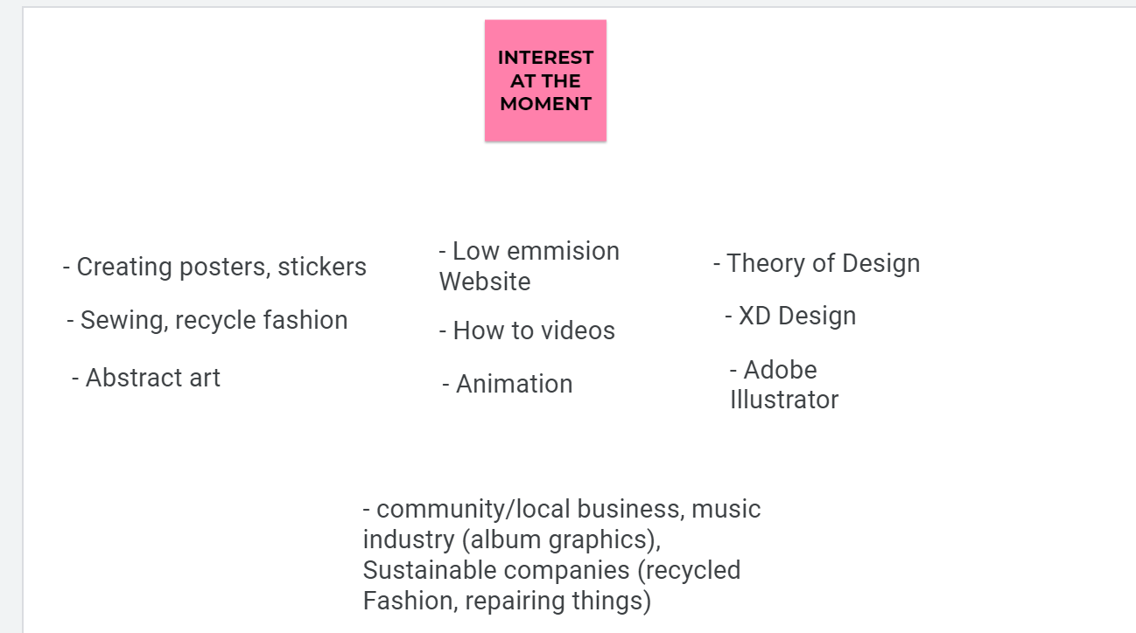

What content I could put on the pages?

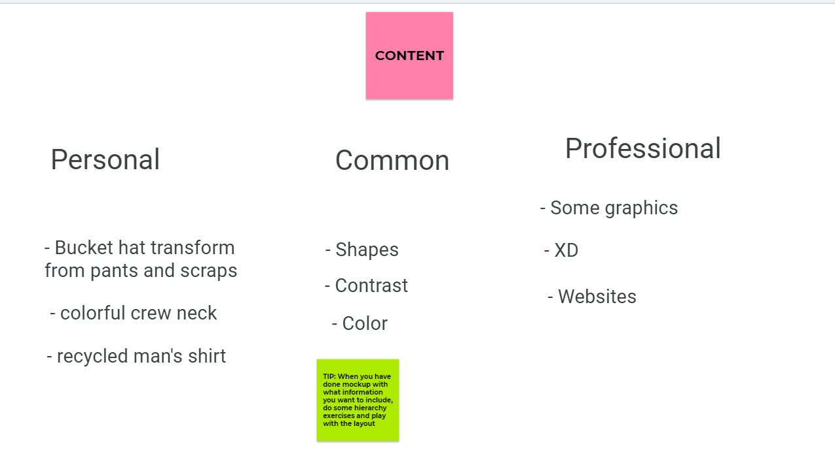

**Example on Observations**

Research nr. 2.

<https://blanchecph.com/pages/about>

Fonts: Fonts used don't have a big font size and in general the writing is small and the text is not as big as used to in websites or have done before in my projects. The Typeface used is Helvetica, which is a font used for big brand identities, like nestle, Lufthansa, tech companies like Apple and Microsoft. Clean and clear neutral font

Logo: No Logo itself, just a name in the top middle of the page

Colors: Kind of the same colors as the previous, the products themselves are also not in bright colors

Language: not too long text, apart from the about, which is also still longer but on point and straightforward, no unnecessary content.

Research nr. 3.

<https://www.bymalenebirger.com/dk>

Fonts: Campton, with this font you are attracting neutrality. Lato, interesting font gives approachable warmth to its readers

Logo: no logo

Contact: email, phone, map, not other media

Colors: White and black letters and big pictures, presenting the neutral color clothing

 Research nr. 4

<https://www.keepit.com/>

Fonts: Pretty big font size

Logo: simple logo representing recycling and its message

Colors: green

Research nr. 5

<https://res-res.com/>

Fonts: Roboto default font which is modern approachable and emotional and designed by Google, Helvetica

Logo: Black and white logo with brands name included in the circle

Colors: black and white

Language: Detailed text, without unnecessary stuff, but really going into the depths of their content to make sure the users understand them

Research nr 6

<https://www.wauw-design.dk/pages/om-os>

Fonts: Cabin san-serif

Logo: Letter logo

Colors: white and grey

Language: Easy going and explaining the environment and people shes giving in her studio and their background

Media used: Pinterest, Instagram, Facebook, Youtube, and e-mail

**Conclusion**

All the sustainable brands that I have researched so far are neutral, rarely using a logo and when using a logo then it's usually in a circle or some other circular graphic, but mostly simply named in some different font used as a logo. Mostly used fonts are modern, easy to read, san serif fonts

**Structure**

I structured my project in one note, where I made different sections for different topics I was working on. My sections were split into daily journaling about the process, Fonts, Colors, Marketing strategy, Target group research, Marketing strategy, Content, Tests. Overall before starting a project I put all my deadlines and things I have to do on Google calendar, but do not follow the deadlines strictly.

**Problem?**

put myself or just the company I’m trying to attract

**Moodboards**

**Fonts**

I want to research particularly 90s style fonts, for the page headings where I will represent myself and my personality. As I'm a 90s kid and in love with fun and bold poster fonts

**Font nr. 1** <https://ifonts.xyz/gimbo-font.html>

<https://www.myfonts.com/fonts/letter-omega/gimbo/>

**Font nr. 2**

I like this font because it has a futuristic and future vibe and as humans and myself, the universe and life beyond the earth have always been very interesting and exciting. Thus font also reminds me of all the different reality movies I used to watch as a kid -  Galaxy quest

<https://www.behance.net/gallery/115449661/Discopia-Futuristic-Tech-Fonts>

<https://www.myfonts.com/fonts/KonstantineStudio/discopia/>

**Option 1.** Cascade, san serif font

<https://elements.envato.com/de/cascade-futuristic-display-typeface-ML7N64W?clickid=WHwUn4wYjxyIWaGW3Qy3XRbDUkGzDE2meRKzVw0&iradid=275988&iradtype=ONLINE_TRACKING_LINK&irgwc=1&irmptype=mediapartner&irpid=2461135&mp_value1=&utm_campaign=af_impact_radius_2461135&utm_medium=affiliate&utm_source=impact_radius>

**Option 2.**  Designer Block Font Free to use for personal stuff

<https://www.1001fonts.com/designer-block-font.html>

**Option 3.** Halo Font

<https://www.1001fonts.com/halo-font.html>

**Option 4.**Techno overload Font

<https://www.1001fonts.com/techno-overload-brk-font.html>

**Conclusion:**

I cant choose this font, because the futuristic fonts don’t really represent the 90s. Some of the futuristic fonts actually go back to the 40s til 60s when these fonts were used for car advertisement

The second fonts I want to research are for the main page

attracting companies I would like to work with in the future. I want to attract companies that are involved in climate change campaigns or small projects. In general, the companies I want to attract are focused on people, sustainability and are open-minded. I still want the fonts from my page to be a bit similar to the main page

Headings: I want for the headings Rounded display fonts, like in comics or fairytale posters, disney movie advertisments

Museo Sans – San serif typeface, rounded

<https://fonts.adobe.com/fonts/museo-sans#fonts-section>

FF Unit Rounded

<https://fonts.adobe.com/fonts/ff-unit-rounded#fonts-section>

Chee Font – a mix of galactic and rounded cartoon font (my choice chee jimbo)

<https://fonts.adobe.com/fonts/cheee#fonts-section>

**Conclusion:**

Decided to use the round display Font only for the logo and for the rest of the headings and paragraphs throughout the webpage, to use default fonts

Overall I want the webpage to be playful but at the same time serious.  I want to have bright colors to attract attention and make the page colorful and dynamic. Showcasing that I'm not just one thing and I'm not afraid to explore my life and try new things.

This is the mockup I started with, afterwards, I put together all the content I want to put in my page and what projects I want to showcase.

**Marketing Strategy**

DNA

**Needs?**

 I want to attract companies that are involved in climate change campaigns or small projects. In general the companies I want to attract are focused on people, sustainability and are open minded. I still want the fonts from my page be a bit similar to the main page

**Why to attract sustainable businesses?**

Ever since a started with sewing and even that started because of my beliefs. Save, reuse, recycle. The obssesion with ''not wasting'' comes from my family, but for my  family it was more about saving the moeny, rather than enviorment. After I finished high school I knew that I want to give something back to the nature and build my life around nature. In sewing I also save the materials that others call ''waste'' and challange myself to create something out of the ''leftovers'' I want to attract sustainable business becase I still have so much to learn about sustainabilty and how to execute it through my works and the things I do.

**Why multimedia?**

It comes from my childood as well. Its my obsession with storytelling, my diverse personalities, the love for working with people. For me multimedia is the area where its not about one thing, but its about many things and the story behind them, what matters.

**Why do I care?**

I care about my enviorment and what happens around me . For me to be involved in projects that make a difference in a concious way, not only for myself, at home, but at my workplace as well, is the most important thing to me.

**What is the core of my concept?**

Colors, representing rebellion against the society norms

Open mind to new things

Growing through discomfort

Low emmision Products

Reusing/Recycle

**What is my story?**

I have no background in design, meaning I didn't grow up around creative parents who would thaught me things and helped me develop my skills. But I was always involved in music, wondering around the nature and learning new crafts, which now is mostly sewing and creating my own christmas presents for friends and family, instead of buying. As a junior multidesigner I want to challange myself and take my perspective of life in a form of new possibilities and exploring each aspect of multimedia design as much as i can. I also believe by being cautious of external factors when designing, like the enviorment and social aspect, I can make a big impact to the future I see and those things are very important to me. My passion for "life" and interest in making things in different ways and forms has lead me here and I have just touched a small part of who I am and I'm excited for the journey ahead of me.

Value proposition

Is also a part from DNA

**What value do I create for a company?**

I create compassion,

Different perspectives and ideas

**What needs do I cover?**

Content creation

Usabilty of websites

Storytelling through design

**What problems do I solve?**

Objectives

**What do I want to achieve?**

Intermediate knowledge in design theory and how to communicate my language and vision for everybody to understand

**Goals?**

To create graphics and logos, brand visual content and being involved in enviorment and social projects through design

Visual Identity

What is my Logo ?

What are my colors?

What are the fonts?

What are my graphic elements?

All of the other visual choices that are being made

The goal - Delft Design Guide

• Identifiable - One can identify that something is sent from this company due to the visual appearance • Easy to remember - It should be easy to remember and recognize

• Distinctive feature - Outstanding to competitors

• Sustainable - It lasts for many years

• Flexible - It can fit into multiple contexts and across multiple platforms. And it can be extended / “deepened”.