BIT 4107 – Mobile Application Development
ENHANCED PROFESSIONAL STUDENT LOGBOOK
Student Name: Adimo Lopir
Admission Number: BIT/2024/34555
School/Faculty: Computing and Informatics
Programme: Bachelor Of Information Technology
Academic Year: IV
Semester: II
Lecturer: Michael Nyoro
Phone Number: 0742509779

Instructions
This logbook is used to document weekly learning activities, practical exercises, skills acquired, challenges encountered, solutions applied, and reflections. Students should complete all sections every week.
Each week to follow remarks in week 1 section.

Autogenerated Table of content

Week 1: Introduction to Mobile Application Development
Objective
Understand the mobile application ecosystem (Android, iOS, cross-platform).
Set up a professional development environment.
Create and run the first Flutter app successfully.

Practical Activities Undertaken

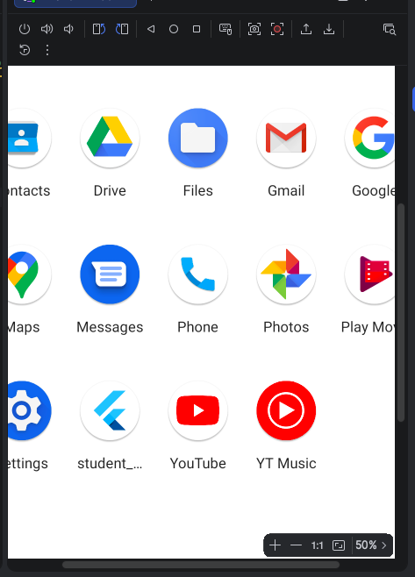
created a student app and deployed it with flutter and android emulator

Tools/Software Used

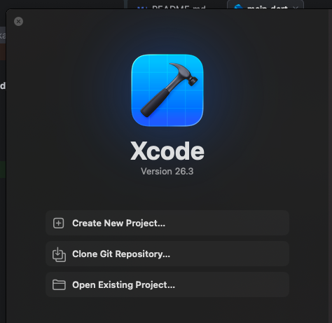
installation of xcode

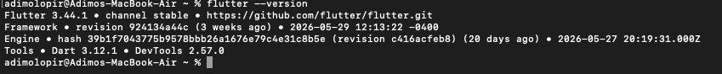
installed fluter

installed android studio
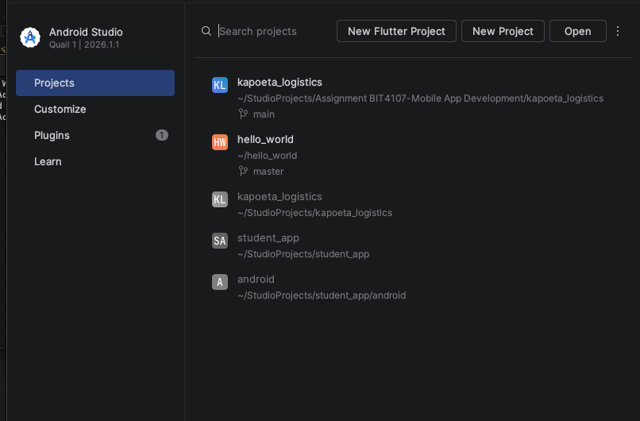

Personal Reflection

Installed Flutter SDK, Android Studio, VS Code, Git, Java JDK, Node.js, Python 3.x.
Configured Android Emulator (Pixel5_API33 with GPU acceleration).
Ran flutter doctor to confirm environment setup.
Created first Flutter project (flutter create firstapp).
Customized app by changing title, background color, and font size.
Deployed app to emulator and confirmed Kapoeta Logistics & parcels appears in app drawer.
I was able to familiarize with development tools despite having troubles configuring the flutter and its dependencies.

Week 2: Mobile Development Environment
Same as week 1
Practice syntax in Kotlin, Dart, JavaScript, and Python.
Build UI components (buttons, text fields, images, menus, navigation bars).
Create a cross-platform Flutter project.
Implement a Mini Student Management App with login, registration, and local record
saving.

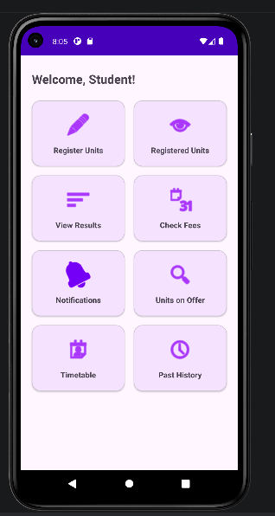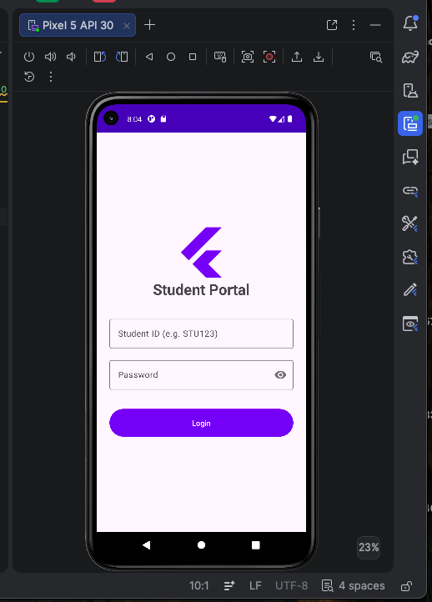
Student app user interface

Personal Reflection

Practiced variables, functions, loops, and classes in Dart.
Created basic UI components in Flutter (buttons, text fields, images).
Built navigation routes between login, registration, and dashboard screens.
Integrated local storage using SQLite (sqflite package) or JSON file.
Tested app flow: login → register student → view dashboard with saved records.
I introduced real app logic beyond setup.
Practicing multiple languages improved understanding of syntax differences.
Building the student app gave hands-on experience with navigation and local storage.
Ready to move into UI/UX design in Week 3.

Challenges Faced
Setting up navigation between multiple screens.
Handling form validation for login and registration.
Configuring SQLite database in Flutter.

Solutions Implemented
Used Navigator.push and Navigator.pop for screen transitions.
Added input validation using TextFormField with validators.
Installed and configured sqflite package for local database storage.

Outcome
Student Management App runs successfully with login, registration, and dashboard.
Records are saved locally and displayed in the app.
Learned how to connect UI with data storage and navigation.

Week 3: User Interface Design

Same as week 1
Objective
Design wireframes for Kapoeta Logistics &parcel app.
Create GUI designs with color schemes, typography, and responsive layouts.
Convert designs into Flutter code.
Implement UI interactions (validation, alerts, menus, transitions).
Test app on emulator and real device.

Activities Completed
Designed wireframes for 5 users Kapoeta Logistics app screens: Landing screen, Admin Dashboard, Agent Dashboard, Driver Dashboard and Feeding assistant Drive r dashboard,
Expense Log, Reports.
Applied consistent color scheme (green/yellow for farming theme) and modern
typography.
Converted wireframes into Flutter layouts using Scaffold, AppBar, TextFormField,
and ListView.
Implemented navigation between screens using Navigator.pushNamed.
Added form validation for Feeding and Expense entries.
Tested UI flow on emulator and Android device.

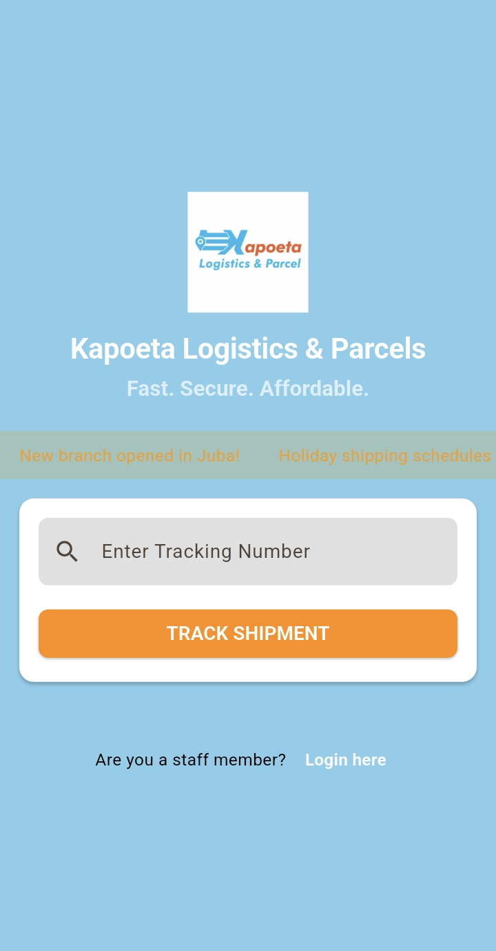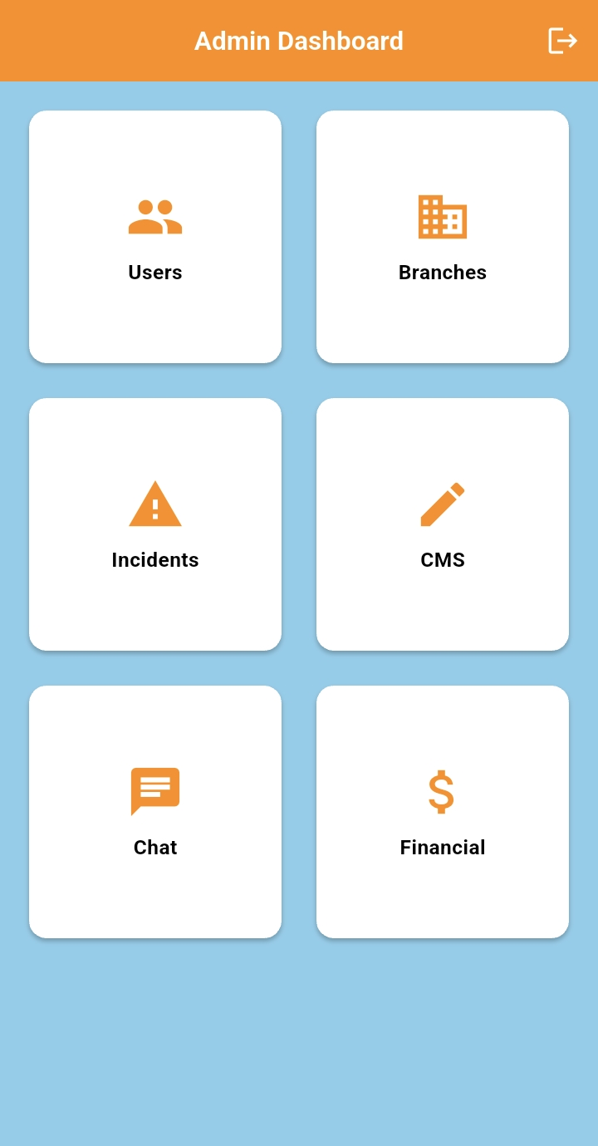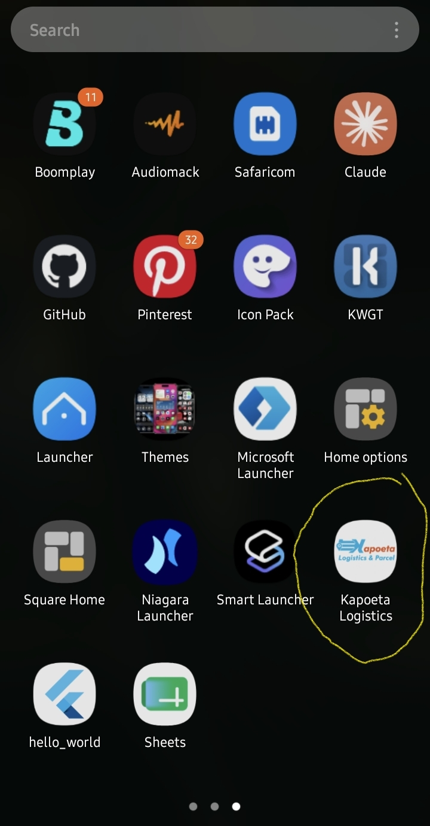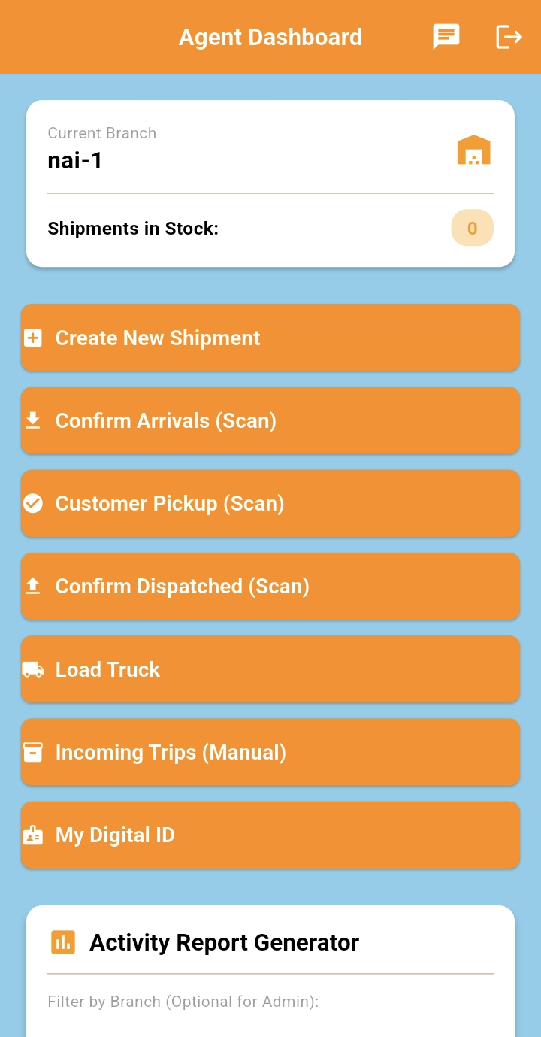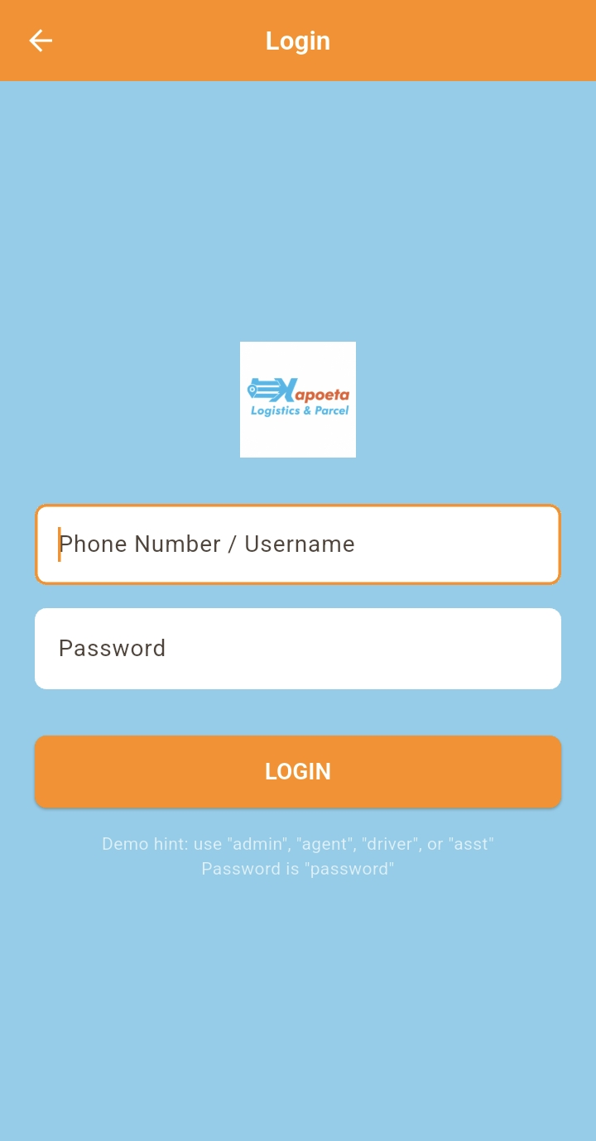
Solutions Implementedå
Used MediaQuery in Flutter for responsive layouts.
Applied TextFormField validators for input validation.
Debugged navigation routes to ensure smooth flow.

Outcome
Kapoeta Logistics & parcels prototype completed with 5 functional screens.
Navigation works between login, dashboard and reports.
UI design is consistent, responsive, and aligned with farming theme.

Reflection
Week 3 marked the transition from practice apps to the real project (Kapoeta logistics).
Learned how to bridge design with implementation (Flutter).
Gained experience in UI/UX design, validation, and responsive layouts.
Ready to move into database integration and deployment in later weeks.

Week 4: Event Handling and User Interaction

Same as week 1
Objective
Develop an entity Record Management with add, update, delete and search functionality.
What is Completed:
Form Interactions: Implemented robust login and shipment creation forms using TextEditingControllers and GlobalKeys for validation.Advanced Gestures: Integrated a Signature Pad in the Delivery Screen, allowing users to draw signatures directly on the screen using the signature package.
Hardware Integration: Implemented QR Code Scanning using mobile_scanner to trigger events like "Confirm Arrival" or "Load Truck."
User Feedback: Used Snackbars and AlertDialogs to provide real-time feedback (e.g., "Payment Collected" or "Too far from branch").
Challenges:
Location Verification: Calculating the distance (Haversine formula) between the user and the branch in real-time to "unlock" the delivery event was complex to calibrate.
Concurrency: Handling multiple button taps during slow network requests required implementing loading states to prevent duplicate shipment creation.
Personal Reflections:
Learning how to handle hardware-level events (Camera and GPS) made me realize that mobile interaction is much more than just clicking buttons; it's about reacting to the physical world.

a screenshot of the Delivery Screen showing the Signature Pad and the QR Scanner in action.

Week 5: Data Management

Same as week 1

What is Completed and implemented :
State Management: Used the Provider pattern to manage global states for Auth, Shipments, Trips, and Connectivity across the entire app.
Local Persistence: Implemented shared_preferences via a custom StorageService to save user sessions and cached shipment data.
Offline Queue: Developed a Sync Queue that stores actions (like "Create Shipment") while the user is offline and automatically syncs them when a connection is restored.
Complex Models: Created structured Data Models (User, Shipment, Trip) with JSON serialization to handle nested logistics data.
Challenges:
Web vs. Mobile Storage: shared_preferences works differently on Web. Ensuring the storage logic remained consistent across platforms required careful abstraction.
State Synchronization: Keeping the "Summary Dashboard" updated immediately after a new shipment was added to the list required deep understanding of notifyListeners().
Personal Reflections:
Implementing the "Offline-First" approach taught me the importance of data integrity. Using Provider kept my UI code clean and separated from the logic of saving data.

a screenshot of the Agent Dashboard showing the "Shipments in Stock" count and the Admin Dashboard with financial analytics.

Week 6: Networking and APIs

Same as week 1

What is Completed:
REST API Integration: Built a centralized ApiService using the http package to handle GET/POST requests to the backend.
Connectivity Monitoring: Implemented a real-time Connectivity Provider that listens to network changes and displays a "No Internet" warning bar at the top of the app.
Error Handling: Created a custom Exception system (ApiException, UnauthorizedException) to map raw HTTP errors into user-friendly messages.
Document Generation: Implemented a networking-style flow to generate and share PDF Reports and Receipts.
Challenges:
Platform Exceptions: dart:io networking code caused crashes on the Web version. I had to refactor the networking layer to be "Platform-Agnostic."
API Timeouts: During the build process, we encountered timeouts with pub.dev, which taught me how to use --offline and --no-pub flags to build projects in low-bandwidth environments.
Personal Reflections:
I learned that networking isn't just about sending data—it's about handling the "unknown." Building a reliable app means assuming the internet will fail and designing the UI to handle that failure gracefully.
a screenshot of the Landing Page (Tracking) and the Red Offline Banner that appears when the internet is disconnected.
I have successfully optimized the app for Release on both Android and Web, including custom CSS loading spinners for the web and Launcher Icons manually generated for Android.

Task 1: Mobile Application Networking Analysis
Application | Client | Server | Data Exchanged
WhatsApp | WhatsApp mobile app | WhatsApp servers | Text messages, voice notes, images, videos, contacts, status updates
Facebook | Facebook mobile app/web browser | Facebook servers | Posts, comments, likes, messages, photos, videos, user profiles
Uber | Uber Rider/Driver app | Uber servers | Ride requests, driver locations, GPS coordinates, payment details, trip information
M-Pesa | M-Pesa mobile app/USSD/SIM Toolkit | Safaricom M-Pesa servers | Account details, transaction requests, balances, payments, confirmations
YouTube | YouTube mobile app/web browser | YouTube servers | Video streams, comments, likes, subscriptions, search queries

All these applications use a client-server architecture where the client (user application) sends requests to the server, and the server processes the requests and returns the required information.

Task 2: API Investigation
API Name: OpenWeather API
Purpose
The OpenWeather API provides current weather data, forecasts, and climate information for locations worldwide.

GET Request Example
GET https://api.openweathermap.org/data/2.5/weather?q=Nairobi&appid=YOUR_API_KEY
Expected Response
{
"coord": {
"lon": 36.8167,
"lat": -1.2833
},
"weather": [
{
"main": "Clouds",
"description": "scattered clouds"
}
],
"main": {
"temp": 298.15,
"humidity": 65
},
"name": "Nairobi"
}
OenWeather API Report

The OpenWeather API is a public web service that provides weather information for cities and regions around the world. Developers use this API to integrate weather data into mobile applications, websites, and information systems. The API follows REST architecture and supports HTTP GET requests. A typical request includes the city name and an API key. The server processes the request and returns weather information in JSON format. The response may contain temperature, humidity, weather conditions, wind speed, and location details. OpenWeather API is widely used because it is simple, reliable, and easy to integrate with software applications.

Task 3: JSON Creation
{
"regno": "BIT202434555",
"name": "Adimo Lopir",
"course": "Bachelor of Information Technology",
"year": "4"
}

Week 7: Application Architecture

Same as week 1
Task 1: Storage Method Comparison
Storage Method | Advantages | Disadvantages
Shared Preferences | Easy to use, suitable for storing small amounts of data such as settings and user preferences, lightweight. | Cannot store complex or large datasets, less secure for sensitive information.
SQLite | Stores structured data efficiently, supports SQL queries, works offline, suitable for large datasets. | More complex to implement and manage than Shared Preferences.
Firebase | Real-time synchronization, cloud storage, supports authentication, accessible from multiple devices. | Requires internet connection for most features, may incur costs for large-scale usage.
Internal Storage | Data is private to the application, secure, works offline, no permission required. | Limited storage space and not suitable for structured relational data.

Task 2: Student Database Design
Student Table Structure
Field Name | Data Type | Description
StudentID | INT | Unique student identifier
Name | VARCHAR(100) | Student name
Course | VARCHAR(100) | Course enrolled
Year | INT | Year of study
PhoneNumber | VARCHAR(15) | Student contact number

Table Diagram
STUDENTS

StudentID(PK)
Name
Course
Year
PhoneNumber

Primary Key.
StudentID is the Primary Key (PK) because it uniquely identifies each student record.

Task 3: Mini Project – Student Attendance Management Application
Application Concept

A mobile application that helps lecturers manage student attendance electronically.

Features
- Register Students
- Add student details.
- Store student information in the database.
- Record Attendance
- Mark students as Present or Absent.
- Store attendance date and status.
- Generate Reports
- View attendance history.
- Calculate attendance percentages.
- Generate attendance summaries.
1. Storage Method Selected

SQLite Database

2. Why It Was Selected
Stores large amounts of structured data efficiently.
Supports relationships between tables.
Works without an internet connection.
Fast retrieval of attendance records.
Suitable for mobile applications.
3. Database Structure
Students Table
STUDENTS

StudentID (PK)
Name
Course
Year
PhoneNumber

Attendance Table
ATTENDANCE
AttendanceID (PK)
StudentID (FK)
AttendanceDate
Status

PK = Primary Key
FK = Foreign Key

Relationship:
STUDENTS

StudentID

ATTENDANCE

One student can have many attendance records.

4. Expected Outputs
This design satisfies the requirements of registering students, storing attendance records, and generating attendance reports using a structured SQLite database.

Week 8: Project Planning

Week 9: Device Features and Sensors

Same as week 1

Week 10: Notifications and Background Services

Same as week 1

Week 11: Mobile Security

Same as week 1

Week 12: Testing and Debugging

Same as week 1

Week 13: Application Deployment

Same as week 1

Week 14: Final Project Presentation

Same as week 1

Semester Project Tracking

Project Title

Project Objectives

Project Requirements

Development Milestones

Testing Results

Lessons Learned

Future Improvements

End of Semester Reflection

Summary of Skills Acquired

Most Interesting Topic

Major Challenges Faced

How Challenges Were Overcome

Professional Growth Achieved

Overall Course Experience

Final Approval
Student Name: __________________________
Student Signature: ______________________
Date: _________________________________
Lecturer Name: _________________________
Lecturer Remarks: _____________________
Date: _________________________________

