

AI Assisted Problem Solving Using Python

AcademicYear:2025-2026

| Assignment Type: Lab  Assig_No. 1 |
| --- |

Submitted by:

Name: **Elijah M. Flomo**

Enrol No. **2506B09602**

Course: Msc Computer Science

Submitted to:

Name: Venkataramana Veeramsetty

Title: Course Instructor

Date: 27 Oct 2025

Q 2: Use Copilot to generate a is_prime() Python function.

Code:

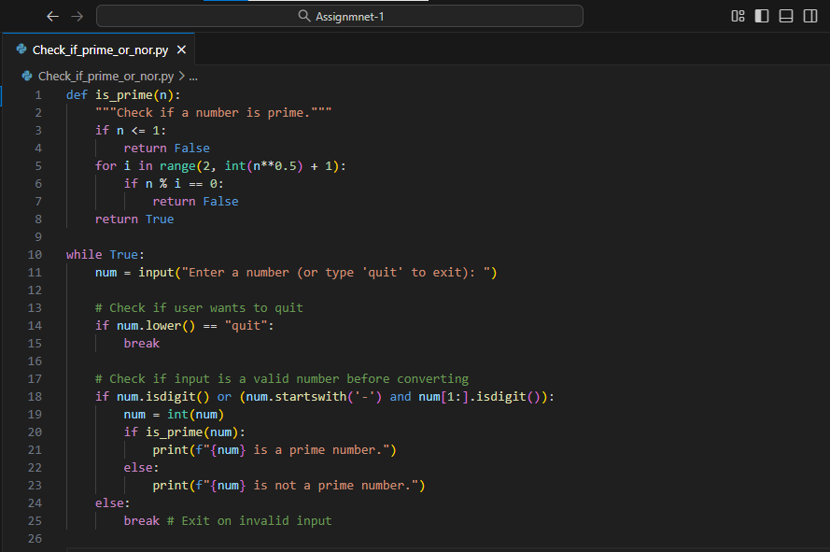

Output screenshot:

Function to check primality with correct logic.

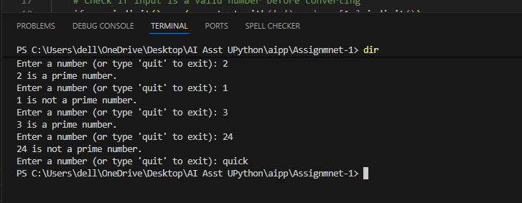

Q 3: Write a comment like # Function to reverse a string and use Copilot to generate the function.

Code:

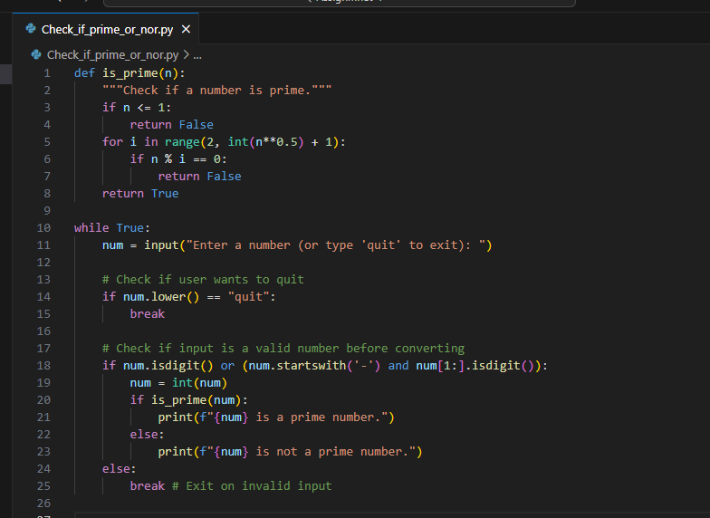

Output: Auto-completed reverse function

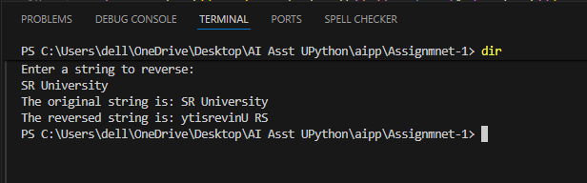

Q4: Generate both recursive and iterative versions of a factorial function using comments..

Code:

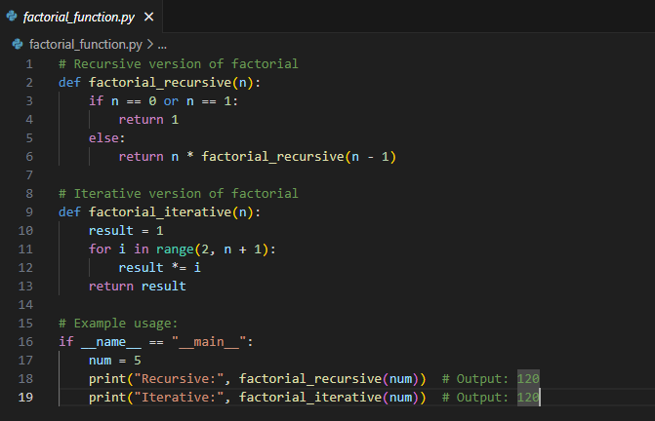

Output: Two working factorial implementations

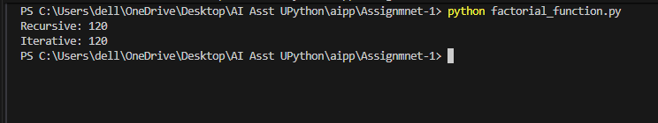

Q 5: Use Copilot to find the largest number in a list. Assess code quality and efficiency

Code:

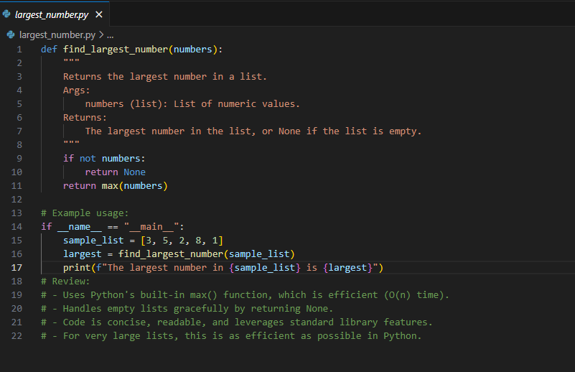

Output: A valid function with your review

