##Reading in the Data##

student <- read_csv("ames_student.csv")

## Warning: Missing column names filled in: 'X1' [1]

##   
## ── Column specification ────────────────────────────────────────────────────────  
## cols(  
## .default = col_character(),  
## X1 = col_double(),  
## Lot_Frontage = col_double(),  
## Lot_Area = col_double(),  
## Year_Built = col_double(),  
## Year_Remod_Add = col_double(),  
## Mas_Vnr_Area = col_double(),  
## BsmtFin_SF_1 = col_double(),  
## BsmtFin_SF_2 = col_double(),  
## Bsmt_Unf_SF = col_double(),  
## Total_Bsmt_SF = col_double(),  
## First_Flr_SF = col_double(),  
## Second_Flr_SF = col_double(),  
## Low_Qual_Fin_SF = col_double(),  
## Gr_Liv_Area = col_double(),  
## Bsmt_Full_Bath = col_double(),  
## Bsmt_Half_Bath = col_double(),  
## Full_Bath = col_double(),  
## Half_Bath = col_double(),  
## Bedroom_AbvGr = col_double(),  
## Kitchen_AbvGr = col_double()  
## # ... with 15 more columns  
## )  
## ℹ Use `spec()` for the full column specifications.

#summary(student)  
#str(student)  
#glimpse(student)

competition <- read_csv("ames_competition.csv")

##   
## ── Column specification ────────────────────────────────────────────────────────  
## cols(  
## .default = col_character(),  
## ID = col_double(),  
## Lot_Frontage = col_double(),  
## Lot_Area = col_double(),  
## Year_Built = col_double(),  
## Year_Remod_Add = col_double(),  
## Mas_Vnr_Area = col_double(),  
## BsmtFin_SF_1 = col_double(),  
## BsmtFin_SF_2 = col_double(),  
## Bsmt_Unf_SF = col_double(),  
## Total_Bsmt_SF = col_double(),  
## First_Flr_SF = col_double(),  
## Second_Flr_SF = col_double(),  
## Low_Qual_Fin_SF = col_double(),  
## Gr_Liv_Area = col_double(),  
## Bsmt_Full_Bath = col_double(),  
## Bsmt_Half_Bath = col_double(),  
## Full_Bath = col_double(),  
## Half_Bath = col_double(),  
## Bedroom_AbvGr = col_double(),  
## Kitchen_AbvGr = col_double()  
## # ... with 15 more columns  
## )  
## ℹ Use `spec()` for the full column specifications.

##Consolidating Variables##

student2 <- student %>% dplyr::select("Above_Median", "Lot_Area", "Neighborhood", "House_Style", "Overall_Cond", "Year_Built", "Roof_Style", "Exter_Cond", "Central_Air", "Full_Bath", "Pool_QC", "Kitchen_Qual")

##Recoding variables to factors##

student2 <- student2 %>%   
 mutate(Above_Median = as_factor(Above_Median)) %>%  
 mutate(Above_Median = fct_recode(Above_Median, "No" = "0", "Yes" = "1" )) %>%   
  
 mutate(Neighborhood = as_factor(Neighborhood)) %>%  
   
 mutate(House_Style = as_factor(House_Style)) %>%  
   
 mutate(Overall_Cond = as_factor(Overall_Cond)) %>%   
 mutate(Overall_Cond = fct_recode(Overall_Cond, "Very Poor" = "1", "Poor" = "2","Fair" = "3", "Below_Average" = "4","Average" = "5", "Above_Average" = "6", "Good" = "7", "Very_Good" = "8", "Excellent" = "9", "Very_Excellent" = "10")) %>%  
   
 mutate(Roof_Style = as_factor(Roof_Style)) %>%  
   
 mutate(Exter_Cond = as_factor(Exter_Cond)) %>%   
 mutate(Exter_Cond = fct_recode(Exter_Cond, "Poor" = "0", "Fair" = "1", "Typical" = "2", "Good" = "3", "Excellent" = "4")) %>%  
   
 mutate(Central_Air = as_factor(Central_Air)) %>%  
 mutate(Central_Air = fct_recode(Central_Air, "N" = "0", "Y" = "1" )) %>%  
   
 mutate(Full_Bath = as_factor(Full_Bath)) %>%  
   
 mutate(Pool_QC = as_factor(Pool_QC)) %>%  
 mutate(Pool_QC = fct_recode(Pool_QC, "No_Pool" = "0", "Fair" = "1", "Typical" = "2", "Good" = "3", "Excellent" = "4")) %>%  
   
 mutate(Kitchen_Qual = as_factor(Kitchen_Qual)) %>%   
 mutate(Kitchen_Qual = fct_recode(Kitchen_Qual, "Poor" = "0", "Fair" = "1", "Typical" = "2", "Good" = "3", "Excellent" = "4"))

## Warning: Unknown levels in `f`: 0, 1

## Warning: Unknown levels in `f`: 1, 2, 3, 4, 5, 6, 7, 8, 9, 10

## Warning: Unknown levels in `f`: 0, 1, 2, 3, 4

## Warning: Unknown levels in `f`: 0, 1

## Warning: Unknown levels in `f`: 0, 1, 2, 3, 4  
  
## Warning: Unknown levels in `f`: 0, 1, 2, 3, 4

##Examining individual neighborhoods##

table(student2$Neighborhood)

##   
## North_Ames Gilbert   
## 327 109   
## Stone_Brook Northwest_Ames   
## 39 95   
## Somerset Briardale   
## 119 22   
## Northpark_Villa Northridge_Heights   
## 15 105   
## Bloomington_Heights Northridge   
## 21 50   
## Sawyer_West Sawyer   
## 82 109   
## Greens Old_Town   
## 7 181   
## Brookside Iowa_DOT_and_Rail_Road   
## 74 57   
## Clear_Creek South_and_West_of_Iowa_State_University   
## 31 35   
## Edwards College_Creek   
## 129 183   
## Crawford Mitchell   
## 77 79   
## Timberland Meadow_Village   
## 60 24   
## Veenker Blueste   
## 16 5   
## Landmark Green_Hills   
## 1 1

##Splitting the data##

set.seed(123)   
student_split = initial_split(student2, prop = 0.7, strata = Above_Median) #70% in training  
train = training(student_split)  
test = testing(student_split)

##Plotting neighborhoods first##

p1 = ggplot(train, aes(x = Neighborhood, fill = Above_Median)) + geom_bar(position = "fill") + theme(axis.text.x = element_text(angle = 90, vjust=0.5))  
grid.arrange(p1)

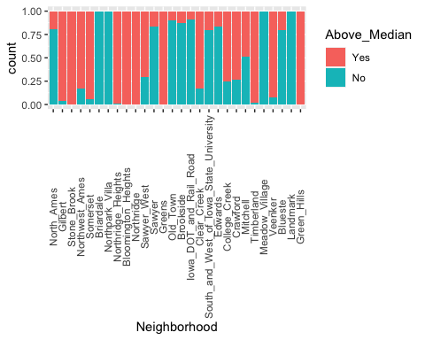

##Plotting more bar charts##

p1 = ggplot(train, aes(x = Pool_QC, fill = Above_Median)) + geom_bar(position = "fill") + theme(axis.text.x = element_text(angle = 90, vjust=0.5))  
p2 = ggplot(train, aes(x = House_Style, fill = Above_Median)) + geom_bar(position = "fill") + theme(axis.text.x = element_text(angle = 90, vjust=0.5))  
p3 = ggplot(train, aes(x = Overall_Cond, fill = Above_Median)) + geom_bar(position = "fill") + theme(axis.text.x = element_text(angle = 90, vjust=0.5))  
p4 = ggplot(train, aes(x = Exter_Cond, fill = Above_Median)) + geom_bar(position = "fill") + theme(axis.text.x = element_text(angle = 90, vjust=0.5))  
grid.arrange(p1,p2,p3,p4)

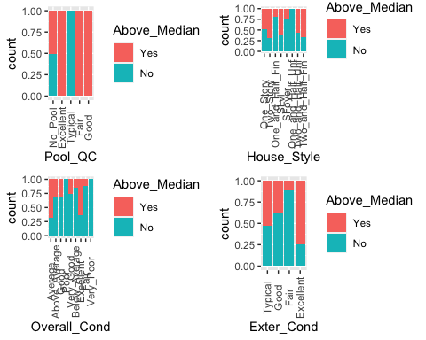

##Plotting nominal variables via box-plots##

p1 = ggplot(train, aes(x = Full_Bath, fill = Above_Median)) + geom_bar(position = "fill")  
p2 = ggplot(train, aes(x = Central_Air, fill = Above_Median)) + geom_bar(position = "fill")  
p3 = ggplot(train, aes(x = Lot_Area, fill = Above_Median)) + geom_boxplot()  
p4 = ggplot(train, aes(x = Year_Built, fill = Above_Median)) + geom_boxplot()  
grid.arrange(p1,p2,p3,p4)

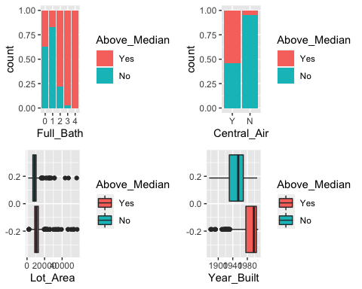

p1 = ggplot(train, aes(x = Roof_Style, fill = Above_Median)) + geom_bar(position = "fill") + theme(axis.text.x = element_text(angle = 90, vjust=0.5))  
p2 = ggplot(train, aes(x = Exter_Cond, fill = Above_Median)) + geom_bar(position = "fill") + theme(axis.text.x = element_text(angle = 90, vjust=0.5))  
p3 = ggplot(train, aes(x = Kitchen_Qual, fill = Above_Median)) + geom_bar(position = "fill") + theme(axis.text.x = element_text(angle = 90, vjust=0.5))  
grid.arrange(p1,p2,p3)

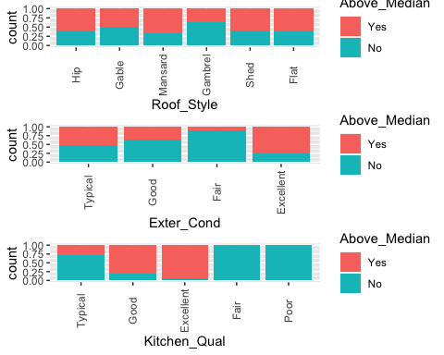

##Further examining variables that stuck out in our visuals##

t1 = table(train$Above_Median, train$Overall_Cond)  
prop.table(t1, margin = 2)

##   
## Average Above_Average Good Poor Very_Good Below_Average  
## Yes 0.6826196 0.3283019 0.3010204 0.0000000 0.2567568 0.1481481  
## No 0.3173804 0.6716981 0.6989796 1.0000000 0.7432432 0.8518519  
##   
## Excellent Fair Very_Poor  
## Yes 0.6315789 0.1153846 0.0000000  
## No 0.3684211 0.8846154 1.0000000

t1 = table(train$Above_Median, train$Central_Air)  
prop.table(t1, margin = 2)

##   
## Y N  
## Yes 0.54347826 0.04854369  
## No 0.45652174 0.95145631

t1 = table(train$Above_Median, train$Full_Bath)  
prop.table(t1, margin = 2)

##   
## 0 1 2 3 4  
## Yes 0.37500000 0.17027864 0.77882038 0.97142857 1.00000000  
## No 0.62500000 0.82972136 0.22117962 0.02857143 0.00000000

t1 = table(train$Above_Median, train$Pool_QC)  
prop.table(t1, margin = 2)

##   
## No_Pool Excellent Typical Fair Good  
## Yes 0.5073273 1.0000000 0.0000000 1.0000000 1.0000000  
## No 0.4926727 0.0000000 1.0000000 0.0000000 0.0000000

folds = vfold_cv(train, v = 10)