2. System description

A schematic of the DSSC-TTG hybrid system is put forward in Fig1. As we can see from it, the hybrid device concludes two parts. One part is a DSSC, which can convert the solar energy from the sun into the electrical power and a high-grade waste heat. Another part is a TTG consisted of an external resistance and two stage TEGs, by which the waste heat could be properly used to generate extra electric current. Therefore, the system can decline the emission of heat and increase the ratio of solar energy usage. Otherwise, as is shown in Fig2, to use the electric energy more efficient, the whole system should supply for two independent loads.

3. Mathmatical model of DSSC

The typical structural of the DSSC is shown in Fig3. As DSSC is irradiated by the sunlight, the dye molecules absorb the photon from its ground state into an excited state, as described in Eq(1). Then the excited dye molecule generates an electron described in Eq(2). Due to the diffusion effect, the electron conducted by the TiO2 nanoparticles film into the transparent conduction oxide (TCO) layer, and then, flows into the external circuit to drive an electrical load. On the other side, at the interface of the dye molecules and the electrolyte, the dye molecule with losing a electron can be reduced by the Iodide(I-). The Iodide(I-) also can be recreated by the tri-iodide collecting the electron through the counter electrode from the external circuit. At last, the cycle circuit is complete.

Under a steady-state condition of an irradiated DSSC, the electron generation, transport, and recombination can be described by the following diffusion differential equation[]:



where x is the coordinate measured from the TiO2/TCO interface, n(x) is the excessive electron concentration at x, n0 is the electron concentration under a dark condition, D is the electron diffusion length, tao is the electron lifetime, fai = fai0*yita_opt is the incident irradiation intensity considering the transmission and reflection loss, fai0 is the light intensity at 1 sun condition (G = 100 mW/cm2), yita_opt is the optical efficiency of the glass cover, and a is the light absorption coefficient of the porous electrode.

To solve this differential equation, Table I summarizes the list of boundary conditions.

The short circuit current density Jsc is derived from Eq. ():





The DSSC photovoltage can be stated as the following:



where V0 is the potential difference of the redox potential of electrolyte and the TiO2 Fermi level, and V1 is the voltage loss at the TiO2/TCO interface.

Solving Eq. () with aforementioned boundary conditions gives the relationship between current density and the potential difference as follows:



The V1 can be calculated with the following equation:



where Φb is Schottky barrier height, which is the potential energy barrier for electrons formed at a metal–semiconductor junction, and A* is the Richardson constant of TiO2; A* can be calculated with the following:



Rearranging Eq. () gives the following:

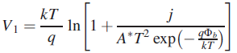

The electron diffusion length can be calculated with the following equation:



The electrode porosity affects the electron diffusion coefficient and the light absorption coefficient; based on the experimental results and modeling described in [], the following relationship is obtained:



where the critical porosity Pc and the constant a, μ, are 0.76, 4 × 10–4 cm-2 s-1, and 0.82, respectively [17]. Based on Eq. (19), the light absorption coefficient is strongly dependent on the porosity of the nanoporous electrode.

From Eqs. (6) and (18), the following equation is derived for the power density of the DSSC:



Previous studies [18,19] show the temperature dependent effects on the efficiency and power density of the DSSC. In order to describe the deviation of the power output due to heat losses from the ones at reference temperature as described in Eqs. (18) and (36), the following equation is derived for maximum power density.





The yita and beta are the decreasing rate of the power output and efficiency as the operating temperature T increases and are dependent on each other. It is found that when yita = 0.00506mWK^-1, the curve of the maximum power output of the DSSC fits well with the experimental data obtained in Ref.[29], as shown in Fig. 2. According to Eqs. ()–(), one can calculate beta = 0.0278 K^-1 when yita = 0.00506mWK^-1. Substituting Eqs. () and () into Eqs. () and (), one has which can be used to describe the performance of the DSSC varying with the operating temperature.

4.TTG

A two-stage thermoelectric generator was illustrated in Fig3. It was consisted of a top stage with m pairs of thermoelectric elements and a bottom stage with n pairs of thermoelectric elements. The top stage adheres tightly to the DSSC, a heat source at temperature of TH, while the bottom stage is in contact with surroundings, a heat source at temperature of TL. The heat is originated from the heat source at temperature of TH, and released at temperature of TL. In order to simplify the whole system, the Thomson effect will be neglected, we only consider the Joule effect and the Seebeck effect. The mathematic model of TTG can be described by eqs.().



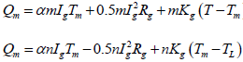



Where arfa=(arfan-arfap) is the Seebeck coefficient of a thermoelectric element, arfa and arfa are the Seebeck coefficients of the P-type and N-type semiconductor materials, respectively.

Eliminating m T in Eqs. (10) - (13), the power output PTTG and efficiency yitaTTG of the TTG can be, respectively, expressed as

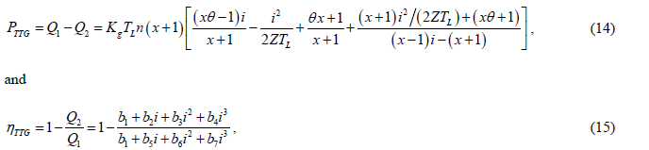

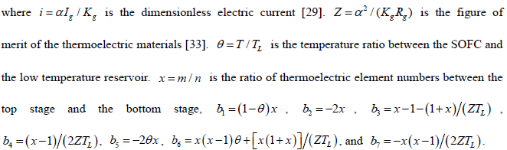

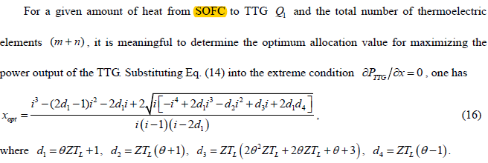

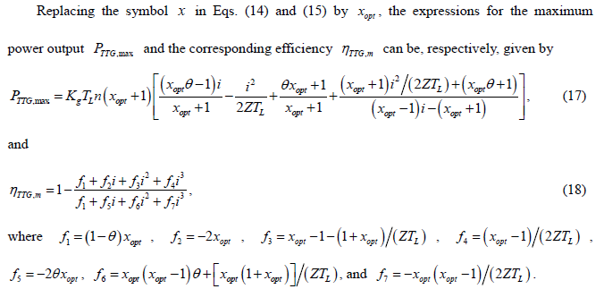

2.3The power output and efficiency of a hybrid device

As the TTG couldn’t absorb all of heat produced in the DSSC, one part of the heat is directly released to the surroundings. The heat leak may be simply determined by



According to the energy conservation law, the input heat from the DSSC to the TTG is



Due to the TTG should absorb a certain amount of heat when it works properly, there is a range of limited.

On the one hand, as is shown in the Fig, the heat which can be used to convert to electric energy is limited



On the other hand, Analyzing the TTG’s mathematic model, there are three parameters, ,n, x_opt and I, which can be optimized to make the output of TTG more efficient. The parameters are not independent variable. They could be figured out if the absorption heat of TTG (Q1) is a constant. In addition, n and x_opt are the structural parameters and couldn’t be changed any longer if they are once determined. So, a proper Q1 should be found. The heat in the system should be reused as much as possible to achieve better performance. The DSSC converts all the solar energy into heat at the two ends of a curve in the Fig. It is apparently that the best value of min(Q1) is

So, the structural parameter, n and x_opt can be given

With two devise’s features have been designed perfectly. Another problem needing to be solved is how to link two devices. According to the first law of thermodynamics, the input heat from the DSSC to the TTG is

With considering equs.(), the current of TTG ,as it is shown in the Fig, could be figured out.

It should be caution that the TTG would stop working when the heat released from the DSSC is over the absorption capacity of the TTG. However, because of the system is designed to adjust to the maximum output of heat in the DSSC at the start. It is needn’t to consider whether the system can operate proper.

3. Performance evaluation

