

FIJI HEAD TEACHERS’ ASSOCIATION
Strengthening Primary
School Leadership
A briefing booklet for the Minister for Education on the online FHTA Website platform

Leadership • Advocacy • Excellence

OUR NATIONAL LEADERSHIP NETWORK

One association. A nationwide voice.
The Fiji Head Teachers Association (FHTA) connects primary school leaders across Fiji, representing their professional interests and strengthening the leadership that shapes schools, teachers and student outcomes.
735  Heads of Schools | 12  District networks | 43  Years established

What FHTA contributes
- A trusted channel between Heads of Schools, communities, partners and the Ministry of Education.
- Professional learning and peer networks that translate policy into effective school-level practice.
- National, divisional and district representation on the issues affecting primary education.
- Practical member support, shared resources and timely communication.

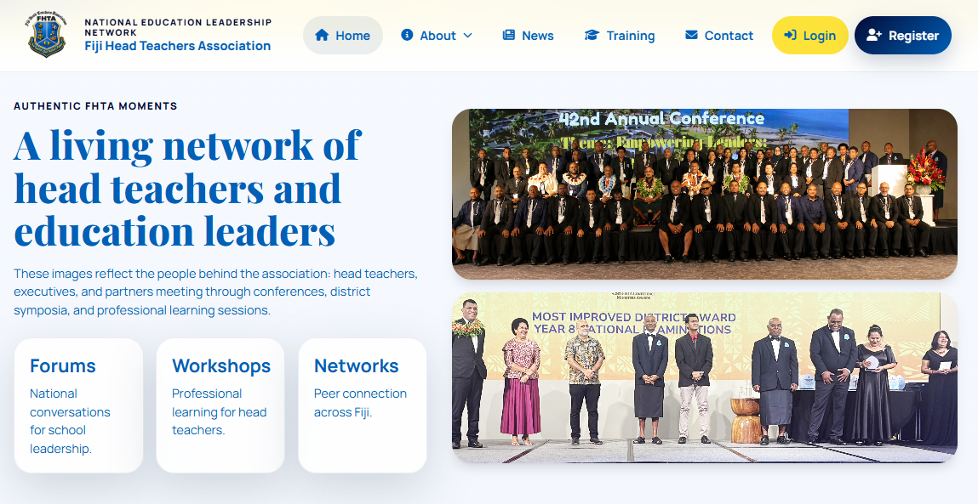
PURPOSE IN PRACTICE

Leading schools. Shaping futures.
FHTA's work is grounded in the daily realities of school leadership. The Association helps Heads of Schools lead teaching and learning, manage people and resources, respond to community needs, and sustain improvement.

Six areas of service
Advocacy and representation. A coordinated voice at district, divisional and national levels.
Professional concerns. Support pathways for members facing workplace and leadership issues.
Professional learning. Workshops, online learning and capacity building.
Leadership practice. Approaches that strengthen teaching, learning and school operations.
Collaboration. Peer exchange through area, branch and national networks.
Ministry partnership. Constructive engagement in education initiatives and policy implementation.

DIGITAL ASSOCIATION PLATFORM

A connected website for public information and member service
The FHTA website combines a public communications channel with secure member and staff services. It gives the Association one place to inform, support, train and connect school leaders.


Three connected experiences
Public website — Association information, news, events, services, resources, leadership and district coverage.
Member portal — Profiles, membership status, documents, helpdesk support, representatives and learning.
Staff operations — Member approvals, content publishing, events, resources, support tickets, training, attendance and certificates.

PROFESSIONAL LEARNING

From enrolment to evidence of completion
The training platform supports online, workshop and blended learning. Members can move through a clear pathway while staff manage delivery and participation.

01 Browse published courses and select an available schedule.
02 Enrol, access lessons, resources and learning outcomes.
03 Complete quizzes and track progress.
04 Check in at workshops using authenticated QR attendance.
05 Receive a printable certificate when completion requirements are met.

SCHOOL LEADERSHIP PRIORITIES

Practice for stronger schools
FHTA promotes leadership approaches aligned with the changing needs of learners, teachers and communities.
Instructional leadership
Keep teaching quality and learning outcomes at the centre.

Digital integration
Use appropriate technology to improve access, administration and learning.

Inclusive education
Advance equity, participation and support for every learner.

Community engagement
Build productive relationships with parents and stakeholders.

Data-informed decisions
Use evidence for planning, accountability and improvement.

Student wellbeing
Support learners' safety, belonging and holistic development.

OPPORTUNITY FOR PARTNERSHIP

A practical bridge between policy and schools
FHTA is positioned to support effective dialogue and implementation by connecting national priorities with the experience of primary school leaders.

Partnership opportunities
- Structured consultation with Heads of Schools before and during major policy initiatives.
- Joint professional learning on leadership, curriculum, inclusion, wellbeing and digital transformation.
- District-level feedback loops that identify implementation barriers and promising practice early.
- Coordinated communication of key notices, resources and opportunities through the FHTA network and portal.
- Collaborative recognition of school leadership excellence and innovation.
A shared goal
Confident school leaders, supported teachers,
and better outcomes for Fiji's children.


FIJI HEAD TEACHERS ASSOCIATION
A national network for primary
school leadership
Connect with FHTA
fijiheadteachersassociation@gmail.com
Website services include news, events, resources,
member support, representatives and professional learning.
Prepared from the current FHTA website and platform capabilities.

