Statistical/ML Innovation in Cybersecurity: Student-Feasible Research Landscape
Evidence window: 1 October 2024–7 October 2026, the latest date currently observable. I have not treated material scheduled after 7 October 2026 as completed evidence. Older work is included only where it defines a benchmark lineage or exposes a persistent methodological problem.
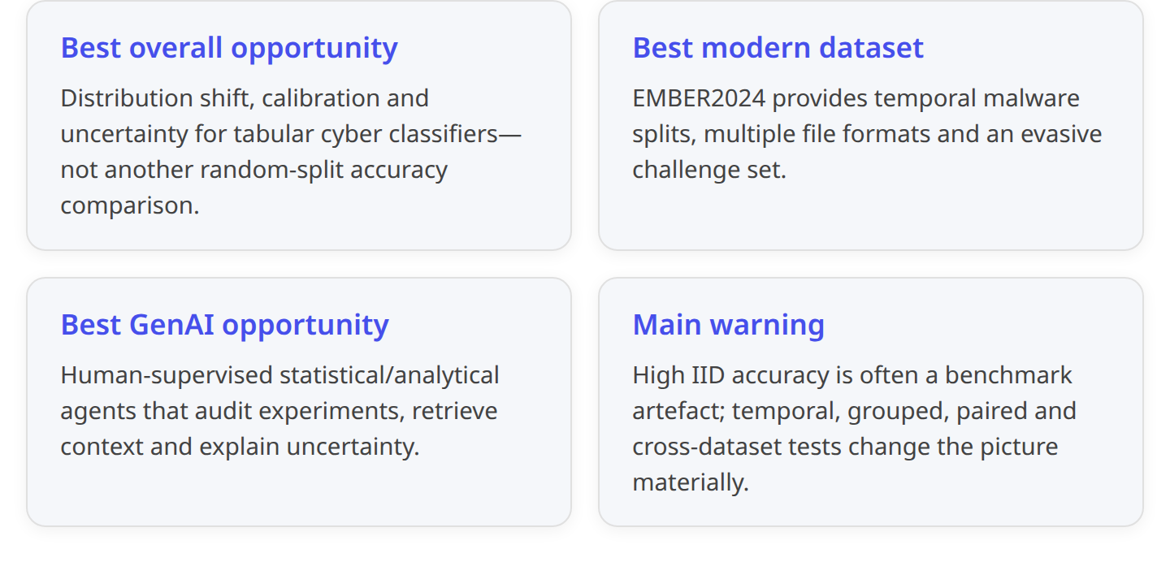

Concise overview

Priority 1 — Calibrated tabular intrusion/anomaly detection under shift
This is the strongest intersection of statistical innovation, TabPFN-style foundation models, modest compute and industry relevance. The recent tabular-foundation-model evidence is genuinely strong on small IID datasets, but fine-tuning experiments show reduced stability under gradual temporal shift and rich feature sets; a 2026 uncertainty study also found that high-AUC tabular foundation models had poorer conditional conformal coverage than gradient-boosted trees. Those limitations align unusually well with operational IDS requirements: rare attacks, changing traffic, asymmetric false-positive costs and the need to know when a prediction is unreliable.1 2
A tractable UCL question would therefore be: “When do tabular foundation models outperform calibrated GBDTs for cyber detection under temporal/device/domain shift, and can conformal or drift-aware calibration make their alerts more operationally trustworthy?” An open implementation already integrates TabPFN, TabICL, TabNet and classical models with CIC-IDS2017, N-BaIoT and CIC-UNSW pipelines, although it is a small community artefact rather than validation evidence.3 4

Priority 2 — Temporal and evasive malware detection
EMBER2024, published at KDD 2025, materially improves student feasibility: it contains features and labels for more than 3.2 million files across six formats, seven label/tag families, chronological training/testing and a deliberately evasive challenge set.5 6 The official repository records 2,626,000 training and 606,000 test files, plus 6,315 malicious files initially missed by roughly 70 antivirus products; crucially, students can download smaller file-type subsets rather than the full tens-of-gigabytes corpus.6
The best project is not “beat LightGBM on malware accuracy”. It is selective prediction under drift: compare GBDT, compact neural and tabular-foundation approaches on a manageable PDF, ELF, APK or sampled PE subset; measure temporal degradation, challenge-set recall, calibration and abstention at strict false-positive budgets.

Priority 3 — Modern phishing detection under generator and domain shift
The 2025 E-PhishGen study found that legacy phishing datasets are frequently obsolete, English-heavy and deceptively easy under within-dataset testing; its multilingual E-PhishLLM benchmark contains 16,616 emails in three languages and produced substantially lower detector performance than legacy benchmarks.7 A peer-reviewed July 2026 study then found a 28-point cross-generator F1 gap for stylometric detection of LLM-written phishing, despite off-diagonal AUC remaining above 0.96. Threshold recalibration reduced that gap to four points, whereas pooled multi-generator training reached F1 0.997—but only for the narrower task of distinguishing human-written from LLM-written phishing, not phishing from legitimate mail.8
This makes a statistically clean student project possible: calibration and robustness of phishing detectors across generators, languages, corpora and writing registers, including whether unsupervised or low-label recalibration works when the source generator is unknown.

Priority 4 — Context-aware software vulnerability detection
Recent evidence is both innovative and sobering. PrimeVul showed that a 7B code model’s F1 fell from 68.26% on BigVul to 3.09% on PrimeVul under more realistic deduplication and chronological evaluation.9 SecVulEval contains 25,440 C/C++ function samples from 5,867 CVEs with statement-level labels and context; its best reported model achieved only 23.83% F1 for identifying vulnerable statements with correct reasoning.10
JITVul adds a particularly valuable experimental design: 1,758 vulnerable/patched commit pairs from 879 CVEs and 91 CWEs. ReAct agents improved paired accuracy through adaptive context retrieval, but often over-predicted vulnerabilities, over-analysed patched guards and behaved inconsistently across a vulnerable/fixed pair.11 This area offers high academic novelty, although repository parsing, code context and model/API costs make it somewhat less straightforward than tabular IDS, phishing or malware.

Priority 5 — CTI and SOC analyst augmentation
CTIBench provides 4,610 released examples spanning CTI knowledge, CWE mapping, CVSS prediction, ATT&CK extraction and threat attribution. Its strongest tested model achieved 71% CTI knowledge accuracy, 72% root-cause mapping accuracy and macro-F1 0.639 on ATT&CK extraction—useful but not evidence for autonomous intelligence production.12 13 More recent work identifies CTI-specific failure mechanisms: superficial correlations, contradictory sources and weak generalisation to emerging threats.14
A 2025 longitudinal preprint covering 3,090 queries from 45 SOC analysts over ten months found that analysts mainly used LLMs for sensemaking, telemetry interpretation and communication rather than high-stakes determinations.15 This supports an assistive analyst project—evidence-grounded extraction, calibrated confidence and human review—not autonomous triage.
The following diagram shows how the three Generative-Data Science strands fit these priorities and where evaluation controls must sit. General data-science agents still perform modestly on executable analytical benchmarks, while tabular foundation models remain sensitive to shift and uncertainty; cyber agents similarly require paired, temporal and operational evaluation rather than a single headline score.16 1 11
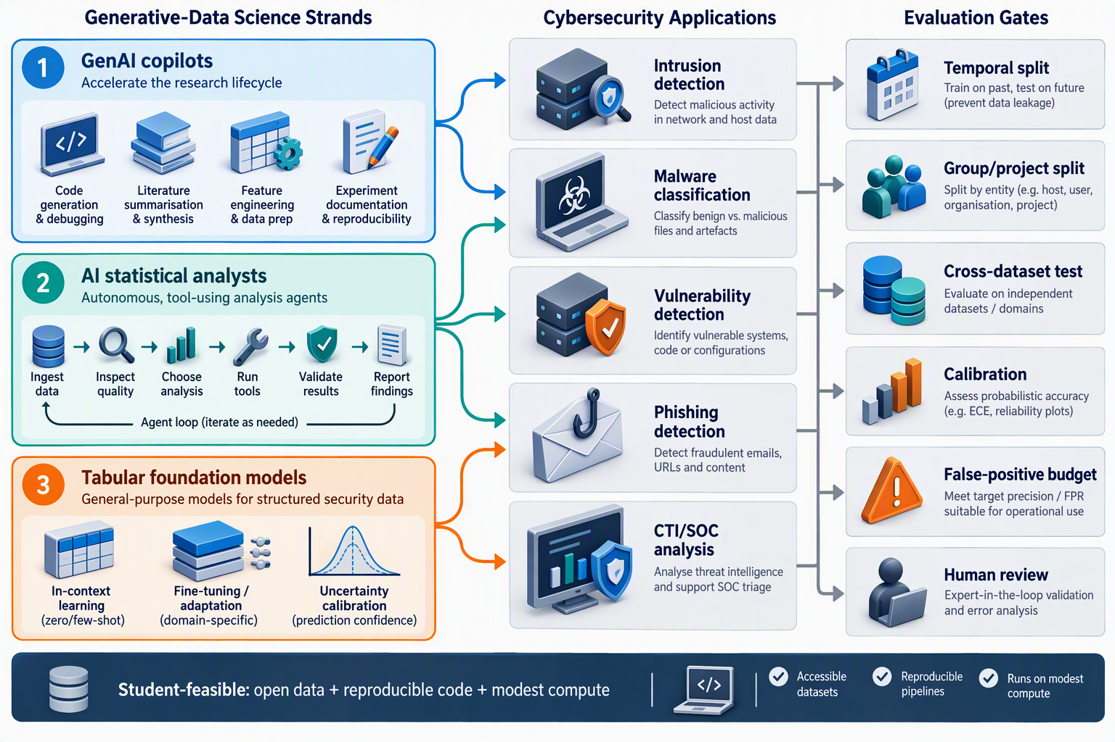
Figure 1: Three Generative-Data Science strands can contribute at different stages, but every cyber experiment should pass temporal, cross-domain, calibration and operational-usefulness checks.

Prioritised comparison
Cybersecurity problem area | Challenge | Methods | Evidence and limitations | Research gap | Relevant datasets or benchmarks
1. Intrusion/anomaly detection under shift | Highly imbalanced attacks; traffic changes by device, network and time; false positives dominate usefulness | GBDT, isolation/anomaly models, deep tabular models, TabPFN/TabICL, conformal prediction, drift detection, active learning | Established outside cyber: TFMs are competitive on small tabular problems. Emerging in cyber: open IDS frameworks now include TabPFN/TabICL. Limitation: fine-tuned TabPFNv2 was less stable under temporal shift; TFMs showed weaker uncertainty coverage than GBDTs.1 2 3 | Compare IID, temporal and device/site-held-out performance; conditional coverage by attack family; calibrated abstention; label-efficient adaptation after drift | CIC-IDS2017, N-BaIoT and CIC-UNSW loaders in the open AI-for-IDS framework. Dataset licences, split semantics and raw-capture provenance should be independently checked before freezing the protocol.3
2. Malware detection, family and behaviour classification | Novel families, temporal drift, evasive samples, noisy antivirus-derived labels and very low acceptable FPR | LightGBM/XGBoost, compact neural models, representation learning, TFMs on static features, conformal/selective classifiers, continual learning | Established: EMBER2024 supplies chronological splits and an evasive challenge set across six formats. Limitation: labels remain partly derived from antivirus consensus; the full corpus is large and feature-based experiments do not test dynamic behaviour.5 6 | Which models retain calibration and recall on later weeks and evasive samples? Can uncertainty identify new-family or label-noise cases? Does adaptation improve drift without forgetting? | EMBER2024: >3.2m files, 2.626m train/606k temporal test, 6,315 challenge, Apache-2.0 repository; individual PDF/ELF/APK subsets are practical. BODMAS: 57,293 malware + 77,142 benign, timestamped, but 2019–20 and binary access is restricted; useful as an older cross-dataset check.6 17
3. Phishing and AI-generated social engineering | Legacy corpora look solved; generators, languages, themes and register shift rapidly | TF-IDF/linear models, gradient boosting, transformer embeddings, LLM classifiers, stylometry, calibration and domain adaptation | Established: same-dataset testing can be near-perfect yet unrepresentative. Established recent result: cross-generator stylometric F1 degraded by 28 points; recalibration recovered most of the loss. Limitation: synthetic-email prompts can create obvious artefacts, and authorship detection is not phishing detection.7 8 | Low-label or unsupervised recalibration; leave-one-generator/language/theme-out testing; adversarial register shifting; combined content, URL and header signals; calibrated human-review thresholds | E-PhishLLM: 16,616 emails, three languages. Cross-model corpus: 9,986 phishing emails—5,000 human and 4,986 from three LLMs—publicly archived with code. MeAJOR: 108,685 anonymised multi-source samples, but inherits old TREC/Nazario source distributions.7 8 18
4. Software vulnerability detection and triage | Extreme class imbalance; vulnerable code differs subtly from its patch; function-only views omit interprocedural context | Code encoders/LLMs, LoRA, graph/static analysis, retrieval, ReAct agents, paired ranking, uncertainty calibration | Established: older benchmarks overstate performance. PrimeVul, SecVulEval and JITVul expose large drops, weak statement localisation and low paired consistency. Emerging: adaptive context retrieval helps compared with indiscriminate context insertion, but autonomy remains unreliable.9 10 11 | Small-model or hybrid static-analysis/agent methods; calibrated ranking under fixed alert budgets; consistent vulnerable–patched reasoning; project/time-held-out generalisation | PrimeVul: chronological, deduplicated C/C++ functions. SecVulEval: 25,440 functions/5,867 CVEs, statement labels and context. JITVul: 1,758 paired commit states/879 CVEs/91 CWEs. CVEfixes is broader but its July 2024 snapshot can be large to process.10 11 19
5. CTI extraction and SOC assistance | Volatile and contradictory sources; long, low-level telemetry; hallucination and attribution risk | RAG, structured extraction, tool-using agents, evidence graphs, ATT&CK/STIX mapping, retrieval-assisted statistical summaries | Established: CTIBench shows partial competence, not autonomous reliability. Emerging: real analysts use LLMs mostly as cognitive aids; recent CTI work documents failure under contradictory and emerging evidence. Practitioner evidence: current open SOCBench has published detection only; broader SOC capabilities remain roadmap items.12 15 14 20 | Evidence-cited extraction with calibrated abstention; temporal CTI tests after model cut-off; human–AI workload/accuracy studies; detection of contradictory evidence | CTIBench: 4,610 examples, five task families, released responses/logs. MITRE ATT&CK STIX: versioned machine-readable CTI with research/commercial-use permission. SOCBench: 1,205 flow units for its current detection lane, Apache-2.0 but vendor-developed.12 21 20

Generative-Data Science assessment
Strand | Established evidence | Most useful contribution to cyber research | Main limitations and evidence status
1. Generative AI supporting data-science work | DA-Code, released October 2024 and accepted at EMNLP 2024, contains 500 executable wrangling, EDA and ML tasks. Its best reported baseline reached only 30.5% total accuracy, despite 76.8% executable code.16 | Generate reproducible preprocessing code, data dictionaries, leakage checks, metric dashboards, SHAP summaries and experiment documentation—with tests and human approval | Established: useful code can be produced. Not established: autonomous correctness. Cyber use adds risks from poisoned artefacts, unsafe parsing, confidential data and plausible but wrong statistical explanations
2. AI systems acting as statistical analysts | The SOC field study shows genuine use for contextual interpretation and report support, while retaining human authority. JITVul shows agents can retrieve context adaptively yet remain inconsistent.15 11 | An “experiment auditor” that inspects splits, imbalance, calibration, confidence intervals and provenance; or a CTI analyst that outputs evidence-linked structured claims | Emerging hypothesis: tool use can improve analytical workflow quality. There is not yet strong evidence that agents autonomously select valid cyber study designs, diagnose leakage or make high-stakes statistical conclusions
3. Tabular foundation models, including adaptation | TabPFN’s small-data results appeared in Nature on 8 January 2025. A June 2025 study found full fine-tuning practical up to 50,000 rows, but weaker stability under temporal shifts; 2026 evidence identifies uncertainty calibration as unresolved.4 1 2 | Fast small-data baselines; few-shot adaptation to a new device/site; probabilistic ensembles; data-efficient experiments in IDS, malware-feature and phishing-feature tables | Established: strong IID potential. Emerging in cyber: direct comparisons and open implementations exist, but cross-site robustness is not settled. Fine-tuning may change thresholds without producing robust domain understanding; always retain GBDT and linear baselines22 3

Benchmark comparability: non-negotiable controls
Reported improvements should not be treated as comparable unless the following match:
- Split unit: row-random versus time, host/device, campaign, malware family or software project. PrimeVul and JITVul demonstrate how chronological, deduplicated and paired evaluation can reverse optimistic conclusions.9 11
- Preprocessing boundary: scaling, PCA, feature selection, imputation and SMOTE must be fitted inside each training fold. Synthetic augmentation must never precede splitting.
- Data version and provenance: “CIC-IDS2017” or “Enron phishing” can denote different cleaned derivatives. Record hashes, download date, transformation code and exclusions.
- Task definition: LLM-versus-human phishing authorship is not phishing-versus-legitimate detection; function classification is not statement localisation; CTF completion is not SOC triage.8 10 23
- Metrics: report PR-AUC, per-class recall, MCC, Brier score/ECE, calibration plots and recall at a fixed operational FPR—not accuracy alone. For paired code, include paired accuracy; for agent tasks, include completion, cost, latency and malformed-output rate.11 20
- Repeated uncertainty: publish seeds, confidence intervals and paired statistical tests. For stochastic agents, use repeated runs rather than a single success trace.
- Contamination: test examples, CVEs, threat reports and CTF write-ups may be in model training data. Prefer post-cut-off, private-before-release or transformation-resistant tests; do not assume that “new benchmark” means uncontaminated.

Practitioner and social signals
These should be treated as signals, not established findings:
- A 2025 Hacker News discussion described vulnerability-model results as “hit-or-miss” and SAST-like, requiring additional prompting; the thread also emphasised that remediation ownership and developer confidence can matter more than finding another alert.24
- A 2025 practitioner discussion reported LLM use for understanding commands, generating queries and polishing reports, but raised concerns about sensitive SOC data and explainability.25 This matches the more systematic SOC field study’s finding that LLMs augment sensemaking rather than replace analyst judgement.15
- SOCBench is a useful open practitioner initiative because it records efficacy, cost, latency and reliability, but it is developed by a vendor whose own specialised model is part of the comparison, and only its detection capability is currently published. Results should therefore be reproduced independently before being treated as general evidence.20

Best-supported UCL candidate directions

A. Recommended: uncertainty-aware tabular foundation models for IDS under realistic shift
Core experiment: GBDT, logistic/linear, TabPFN and TabICL across IID, temporal and device/site-held-out splits; post-hoc calibration, conformal prediction and abstention; evaluation at fixed false-positive budgets.
Why it wins: strongest Generative-Data Science fit, modest compute, clear statistical contribution, direct operational relevance and an identifiable evidence gap around TFM reliability under cyber shift.1 2 3

B. Recommended: calibrated detection of evolving AI-generated phishing
Core experiment: train on one set of corpora/generators/languages, hold out another; compare recalibration, pooled training and label-efficient adaptation; include a phishing-versus-legitimate task so authorship is not confused with maliciousness.
Why it wins: recent peer-reviewed evidence already isolates calibration as a major failure mode, while multilingual and multi-generator datasets are openly available and small enough for laptop or modest-GPU experimentation.7 8

C. Recommended: selective malware classification under time and evasion
Core experiment: use a student-sized EMBER2024 subset; compare temporal performance, evasive challenge-set recall, uncertainty, abstention and family-level error concentration.
Why it wins: exceptionally strong benchmark design, genuine operational failure modes and reproducible open tooling. The uncertainty/calibration angle is more novel and valuable than another architecture comparison.5 6

D. High novelty, higher difficulty: context-aware vulnerability triage
Use JITVul or a sampled SecVulEval subset to test whether static-analysis-derived context, paired reasoning and uncertainty-aware ranking improve small/open code models. This is likely the most academically novel direction, but it carries higher software-engineering complexity and potentially greater API/GPU cost.10 11

Bottom line
The most defensible project theme is not “apply a newer model to a cybersecurity dataset”. It is:
Evaluate whether modern tabular or generative models remain calibrated, selective and useful when cyber data changes across time, generator, device, campaign or project—and whether a human-supervised analytical agent can diagnose and communicate those failures.
The strongest starting choice is tabular IDS under shift, with modern phishing calibration and EMBER2024 temporal/evasive malware as close alternatives. The unresolved decision is principally the team’s preferred data modality—network tables, email text or malware features—rather than whether enough evidence exists for a meaningful student project.

