* A link to the GitHub repository containing the code for your project.

<https://github.com/elikrm/She-Codes-Django-Project>

* main page when user is not logged in

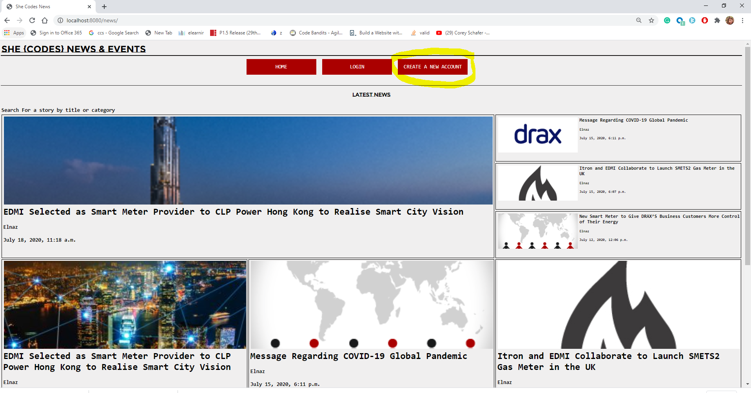

* Main page when a user is logged in:

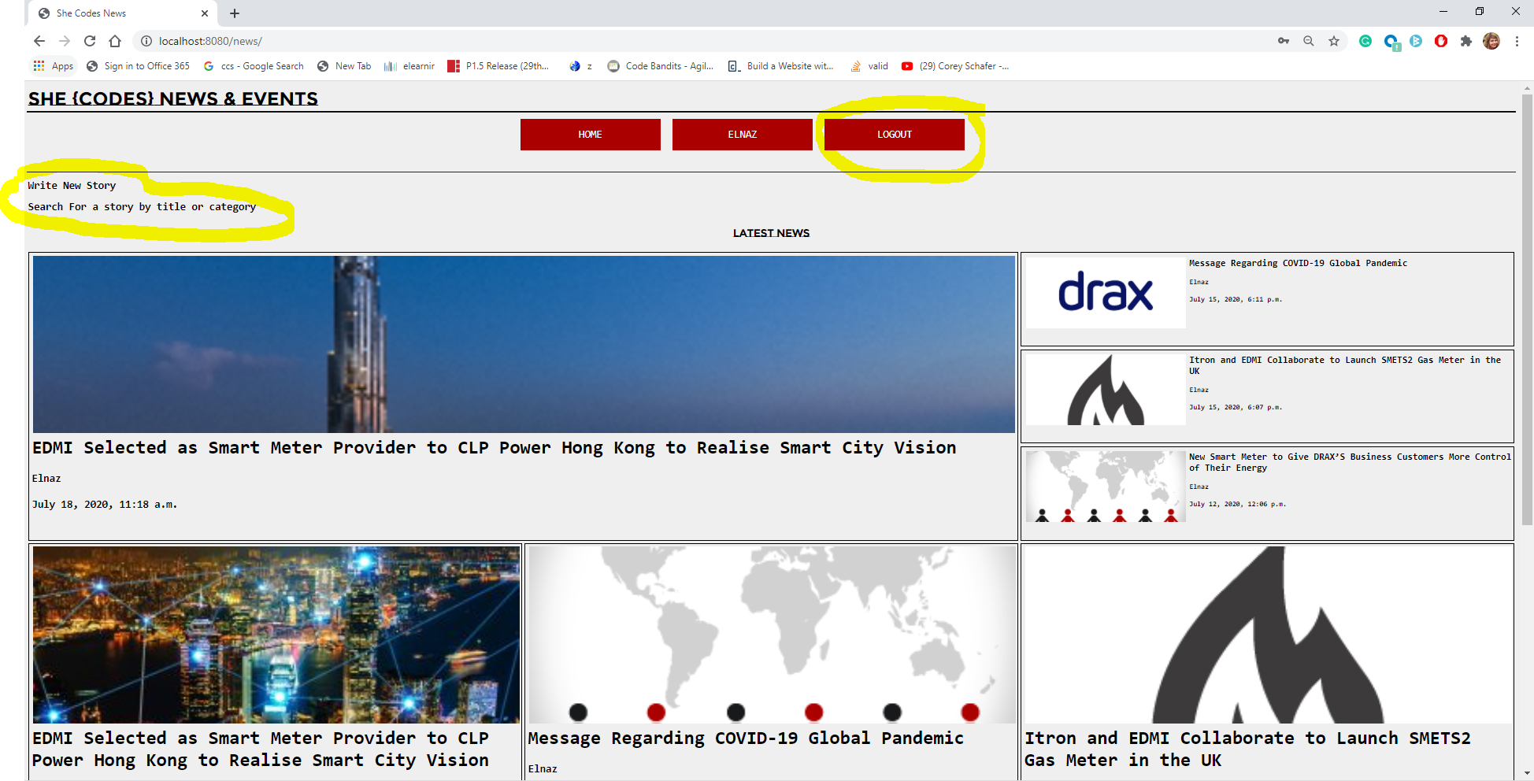

* This is a page for adding a new story that has a field to the NewsStory model for an image url and use this image url rather than the default images provided in the starter

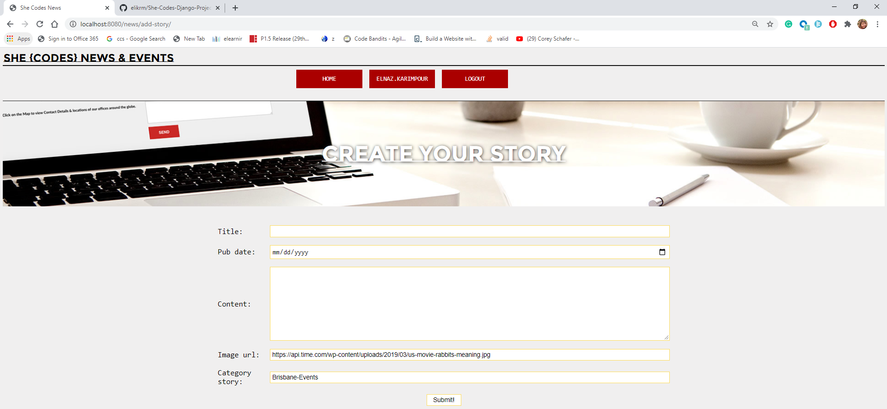

* Just the user who login can add the new stories.

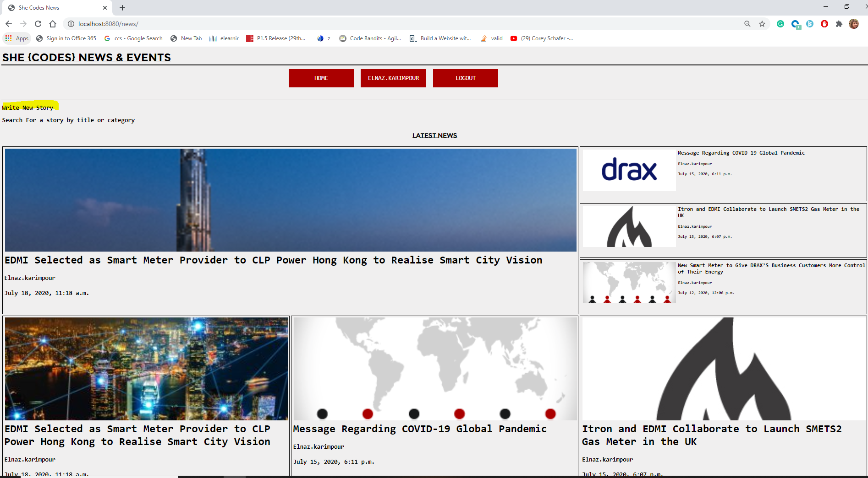

* It has the account view so authors can see their profile information.

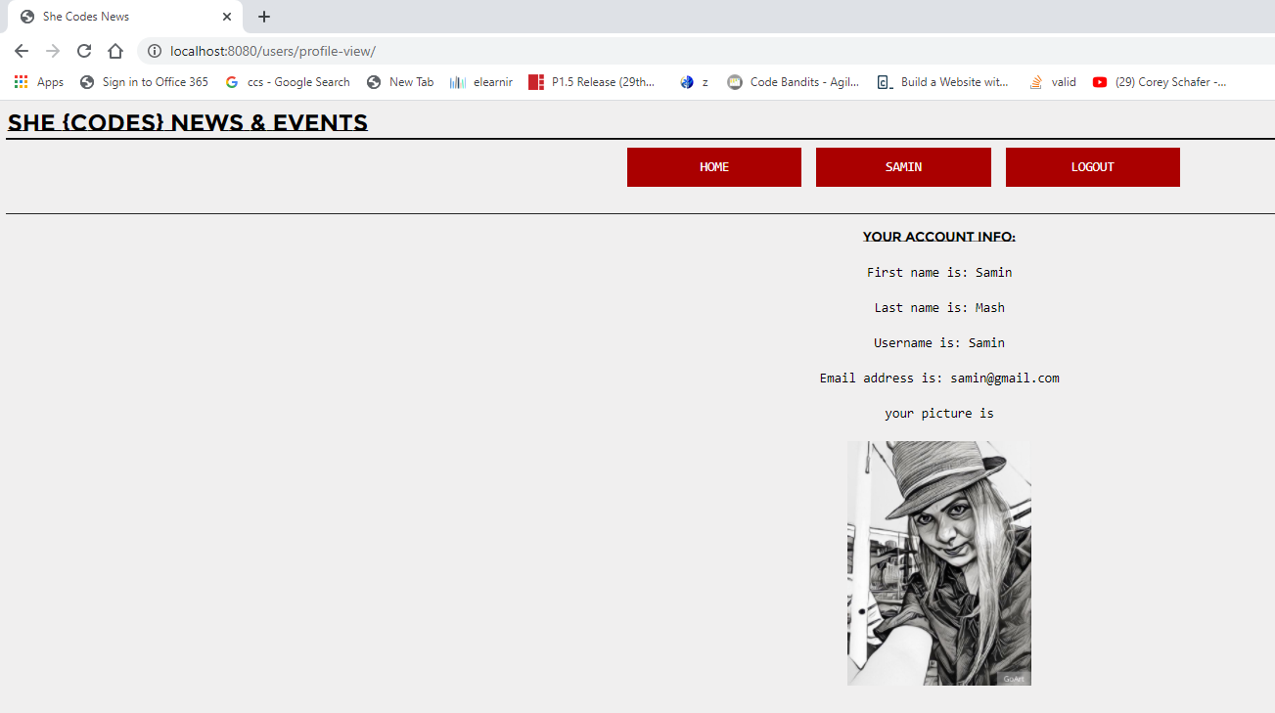

* Create Account functionality, so a new user can sign up to be an author.

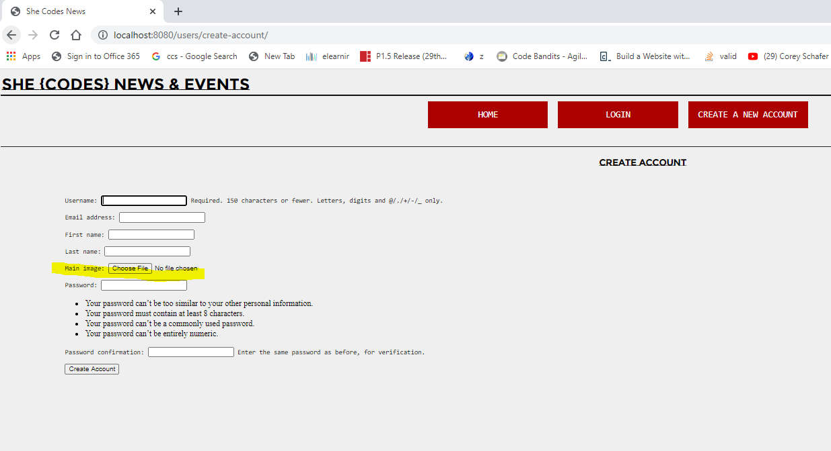

* If you log in with only a super user account in each story you can see features to Edit and Delete the story
* Show/Hide the relevant information and buttons based on whether the user is logged in/out (e.g.should only be able to see the button to create a new story if I am logged in).

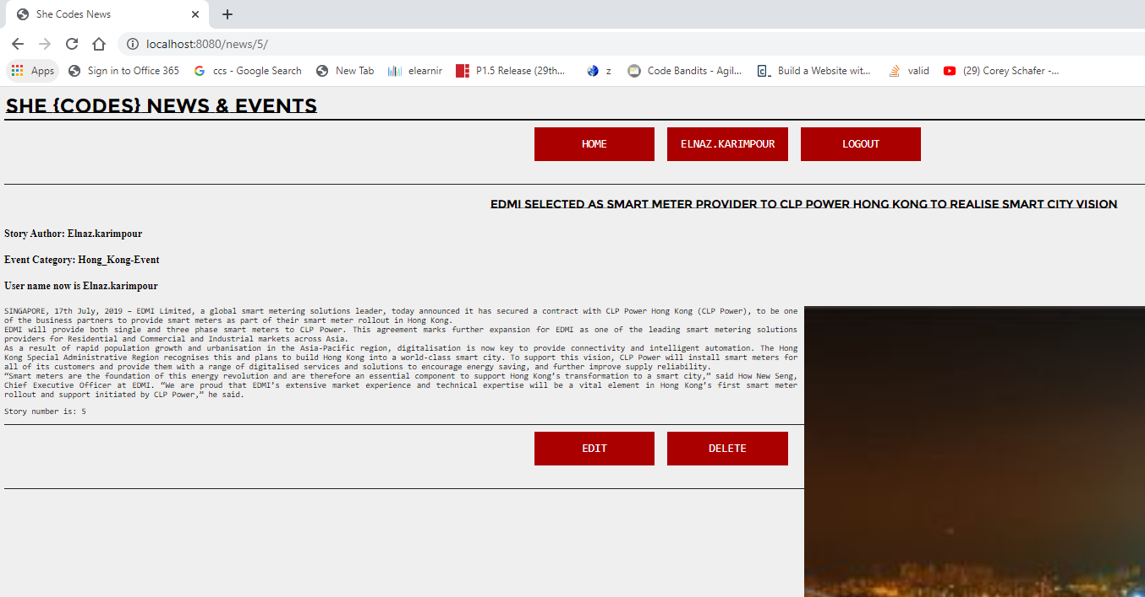

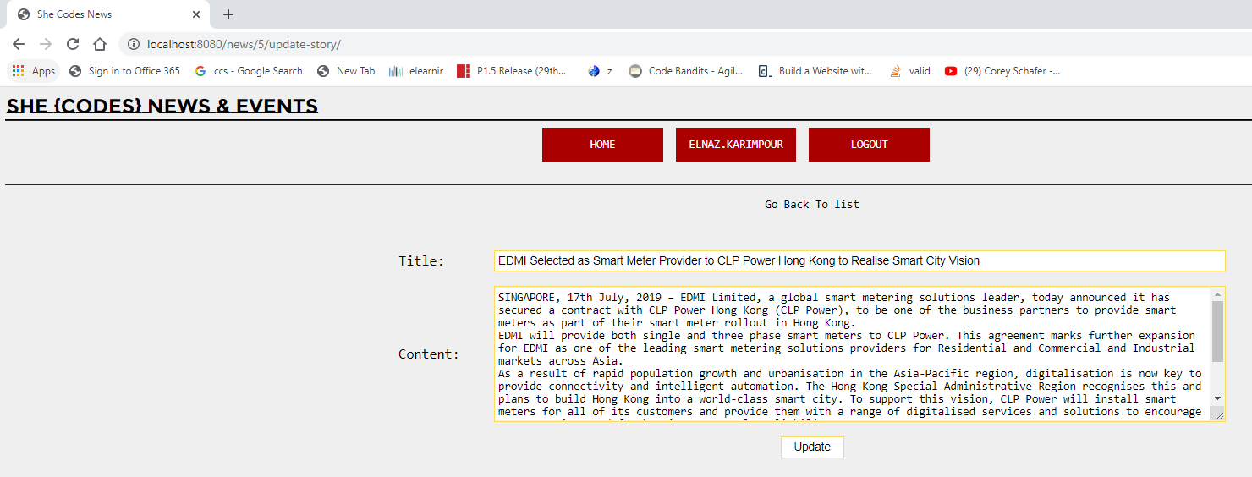

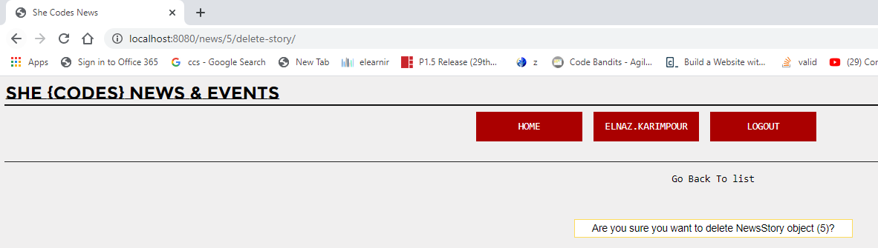

* Each story has a category and search feature allow the user to search for stories by category and titles.

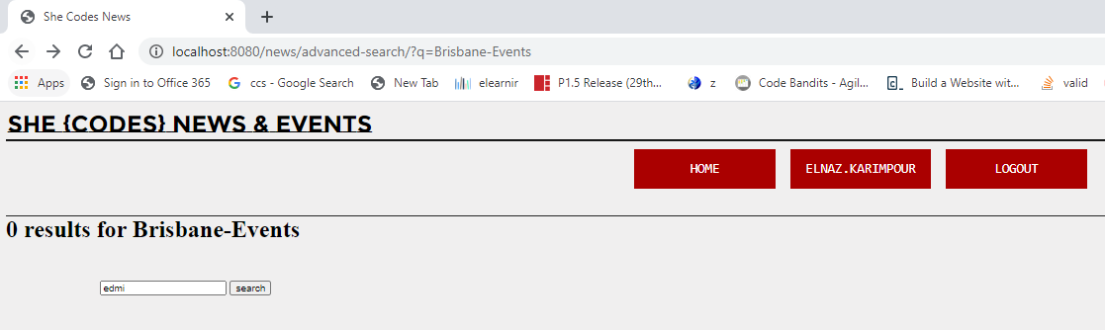

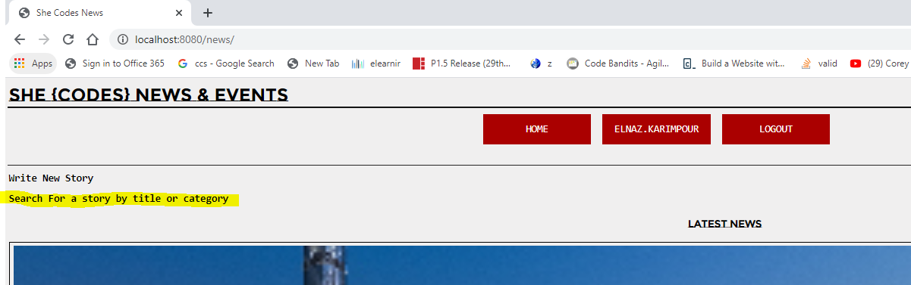

1. Show the results by title

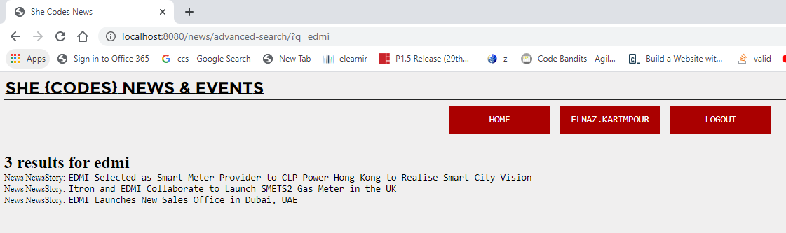

1. Show the results by categories

