Phase 1 Report

1. System Function and Decomposition 2
1.1 System Function 2
1.1.1 Overall Function 2
1.1.2 Expected Operating Conditions 2
1.1.2.1 Mechanical/actuation 2
1.1.2.2 Performance and Safety Expectations 2
1.2 System Decomposition 3
1.2.1 Blade-Hub Interface Subsystem 3
1.2.2 Pitch Actuation Subsystem 3
1.2.3 Power Generation 3
2. Kinematics 4
2.1 Kinematic Relationships 4
2.2 Key states 4
3. Preliminary Failure Mode Review 4
3.1 Likely Failure Modes 4
3.1.1 Actuator Failure 4
3.1.2 Linkage Failure 5
3.2 Identifying Failure Solutions 5
3.2.1 Actuator Failure Solutions 5
3.2.1.1 Design Solutions 5
3.2.1.2 Control (Safety) Solutions 5
3.2.2 Linkage Failure Solutions 6
3.2.2.1 Design Solutions 6
3.2.2.2 Control (Safety) Solutions 6
4. Critical Design Parameters 6
4.1 Geometric Parameters 6
4.2 Material Parameters 6
5. References (if needed) 6

1. System Function and Decomposition

1.1 System Function

1.1.1 Overall Function
The active pitch mechanism rotates each turbine blade about its blade pitch axis (the blade root) to dynamically adjust the blade’s angle of attack relative to the velocity of incoming wind. By dynamically controlling the pitch angle, the system:
- Optimizes power capture below rated wind speed by maintaining an optimal aerodynamic operating point (usually near the optimal tip-speed ratio and lift-to-drag ratio).
- Regulates power and rotor speed at and above rated wind speed by pitching toward feather to reduce torque caused by turbulent wind flows.
- Reduces structural loads during large gusts, turbulence, emergency shutdowns, and starting/stopping procedures.
- Allows for safe shutdown and powering-down operations by quickly pitching the blades to a low-torque condition.
In normal operating conditions, the turbine blade pitch will be positioned based on measured/estimated wind speed, rotor speed, generator power, and sometimes blade root bending moments.

1.1.2 Expected Operating Conditions

1.1.2.1 Mechanical/actuation
- Pitch range: typically 0-90 degrees (often operated within -5 to 30 degrees for better control, larger angles will be used to feather and/or shutdown operation).
- Loads through the pitch joint: large combined aerodynamic bending moments. axial/radial forces, and fatigue cycles (will be detailed later).
- Duty Cycle: very high cycle count over lifespan; design is relatively fatigue-critical.

1.1.2.2 Performance and Safety Expectations
- Accurate pitch positioning (will require closed-loop control)
- High reliability (pitch is the primary safety function)
- Fail-safe ability to reach the feather position at any point.

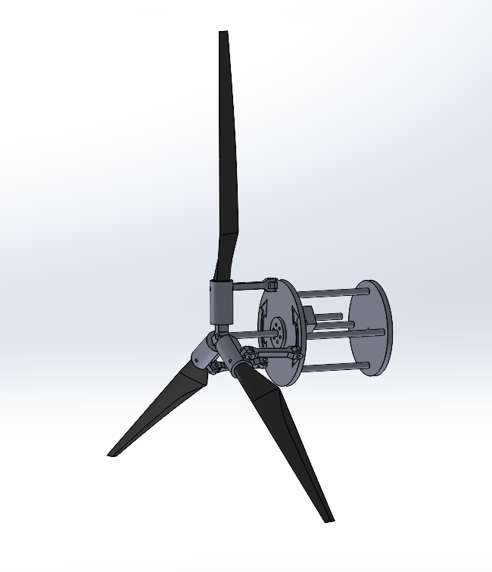
1.2 System Decomposition
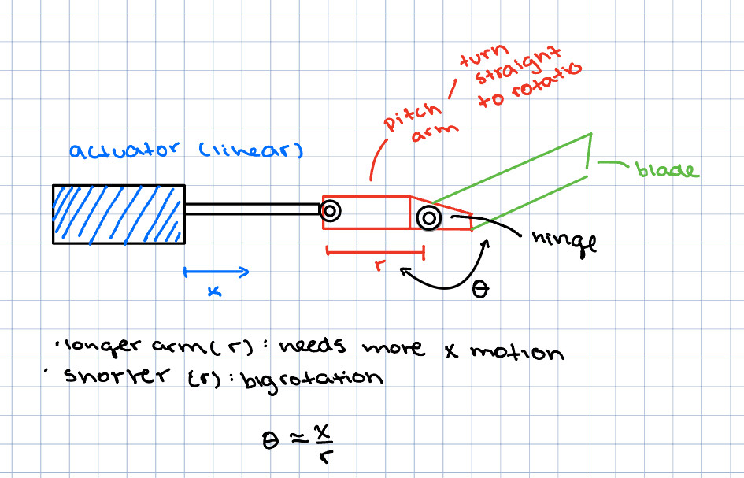

1.2.1 Blade-Hub Interface Subsystem
The blade-hub interface consists of a fixed shaft with a center hub bearing at the front attached to three wind turbine blades through bearings. About midway down the fixed shaft are two plates; the back one has fixed rotation but allows translation up and down the shaft. The front one is free to rotate and translate about the shaft. The two plates experience sliding friction between them as the front one rotates. The front plate is pinned to three coupler links, one for each blade, and the other side of the couplers is pinned to one side of the collar of each turbine blade. The end of the fixed shaft is attached to a fixed support that has a hole offset from the middle to allow for another shaft. This other shaft is fixed to the back plate, only allowing for translational motion along the axis of the fixed shaft.

1.2.2 Pitch Actuation Subsystem
The pitch of the turbine blades is controlled by the translating shaft. As it moves back and forth with the fixed shaft, the two plates will also translate, pushing and pulling the couplers attached to the turbine blades. This causes the blades to rotate about their pitch axis along with the bearings between the blades and the center hub. A linear actuator will be used to control the motion of the blade pitch, driven by data such as optimal pitch vs wind speed.

Slider motion 19.95mm
distance from joint to axis of blade 14.46
79.05 degrees of rotation

1.2.3 Power Generation
To generate power, a motor is placed in the back attached to a shaft that spins with the sliding plate. To harness and use the energy produced by the wind turbine model, a 12V DC motor (500-1000rpm) is used as a generator. A diode must be placed in line with the positive output lead to ensure no power is going back to the motor, potentially causing harm. A capacitor such as 1000μF is placed across the output terminals of the motor, and if needed, a DC-DC boost converter is used to provide a steady output voltage.

2. Kinematics

2.1 Kinematic Relationships
The mechanism uses rods to translate linear motion into rotational motion between the sliding hub and the blade itself. There is a fixed and rotating section of the mechanism. The fixed end consists of a plate and an actuator. The plate slides along a shaft or rail to transmit the linear motion. The fixed plate interfaces with a sliding plate that has rods and a housing that interfaces with the blade. The linear motion of the sliding plate is translated through the push rods into an offset housing that allows for the blade to pivot, causing a change of pitch.
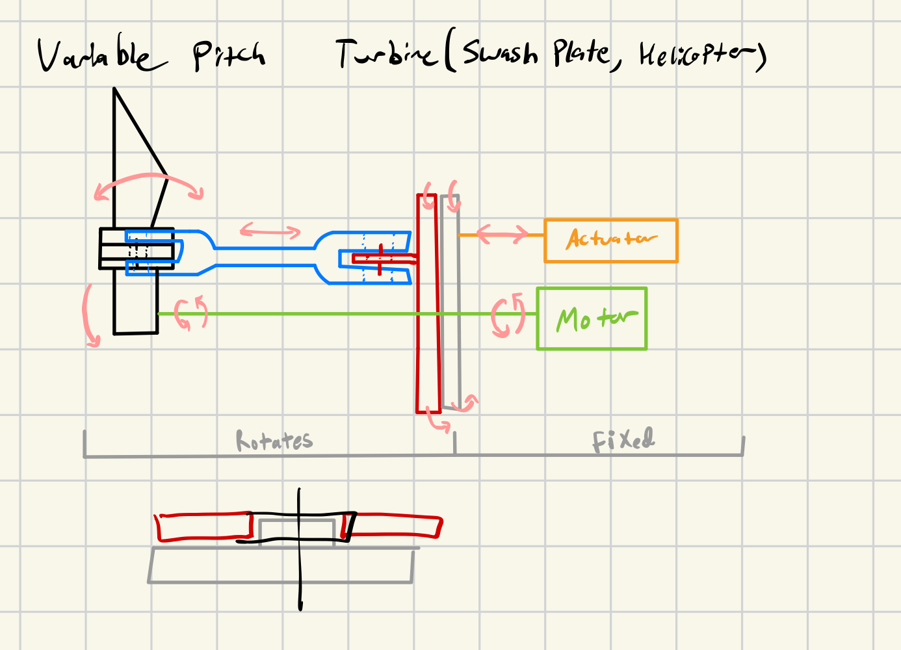

2.2 Key states
- Fully Open - no pitch, broad side to wind
- Fully Closed - full pitch, narrow edge to wind

3. Preliminary Failure Mode Review

3.1 Likely Failure Modes
The pitch mechanism operates in a high-cycle, outdoor, and vibration-filled environment, which will cause it to be subjected to aerodynamic load reversals, centrifugal effects, and gust-driven transients. Failure modes due to these conditions are dominated by fatigue, wear, misalignment, and loss of control.

3.1.1 Actuator Failure
- Linear actuator stall or insufficient force
- Underestimated aerodynamic pitch torque, cold temperature effects, high friction, and binding in the linkages.
- Possible effects: the blade cannot reach the suggested pitch.
- Actuator mechanical failure due to wear
- Possible mechanical failures include: high duty cycle, Contamination, poor lubrication, and side loads.
- Possible effects: degraded control and eventual seizure can happen.
- Actuator electrical failure
- Possible electrical failures include: Motor/driving overheating, water ingress, cable fatigue, and erosion between connectors.
- Possible effects: Loss of pitch motion.

3.1.2 Linkage Failure
- Linkage fatigue cracking
- Possible linkage fatigue cracking includes: cyclic loading from pitch commands and aerodynamic oscillations; stress concentrations at holes and threads.
- Possible effects: partial or total loss of pitch authority for one blade; imbalance and high vibration.
- Linkage pin wear and deformation
- Possible pin wear and deformation stems from: fretting, poor lubrication, and contamination.
- Likely effects: backlash leads to pitch angle error, control oscillations, and shock loads that accelerate fatigue.
- Buckling of members under compression
- Buckling possibilities under compression causes: actuator pushing toward hub loads linkage in compression; slender rods can buckle under gust loads.
- Likely effects: sudden loss of pitch command transmission.

3.2 Identifying Failure Solutions

3.2.1 Actuator Failure Solutions

3.2.1.1 Design Solutions
- Mechanical advantage in linkage geometry: Design the linkage so the actuator has its highest mechanical advantage near the most load-bearing pitch positions.
- Linear cylinder support: Add linear guides to keep the sliding cylinder coaxial and prevent side-loading the actuator rod.
- Reduce friction sources: Use spherical rod ends that tolerate misalignment; avoid binding at the blade hub interface by using a proper pitch bearing/bushing.

3.2.1.2 Control (Safety) Solutions
- Current/force monitoring: Implement actuator current monitoring (or force sensor/load monitoring) to detect stall early and stop before damage.
- Fail-safe to feather: Provide a backup method to reach the feather so loss of force doesn’t equal loss of safety.
- Emergency shutdown logic: If a stall is detected, there should exist a command that reduces torque and trigger shutdown procedure.

3.2.2 Linkage Failure Solutions

3.2.2.1 Design Solutions
- Use rod-end bearings: Replace simple pins with spherical rod ends to prevent binding from misalignment.
- Bushings at pins: Use replaceable bushings (Bronze/strong polymer) or rolling joints; These allow for easy replacement.
- Double-shear connections: Put pins in double shear and use shoulder bolts so threads never sit in the shear plane.
- Increase bearing area: Larger pin diameter and thicker lugs reduce contact pressure and reduce wear.

3.2.2.2 Control (Safety) Solutions
- Backlash control: Add a small deadband/filters in the pitch controller so it doesn’t become damaged.
- Dual position sensing: Use sensors to detect possible drift or backlash in the pitch.
- Vibration testing: Check that locking mechanisms prevent loosening under vibrations.

4. Critical Design Parameters

4.1 Geometric Parameters
Adding Fillets to parts can add strength and reduce stress concentrations, similarly to creating models with fewer holes. The lengths of the actuator and the blade-housing arm are important for calculating the angle of twist we can achieve in the blade.

4.2 Material Parameters
The material we are using is 3D printable PLA filament. Since we are using 3D printing, we must account for the stresses and strains induced by motion so we can align the model for optimal strength within the layers. If the layers are parallel to the strain, they may come apart, and if they are perpendicular to the normal stresses, then they can also come apart.

5. References (if needed)
CAD MODEL IDEAS:

CAD MODELS

