1. After running otEdit.exe for the first time – “Reset Toolbar” – or otherwise

the database functionality will not work:

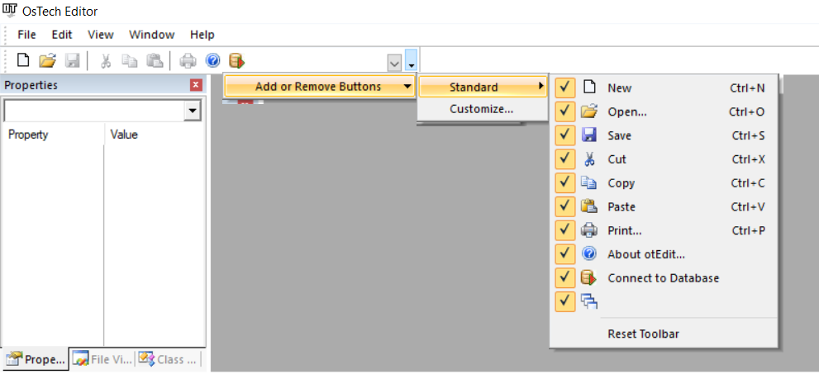

1A. Set up a connection string in otConnections table, in the accompanying Microsoft Access database.

Example would be

Driver={SQL Server};Server=;Database=;Uid=;Pwd=

1. The editor is equipped with an interface to help you edit access tables, even if you do not have MS Access.

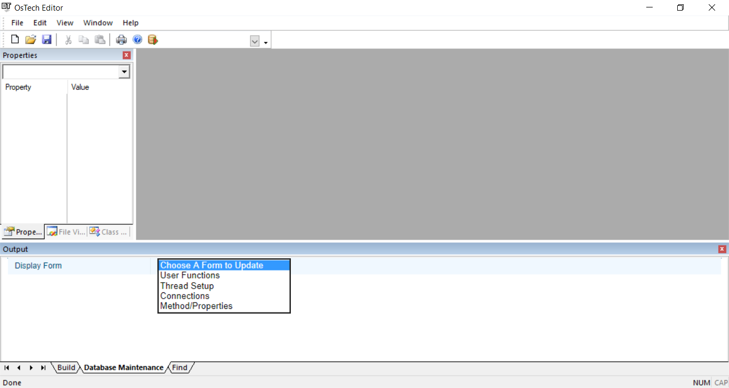

The editor was developed back in 1998, when code completion and variable look up for html and .JS files was non-existent.

As a testament of how stable the MFC classes are, I upgraded from Visual Studio 6 to Visual Studio 2008 and from 2008 to Visual Studio 2015.

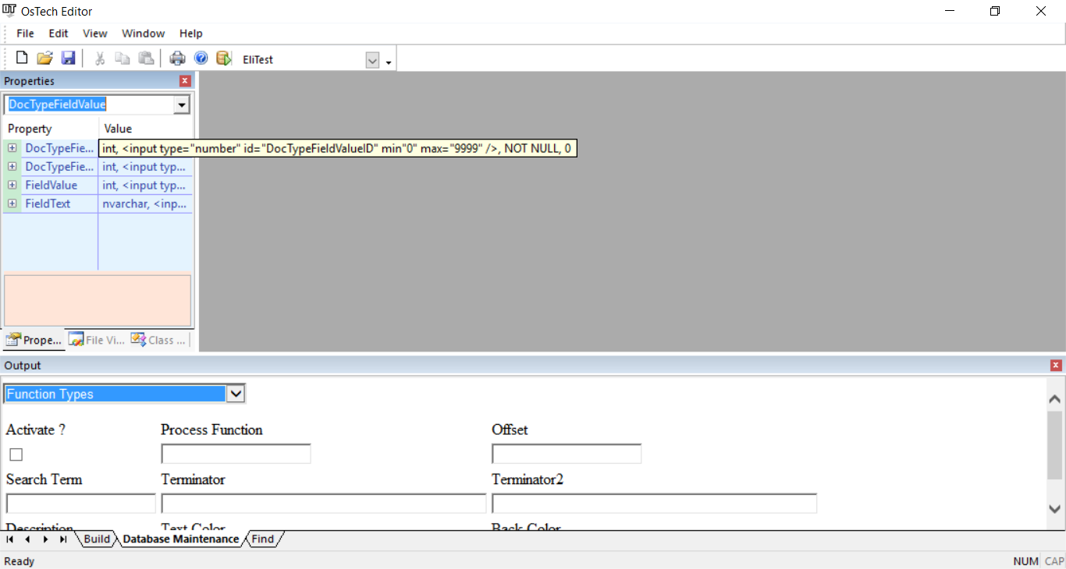

When you open a file, all the variables defined in MS Access to find, are available.

