Eunice Lim

Web 335

Exercise 4.2

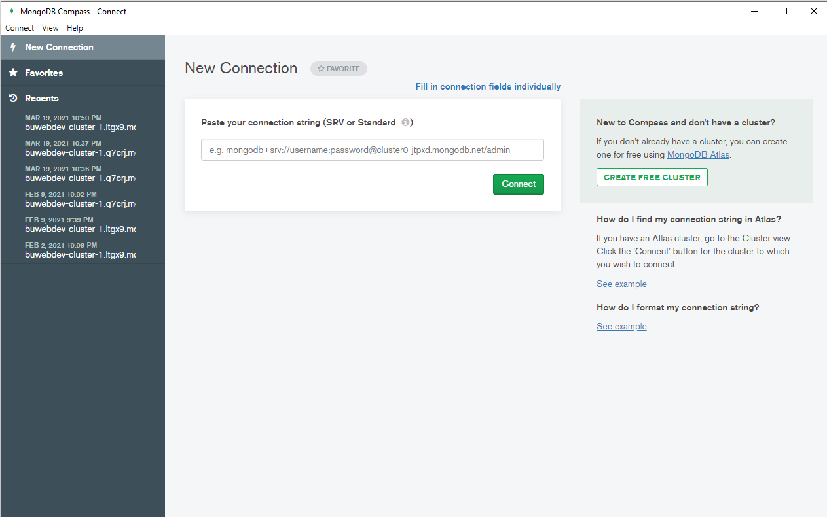I do not have a screenshot of the installation as MongoDB was installed a while back.

