I decided to do a website on my significant other. This is my very first website and he has been super supportive of me doing this program for a career change, so I wish to dedicate this site to him.

I thought of his interests and want to use the colors and fonts that are related those interests on his site.

He likes to ride his motorcycle, loves the beach and sun. Works hard, been at the same company for over 34 years. He has two children, had dogs all his life because he’s allergic to cats.

I decided to go with a scroll page site, since this is a single page website. I came up with two layouts below and then moved on to look at fonts and colors.

Title Title

introduction introduction

c

c

Eg xxxxx

c

c

Initially I went with rectangles for pictures, but I thought circles would be unique and also because they look like the wheels on his Harley. There is an introduction paragraph and under each pictures a little story about him.

He’s traveled to the mountains and has a list of places he wants to go to. Singapore, Germany, Japan and Dubai to name a few. Right now, Cancun is our favorite place so far and I thought a fun font would work. Google search gave me some ideas and I want to find a font available that looks close to what I feel is beachy/tropical.

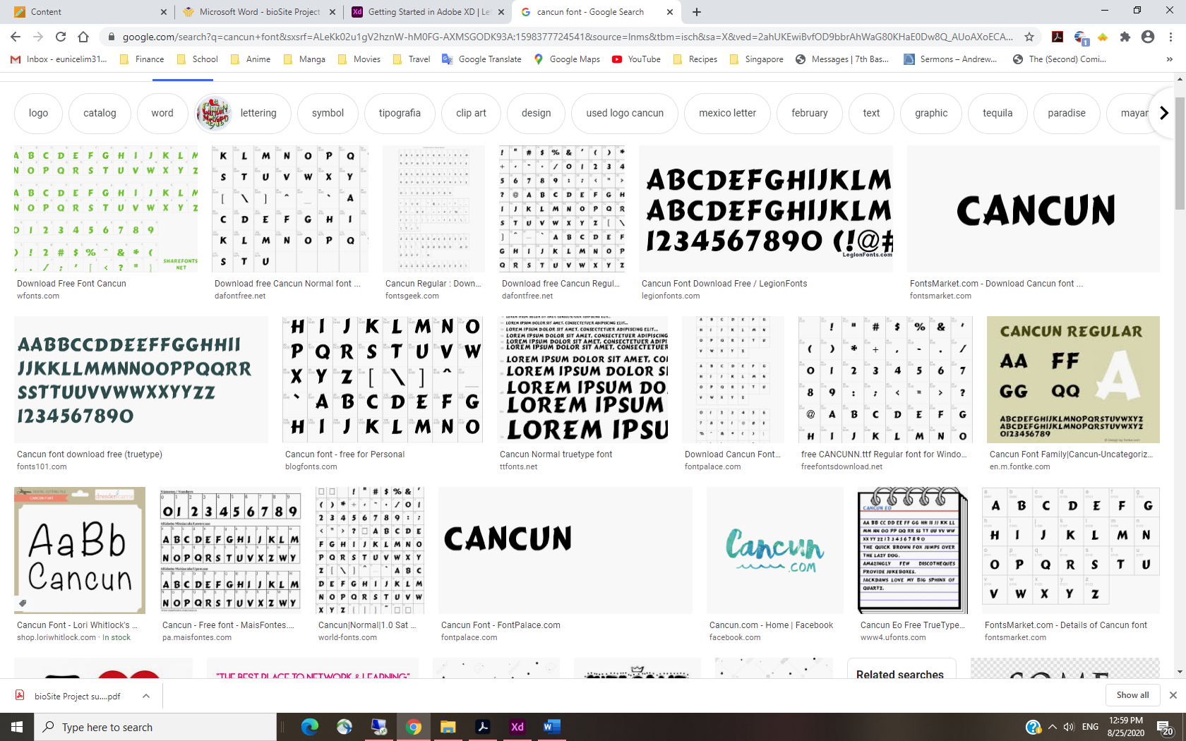

A fancy font would work for the title/heading but his story needs to be a readble font.

I found more ideas for the heading.

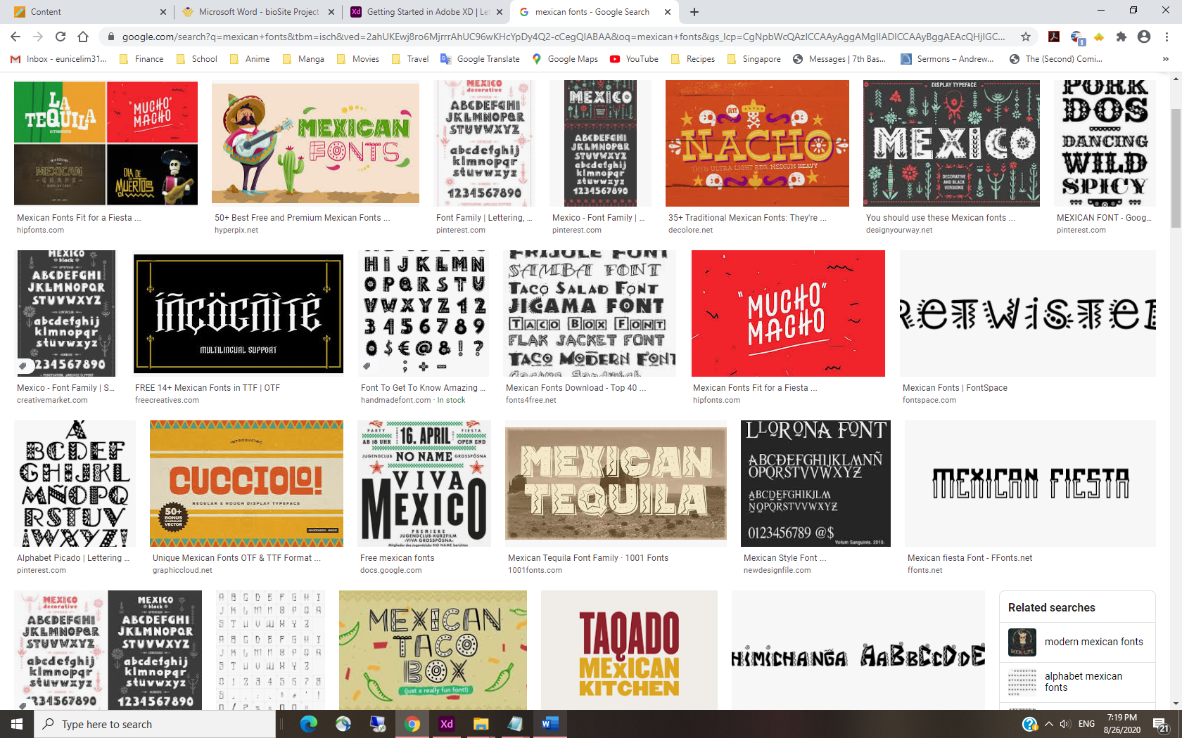

Next were colors, something to do with Harley Davidson or the blue beach waters and sand.

I felt that the HD colors might be too strong, orange and black really isn’t very eye friendly on a website. I came up with some blues, greys and off-whites. His favorite color is pink, but I know he will not want pink on his website, or maybe not? He likes black as well.

In terms of texture, perhaps tire tracks or a grainy look would be nice. He loves a good looking lawn, so grass as a texture is something I will consider. Blades of grass, or lines depicting the sea breeze.

He makes really good hamburgers on the grill, a sesame seeded hamburger bun also sounds like something I could incorporate into the background somehow? He’s a big fan of sports in general but with everything going on, sports has taken a back seat in his life. We used to watch live games but not anymore. He is interested in scuba diving and tried it once, sadly I wasn’t as enthusiastic. We do enjoy snorkelling though. Some deep sea creatures would be good to throw in here. He is allergic to shellfish, so I won’t tempt him with shrimp or lobster.

Going back to the motorcycle hobby, skulls seem to be a big part of that culture. Instead of sesame buns, skulls would be more of his thing, more manly in his eyes. He has been working out very hard to keep in shape so I think he would prefer skulls to sesame buns.

Found an article as to why skulls are associated with motorbike riding.

<https://motohog.com/blogs/news/born-to-ride-the-skull-symbolism-in-motorcycling>

Only skull I found on Word is this:

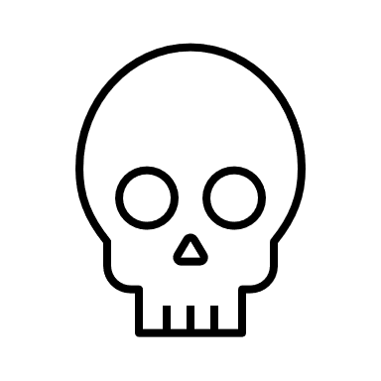Not very intimidating!

Chuck is not terribly social. He has a few close friends, most of them from work. One of his friends I’ve met and heard stories about them, they’ve been buddies for twenty plus years. It’s hard to get him to make new friends at this age. We keep in touch with one of our former neighbors rather frequently and have made small talk with our new neighbors. Otherwise, I’m pretty much the only person he hangs out with other that his co-workers. There is a supervisor that works under him that he likes to talk financial stuff with. The both of them are big into investments and business news. Not sure if he wants to see $$$ on his website. I think he might find that tacky.