Eunice Lim

Web 231

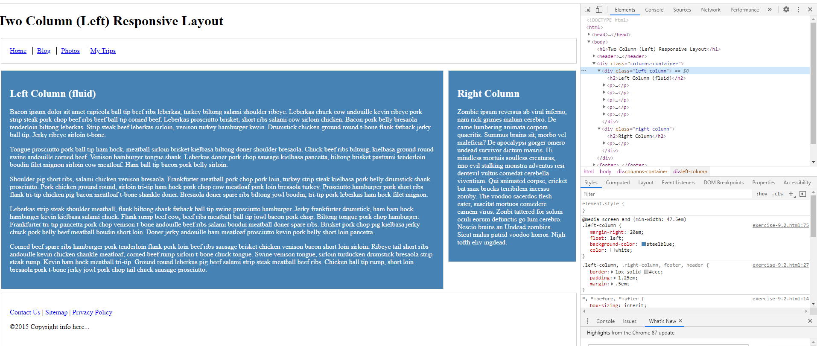Exercise 9.2