Eunice Lim

Web 330

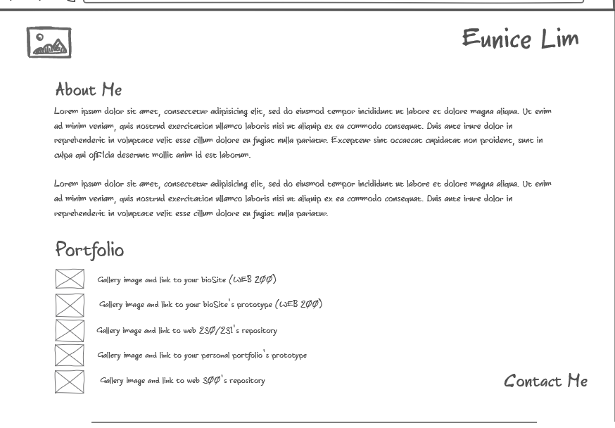Assignment 2.4

https://github.com/elim31/elim31.github.io