ARCHITECTURE & VISION BOOK · v0.4.3 · ENGLISH EDITION
Waaxalma
From realtime interpretation to universal conferencing audio output
1 October 2026 · Universal Audio Output & Conferencing Bridge · Repository milestone v0.4.3
VISION Waaxalma (“speak for me”) turns speech — particularly in Wolof — into understandable translated text and natural audio. v0.4.3 preserves the v0.4 extensible framework, Realtime Direct and Realtime Enhanced while adding a shared browser audio-output layer that can route translated speech to physical or virtual devices for conferencing.

1. Vision and scope
The product goal remains simple: capture speech, preserve intent, translate accurately and return natural-sounding audio. v0.4.3 supports composable standard interpretation, two explicit realtime modes, and a universal final-output layer that can bridge translated audio into conferencing applications without merging the execution pipelines.
- Inputs — microphone audio or a file, a text mode for testing, and live microphone streams for Direct or Enhanced realtime interpretation.
- Outputs — source text when available, interpreted text, generated or streamed audio, session metadata, quality information, realtime latency signals and a selectable browser playback destination.
- Direction — preserve the registry- and contract-based standard architecture and explicit realtime modes while treating audio-output routing as an independent browser capability.

2. Foundation now built
Layer | v0.4.3 state | Architectural interpretation
API | Generic FastAPI API | One execution endpoint resolves any registered agent by name.
Orchestration | AgentOrchestrator | Executes agents with normalized results, error mapping, timing and cancellation behavior.
Discovery | AgentRegistry | Single source of truth for available agents.
Composition | PipelineRegistry | Named text and audio workflows built from reusable stages.
Providers | ProviderRegistry | Resolves interchangeable implementations by capability and provider name.
Reliability | v0.3+ foundation | Validation, timeouts, retries, tracing, metrics and normalized failures remain cross-cutting.
Realtime | Direct + Enhanced realtime capabilities | Direct keeps the provider-native low-latency path; Enhanced adds explicit streaming STT, translation and speech capabilities with contextual control.
Audio output | Shared browser output manager | Standard, Direct and Enhanced retain independent audio generation while sharing one selectable final sink.

3. Guiding principles
- Stable API — new agents do not require agent-specific FastAPI routes.
- Dependency inversion and registries — Skills depend on provider contracts, while registries remain the explicit sources of truth for agents, pipelines and providers.
- Composable workflows — agent behavior is assembled from ordered pipeline stages rather than embedded orchestration logic.
- Fail fast — invalid provider or pipeline configuration fails at composition time instead of silently falling back.
- Observable by default — session context, tracing, metrics and normalized errors remain part of every execution.
- Explicit execution modes and output separation — Standard optimizes composability; Direct optimizes provider-native latency; Enhanced optimizes source visibility and control; the shared output layer chooses the final playback destination without changing how each mode generates audio.

4. Current architecture — v0.4.3
v0.4.3 keeps the v0.4 framework architecture intact for standard interpretation, retains Realtime Direct and Realtime Enhanced as separate streaming paths, and adds a browser-side AudioOutputManager after audio generation. The composition root remains the only backend layer that knows concrete provider implementations; output-device selection stays in the client.
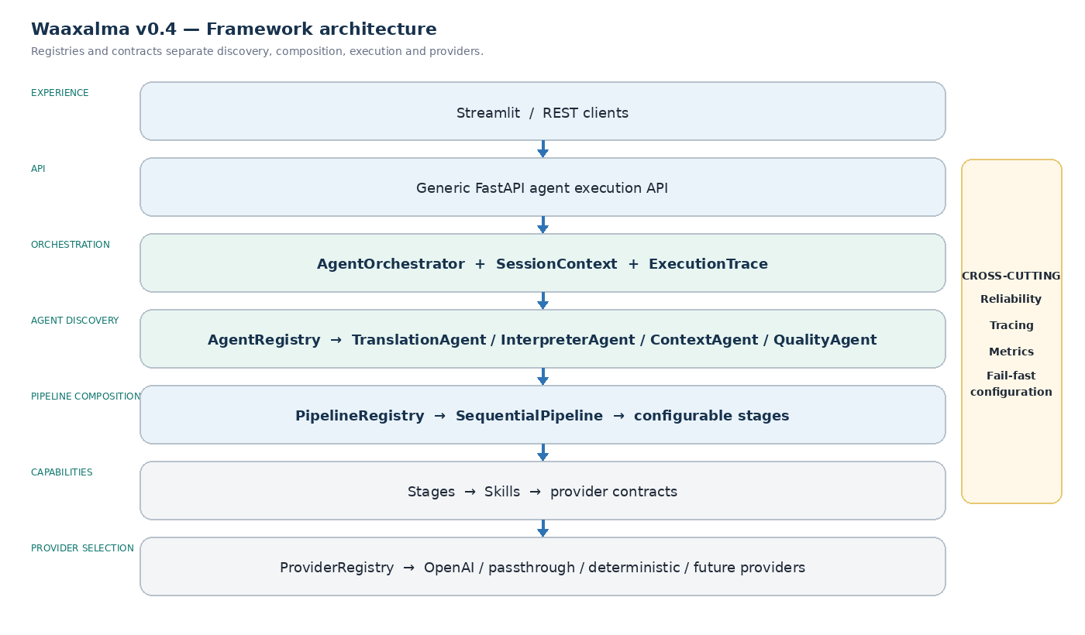
Reading: the standard v0.4 framework diagram remains the request/response execution path. Direct and Enhanced remain beside it as long-lived realtime services. v0.4.3 adds a final client-side output destination layer used by all three modes.

5. Standard interpreter execution flows
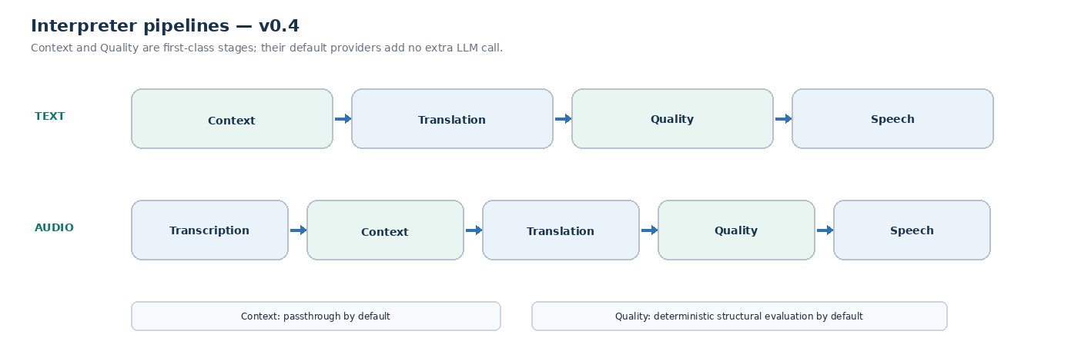
PIPELINE CONTRACT Each stage receives a PipelineState plus SessionContext and returns the updated state. This remains the standard execution contract in v0.4.3; Realtime Direct and Realtime Enhanced continue to use dedicated streaming session contracts, while output routing occurs after audio generation.

6. Realtime Direct architecture — retained in v0.4.3
Realtime Direct remains intentionally separate from normal request/response Skills. It keeps the v0.4.1 provider-native WebRTC path as the latency reference for live translated text and audio.
DIRECT FLOW Microphone → Realtime Session API → RealtimeTranslationService → ProviderRegistry → RealtimeTranslationProvider → WebRTC → translated transcript + translated audio.
Component | v0.4.3 role | Architectural interpretation
Realtime Session API | POST /api/realtime/translation/session | Creates a short-lived provider session and returns an ephemeral client secret.
RealtimeTranslationService | Capability service | Resolves the configured realtime provider and owns backend session metrics.
RealtimeTranslationProvider | Provider contract | Keeps the service independent from a concrete realtime vendor.
OpenAI realtime provider | gpt-realtime-translate | Creates translation client secrets for the dedicated realtime translation endpoint.
Browser WebRTC client | Streamlit embedded client | Captures microphone audio, negotiates SDP, receives translated audio and listens for transcript events.

7. Realtime Enhanced architecture — retained in v0.4.3
Realtime Enhanced decomposes live interpretation into independent streaming capabilities so Waaxalma can expose the source transcript, apply terminology and rolling context, and start speech synthesis before the full translation is complete.
ENHANCED FLOW Microphone → WebRTC streaming STT → authoritative final transcript → RealtimeEnhancedProcessor → rolling context + terminology → streaming translation → SpeakableTextBuffer → streaming TTS → PCM continuity + jitter-buffered translated audio.
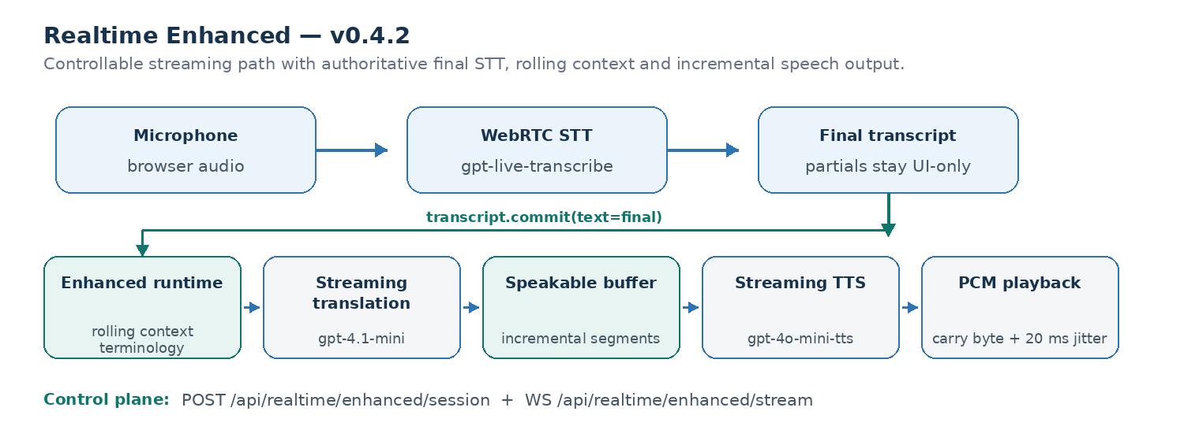
Component | v0.4.3 role | Architectural interpretation
Enhanced Session API | POST /api/realtime/enhanced/session | Creates a short-lived streaming transcription session and returns an ephemeral provider secret.
Enhanced WebSocket | WS /api/realtime/enhanced/stream | Carries session control, transcript deltas/commits, translated text and streamed audio.
StreamingTranscriptionProvider | Provider contract | Keeps realtime STT independent from the concrete provider implementation.
OpenAI streaming STT | gpt-live-transcribe | Produces incremental source deltas and a final transcript; the final transcript is authoritative for translation.
RealtimeEnhancedProcessor | Session-scoped runtime | Owns transcript commits, three-segment rolling source context, terminology and concurrent translation/TTS coordination.
StreamingTranslationProvider | gpt-4.1-mini default | Streams ASR-aware translation while using prior source segments only as disambiguation context.
StreamingSpeechProvider | gpt-4o-mini-tts default | Streams PCM speech from incremental speakable text segments.
Browser playback | PCM16 continuity + 20 ms jitter buffer + output bridge | Preserves byte alignment and scheduling, then routes Web Audio through a MediaStream destination and managed HTML audio element.

8. Realtime configuration and hardening
- Voice configuration — VoiceConfig keeps provider and voice_id explicit for standard speech; Enhanced can use a configured streaming voice while Direct keeps provider-specific realtime voice behavior.
- Source control — Enhanced supports an explicit source language plus STT prompt/keyword hints so names and technical terminology can be recognized more consistently.
- Turn detection — the browser uses a lightweight RMS detector with an approximately 320 ms silence window before committing an utterance; this is a latency/segmentation compromise rather than a semantic endpoint detector.
- Streaming hardening — final STT text replaces partial-delta reconstruction, PCM16 carry-byte continuity prevents sample misalignment, a 20 ms client jitter buffer smooths playback, and WebSocket disconnects stop output cleanly without a second send on a closed socket.
- Resource cleanup — Stop closes data channels, peer connections, microphone tracks, playback state, managed output elements and local audio monitors; Realtime Direct keeps its controlled reconnect policy with a fresh ephemeral secret.

9. Realtime observability and measured baselines
Realtime observability separates startup, recognition, translation and speech-synthesis latency. Direct keeps the v0.4.1 browser QoE baseline and Enhanced keeps the v0.4.2 per-utterance / processor checkpoints. v0.4.3 does not re-baseline provider latency because its principal change is the final browser output destination.
PROMETHEUS waaxalma_realtime_sessions_total · waaxalma_realtime_session_creation_duration_seconds · waaxalma_realtime_session_errors_total · waaxalma_realtime_client_latency_seconds
Measured signal | Direct observed baseline
Realtime session request | ~1.61 s
Microphone acquisition | ~0.47 s
WebRTC establishment | ~1.84 s
Speech → first translated text | ~0.39 s
Speech → first translated audio | ~1.35 s
Translated text → translated audio | ~0.96 s
ENHANCED BENCHMARK 10-segment local warm-path sample. Values describe observed provider/runtime behavior and are not service-level guarantees.
Enhanced warm-path metric | p50 | p95
Commit → first translation | ~0.55 s | ~0.75 s
Translation → first audio | ~0.60 s | ~0.81 s
Commit → first audio | ~1.17 s | ~1.46 s
TTS start → first audio | ~0.51 s | ~0.69 s

10. Framework extensibility model
The central v0.4.x design rule remains unchanged: extension happens through registration, contracts and composition, not through edits to the API or orchestration core. v0.4.3 extends this separation to audio output: execution modes produce audio independently, and a shared client-side manager selects the destination.
Extension | Required change | No required change
New agent | Implement BaseAgent contract; register in AgentRegistry | Generic API, AgentOrchestrator
New provider | Implement capability contract; register by capability + name | Skill, Agent, API
New pipeline | Compose PipelineStage implementations; register by name | SequentialPipeline engine
New stage | Implement PipelineStage contract and add to a pipeline | InterpreterAgent, API
New quality/context strategy | Provide another QualityProvider or ContextProvider | Pipeline structure and response contract
New Direct realtime provider | Implement RealtimeTranslationProvider; register capability + name | Realtime Direct API contract, RealtimeTranslationService
New streaming STT provider | Implement StreamingTranscriptionProvider; register capability + name | Enhanced API contract, RealtimeEnhancedProcessor
New streaming translation provider | Implement StreamingTranslationProvider; register capability + name | Enhanced WebSocket protocol, processor orchestration
New streaming speech provider | Implement StreamingSpeechProvider; register capability + name | SpeakableTextBuffer, browser playback contract
New audio-output destination | Expose the device to the browser / output manager | Standard, Direct and Enhanced generation pipelines

11. Context, terminology and Quality across execution modes
Context and Quality remain first-class capabilities in the standard text and audio pipelines. Realtime modes deliberately use different latency/control trade-offs: Direct bypasses standard Context/Quality stages, while Enhanced introduces a dedicated streaming context mechanism without pretending that it is the same pipeline stage chain.
- Standard Context — PassthroughContextProvider preserves source text and metadata while keeping the enrichment slot active for standard interpreter pipelines.
- Realtime Direct — bypasses Context and Quality stages to minimize provider-native translation latency.
- Realtime Enhanced source authority — partial STT deltas remain useful for live UI feedback, but the provider final transcript becomes the committed text used for translation.
- Realtime Enhanced context — terminology is supplied to STT and translation, while the previous three final source segments are retained as reference-only rolling context and are never translated again.
- Quality — DeterministicQualityProvider remains the standard pipeline default. Enhanced does not add an extra semantic evaluator in v0.4.3; a future quality strategy can be introduced behind the existing provider contracts without changing the core execution boundaries.
DEFAULT PROVIDERS translation/openai · speech/openai · speech_to_text/openai · context/passthrough · quality/deterministic · realtime_translation/openai · streaming_transcription/openai · streaming_translation/openai · streaming_speech/openai

12. Reliability and observability inheritance
The v0.4.3 framework reuses the reliability guarantees introduced in v0.3, the Direct hardening introduced in v0.4.1 and the Enhanced streaming hardening introduced in v0.4.2, then adds deterministic cleanup and fallback behavior for managed browser audio outputs.
- Provider retries and timeout policy stay centralized and explicit where the provider contract supports request retries.
- AgentOrchestrator preserves stable error codes, HTTP status metadata and cancellation propagation for standard execution.
- ExecutionTrace continues to record stage name, provider, duration, outcome and error information for standard pipelines.
- Prometheus continues to expose agent duration, stage duration, execution counts, provider retries and realtime session creation signals.
- Realtime Direct keeps normalized session creation failures and browser QoE telemetry from v0.4.1.
- Realtime Enhanced exposes per-utterance browser timings plus backend commit → translation / TTS latency checkpoints; low-cardinality operational logging is kept at INFO while detailed internals move to DEBUG.
- Streaming disconnect hardening stops translation/audio delivery cleanly when the browser closes the WebSocket, avoiding secondary send failures during long-running provider output.

13. Universal Audio Output & Conferencing Bridge — v0.4.3
v0.4.3 introduces one shared browser-side output destination layer. It does not merge the Standard, Direct and Enhanced audio-generation paths; it normalizes only where completed or streamed audio is played.
UNIVERSAL OUTPUT FLOW Standard generated audio / Direct WebRTC translated track / Enhanced scheduled PCM → AudioOutputManager → selected physical or virtual output → optional conferencing microphone bridge.
Execution mode | v0.4.3 output bridge | Preserved behavior
Standard | Generated audio URL → managed HTMLAudioElement → selected sink | Standard request/response pipeline and input recorder
Realtime Direct | Remote WebRTC MediaStream → managed HTMLAudioElement → selected sink | Provider-native WebRTC, transcript, telemetry and reconnect behavior
Realtime Enhanced | Scheduled Web Audio → MediaStreamAudioDestinationNode → managed HTMLAudioElement → selected sink | PCM carry-byte continuity, 20 ms jitter buffer and ordered scheduling
Conferencing | CABLE Input → VB-CABLE → CABLE Output → conferencing microphone | Application-agnostic bridge; no Teams SDK required
- Device discovery — the client uses enumerateDevices(); browser permission can be required before non-default outputs are exposed.
- Sink selection — managed HTML audio elements use setSinkId() when supported and fall back to the browser default when the selected device disappears.
- Shared selection — the selected output device is persisted browser-side and reused across Standard, Direct and Enhanced embedded clients.
- Streamlit embedding — deprecated st.components.v1.html usage was removed in favor of st.iframe.
- VB-CABLE reference mapping — Waaxalma selects CABLE Input; the conferencing application selects CABLE Output as its microphone; Windows default input remains the physical microphone.
- Teams validation — a real call was validated end-to-end with Microsoft Edge and a remote participant successfully received the translated Waaxalma audio.
- Browser limitation — in the tested environment Chrome exposed and selected the same virtual output after permission was granted, but the remote Teams participant did not receive audio; Edge is the validated reference browser for this milestone.

14. Technical roadmap
Prototype, orchestration, reliability, framework extensibility, Realtime Direct, Realtime Enhanced and universal audio output are now successive validated foundations. A follow-up can add explicit input-device selection, local monitoring and inbound / bidirectional conferencing audio before Product Readiness.
REPOSITORY MILESTONE V0.4.3 Shared output-device discovery/selection, managed playback across Standard / Direct / Enhanced, virtual audio cable routing, Teams microphone bridging and real-call validation complete the Universal Audio Output & Conferencing Bridge milestone.
Stage | Status | Objective | Technical deliverables | Exit criterion
0 · Prototype | Validated | Prove voice → translation → audio | FastAPI, Streamlit, text/voice flows | Functional journey demonstrated
1 · Orchestration | Validated | Unify execution behind agents | Agent contracts, AgentOrchestrator, SessionContext | One execution model for text and voice
2 · Reliability | Validated | Make real-world use dependable | Validation, async, retries/timeouts, tracing, metrics | Controlled recovery and observable errors
3 · Framework | Validated | Make architecture extensible | Registries, provider contracts, configurable pipelines, Context/Quality | Add capabilities without changing API/orchestration core
4 · Realtime Direct | Validated | Add low-latency live interpretation | Ephemeral sessions, WebRTC, realtime provider, QoE metrics | Live translated text/audio with measured baseline
5 · Realtime Enhanced | Validated | Add controllable streaming interpretation | Streaming STT, final transcript authority, rolling context, terminology, streaming translation/TTS | Source-visible contextual streaming with measured warm-path latency
6 · Universal Audio Output | Validated | Bridge translated audio to physical / virtual devices | AudioOutputManager, setSinkId, Standard/Direct/Enhanced routing, VB-CABLE, Teams POC | All three modes reach one selected output and a remote Teams participant receives translated audio
7 · Product | Next | Prepare sustainable deployment | Persistent sessions, security/privacy, CI/CD, packaging, production observability | Deployable and governed version

15. Git release map
Git tag | Milestone | Status
v0.1.0 | Prototype | Released
v0.2.0 | Agent Orchestration | Released
v0.3.0 | Reliability | Released
v0.4.0 | Framework Next | Released
v0.4.1 | Realtime Translation & Voice Configuration | Released
v0.4.2 | Realtime Enhanced Streaming | Released
v0.4.3 | Universal Audio Output & Conferencing Bridge | Current release
v0.5.0 | Product Readiness | Next
v1.0.0 | Stable Framework | Release target

16. v0.4.3 definition of done
The v0.4.3 milestone is complete when translated audio from all three execution modes can be routed to one selectable browser output, virtual-audio transport works without changing backend orchestration, and the conferencing bridge is demonstrated in a real call.
- Standard generated audio is played through a managed HTML audio element and honors the selected output device.
- Realtime Direct attaches the provider WebRTC translated stream to the shared output manager without weakening reconnect, telemetry or cleanup behavior.
- Realtime Enhanced routes its existing scheduled PCM through a MediaStream destination and the shared output manager while preserving carry-byte continuity and the 20 ms jitter buffer.
- A missing or disconnected selected output falls back safely to the browser default and Stop / unload releases managed playback resources.
- VB-Audio Virtual Cable transports Waaxalma output from CABLE Input to CABLE Output, which can be selected as the conferencing microphone.
- A real Microsoft Teams call is validated with Microsoft Edge and the remote participant hears Waaxalma translated audio.
- Browser device-permission requirements and the tested Chrome limitation are documented.
- Native Teams SDK integration, inbound meeting audio, bidirectional translation, explicit input-device selection and separate local monitoring remain out of scope.
- The last full backend regression baseline remains 216 passing tests from v0.4.2; rerun the suite immediately before tagging because v0.4.3 changes are primarily browser-side.
FRAMEWORK PRINCIPLE Execution modes remain independent; the shared audio-output layer controls only the final destination.

17. Product Readiness — v0.5.0
After the v0.4.3 conferencing bridge, the framework can add explicit input-device selection, local monitoring and inbound / bidirectional conference audio as an isolated follow-up before or alongside Product Readiness. v0.5 should still make the framework deployable, governable and maintainable in long-running environments without weakening the v0.4.x execution boundaries.
- Persist sessions and selected conversation state behind explicit retention rules.
- Add authentication, authorization and security boundaries suitable for public or shared deployments.
- Package configuration and provider credentials for repeatable environments.
- Add CI/CD quality gates, release automation and reproducible packaging.
- Extend production observability with operational dashboards, alerts and service-level signals.
- Document privacy, data lifecycle and provider-specific operational responsibilities.
PRODUCT EXIT CRITERION A deployable and governed v0.5 package can run with persistent state, security controls, automated delivery and production-grade observability without weakening the v0.4.x extension contracts.
OUT OF SCOPE FOR V0.4.3 Native Teams / Graph calling integration, automatic meeting joining, inbound participant audio capture, bidirectional conferencing translation, explicit Waaxalma input-device selection and a separate local monitoring sink are not part of the Universal Audio Output milestone.

