
Waaxalma — Speak for me
28.06.2026
─
Elimane DIOP
Laffaxexeul SA
7 rue du général PAU
Slogan: Speak naturally. Speak through AI.
Mission: Enable seamless multilingual communication through intelligent AI voice agents.
26200, Montélimar
Meaning: Speak for me (Wolof)
Category: AI Voice Agent Framework
Primary Language: Python
Architecture: Agent-based, Skills-based, Provider-independent
Status: Early Development (v0.x)

Overview
Waaxalma is an AI Voice Agent Framework that enables people to communicate naturally across languages.
Instead of acting as a traditional translator, Waaxalma understands the speaker's intent, preserves the conversational context, and speaks naturally in the target language.
The project aims to provide an extensible framework for building multilingual voice agents powered by modern Large Language Models (LLMs), speech recognition, speech synthesis, and conversational memory.
Waaxalma means "Speak for me" in Wolof, reflecting its mission of becoming an intelligent voice companion rather than a simple translation tool.

Goals

Primary Goals
- Build an extensible AI Voice Agent Framework.
- Enable multilingual real-time conversations.
- Support multiple AI providers through a unified abstraction.
- Keep conversation context across sessions.
- Offer a modular architecture for custom voice agents.

Secondary Goals
- Support on-premise and cloud LLM providers.
- Enable voice cloning.
- Provide streaming voice conversations.
- Expose REST and WebSocket APIs.
- Offer a Python SDK.

Problem Statement
The goal is not to translate words. The goal is to communicate intentions.

Core Principles

Agent-first
Everything is an Agent.

Skills-based
Agents are composed of reusable skills.

Provider-independent
Agents never depend directly on OpenAI, Gemini, or any specific provider.

Conversation-aware
Every interaction belongs to a conversation.

Extensible
New Agents, Skills, Providers and Memories can be added without modifying existing code.

Architecture
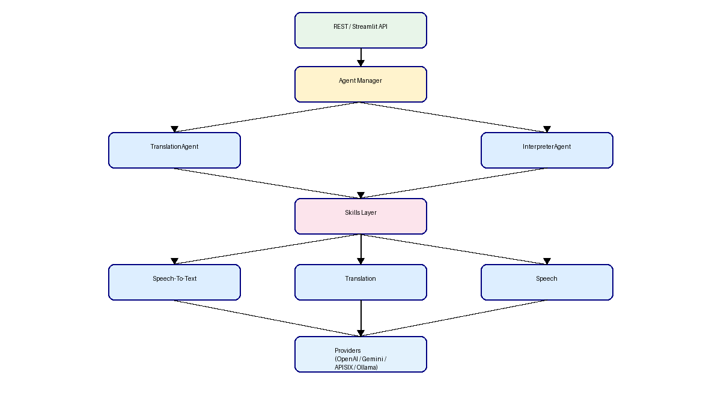

Roadmap
✅ Sprint 1: Core Translation API
✅ Sprint 2: Agent Framework
✅ Sprint 3: Multi-Agent & Session Framework
🚧 Sprint 4 : Voice Pipeline
🔜 Sprint 5 : Conversation Memory
🔜 Sprint 6 : Streaming
🔜 Sprint 7 : Voice Clone
🔜 Sprint 8 : Meeting Assistant

Future Vision
Waaxalma is designed to become a complete ecosystem for AI-powered voice agents. The framework will support multilingual conversations, meeting assistants, real-time interpreters, customer service agents, travel assistants, and domain-specific voice copilots. Through its modular architecture, developers will be able to build new voice agents by composing reusable capabilities rather than implementing complete applications from scratch.
Figure 1. Waaxalma high-level architecture.

