ARCHITECTURE & VISION BOOK · v0.4.2 · ENGLISH EDITION
Waaxalma
From low-latency realtime interpretation to controllable enhanced streaming
28 September 2026 · Realtime Enhanced Streaming · Repository milestone v0.4.2
VISION Waaxalma (“speak for me”) turns speech — particularly in Wolof — into understandable translated text and natural audio. v0.4.2 preserves the v0.4 extensible framework and the v0.4.1 Realtime Direct path while adding a controllable Enhanced streaming mode with source transcription, terminology, rolling context and incremental speech synthesis.

1. Vision and scope
The product goal remains simple: capture speech, preserve intent, translate accurately and return natural-sounding audio. v0.4.2 supports composable standard interpretation plus two explicit realtime modes: Direct for provider-native low latency and Enhanced for source visibility, terminology control and streaming STT → translation → TTS.
- Inputs — microphone audio or a file, a text mode for testing, and live microphone streams for Direct or Enhanced realtime interpretation.
- Outputs — source text when available, interpreted text, generated or streamed audio, session metadata, quality information and realtime latency signals.
- Direction — preserve the registry- and contract-based standard architecture while exposing realtime capabilities through explicit provider contracts and independently measurable execution modes.

2. Foundation now built
Layer | v0.4.2 state | Architectural interpretation
API | Generic FastAPI API | One execution endpoint resolves any registered agent by name.
Orchestration | AgentOrchestrator | Executes agents with normalized results, error mapping, timing and cancellation behavior.
Discovery | AgentRegistry | Single source of truth for available agents.
Composition | PipelineRegistry | Named text and audio workflows built from reusable stages.
Providers | ProviderRegistry | Resolves interchangeable implementations by capability and provider name.
Reliability | v0.3+ foundation | Validation, timeouts, retries, tracing, metrics and normalized failures remain cross-cutting.
Realtime | Direct + Enhanced realtime capabilities | Direct keeps the provider-native low-latency path; Enhanced adds explicit streaming STT, translation and speech capabilities with contextual control.

3. Guiding principles
- Stable API — new agents do not require agent-specific FastAPI routes.
- Dependency inversion and registries — Skills depend on provider contracts, while registries remain the explicit sources of truth for agents, pipelines and providers.
- Composable workflows — agent behavior is assembled from ordered pipeline stages rather than embedded orchestration logic.
- Fail fast — invalid provider or pipeline configuration fails at composition time instead of silently falling back.
- Observable by default — session context, tracing, metrics and normalized errors remain part of every execution.
- Explicit execution modes — standard pipelines optimize composability; Direct optimizes provider-native latency; Enhanced optimizes control and source visibility with cost-aware defaults.

4. Current architecture — v0.4.2
v0.4.2 keeps the v0.4 framework architecture intact for standard interpretation and retains the v0.4.1 Direct capability path. Enhanced is added beside Direct as a second realtime execution mode, with its own streaming provider contracts and session runtime. The composition root remains the only layer that knows concrete implementations.
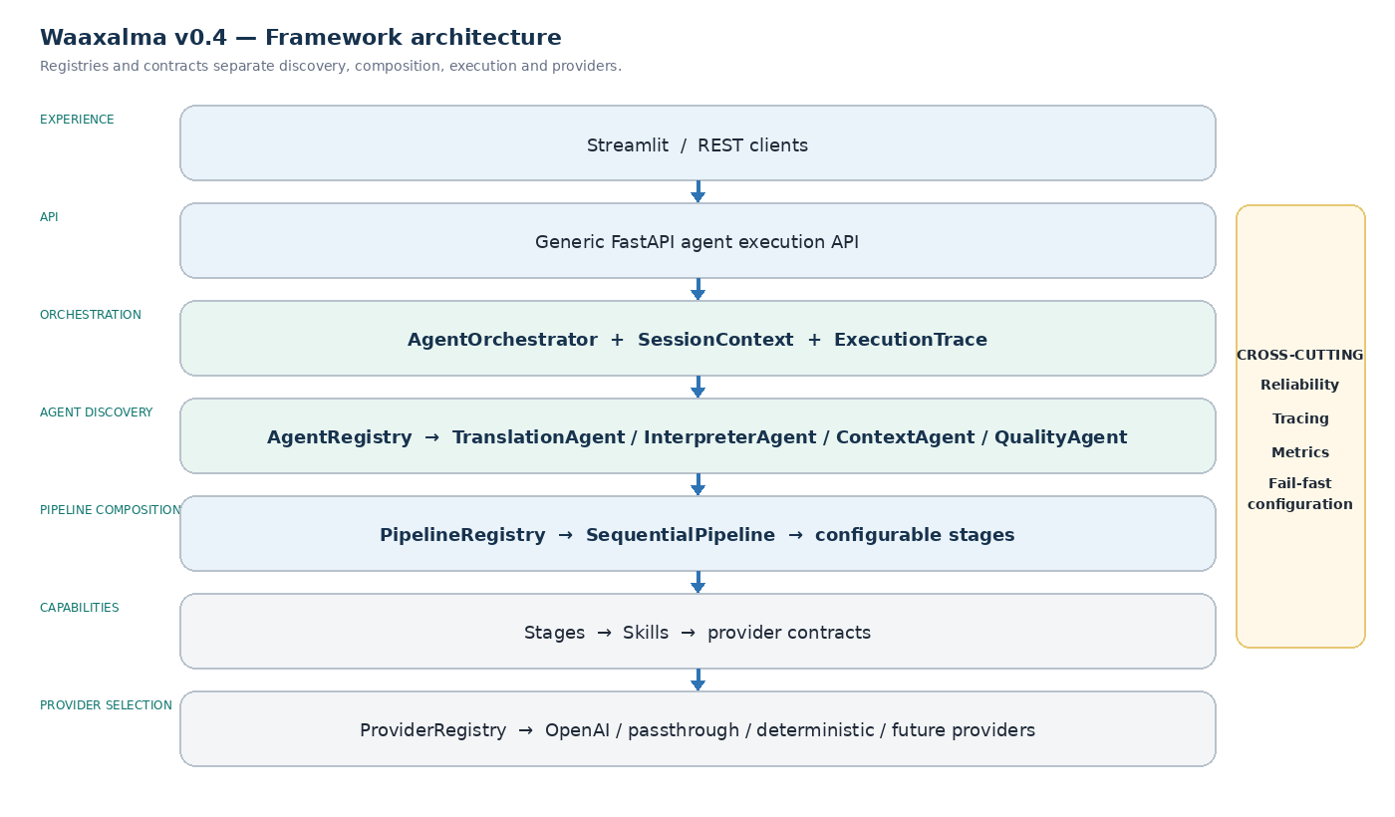
Reading: the diagram below remains the standard v0.4 framework path. In v0.4.2, Direct and Enhanced realtime services sit beside it rather than forcing long-lived streaming sessions through AgentOrchestrator or SequentialPipeline.

5. Standard interpreter execution flows
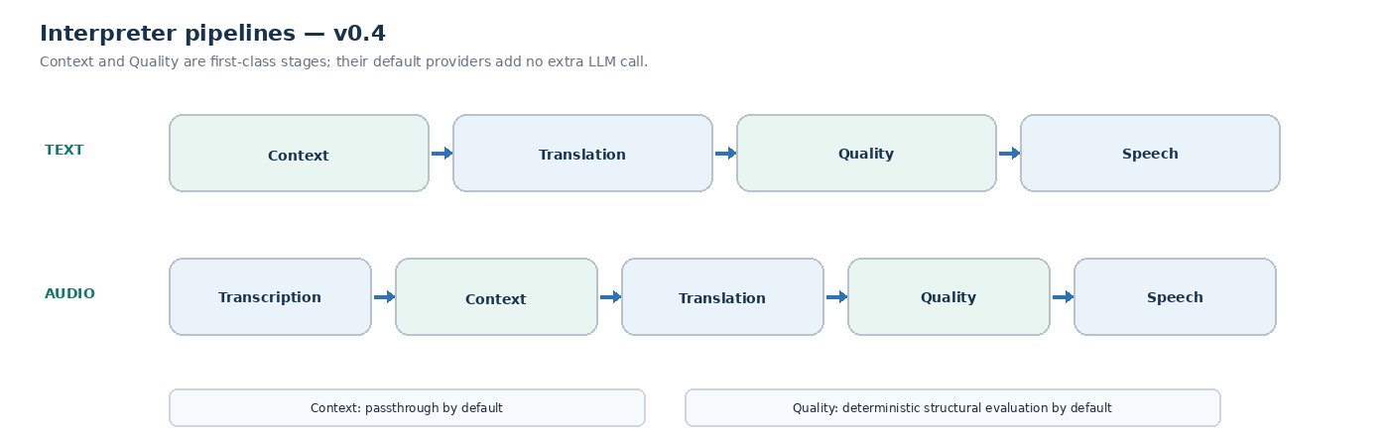
PIPELINE CONTRACT Each stage receives a PipelineState plus SessionContext and returns the updated state. This remains the standard execution contract in v0.4.2; both Realtime Direct and Realtime Enhanced use dedicated streaming session contracts.

6. Realtime Direct architecture — retained in v0.4.2
Realtime Direct remains intentionally separate from normal request/response Skills. It keeps the v0.4.1 provider-native WebRTC path as the latency reference for live translated text and audio.
DIRECT FLOW Microphone → Realtime Session API → RealtimeTranslationService → ProviderRegistry → RealtimeTranslationProvider → WebRTC → translated transcript + translated audio.
Component | v0.4.2 role | Architectural interpretation
Realtime Session API | POST /api/realtime/translation/session | Creates a short-lived provider session and returns an ephemeral client secret.
RealtimeTranslationService | Capability service | Resolves the configured realtime provider and owns backend session metrics.
RealtimeTranslationProvider | Provider contract | Keeps the service independent from a concrete realtime vendor.
OpenAI realtime provider | gpt-realtime-translate | Creates translation client secrets for the dedicated realtime translation endpoint.
Browser WebRTC client | Streamlit embedded client | Captures microphone audio, negotiates SDP, receives translated audio and listens for transcript events.

7. Realtime Enhanced architecture — v0.4.2
Realtime Enhanced decomposes live interpretation into independent streaming capabilities so Waaxalma can expose the source transcript, apply terminology and rolling context, and start speech synthesis before the full translation is complete.
ENHANCED FLOW Microphone → WebRTC streaming STT → authoritative final transcript → RealtimeEnhancedProcessor → rolling context + terminology → streaming translation → SpeakableTextBuffer → streaming TTS → PCM continuity + jitter-buffered translated audio.
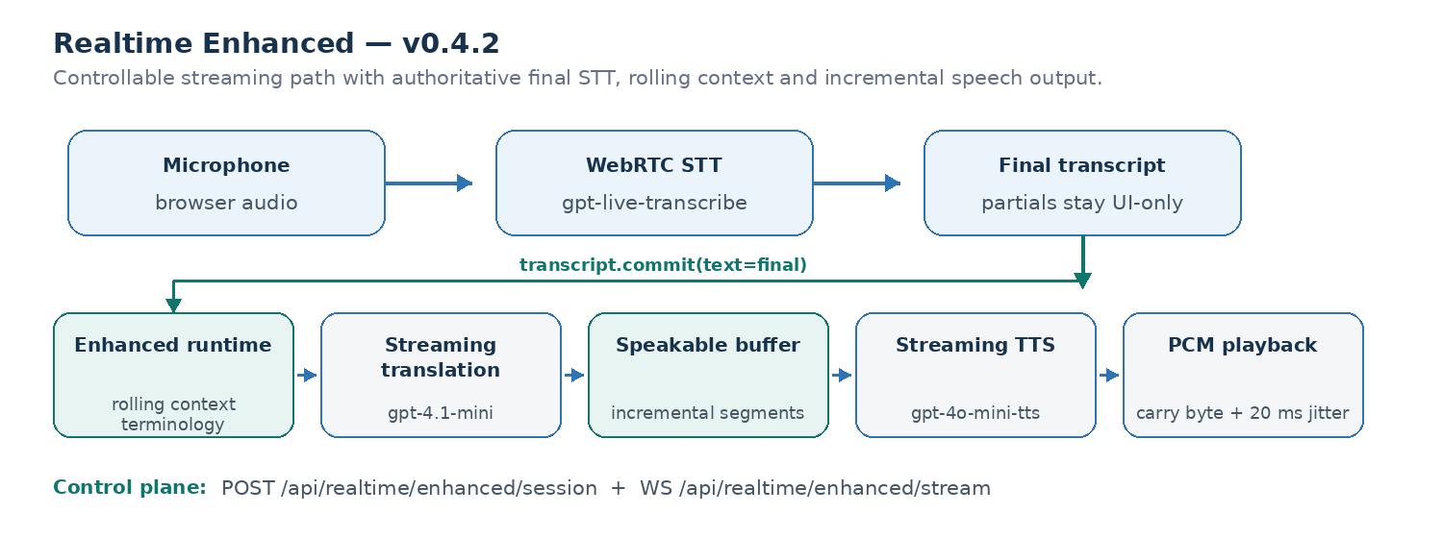
Component | v0.4.2 role | Architectural interpretation
Enhanced Session API | POST /api/realtime/enhanced/session | Creates a short-lived streaming transcription session and returns an ephemeral provider secret.
Enhanced WebSocket | WS /api/realtime/enhanced/stream | Carries session control, transcript deltas/commits, translated text and streamed audio.
StreamingTranscriptionProvider | Provider contract | Keeps realtime STT independent from the concrete provider implementation.
OpenAI streaming STT | gpt-live-transcribe | Produces incremental source deltas and a final transcript; the final transcript is authoritative for translation.
RealtimeEnhancedProcessor | Session-scoped runtime | Owns transcript commits, three-segment rolling source context, terminology and concurrent translation/TTS coordination.
StreamingTranslationProvider | gpt-4.1-mini default | Streams ASR-aware translation while using prior source segments only as disambiguation context.
StreamingSpeechProvider | gpt-4o-mini-tts default | Streams PCM speech from incremental speakable text segments.
Browser playback | PCM16 continuity + 20 ms jitter buffer | Preserves byte alignment and smooths network chunk boundaries before local playback.

8. Realtime configuration and hardening
- Voice configuration — VoiceConfig keeps provider and voice_id explicit for standard speech; Enhanced can use a configured streaming voice while Direct keeps provider-specific realtime voice behavior.
- Source control — Enhanced supports an explicit source language plus STT prompt/keyword hints so names and technical terminology can be recognized more consistently.
- Turn detection — the browser uses a lightweight RMS detector with an approximately 320 ms silence window before committing an utterance; this is a latency/segmentation compromise rather than a semantic endpoint detector.
- Streaming hardening — final STT text replaces partial-delta reconstruction, PCM16 carry-byte continuity prevents sample misalignment, a 20 ms client jitter buffer smooths playback, and WebSocket disconnects stop output cleanly without a second send on a closed socket.
- Resource cleanup — Stop closes data channels, peer connections, microphone tracks, playback state and local audio monitors; Realtime Direct keeps its controlled reconnect policy with a fresh ephemeral secret.

9. Realtime observability and measured baselines
Realtime observability separates startup, recognition, translation and speech-synthesis latency. Direct keeps the v0.4.1 browser QoE baseline; Enhanced adds per-utterance browser timings and processor-level checkpoints for commit → translation, speakable segmentation and TTS first audio.
PROMETHEUS waaxalma_realtime_sessions_total · waaxalma_realtime_session_creation_duration_seconds · waaxalma_realtime_session_errors_total · waaxalma_realtime_client_latency_seconds
Measured signal | Direct observed baseline
Realtime session request | ~1.61 s
Microphone acquisition | ~0.47 s
WebRTC establishment | ~1.84 s
Speech → first translated text | ~0.39 s
Speech → first translated audio | ~1.35 s
Translated text → translated audio | ~0.96 s
ENHANCED BENCHMARK 10-segment local warm-path sample. Values describe observed provider/runtime behavior and are not service-level guarantees.
Enhanced warm-path metric | p50 | p95
Commit → first translation | ~0.55 s | ~0.75 s
Translation → first audio | ~0.60 s | ~0.81 s
Commit → first audio | ~1.17 s | ~1.46 s
TTS start → first audio | ~0.51 s | ~0.69 s

10. Framework extensibility model
The central v0.4.x design rule remains unchanged: extension happens through registration, contracts and composition, not through edits to the API or orchestration core. v0.4.2 extends that rule to decomposed streaming capabilities.
Extension | Required change | No required change
New agent | Implement BaseAgent contract; register in AgentRegistry | Generic API, AgentOrchestrator
New provider | Implement capability contract; register by capability + name | Skill, Agent, API
New pipeline | Compose PipelineStage implementations; register by name | SequentialPipeline engine
New stage | Implement PipelineStage contract and add to a pipeline | InterpreterAgent, API
New quality/context strategy | Provide another QualityProvider or ContextProvider | Pipeline structure and response contract
New Direct realtime provider | Implement RealtimeTranslationProvider; register capability + name | Realtime Direct API contract, RealtimeTranslationService
New streaming STT provider | Implement StreamingTranscriptionProvider; register capability + name | Enhanced API contract, RealtimeEnhancedProcessor
New streaming translation provider | Implement StreamingTranslationProvider; register capability + name | Enhanced WebSocket protocol, processor orchestration
New streaming speech provider | Implement StreamingSpeechProvider; register capability + name | SpeakableTextBuffer, browser playback contract

11. Context, terminology and Quality across execution modes
Context and Quality remain first-class capabilities in the standard text and audio pipelines. Realtime modes deliberately use different latency/control trade-offs: Direct bypasses standard Context/Quality stages, while Enhanced introduces a dedicated streaming context mechanism without pretending that it is the same pipeline stage chain.
- Standard Context — PassthroughContextProvider preserves source text and metadata while keeping the enrichment slot active for standard interpreter pipelines.
- Realtime Direct — bypasses Context and Quality stages to minimize provider-native translation latency.
- Realtime Enhanced source authority — partial STT deltas remain useful for live UI feedback, but the provider final transcript becomes the committed text used for translation.
- Realtime Enhanced context — terminology is supplied to STT and translation, while the previous three final source segments are retained as reference-only rolling context and are never translated again.
- Quality — DeterministicQualityProvider remains the standard pipeline default. Enhanced does not add an extra semantic evaluator in v0.4.2; a future quality strategy can be introduced behind the existing provider contracts without changing the core execution boundaries.
DEFAULT PROVIDERS translation/openai · speech/openai · speech_to_text/openai · context/passthrough · quality/deterministic · realtime_translation/openai · streaming_transcription/openai · streaming_translation/openai · streaming_speech/openai

12. Reliability and observability inheritance
The v0.4.2 framework reuses the reliability guarantees introduced in v0.3 and the realtime hardening introduced in v0.4.1, then extends them to the Enhanced session runtime and its multi-stage streaming path.
- Provider retries and timeout policy stay centralized and explicit where the provider contract supports request retries.
- AgentOrchestrator preserves stable error codes, HTTP status metadata and cancellation propagation for standard execution.
- ExecutionTrace continues to record stage name, provider, duration, outcome and error information for standard pipelines.
- Prometheus continues to expose agent duration, stage duration, execution counts, provider retries and realtime session creation signals.
- Realtime Direct keeps normalized session creation failures and browser QoE telemetry from v0.4.1.
- Realtime Enhanced exposes per-utterance browser timings plus backend commit → translation / TTS latency checkpoints; low-cardinality operational logging is kept at INFO while detailed internals move to DEBUG.
- Streaming disconnect hardening stops translation/audio delivery cleanly when the browser closes the WebSocket, avoiding secondary send failures during long-running provider output.

13. Technical roadmap
Prototype, orchestration, reliability, framework extensibility, Realtime Direct and Realtime Enhanced are now successive validated foundations. The next major slice moves from realtime capability breadth to Product Readiness and sustainable deployment.
REPOSITORY MILESTONE V0.4.2 Streaming transcription/translation/speech provider contracts, authoritative final STT commits, rolling context, terminology controls, concurrent translation/TTS, PCM continuity, jitter buffering, per-turn metrics, disconnect hardening and regression coverage complete the Realtime Enhanced milestone.
Stage | Status | Objective | Technical deliverables | Exit criterion
0 · Prototype | Validated | Prove voice → translation → audio | FastAPI, Streamlit, text/voice flows | Functional journey demonstrated
1 · Orchestration | Validated | Unify execution behind agents | Agent contracts, AgentOrchestrator, SessionContext | One execution model for text and voice
2 · Reliability | Validated | Make real-world use dependable | Validation, async, retries/timeouts, tracing, metrics | Controlled recovery and observable errors
3 · Framework | Validated | Make architecture extensible | Registries, provider contracts, configurable pipelines, Context/Quality | Add capabilities without changing API/orchestration core
4 · Realtime Direct | Validated | Add low-latency live interpretation | Ephemeral sessions, WebRTC, realtime provider, QoE metrics | Live translated text/audio with measured baseline
5 · Realtime Enhanced | Current | Add controllable streaming interpretation | Streaming STT, final transcript authority, rolling context, terminology, streaming translation/TTS | Source-visible contextual streaming with measured warm-path latency
6 · Product | Next | Prepare sustainable deployment | Persistent sessions, security/privacy, CI/CD, packaging, production observability | Deployable and governed version

14. Git release map
Git tag | Milestone | Status
v0.1.0 | Prototype | Released
v0.2.0 | Agent Orchestration | Released
v0.3.0 | Reliability | Released
v0.4.0 | Framework Next | Released
v0.4.1 | Realtime Translation & Voice Configuration | Released
v0.4.2 | Realtime Enhanced Streaming | Current
v0.5.0 | Product Readiness | Next
v1.0.0 | Stable Framework | Release target

15. v0.4.2 definition of done
The v0.4.2 milestone is complete when Enhanced realtime streaming adds source visibility and contextual control without weakening the standard v0.4 framework or the v0.4.1 Direct baseline.
- Standard agents, providers and pipelines continue to execute through the v0.4 registries and contracts without regression.
- Realtime Direct remains independently available through RealtimeTranslationProvider and preserves its provider-native WebRTC path.
- Realtime Enhanced exposes a session endpoint and WebSocket stream without routing long-lived streaming execution through AgentOrchestrator or SequentialPipeline.
- The final STT transcript is authoritative for translation; terminology and three prior final source segments provide reference-only contextual control.
- Streaming translation and TTS overlap through SpeakableTextBuffer so speech can begin before the complete translation is available.
- PCM16 carry-byte continuity and a 20 ms browser jitter buffer prevent chunk-boundary corruption and smooth local playback.
- A local ~320 ms VAD silence window drives utterance commit, while per-utterance metrics separate STT, translation and audio latency.
- Browser logging is quiet by default, detailed backend timing moves to DEBUG, and WebSocket disconnects terminate output cleanly.
- The full backend regression suite passes: 216 tests, including dedicated coverage for final-transcript precedence, rolling context and reset behavior.
FRAMEWORK PRINCIPLE Add an agent, provider, pipeline or realtime streaming capability without changing the API or orchestration core.

16. Product Readiness — v0.5.0
After Realtime Enhanced, v0.5 should make the framework deployable, governable and maintainable in long-running environments while preserving the execution-mode boundaries established in v0.4.x.
- Persist sessions and selected conversation state behind explicit retention rules.
- Add authentication, authorization and security boundaries suitable for public or shared deployments.
- Package configuration and provider credentials for repeatable environments.
- Add CI/CD quality gates, release automation and reproducible packaging.
- Extend production observability with operational dashboards, alerts and service-level signals.
- Document privacy, data lifecycle and provider-specific operational responsibilities.
PRODUCT EXIT CRITERION A deployable and governed v0.5 package can run with persistent state, security controls, automated delivery and production-grade observability without weakening the v0.4.x extension contracts.
OUT OF SCOPE FOR V0.4.2 Virtual Audio Output / Conferencing Integration (for example Teams, Zoom or Meet microphone routing) is a separate future epic and is not part of the Realtime Enhanced milestone.

