ARCHITECTURE & VISION BOOK · v0.4.4 · ENGLISH EDITION

Waaxalma
  - Conferencing Audio and Device Control
1 October 2026 · Conferencing Audio and Device Control
VISION Waaxalma (“speak for me”) turns speech, particularly in Wolof, into understandable translated text and natural audio. The product seeks to preserve intent; the framework separates replaceable agents, pipelines and provider capabilities.

1. Vision and scope
This edition records the v0.4.4 milestone. It retains the architecture template from v0.4 and the capabilities delivered at this point; later milestones remain future work in this historical edition.
- AudioInputManager selects an explicit physical microphone using persisted audioInputDeviceId. Direct and Enhanced stop relying on the Windows default input.
- Conference output remains shared across Standard, Direct and Enhanced. monitorOutputDeviceId and monitorEnabled select a separate local headphone sink without Windows “Listen to this device”.

2. Foundation now built
Layer | Implementation | Meaning
API | FastAPI | Generic registered-agent execution; text/voice routes.
Orchestration | AgentOrchestrator | Results, errors, timing and cancellation.
Discovery | AgentRegistry / ProviderRegistry | Explicit resolution by name and capability.
Composition | PipelineRegistry / SequentialPipeline | Ordered reusable stages.
Realtime | Direct / Enhanced | Dedicated session and live capability paths.
Audio devices | Input / Output / Local Monitor | Browser-side device integration.

3. Guiding principles
- Extend through contracts, registration and composition; fail early for unknown providers/pipelines.
- Skills depend on capability contracts. Reliability and observability stay cross-cutting. Context/Quality defaults add no extra LLM call.
- Separate standard workflows, realtime transports and browser devices; describe validation limits explicitly.

4. Current architecture
The composition root assembles concrete providers, Skills, stages, pipelines and agents. Registries resolve dependencies rather than adding processing stages to every request.
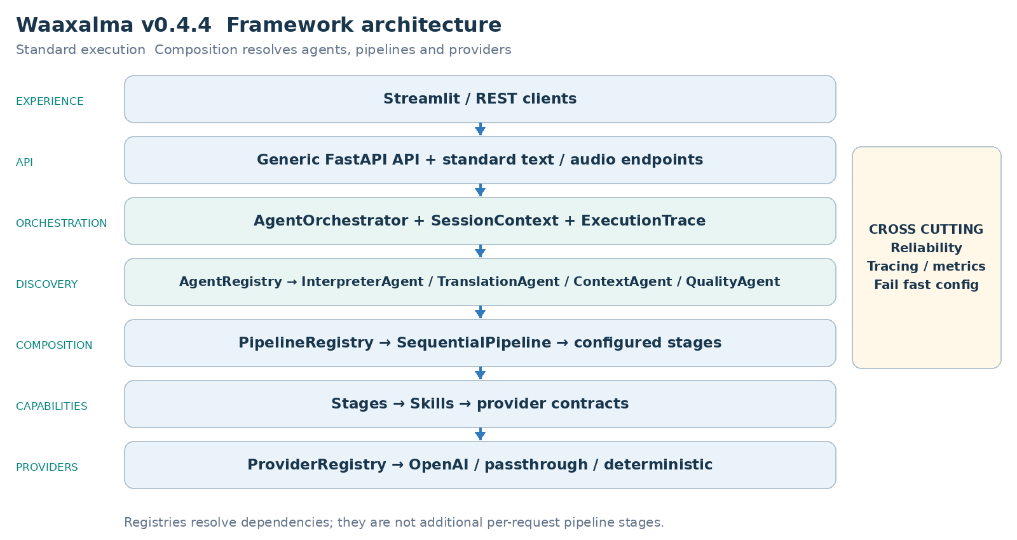
AgentOrchestrator executes registered agents; InterpreterAgent receives its configured text/audio pipelines. Realtime services, where delivered, remain separate from this standard chain.

5. Interpreter execution flows
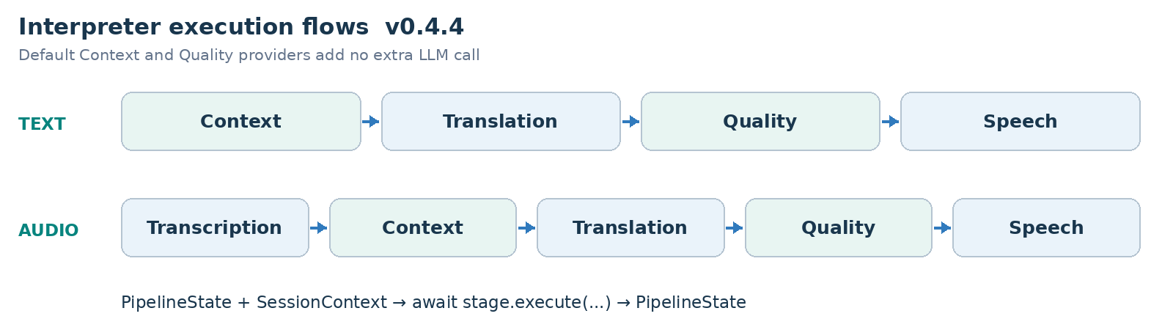
PIPELINE CONTRACT Each stage receives PipelineState and SessionContext and returns updated state. SequentialPipeline awaits stages in order; configured workflows can evolve without rewriting InterpreterAgent.

6. Framework extensibility model
Extension happens through explicit registration and composition, preserving the generic API and orchestration core. Provider adapters can change behind capability contracts.
Extension | Required change | Boundary preserved
New agent | BaseAgent + AgentRegistry | API / AgentOrchestrator
New provider | Implement capability contract; register capability + name. | Skill / Agent / API
New pipeline | Compose stages and register its name. | SequentialPipeline
New stage | PipelineStage | InterpreterAgent / API
Context/quality strategy | ContextProvider / QualityProvider | Configured stage structure.

RealtimeTranslationProvider is resolved by capability and name without routing live sessions through SequentialPipeline.
StreamingTranscriptionProvider, StreamingTranslationProvider and StreamingSpeechProvider isolate Enhanced adapters from processor orchestration and playback.

7. Context and Quality as first class capabilities
- PassthroughContextProvider preserves source text/metadata. TranslationStage prefers enriched_text when supplied and preserves source_text.
- DeterministicQualityProvider evaluates structure, not semantic translation correctness. accepted, score, issues and quality metadata are returned; rejection does not create an implicit blocking policy.
- Direct bypasses standard Context/Quality to keep its provider-native latency path.
- Enhanced uses terminology and three prior final source segments as reference-only context; it does not add an extra semantic quality evaluator.

Realtime architecture and execution
Direct creates a short-lived provider session through the backend. The browser then negotiates SDP and WebRTC and receives live translated text/audio. Session creation and browser/provider media exchange are distinct responsibilities.
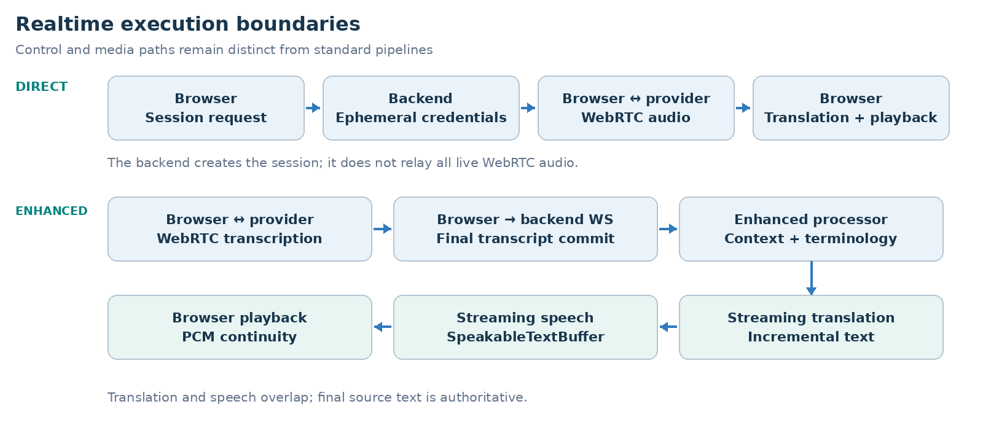
Enhanced creates an ephemeral transcription session, commits final text over /api/realtime/enhanced/stream, and composes streaming translation and TTS. The default adapters use gpt-live-transcribe, gpt-4.1-mini and gpt-4o-mini-tts; these names record the historical configuration, not a new provider availability guarantee.
Responsibility | Execution boundary
Session setup | Backend issues an ephemeral provider credential.
Direct media | Browser and provider exchange WebRTC media.
Enhanced orchestration | Final transcript → streaming translation → TTS.

Realtime measurements and transcript handling

Direct historical measured baseline
Signal | Observed value
Session request | ~1.61 s
Microphone acquisition | ~0.47 s
WebRTC establishment | ~1.84 s
Speech → first translated text | ~0.39 s
Speech → first translated audio | ~1.35 s
Translated text → audio | ~0.96 s

Enhanced historical warm path sample
Metric | p50 | p95
Commit → translation | ~0.55 s | ~0.75 s
Translation → audio | ~0.60 s | ~0.81 s
Commit → audio | ~1.17 s | ~1.46 s
TTS start → audio | ~0.51 s | ~0.69 s

These are historical local observations: Enhanced used a ten-segment warm-path sample. Startup, recognition, translation and audio latency are separate measurements. They are not SLAs or newly rerun benchmarks.

Final transcript and context contract
- Terminology and the previous three final source segments are reference-only context. They are not translated again. Source language, STT prompt and keywords are configurable.
- SpeakableTextBuffer overlaps translation and TTS. PCM16 carry-byte continuity and a 20 ms jitter buffer preserve playback. The browser commits after an approximately 320 ms RMS silence window.

Audio output and conferencing
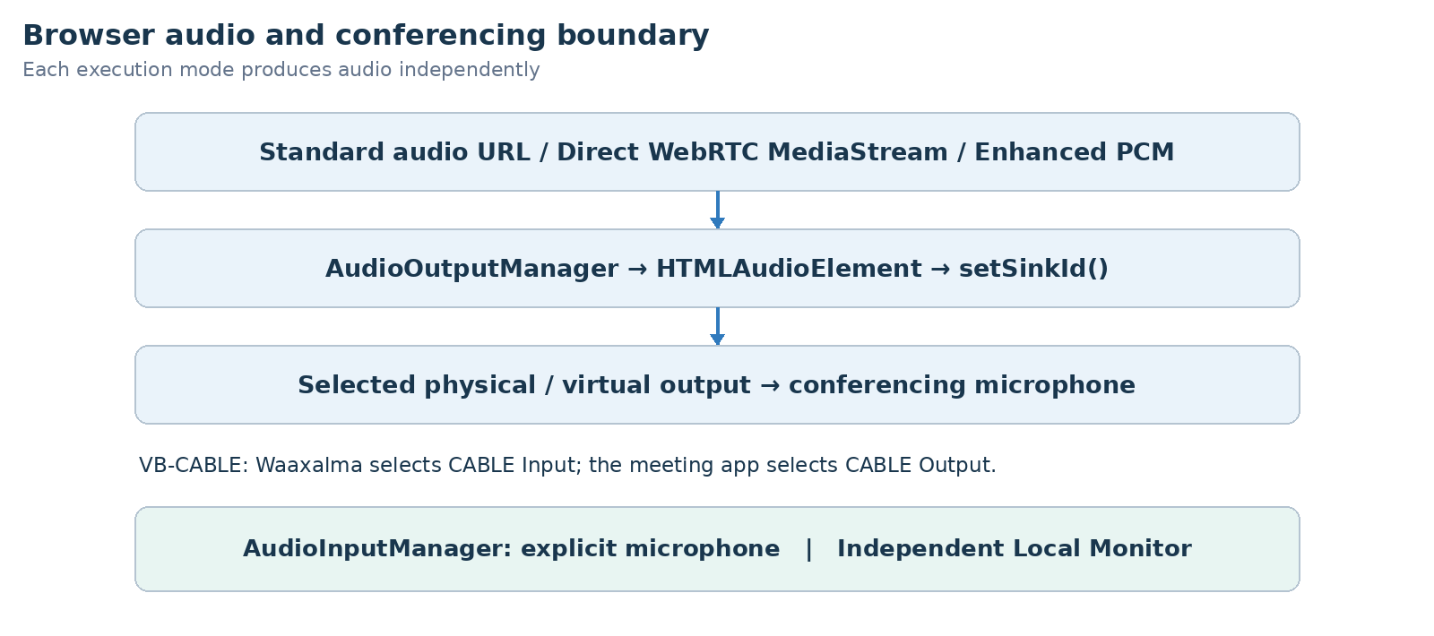
- AudioInputManager selects an explicit physical microphone using persisted audioInputDeviceId. Direct and Enhanced stop relying on the Windows default input.
- Conference output remains shared across Standard, Direct and Enhanced. monitorOutputDeviceId and monitorEnabled select a separate local headphone sink without Windows “Listen to this device”.
- The wide Streamlit workspace consolidates Microphone, Conference Output, Local Monitor and Conference Input controls. Virtual drivers remain external prerequisites, documented under tools/README.md.
- The supported release path is outbound audio to Teams/Meet/Zoom through browser devices and a virtual cable. Edge retains the real Teams outbound validation.
ConferenceInputManager, inbound STT/translation/TTS and Full Duplex coordination remain experimental. Full end-to-end validation needs a second independent virtual path; native meeting joining and Graph calling are not release blockers.
Mode | Audio bridge
Standard | Audio URL → managed HTML audio element.
Direct | WebRTC translated MediaStream → managed playback.
Enhanced | Web Audio → MediaStream destination → managed playback.
Conferencing | CABLE Input → VB-CABLE → CABLE Output meeting microphone.

8. Reliability and observability inheritance
- Provider retry/timeout policies remain centralized where supported. AgentOrchestrator normalizes failures and preserves cancellation.
- ExecutionTrace records stage/provider duration, outcome and error information. Prometheus covers executions, stage timing and retries.
Realtime session creation uses normalized errors and provider/model/outcome metrics. Browser QoE reports bounded latency signals without request_id, session_id or client_secret metric labels. Stop releases live resources; reconnect uses a new ephemeral secret.
Per-utterance metrics separate recognition, translation and audio. Detailed backend timings move to DEBUG; WebSocket disconnects terminate output without secondary send failures.

9. Technical roadmap
Each milestone builds on the preceding architecture. The table records capability delivery, not an assertion that an unseen public Git tag exists. Future scope is preserved from the historical milestone.
Milestone | Position in this edition
Prototype and orchestration | Foundation
Reliability | Foundation
Framework Next | Foundation
Realtime Direct | Foundation
Realtime Enhanced | Foundation
Universal Audio Output | Foundation
Device Control | Milestone documented
Product Readiness | Future at this version
Stable Framework | Future at this version

10. Git release map
Version | Milestone
v0.1.0 | Prototype
v0.2.0 | Agent Orchestration
v0.3.0 | Reliability
v0.4.0 | Framework Next
v0.4.1 | Realtime Translation and Voice Configuration
v0.4.2 | Realtime Enhanced Streaming
v0.4.3 | Universal Audio Output and Conferencing Bridge
v0.4.4 | Conferencing Audio and Device Control
v0.5.0 | Product Readiness
v1.0.0 | Stable Framework Release

11. v0.4.4 definition of done
- AudioInputManager selects an explicit physical microphone using persisted audioInputDeviceId. Direct and Enhanced stop relying on the Windows default input.
- Conference output remains shared across Standard, Direct and Enhanced. monitorOutputDeviceId and monitorEnabled select a separate local headphone sink without Windows “Listen to this device”.
- The wide Streamlit workspace consolidates Microphone, Conference Output, Local Monitor and Conference Input controls. Virtual drivers remain external prerequisites, documented under tools/README.md.
- The supported release path is outbound audio to Teams/Meet/Zoom through browser devices and a virtual cable. Edge retains the real Teams outbound validation.
- ConferenceInputManager, inbound STT/translation/TTS and Full Duplex coordination remain experimental. Full end-to-end validation needs a second independent virtual path; native meeting joining and Graph calling are not release blockers.
- Standard agents, provider selection and configured pipelines preserve the v0.4 extension boundaries and Context/Quality metadata.
- Dedicated live sessions remain independent from standard orchestration; stop/error cleanup and normalized failures stay observable.
VALIDATION RECORD Historical backend freeze: 216 passed, 0 failed, one non-blocking Starlette/httpx deprecation warning, 14.90 seconds.

12. Recommended next slice
Product Readiness follows: persistence, security/privacy boundaries, environment packaging, CI and production observability. Experimental duplex acceptance can mature separately.

Product readiness direction
Persistent conversation state, privacy/security boundaries, repeatable settings/credentials, CI packaging and production signals remain the operational roadmap. Later implementation chooses client isolation, not implicit authentication; future roadmap aspirations are not delivered guarantees of this historical version.
FRAMEWORK PRINCIPLE Add a capability through registration and composition without moving provider-specific or conferencing concerns into generic API/orchestration.

