ARCHITECTURE & VISION BOOK · v0.2 · ENGLISH EDITION

Waaxalma
  - Mission and first high level architecture
28 June 2026 · Elimane DIOP · Laffaxexeul SA · Early development
MISSION Preserve the speaker’s intent across languages through an extensible framework of AI voice agents.

1. Overview
Waaxalma aims to enable natural multilingual communication. Its design seeks to preserve intent and conversational context, then produce natural speech in the target language. These are product goals, rather than guarantees of semantic accuracy or delivered durable memory.
The intended framework combines Large Language Models, speech recognition, speech synthesis and conversational memory. Waaxalma means “speak for me” in Wolof. This edition records the early vision and the historical sprint statuses, without importing capabilities from later releases.

2. Goals
Primary goals are an extensible voice agent framework, multilingual realtime conversations, a unified provider abstraction, context across sessions and a modular architecture for custom agents.
Secondary goals are on premises and cloud providers, voice cloning, streaming conversations, REST and WebSocket APIs and a Python SDK. Each requires its own implementation and validation.

3. Core principles
Principle | Meaning
Agent first | Agents define application behavior.
Skills based | Reusable skills compose agent capabilities.
Provider independent | Agent contracts avoid direct dependency on one provider.
Conversation aware | Interactions belong to a conversation context.
Extensible | Add agents, Skills, providers and memory implementations through explicit boundaries.

4. Architecture
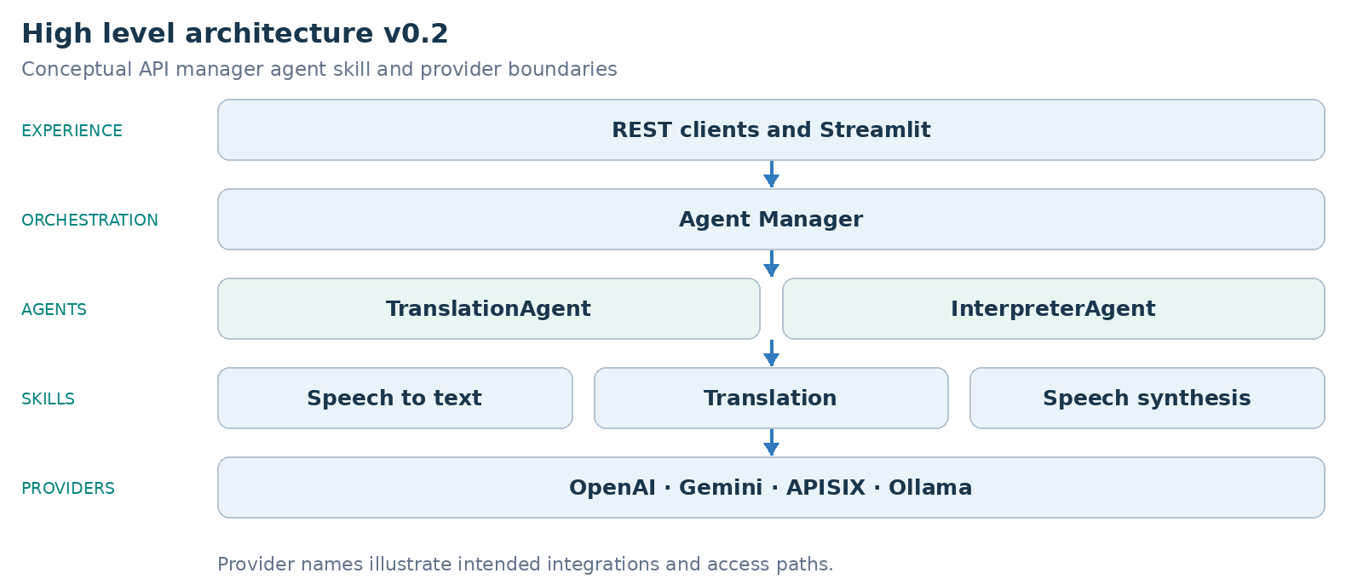
The diagram is a conceptual architecture. Agent Manager coordinates agents; agents compose Skills and access providers through explicit contracts.
OpenAI, Gemini and Ollama illustrate intended integrations. APISIX is an access gateway, not a model provider; its presence does not establish a delivered integration.

5. Roadmap
The original source records the following sprint statuses. They remain historical planning records, not new test results from this review.
Stage | Capability | Historical status
Sprint 1 | Core Translation API | Validated
Sprint 2 | Agent Framework | Validated
Sprint 3 | Multi Agent and Session Framework | Validated
Sprint 4 | Voice Pipeline | In progress
Sprint 5 | Conversation Memory | Planned
Sprint 6 | Streaming | Planned
Sprint 7 | Voice Clone | Planned
Sprint 8 | Meeting Assistant | Planned

6. Future vision
The envisioned ecosystem covers multilingual conversations, meeting assistants, realtime interpreters, customer service, travel assistants and domain specific voice copilots. Developers would compose reusable capabilities rather than rebuild every application. These remain future use cases in this edition.
VERSION FOCUS v0.2 clarifies the mission and the first detailed high level architecture.

