ARCHITECTURE & VISION BOOK · v0.4 · ENGLISH EDITION

Waaxalma
  - Framework Next
22 September 2026 · Framework Next
VISION Waaxalma (“speak for me”) turns speech, particularly in Wolof, into understandable translated text and natural audio. The product seeks to preserve intent; the framework separates replaceable agents, pipelines and provider capabilities.

1. Vision and scope
This edition records the v0.4 milestone. It retains the architecture template from v0.4 and the capabilities delivered at this point; later milestones remain future work in this historical edition.
- AgentRegistry, ProviderRegistry and PipelineRegistry make discovery and composition explicit.
- InterpreterAgent receives named text/audio pipelines. Context and Quality are agents, Skills, providers and pipeline stages.

2. Foundation now built
Layer | Implementation | Meaning
API | FastAPI | Generic registered-agent execution; text/voice routes.
Orchestration | AgentOrchestrator | Results, errors, timing and cancellation.
Discovery | AgentRegistry / ProviderRegistry | Explicit resolution by name and capability.
Composition | PipelineRegistry / SequentialPipeline | Ordered reusable stages.

3. Guiding principles
- Extend through contracts, registration and composition; fail early for unknown providers/pipelines.
- Skills depend on capability contracts. Reliability and observability stay cross-cutting. Context/Quality defaults add no extra LLM call.
- Separate standard workflows, realtime transports and browser devices; describe validation limits explicitly.

4. Current architecture
The composition root assembles concrete providers, Skills, stages, pipelines and agents. Registries resolve dependencies rather than adding processing stages to every request.
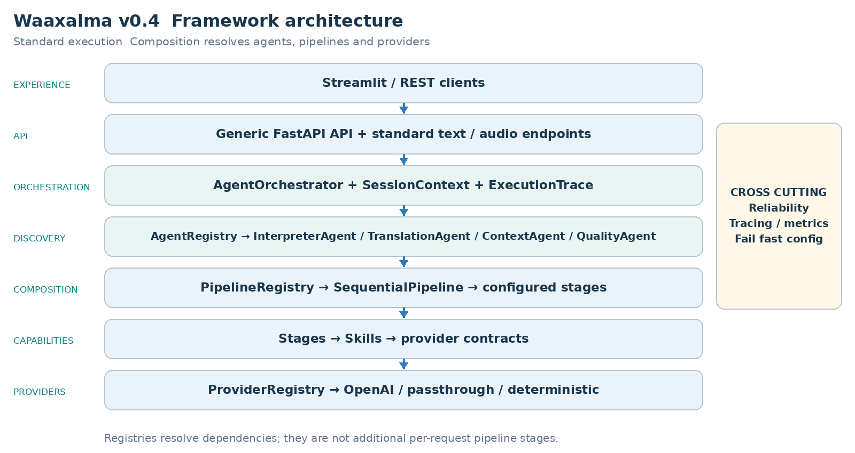
AgentOrchestrator executes registered agents; InterpreterAgent receives its configured text/audio pipelines. Realtime services, where delivered, remain separate from this standard chain.

5. Interpreter execution flows
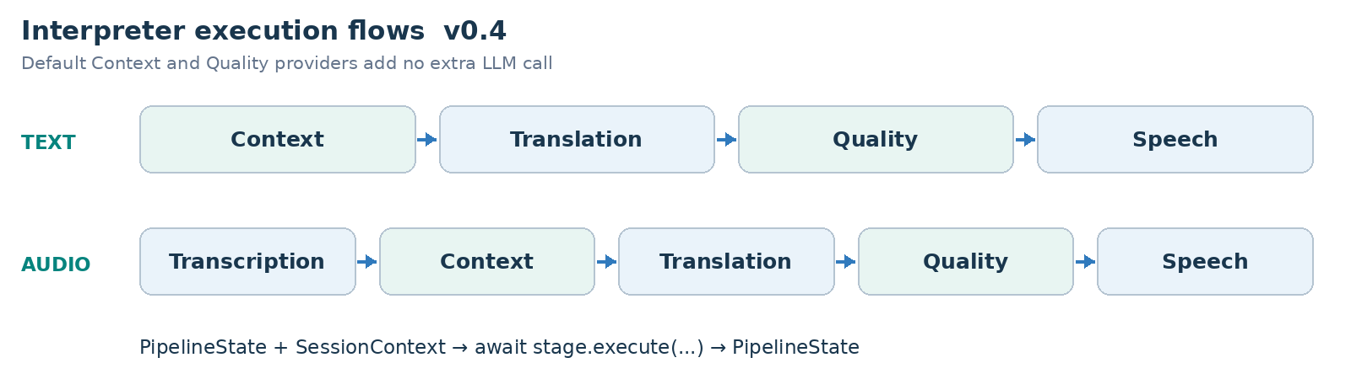
PIPELINE CONTRACT Each stage receives PipelineState and SessionContext and returns updated state. SequentialPipeline awaits stages in order; configured workflows can evolve without rewriting InterpreterAgent.

6. Framework extensibility model
Extension happens through explicit registration and composition, preserving the generic API and orchestration core. Provider adapters can change behind capability contracts.
Extension | Required change | Boundary preserved
New agent | BaseAgent + AgentRegistry | API / AgentOrchestrator
New provider | Implement capability contract; register capability + name. | Skill / Agent / API
New pipeline | Compose stages and register its name. | SequentialPipeline
New stage | PipelineStage | InterpreterAgent / API
Context/quality strategy | ContextProvider / QualityProvider | Configured stage structure.

7. Context and Quality as first class capabilities
- PassthroughContextProvider preserves source text/metadata. TranslationStage prefers enriched_text when supplied and preserves source_text.
- DeterministicQualityProvider evaluates structure, not semantic translation correctness. accepted, score, issues and quality metadata are returned; rejection does not create an implicit blocking policy.

8. Reliability and observability inheritance
- Provider retry/timeout policies remain centralized where supported. AgentOrchestrator normalizes failures and preserves cancellation.
- ExecutionTrace records stage/provider duration, outcome and error information. Prometheus covers executions, stage timing and retries.

9. Technical roadmap
Each milestone builds on the preceding architecture. The table records capability delivery, not an assertion that an unseen public Git tag exists. Future scope is preserved from the historical milestone.
Milestone | Position in this edition
Prototype and orchestration | Foundation
Reliability | Foundation
Framework Next | Milestone documented
Realtime Direct | Future at this version
Realtime Enhanced | Future at this version
Universal Audio Output | Future at this version
Device Control | Future at this version
Product Readiness | Future at this version
Stable Framework | Future at this version

10. Git release map
Version | Milestone
v0.1.0 | Prototype
v0.2.0 | Agent Orchestration
v0.3.0 | Reliability
v0.4.0 | Framework Next
v0.4.1 | Realtime Translation and Voice Configuration
v0.4.2 | Realtime Enhanced Streaming
v0.4.3 | Universal Audio Output and Conferencing Bridge
v0.4.4 | Conferencing Audio and Device Control
v0.5.0 | Product Readiness
v1.0.0 | Stable Framework Release

11. v0.4 definition of done
- AgentRegistry, ProviderRegistry and PipelineRegistry make discovery and composition explicit.
- InterpreterAgent receives named text/audio pipelines. Context and Quality are agents, Skills, providers and pipeline stages.
- This version does not deliver the later Direct/Enhanced paths, persistent owner isolation or production containers.
- Standard agents, provider selection and configured pipelines preserve the v0.4 extension boundaries and Context/Quality metadata.
VALIDATION RECORD Composition, unit, provider interchangeability, pipeline and generic API tests establish the architectural boundaries.

12. Recommended next slice
Product Readiness: persistent state, repeatable configuration, delivery gates, privacy and production observability.

Product readiness direction
Persistent conversation state, privacy/security boundaries, repeatable settings/credentials, CI packaging and production signals remain the operational roadmap. Later implementation chooses client isolation, not implicit authentication; future roadmap aspirations are not delivered guarantees of this historical version.
FRAMEWORK PRINCIPLE Add a capability through registration and composition without moving provider-specific or conferencing concerns into generic API/orchestration.

