ARCHITECTURE & VISION BOOK · v0.3 · ENGLISH EDITION
Waaxalma
From a voice translation prototype to a voice-agent framework
17 July 2026 · Consolidated architecture · Working document
VISION Waaxalma (“speak for me”) turns a voice — particularly in Wolof — into English text and then English audio. The product progressively evolves into a reusable framework for composing, observing and evolving voice agents.

1. Vision and scope
The core value remains simple: capture speech, preserve intent, produce an actionable translation and return a natural-sounding voice. The architecture must allow each capability to improve independently without breaking public interfaces.
- Inputs — microphone audio or a file, with a text mode for testing and non-voice use cases.
- Outputs — source text, English translation, English audio and session metadata.
- Direction — move from service calls inside routes to an orchestrated, extensible agent pipeline.

2. Foundation already built
Layer | Current state | Architectural interpretation
API | FastAPI | Four journeys: text translation, speech synthesis, voice translation and text response.
Interface | Streamlit | Microphone input validated for testing the end-to-end journey in Python.
Agents | InterpreterAgent | Multi-agent session framework validated; one business agent is currently active.
Services | Translate + TTS | Existing capabilities to be encapsulated behind agent contracts and adapters.

3. Guiding principles
- Stable API — FastAPI routes stay thin; business decisions belong to agents.
- Replaceable providers — STT, translation/LLM and TTS are accessed through adapters.
- Traceable session — every execution shares context, identifier, errors, duration and results.
- Privacy by default — minimal collection, explicit retention and no persistent audio without a defined need.

4. Target architecture
The system separates experience, API, orchestration, agents and technical providers. Badges show what already exists and what should be introduced incrementally.
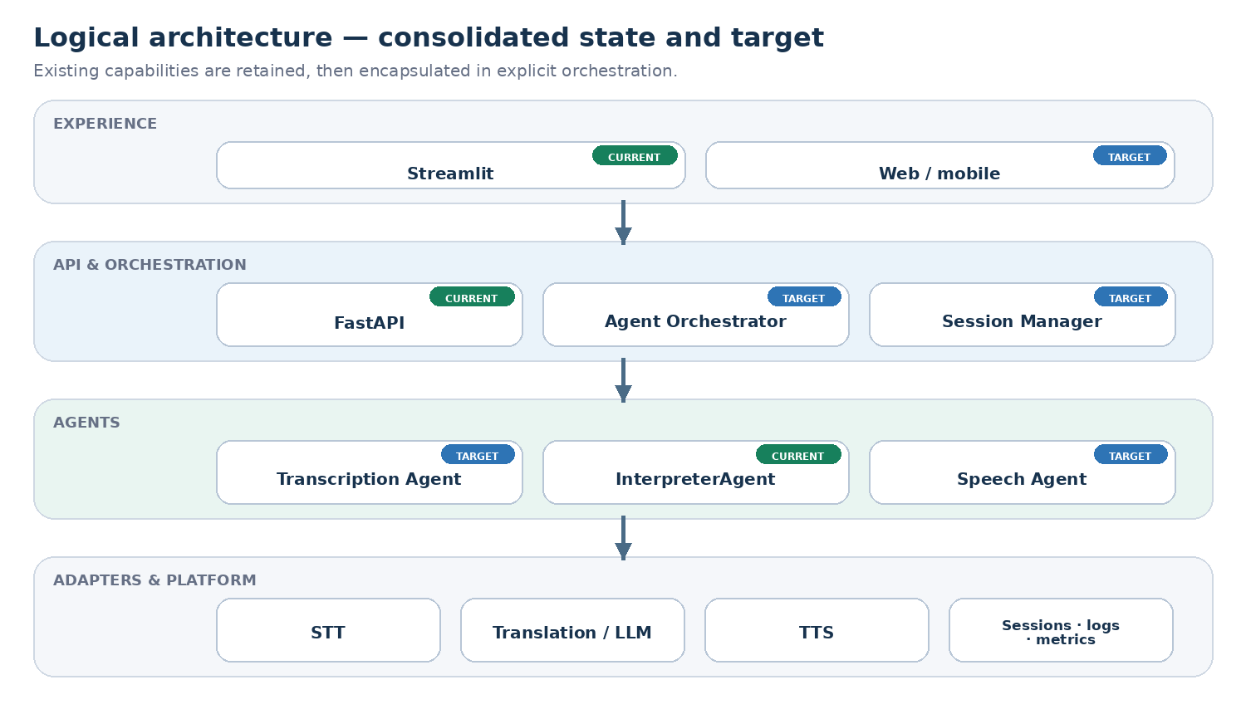
Reading: InterpreterAgent is already validated; Transcription Agent, Speech Agent, the orchestrator and the session manager form the next industrialization step.

5. Agent interactions
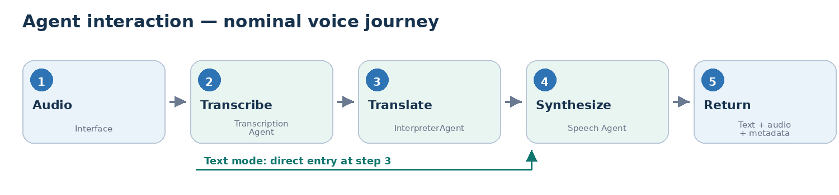
PIPELINE CONTRACT A SessionContext moves between stages. Each agent receives a typed input and returns an AgentResult containing output, status, duration, normalized errors and metadata — without depending directly on FastAPI.

6. Technical roadmap
The path preserves the working prototype, stabilizes orchestration, then opens the architecture to new agents and production constraints.
Stage | Status | Objective | Technical deliverables | Exit criterion
0 · Prototype | Validated | Prove the voice → translation → audio chain | FastAPI API, translate/TTS services, Streamlit interface, text and voice endpoints | Functional journeys tested
1 · Orchestration | Next | Unify execution behind agents | Pydantic contracts, Agent Orchestrator, SessionContext, adapters, integration tests | One pipeline for text and voice
2 · Reliability | Planned | Make real-world usage dependable | Audio validation, async, timeouts/retries, tracing, short history, quality/latency metrics | Observable errors and controlled recovery
3 · Framework | Target | Make the architecture extensible | Agent registry, interchangeable providers, configurable pipelines, quality/context agents | Add an agent without changing the API
4 · Product | Target | Prepare for sustainable deployment | Persisted sessions, security and privacy, CI/CD, packaging, operational observability | Deployable and governed version

7. Recommended next slice
- Define the contracts — SessionContext, AgentInput, AgentResult and shared errors with Pydantic.
- Create the orchestrator — sequential pipeline, correlation by session_id and explicit extension points.
- Wrap existing services — adapters around translate() and generate_speech(), without rewriting validated capabilities.
- Thin the routes — text.py and voice.py call the orchestrator and no longer carry business logic.
- Lock it down with tests — unit tests per agent, text/voice integration and a Streamlit regression test.
DEFINITION OF DONE Text and voice journeys use the same pipeline, every request is correlated to a session, providers are replaceable through configuration, and tests cover success, timeout and provider failure.

