OLYMPIC MEDAL ANALYSIS (1896–2016)

Data Analysis Report

Prepared by

Elina Vatanizadeh

July 2026

Python • Pandas • Matplotlib • Jupyter Notebook

Table of Contents
Abstract 2
1. Introduction 3
2. Objectives 3
3. Dataset Description 3
4. Data Inspection and Quality Assessment 4
5. Data Cleaning 4
6. Exploratory Data Analysis 6
6.1 Olympic Participation Trends 6
6.2 Country Performance Analysis 7
6.3 Sport Medal Analysis 8
6.4 Gender Participation Trends 9
6.5 Country Dominance by Sport 10
6.6 Athlete Age Trends 13
7. Key Findings 14
8. Limitations 15
9. Conclusion 15
10. Future Work 15
11. References 16

Abstract
The Olympic Games provide one of the most comprehensive records of international sporting competition. This project analyses historical Olympic athlete data from 1896 to 2016 to identify long-term trends in participation, medal distribution, gender representation, and athlete characteristics. Using Python and the pandas library, the dataset was cleaned, explored, and visualised to answer a series of research questions. The analysis demonstrates substantial growth in Olympic participation, increasing female representation, concentration of medals among a small number of countries, and differences in success across sports. The project illustrates practical data analysis techniques, including data cleaning, exploratory data analysis (EDA), aggregation, and data visualisation.

1. Introduction
The Olympic Games have evolved from a relatively small international competition into one of the world's largest sporting events. Over more than a century, changes in global participation, sporting disciplines, and gender representation have shaped the modern Olympics.
Historical Olympic datasets provide an opportunity to investigate these changes using data analysis techniques. Rather than focusing on individual athletes or events, this project examines long-term patterns within the complete athlete dataset.

2. Objectives
The objectives of this project were to:
- Examine historical Olympic participation trends;
- Identify the countries that have won the largest number of medals;
- Determine which sports contribute the greatest number of medals;
- Investigate changes in female participation over time;
- Analyse country dominance within selected sports;
- Explore trends in athlete age across Olympic history.

3. Dataset Description
The analysis uses the 120 Years of Olympic History: Athletes and Results dataset, which contains athlete-level records from every Olympic Games between 1896 and 2016.
The dataset includes 15 variables describing athlete characteristics and competition results, including:
- athlete name
- sex
- age
- height
- weight
- team
- National Olympic Committee (NOC)
- year
- season
- city
- sport event
- medal
The dataset contains athletes representing 230 National Olympic Committees and 66 sports across both the Summer and Winter Olympic Games.

4. Data Inspection and Quality Assessment
Initial exploration was performed using pandas functions including head(), info(), describe(), value_counts(), isnull(), and duplicated().
The inspection revealed several important characteristics:
- The dataset contains both numerical and categorical variables;
- Male athletes account for the majority of historical Olympic participants;
- Summer Olympic records greatly outnumber Winter Olympic records;
- Age, Height, and Weight contain missing values;
- The Medal column contains many missing values because most athletes did not receive medals;
- Duplicate records are present.
Extreme values in the numerical variables were inspected individually. Although some observations appeared unusual, they were consistent with the athletes' sports and competition records and therefore were retained.

5. Data Cleaning
A copy of the original dataset was created before cleaning to preserve the raw data.
The following cleaning steps were completed:
- Duplicate records were removed;
- The original dataset was preserved;
- Missing values in the medal column were retained because they indicate athletes who did not win medals rather than missing information;
- Missing values in age, height, and weight were preserved since these variables were not essential for every analysis;
- A new boolean variable, medal_won, was created to simplify medal-based analyses.
The cleaned dataset was exported for use in subsequent analysis.

6. Exploratory Data Analysis

6.1 Olympic Participation Trends
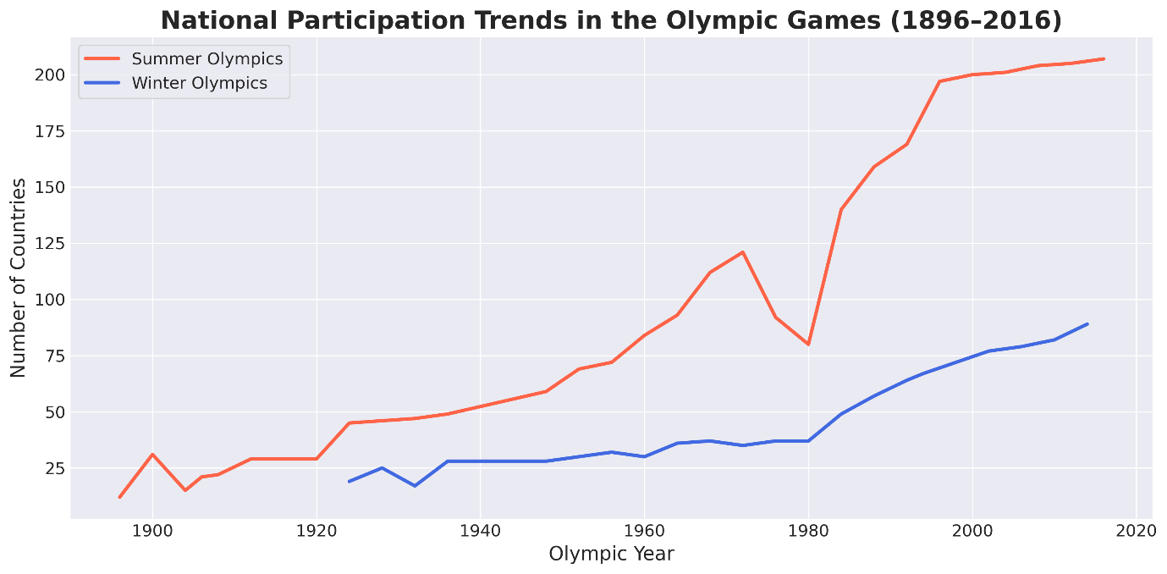
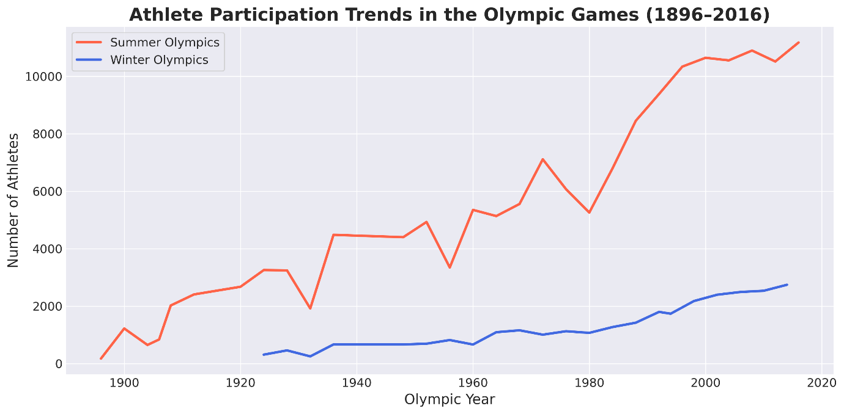
Figure 2. National Participation Trends
Figure 1. Athlete Participation Trends
Participation increased substantially throughout Olympic history. The number of competing athletes and participating countries generally rose over time, reflecting the expansion of international sport and broader global involvement in the Olympic Games.
Although participation fluctuated during certain periods, the long-term trend demonstrates sustained growth.

6.2 Country Performance Analysis
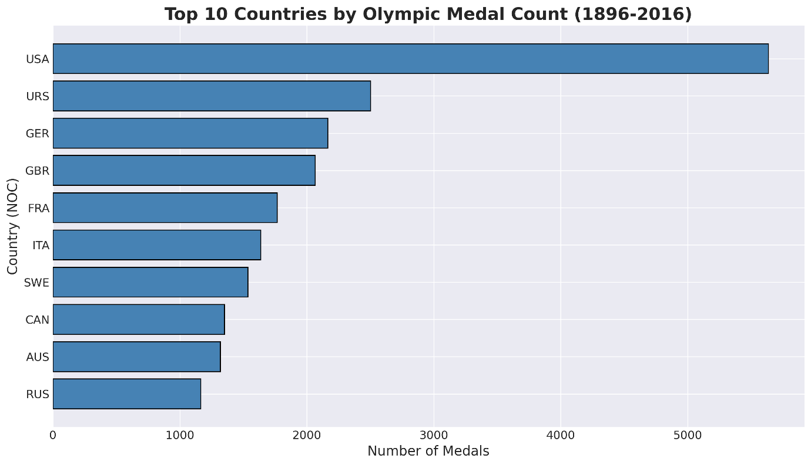
Figure 3. Top 10 Medal-Winning Countries
Medal counts reveal that Olympic success is concentrated among a relatively small number of countries.
Several nations consistently appear among the highest medal winners across multiple Olympic Games. Their success is likely associated with sustained investment in elite sport, larger athlete populations, and long-established sporting programmes.
The ranking highlights considerable differences in competitive performance between countries.

6.3 Sport Medal Analysis
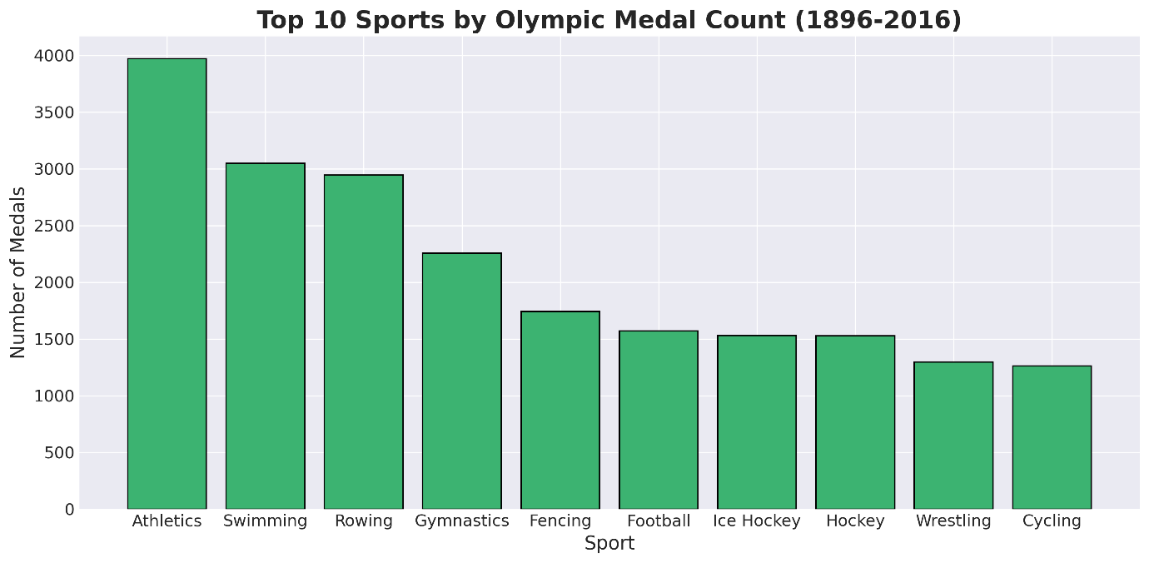
Figure 4. Top 10 Medal-Winning Sports
Medal distribution varies considerably between sports.
Sports containing numerous events naturally contribute larger numbers of medals, while sports with fewer events contribute comparatively fewer.
This analysis demonstrates that medal totals should be interpreted alongside the number of events within each sport.

6.4 Gender Participation Trends
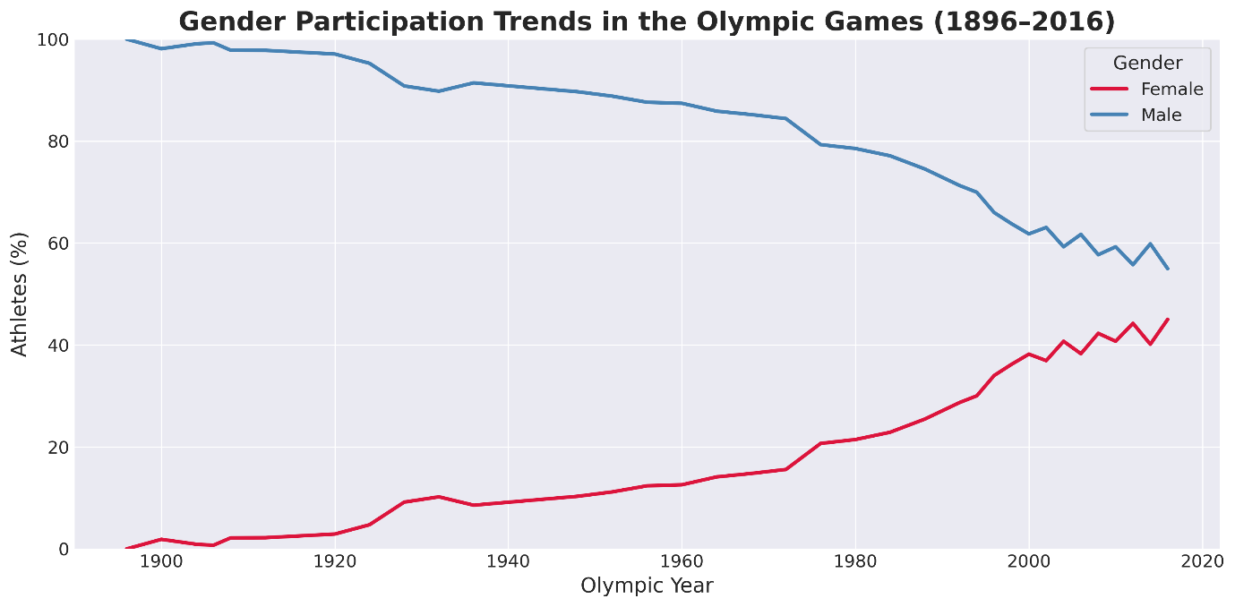
Figure 5. Gender Participation Trends
One of the most significant findings is the steady increase in female participation throughout Olympic history.
Early Olympic Games were overwhelmingly male. However, female representation increased consistently during the twentieth century and continued to rise into the twenty-first century.
This trend reflects broader social changes, increased opportunities for women in sport, and Olympic policies promoting gender equality.

6.5 Country Dominance by Sport
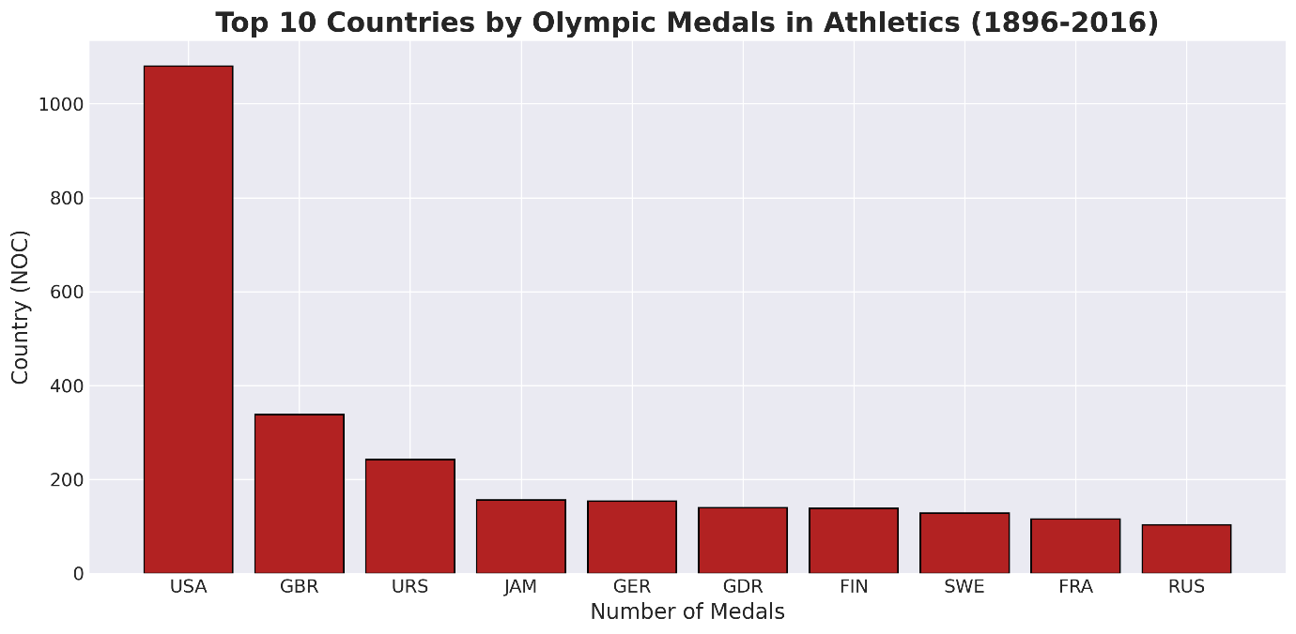
Figure 6. Country Dominance in Athletics based on Total Olympic Medal Counts
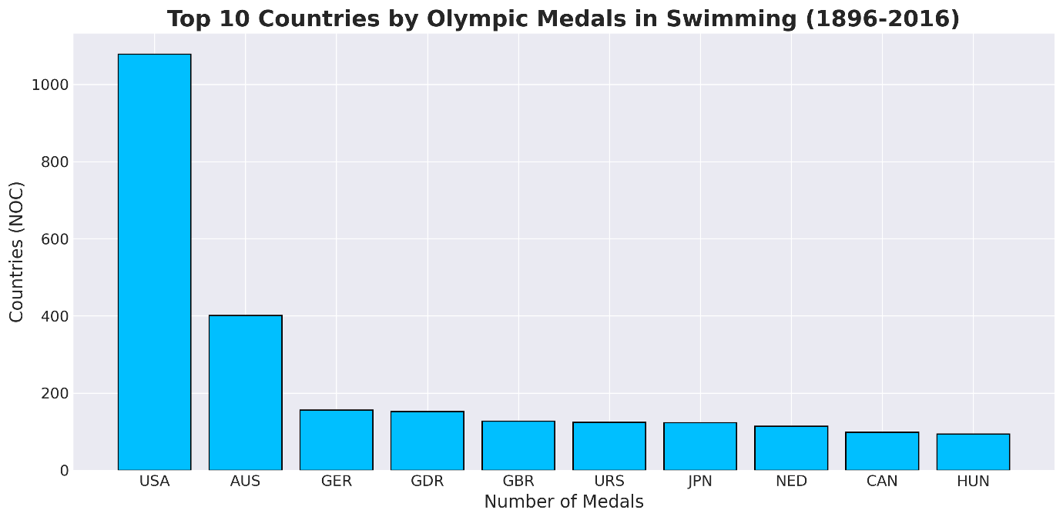
Figure 7. Country Dominance in Swimming based on Total Olympic Medal Counts
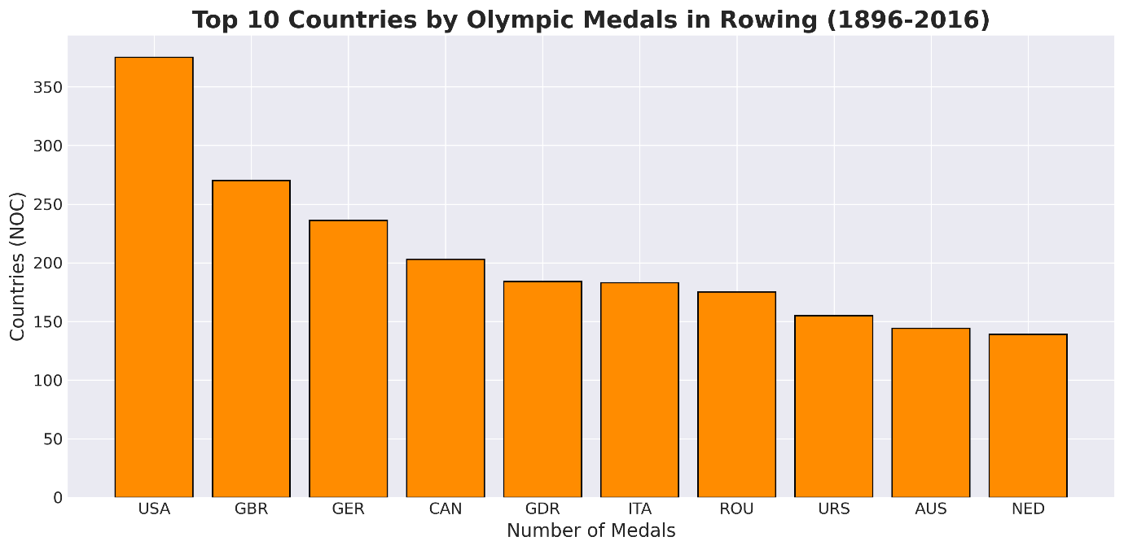
Figure 8. Country Dominance in Rowing based on Total Olympic Medal Counts
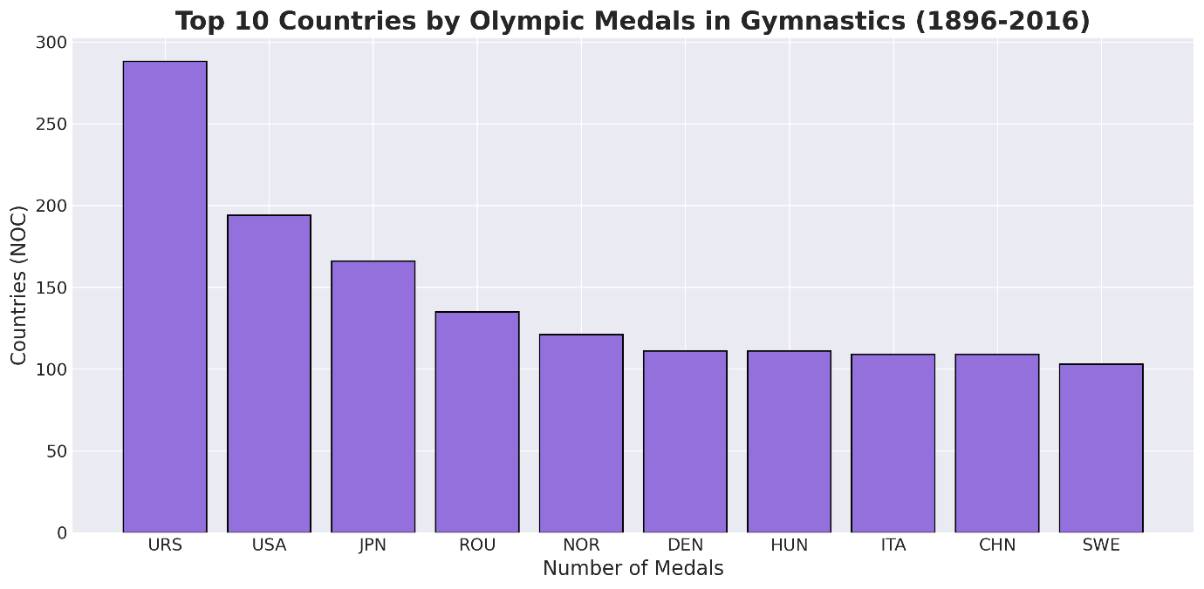
Figure 9. Country Dominance in Gymnastics based on Total Olympic Medal Counts
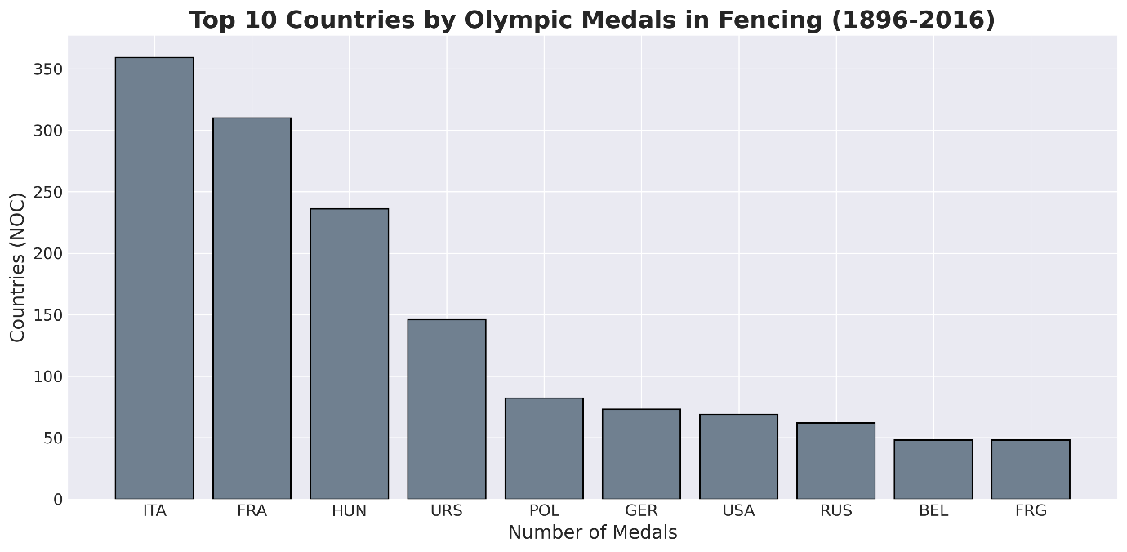
Figure 10. Country Dominance in Fencing based on Total Olympic Medal Counts
Analysis of individual sports shows that competitive dominance varies considerably across disciplines.
Different countries consistently perform well in particular sports due to historical traditions, specialised training programmes, and national sporting priorities.
Examining individual sports provides greater insight than analysing overall medal counts alone.

6.6 Athlete Age Trends
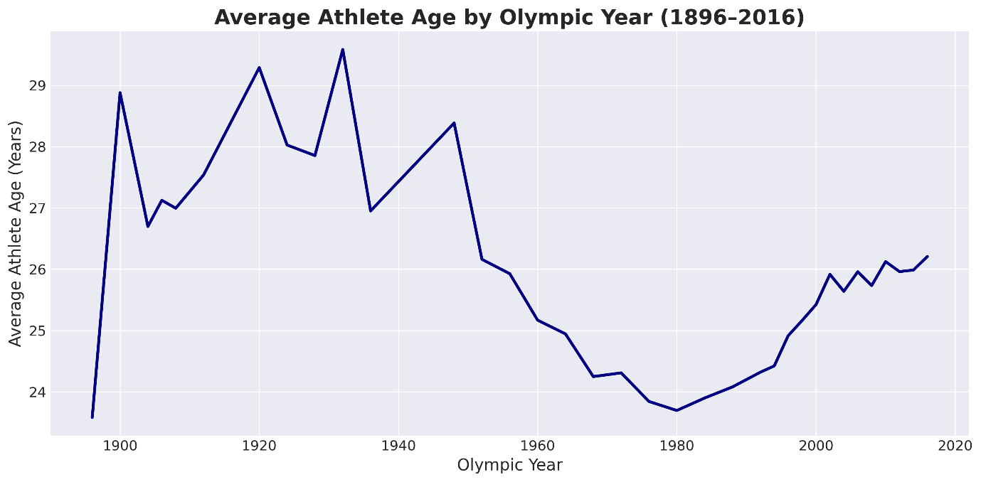
Figure 11. Average Athlete Age by Olympic Year
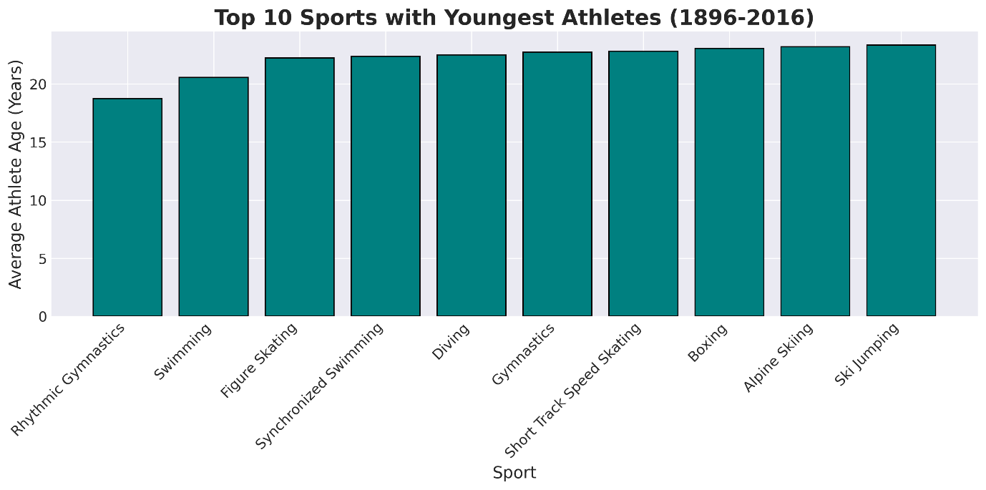
Figure 12. Top 10 Sports with Youngest Athletes
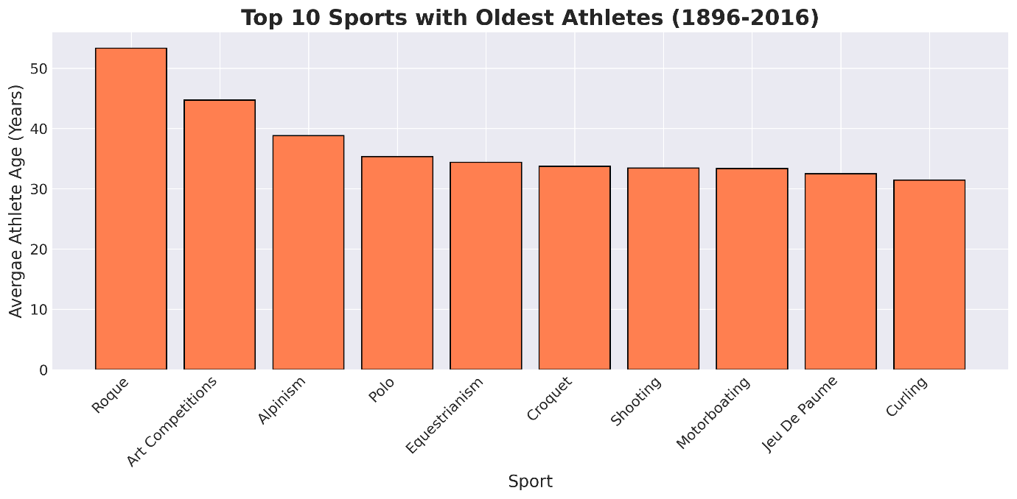
Figure 13. Top 10 Sports with Oldest Athletes
Athlete ages vary across sports and over time.
Some sports favour younger competitors because of physical demands and peak athletic performance, whereas others allow successful competition at older ages due to greater emphasis on experience and technical skill.
Despite these differences, average athlete age has remained relatively stable across much of Olympic history.

7. Key Findings
The analysis produced several important findings:
- Olympic participation has increased substantially since 1896.
- Female participation has grown continuously throughout Olympic history.
- Medal success is concentrated among a relatively small group of countries.
- Sports differ considerably in their contribution to total medal counts.
- Individual countries often demonstrate long-term dominance in particular sports.
- Duplicate records were successfully removed while preserving meaningful missing values.

8. Limitations
Several limitations should be considered.
The dataset ends in 2016 and therefore does not include the most recent Olympic Games.
Missing values remain within the Age, Height, and Weight variables, limiting analyses involving athlete characteristics.
The analysis focuses primarily on descriptive statistics and exploratory data analysis rather than predictive modelling or statistical inference.
Finally, medal counts do not account for factors such as population size, economic resources, or the number of athletes entered by each country.

9. Conclusion
This project demonstrates how Python can be used to clean, explore, and interpret large real-world datasets.
The Olympic athlete dataset reveals clear historical trends in participation, gender representation, and international sporting success. Through systematic data cleaning and exploratory analysis, meaningful insights were obtained without relying on complex machine learning techniques.
The project also demonstrates proficiency in pandas, data cleaning, aggregation, visualisation, and exploratory data analysis, providing a strong example of practical data science skills suitable for an academic or professional portfolio.

10. Future Work
Future development could include:
- Analysing Olympic data beyond 2016;
- Normalising medal counts by population or GDP;
- Building interactive dashboards using Streamlit or Plotly;
- Applying statistical hypothesis testing;
- Developing predictive models to estimate medal outcomes using machine learning.

11. References
- RGRIFFIN.(n.d.). 120 Years of Olympic History: Athletes and Results [Data set]. Kaggle.
- Pandas Documentation.
- Matplotlib Documentation.
- Python Documentation.

