Název práce (v ČJ)
Titul. Jméno Příjmení

Introduction
Modelling of spatial phenomena has always been central to geoinformatics and geographical information science, to the extent that spatial statistics is considered an integral part of the discipline (Goodchild 1992)…

Background

Spatial statistics
Spatial statistics concerns itself with the quantitative analysis and modelling of spatial data (Pilz 2025), drawing its foundations from probability theory, mathematical statistics, and stochastic modelling. Its methods address statistical dependencies between observations, spatial heterogeneity, and uncertainty inherent to geographic data - using techniques such as spatial autocorrelation analysis, clustering, interpolation or spatial modelling among others Fischer and Getis (2010).
A common prerequisite to these methods is a mathematically formalized representation of the relationships between spatial observations. Such relationships are encoded through spatial weights, which define the neighbourhood structure of the data and govern how influence is propagated across space.
This subchapter provides an overview of the core spatial statistical methods employed in the subsequent analysis. It first introduces spatial weights with a focus on contiguity definitions, then presents the most established spatial autocorrelation techniques used to detect homogeneity and heterogeneity in spatial data. Finally, it discusses widely used regionalization methods, which seek to partition spatial units into coherent regions according to attribute similarity and spatial contiguity constraints.

Spatial weights
Spatial weights, formalized by the seminal work by Cliff & Ord (1973), connect objects in geographic space using the spatial relationship between them. They serve for defining spatial neighbourhoods and geographically relevant sites. These relationships can be distance-based (k-nearest neigbours, distance bands), based on a membership in a geographic group (block weights) or adjacency-based (contiguity) among others. Each pair of observations is assigned a weight, which can either be boolean (1 for a spatial relationship, 0 otherwise), or specific numerical value (e. g. inverse distance). We will further focus on contiguity-based spatial weights, as those can be directly impacted by violating polygonal coverage.
Spatial weights can be represented as a matrix, denoted as $W$. $W$ is a $N×N$ matrix, where $N$ is the number observations. Each element $w_{ij}$ corresponds to the weight between observations $i$ and $j$, that is, how much observation $j$ influences observation $i$. Because geographic datasets are rarely fully interconnected, most elements in $W$ are 0. To ensure computational and memory efficiency, tools like libpysal (S. J. Rey et al. 2022), geoda (Anselin, Syabri, and Kho 2006) or spdep (Bivand 2022) also implement sparse matrix, which stores only non-zero elements.
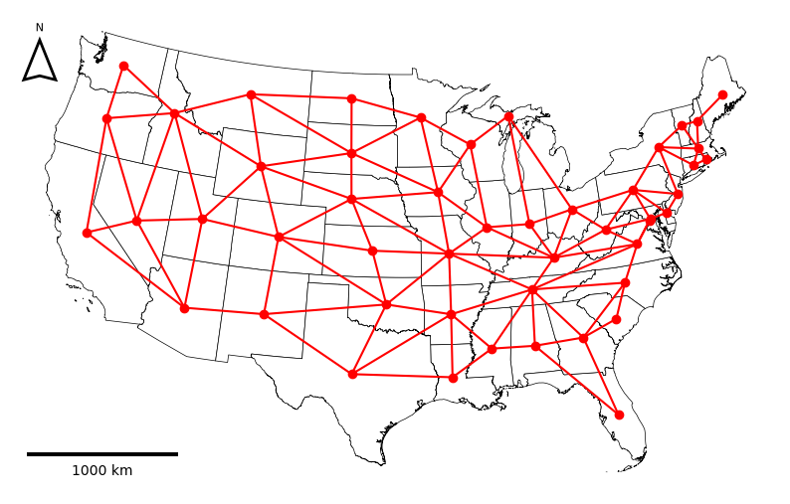
Figure 1: Rook contiguity graph.
Spatial weight matrix can be understood as a graph adjacency matrix, therefore spatial graph (see Figure 1) is another representation of spatial weights. A weighted graph is defined as an ordered triple $G=\left(V,E,ω\right)$, where $V$ is a set of nodes, $E$ is a set of edges representing connectivity between nodes and $ω:E→R$ is a function that assigns real numbers (weights) to edges. Two nodes $i,j∈V$ are adjacent if there exists an edge $\{i,j\}∈E$ connecting them. Each node represents an observation and a weighted edge denotes the relationship between observations. Fundamentally, spatial weights matrices and graphs store the exact same topological information; the matrix is simply the algebraic representation of the spatial graph.
-neco o symetricnosti?

Contiguity
Spatial weight matrices are most commonly defined trough contiguity, meaning that polygons that share a mutual border are considered to be spatial neigbours. However, this definiton isn’t a rigorous, leading to several formal interpretations of contiguity. The primary types of contiguity are named analogically to the movements of chess pieces:
- Rook: The polygons are considered neighbours if they share an edge (a boundary of non-zero length).
- Queen: The polygons are considered neighbours if they share at least one point (vertex or a shared edge).
- Bishop: The polygons are considered neighbours if they share only a point, but no edges. It represents the logical difference between Queen and Rook contiguity (Queen - Rook).
Rook and Queen contiguity matrices dominate in spatial statistics. They are the only valid choice for regionalization methods and are the default for spatial autocorrelation metrics. Bishop is rarely used on its own, but sometimes its used for hybrid weights. Beyond immediate neigbours, contiguty can be expnaded to higer order contiguity weighs (neigbours of neigbours), often used in spatial data modelling.

Spatial autocorrelation
According to Tobler’s Firsts law of geography “everything is related to everything else, but near things are more related than distant things”. This principle underlies the concept of spatial autocorrelation (SAC) - the degree to which the value of an observation resembles the values of its spatial neighbours. Under a positive SAC, observations that are geographically close have similar values and tend to cluster. Under a negative SAC, similar values tend to be spatially dispersed rather than clustered, resembling a checkerboard pattern, visualized in Figure 2. This chapter provides an overview of the often used sac indicators such as Moran’s $I$ (Moran 1950) , Geary’s $C$ (Geary 1954) and Gettis-Ord’s $G$ (Getis and Ord 1992).
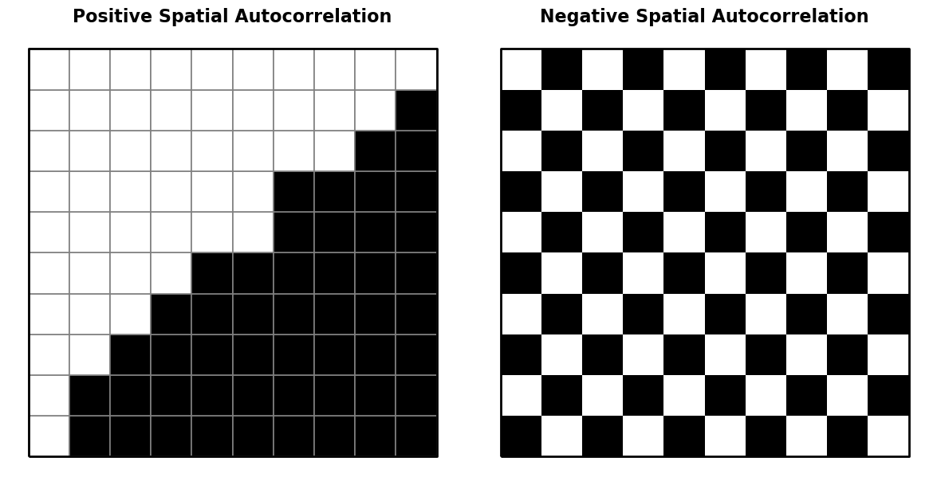
Figure 2: Spatial autocorrelation.

Moran’s I
A useful visualization to built some intuition for SAC is the Moran scatterplot (see Figure 3) which visualizes the relationship between the value of each observation and the values of its neighbour - spatial lag. The spatial lag of observation $i$ is the weighted sum of the centered values of its neighbours, as defined by the spatial weights matrix $W$:
ysl−i=j​wijyj 1
where $w_{ij}$ is an element of $W$ capturing the spatial relationship between observations $i$ and $j$ and $y_{j}$ is the centered value of observation $j$. Common pratice is to row standartize $W$, so that the weights in each row sum to exactly one. Neighbours are most commonly defined using either Queen or Rook contiguity (see Section 2.1.1.1).
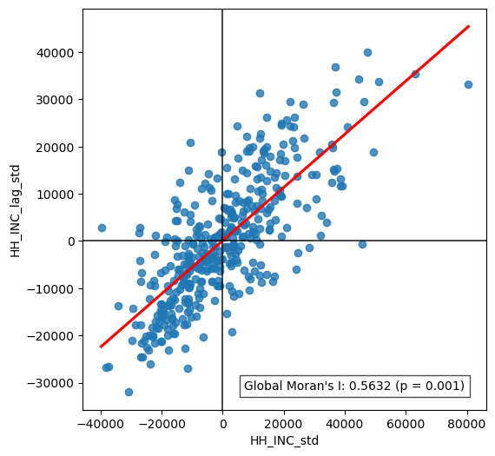
Figure 3: Moran’s scatterplot.
On the Moran scatterplot, each observation is plotted with its centered value on the x-axis and its spatial lag on the y-axis. At the global level, the slope of the best-fit regression line through the scatterplot corresponds to the value of global Moran’s I (Moran 1950), the most widely used SAC statistic. It is defined as
I=ni​j​wiji​j​wijzizji​zi2 2
where $n$ is the number of observations, $w_{ij}$ is an element of $W$ and $z_{i}$ and $z_{j}$ is the standartized values of observation $i$ and $j$.
The value of $I$ typically falls within the interval $\left[−1,1\right]$. Values close to 1 indicate strong positive spatial autocorrelation, values close to -1 indicate strong negative spatial autocorrelation, and values close to 0 indicate a spatially random pattern.
At the local level, the four quadrants of the Moran scatterplot correspond to four characteristic spatial situations, distinguished by the signs of an observation’s value and its spatial lag:
- High-High (HH): an observation with an above-average value surrounded by neighbours with above-average values - a cluster of high values.
- Low-Low (LL): an observation with a below-average value surrounded by neighbours with below-average values - a cluster of low values.
- Low-High (LH): an observation with an above-average value surrounded by neighbours with below-average values - a high-value outlier within a low-value neighbourhood.
- High-Low (HL): an observation with a below-average value surrounded by neighbours with above-average values - a low-value outlier within a high-value neighbourhood.
The quadrant to which an observation belongs can be read directly from the signs of its centered value and its spatial lag. This classification alone does not indicate whether the observation belongs to that category because of a genuine spatial pattern or by chance. To make this distinction, local indicators of spatial association (LISA) are used together with a test of statistical significance. The most commonly used local indicator is local Moran’s I, defined as
Ii=zim2j​wijzj ; m2=i​zi2n 3
where $z_{i}$ and $z_{j}$ are centered values on observation $i$ and $j$, $w_{ij}$ is the spatial weight for a pair of observations $i$ and $j$ and $m_{2}$ is the second moment (variance). A positive value of $I_{i}$​ indicates that observation $i$ belongs to an HH or LL quadrant, whereas a negative value indicates that it belongs to an HL or LH quadrant.
Because a specific local Moran’s I value can be obtained purely by chance, its statistical significance must be assessed before an observation is interpreted as belonging to a genuine cluster. Significance is typically expressed as a p-value under the null hypothesis that the attribute values are randomly distributed in space and carry no information about their surroundings. The p-value is commonly obtained through a permutation procedure, when the observed values are repeatedly reassigned at random to locations (usually 999 times, esda default), local Moran’s I is recalculated for each permutation, and the p-value is given by the proportion of permutations producing a value as extreme as, or more extreme than, the observed one. An observation is conventionally considered a significant part of a spatial cluster if $p<0.05$ . In practice, results are often visualized as LISA cluster maps, in which only statistically significant HH, LL, HL, and LH clusters are highlighted, while non-significant observations are shown in grey.
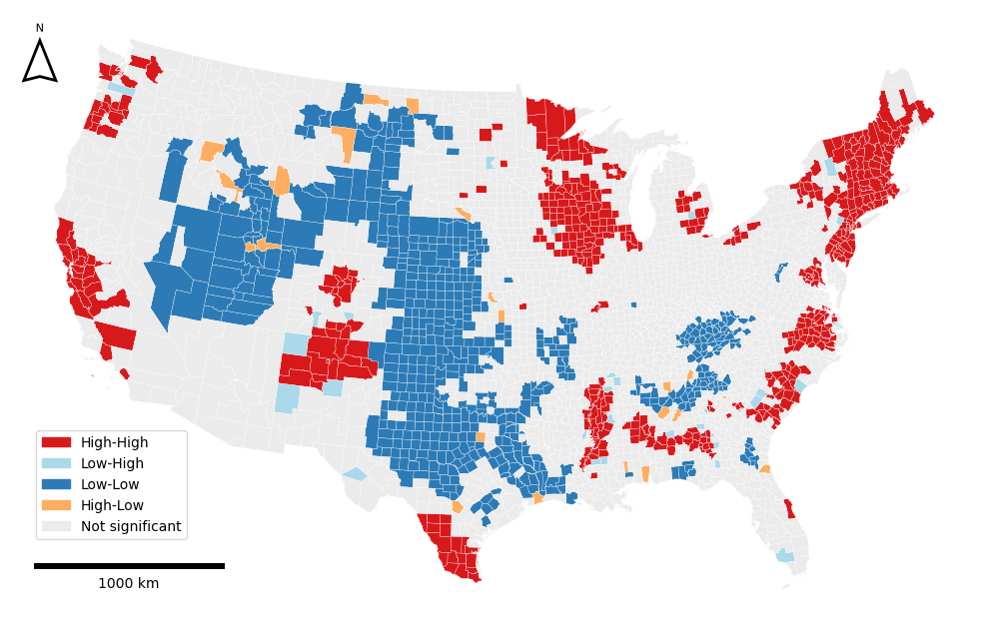
Figure 4: LISA cluster map.
On LISA cluster maps of real-world data, the majority of significant clusters are typically HH or LL, compared to few HL or LH outliers, which is consistent with Tobler’s first law of geography - similar values tend to occur near one another.

Geary C
Geary’s C is another widely used measure of spatial autocorrelation. Its global form is given by
C=n−12i​j​wiji​j​wijyi−yj2i​yi−y2 4
where $n$ is the number of observations, $w_{ij}$ is the spatial weight for a pair of observation $i$ and $j$, $y_{i}$ and $y_{j}$ are raw values of observations $i$ and $j$, respectively and $\overset{‾}{y}$ is the mean value of the whole dataset. Unlike Moran’s I, which uses cross-products on the standartized values, Geary’s C computes differences of raw values, which in case of very different neigbouring values, it inflates the $C$ value, making it more sensitive to appearance of local negative SAC. $C$ is bounded below by zero, which indicates strong positive SAC, values close to one indicate random spatial pattern, and any values markably larger than one indicate negative SAC.
The local version, Local Geary C, proposed by Anselin, is defined for each observation $i$ as:
ci=j​wijyi−yj2 5
where $w_{ij}$ is the spatial weight for a pair of observation $i$ and $j$, $y_{i}$ and $y_{j}$ are raw values of observations $i$ and $j$,. High values of local $c_{i}$ highlight areas of abrupt changes in value. As with any LISA, the magnitude of $c_{i}$ is less important on its own than its statistical significance, which determines whether the identified local pattern is genuine.

Gettis Ord G
Proposed by Getis and Ord (1992), the local $G$ is an indicator of positive spatial autocorrelation. It can be defined in two ways, $G_{i}$ excludes observation’s $i$ own value, wheres $G_{i}^{*}$ includes it:
Gi=j≠i​wijxjj≠i​xj,Gi*=j​wijxjj​xj 6
where $w_{ij}$ is the weight between observation $i$ and $j$. $G$ captures the overall degree of positive spatial autocorrelation, where high $G$ values are associated with hot spots (areas with homogenously high values) and low values are associated with cold spots (areas with homogenously low values).
Getis-Ord G is complementary to local Moran’s I. Local Moran’s I primarily distinguishes between spatial clusters (HH/LL) and spatial outliers (HL/LH), but a positive value of local Moran’s I does not by itself reveal whether the underlying cluster consists of high or low values. $G$ is specifically designed to make this distinction, identifying whether a concentration of similar values forms a hot spot or a cold spot. However, because $G_{i}$ and $G_{i}^{*}$​ are computed from sums of raw, non-negative attribute values rather than centered or standardized ones, they cannot detect negative spatial autocorrelation.

Regionalization
Regionalization is the process of creating regions (Juan Carlos Duque, Ramos, and Suriñach 2007). It is essentially grouping similar observations together, which we recognize as clustering, but with a spatial constraint that two observations (polygons) can be in the same cluster only if they share a border - contiguity. Regionalization is therefore known as spatially constrained clustering.
The objective of any clustering method is to minimize the dissimilarity within each cluster. The overall dissimilarity of a dataset is described with the sum of all pairwise distances $T$:
$$T=\frac{1}{2}\sum_{i=1}^{n}{\sum_{j=1}^{n}{d_{ij}}} \left(7\right)$$
where $d_{ij}$ is a measure of dissimilarity. $T$ consists of two complementary components: within-cluster dissimilarity $W$ and between-cluster dissimilarity $B$, which can be evaluated during the clustering (regionalization) process:
$$T=W+B \left(8\right)$$
where
W=12h=1ki∈h​j∈h​dij, B=12h=1ki∈h​j∉h​dij 9
$W$ acts as a loss function, the goal of clustering is to minimize it. Some methods explicitly use $W$ as the clustering criterion (e. g. SCHC using Ward’s linkage) whereas other methods use different metrics to approximate the goal.
This chapter will serve as an overview of widely used methods discussed in Anselin (2024). In the experimental part, two of those methods will be tested for robustness to polygonal coverage violations - SCHC and SKATER.

SCHC
Spatially constrained hierarchical clustering (SCHC) is a bottom-up approach, where each observation starts as its own cluster ($k=n$) and the clusters (or single observations) are being recursively merged based on their dissimilarity. It is based on agglomerative clustering with a contiguity constraint. It is a greedy algorithm, therefore once the observations are merged, they cannot be split in another iteration.
Dissimilarity is computed based on definition of cluster distance in attribute space, referred to as linkage criterion. The four main types of linkages are:
- Single linkage: dissimilarity is the minimum distance between any pair of observations drawn from the two clusters.
- Complete linkage: dissimilarity is the maximum distance between any pair of observations drawn from the two clusters.
- Average linkage: dissimilarity is the average distance over all pairs of observations, one drawn from each cluster.
- Ward’s linkage: dissimilarity is the increase in total within-cluster $SSD$ (see Equation 10) that would result from merging the two clusters.
In vast majority of applications, dissimilarity is measured using Euclidean distance, which also required for the use of Ward’s linkage, preferred for regionalization and will be further described in this chapter.
The dissimilarity is denoted in dissimilarity matrix $D$, which is initially $n×n$ as each observation starts as its own cluster. Each element $d_{ij}$ represents the dissimilarity between each pair of clusters (or single observations). At each step, the algorithm merges the two clusters/observations, that have the smallest dissimilarity (smallest value from $D$) under the contiguity constraint. After each merge, $D$ is updated using an updating formula, that computes the dissimilarities between the new cluster $C$ and a cluster $P$, reducing both dimensions of $D$ by one in each iteration.
Ward’s method, developed by Ward (1963), explicitly minimizes the within-cluster dissimilarity (variance) defined trough the sum of squared errors ($SSD$). The input structure to use Ward’s method is a $n×p$ matrix $X$, where $n$ is the number of observations, $p$ is the number of variable and each element represents the (standartized) value of each variable for each observation. $SSD$ can be then formally defined as:
SSD=i∈C​xi−xC2 10
where $x_{i}$ is a single row of $X$ (the vector of attributes for observation $i$) and ${\overset{‾}{x}}_{C}$ is the centroid of all observations in cluster $C$. Intuitively, the overall $SSD$ increases when we merge two clusters, so the goal at each step is to choose the merge that increases $SSD$ by the smallest possible amount. This turns out to be equivalent to merging the two clusters whose centroids are closest based on a dissimilarity matrix $D$. Ward’s method expresses the dissimilarity trough the square of the Euclidean distance, therefore the dissimilarity between clusters is defined as
$$d_{AB}^{2}=\frac{2n_{A}n_{B}}{n_{A}+n_{B}}∥{\overset{‾}{x}}_{A}−{\overset{‾}{x}}_{B}∥^{2} \left(11\right)$$
After two clusters $A$ and $B$ are merged into a new cluster $C$, the dissimilarities between $C$ and every other cluster $P$ can be computed without recalculating centroids, using the Lance-Williams updating formula:
$$d_{PC}^{2}=\frac{n_{A}+n_{P}}{n_{C}+n_{P}}d_{PA}^{2}+\frac{n_{B}+n_{P}}{n_{C}+n_{P}}d_{PB}^{2}−\frac{n_{P}}{n_{C}+n_{P}}d_{AB}^{2} \left(12\right)$$
As mentioned above, the clusters/observations can be only merged under the contiguity constraint, which is denoted in spatial weights matrix $W$. For this thesis, we will assume a binary $W$, meaning that observations $i$ and $j$ can be merged only if $w_{ij}=1$. After the merge, $W$ needs to be updated. If $i$ and $j$ were merged into a new cluster $C$, $i$-th and $j$-th row and column will be replaced by $C$. The relationship between $C$ and the rest of the clusters $P$ will be set to $w_{PC}=1$ if $w_{iP}=1∨w_{jP}=1$, inheriting all the neighbours of both $i$ and $j$.
In practice, the number of clusters (regions) $k$ is fixed in advance, and the merging process stops once this number is reached. This corresponds to “cutting” the hierarchical tree refered to as dendrogram, displayed in Figure 5, at the appropriate height.
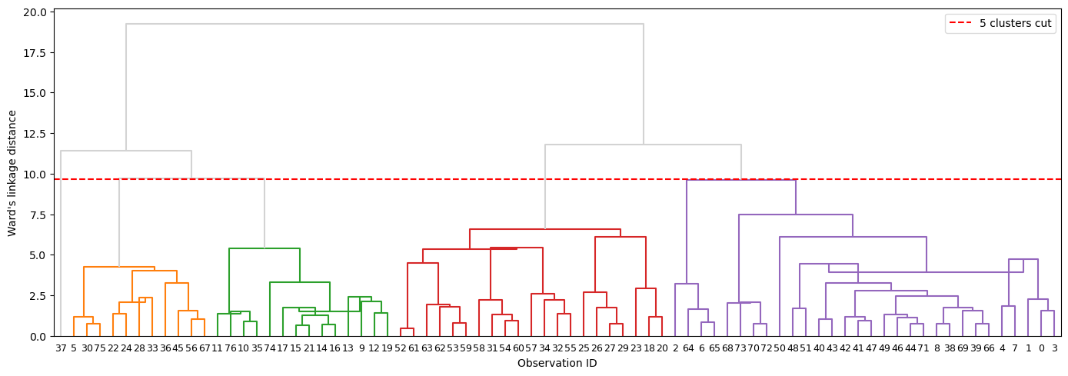
Figure 5: Dendrogram.
-definovany jen pro 1 componentu?

SKATER
Spatial ’K’luster Analysis by Tree Edge Removal (SKATER), developed by AssunÇão et al. (2006), is another hierarchical regionalization method. Unlike SCHC, it is not agglomerative, but divisive. It is based on pruning (illustrated in Figure 6) a minimum spanning tree (MST) - a subgraph that connects all nodes of a graph using the subset of edges with the minimum possible total edge weight, without forming any cycles. The MST is usually built using Prim’s or Kruskal’s algorithm.
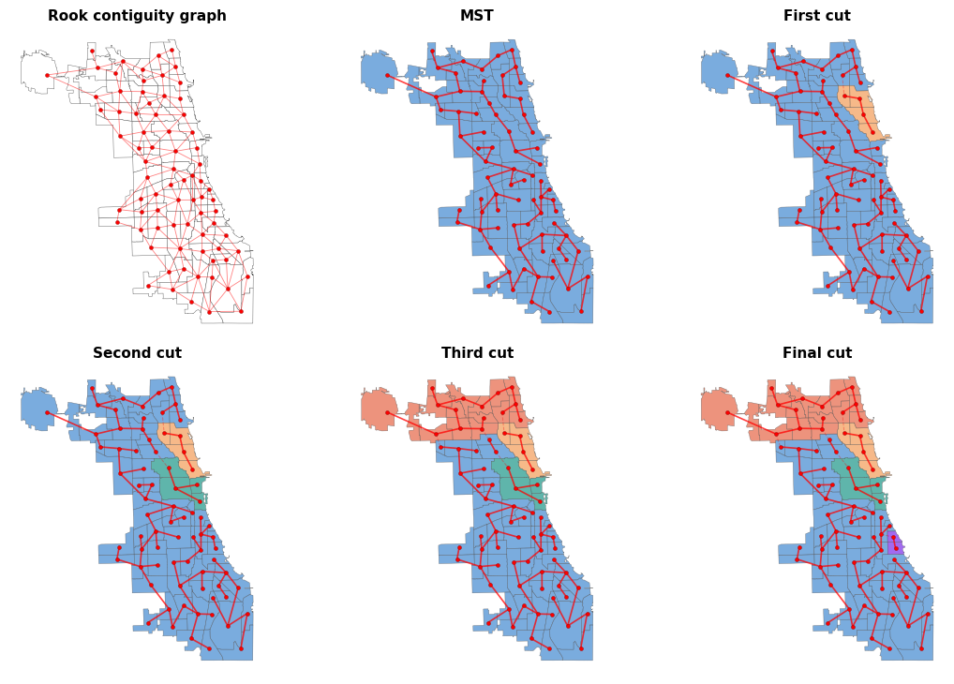
Figure 6: SKATER partitioning.
For the SKATER algorithm, MST is a subset of edges from contiguity spatial weights graph (see definiton in Section 2.1.1.1). The weights are assigned to each $\left(i,j\right)$ edge based on the dissimilarity between the attribute vectors of observations $i$ and $j$, typically their squared Euclidean distance in attribute space:
$$d\left(i,j\right)=d\left(x_{i},x_{j}\right)=\sum_{l=1}^{n}{{\left(x_{il}−x_{jl}\right)}^{2}} \left(13\right)$$
where $x_{i}$, $x_{j}$ are attribute vectors of observations $i$ and $j$.
All observations are considered to be in one region and they are connected by the initial MST, which has exactly $n−1$ edges. The MST is pruned by removing an edge which increases the between-cluster dissimilarity the most. This is accessed trough calculating the sum of squared deviations (see Equation 10). Removing an edge splits a tree $T$ into two subtrees $A$ and $B$. The resulting reduction in within-cluster dissimilarity is given by
$$ΔSSD=SSD_{T}−\left(SSD_{A}+SSD_{B}\right) \left(14\right)$$
At each step, SKATER removes the edge that maximizes $ΔSSD$, i.e. the split that most reduces the combined within-cluster dissimilarity of the two resulting subtrees. This process is repeated $k−1$ times, recursively splitting the resulting subtrees, until the desired number of regions $k$ is reached.

REDCAP
Developed by D. Guo (2008), Regionalization with dynamically constrained agglomerative clustering and partitioning (REDCAP) consists of both merging and divisive processes, combining SCHC and SKATER.
The first part of the algorithm is structurally identical to SCHC - it builds an entire dendrogram. It has a dissimilarity matrix, which we can also think of as a complete graph. That is a graph, that connects all pairs of possible observations with assigned weight based on their dissimilarity. The dissmilarity is based on the linkage parameter (see Section 2.1.3.1). In the original paper, D. Guo (2008) omits Ward’s linkage, though it is implemented in Geoda (Anselin, Syabri, and Kho 2006).
REDCAP introduces an additional parameter governing which observations are considered when computing within-cluster dissimilarity. Two constraining strategies are defined:
- First-order: only edges connecting individual boundary observations from different clusters are considered.
- Full-order: All edges connecting observations from different clusters are considered. This is equivalent to standard SCHC.
During each iteration, the pair of neigbouring clusters that has the smallest dissimilarity is merged, until all observations belong to one cluster and a complete dendrogram is built.
More importantly, during this agglomerative process, a MST is simultaneously constructed. At each iteration, when two clusters are selected for merging, an edge is added to the MST corresponding to the minimum-weight edge connecting boundary observations of the two merging clusters.
After the whole MST is built, the pruning process is the same as in SKATER, meaning $k−1$ edges are removed from the MST to reach $k$ regions. When REDCAP’s First-Order Single-Linkage is used, the MST is identical the SKATER’s one (as well as the resulting regionalization), as it implicitely uses Kruskal’s algorithm.

AZP
Automatic Zoning Procedure (AZP) was proposed by S. Openshaw (1977) and extended in S. Openshaw and Rao (1995). Unlike the approaches discussed above, AZP is not hiearchical. It starts from a complete initial assignment of all $n$ observations to $p$ contiguous regions. For each region, the within-cluster $SSD$ is calculated using Equation 10. Total within $SSD$ corresponds to the sum of all within-cluster $SSD$s.
The algorithm randomly picks one of the $p$ regions (called $c$) and identifies the set $C$ of all observations that belong to a different region but are spatially adjacent to at least one observation in $c$. From $C$, an observation $i$ is randomly selected as a candidate to leave its current region and join $c$. For that move to be accepted, two conditions must be satisfied:
- it must not break the contiguity of $i$’s origin region,
- it must decrease the total within-cluster $SSD$.
If both conditions are satisfied, $i$ is added to region $c$ and $C$ is updated to include any new neighbours introduced by the move. This process continues until $C$ is empty. This full cycle over all regions is repeated from the beginning until a complete pass produces no accepted swaps, at which point no further improvement in total $SSD$ is possible.
AZP does not guarantee a global optimum and can easily become trapped in a local optimum Anselin (2024) . It therefore has several additional parameters that can improve results. It therefore has several additional parameters that can improve results. One such parameter is the search option. The default greedy local search only accepts improving moves. Tabu search augments this by maintaining a list of recently moved observations that are temporarily prohibited from returning to their origin region, preventing cycling and allowing the algorithm to escape local optima. Simulated annealing uses the Metropolis algorithm, proposed by Metropolis et al. (1953), to accept non-improving moves with a probability that decreases over time, introducing controlled randomness early in the search to escape local optima while converging towards a stable solution in later iterations.
The other parameter concerns the initial regionalization. Automatic Regionalization with Initial Seed Location (ARiSeL) constructs better initial solutions by selecting seeds based on their spatial separation and attribute dissimilarity using a K-means++ procedure, rather than relying on random placement. Another option is to supply the output of a hierarchical method such as SCHC or SKATER as the starting assignment. Since hierarchical methods cannot rearrange observations once they are placed in a branch, using their output as an AZP starting point allows boundary observations to be swapped and the solution refined (Anselin 2024).

Max $p$-regions problem
Proposed by Juan C. Duque, Anselin, and Rey (2012), the max-$p$ regions problem seeks to find the maximum number $p$ of contiguous regions such that each region meets a minimum size constraint, typically expressed as a lower bound on a spatially extensive attribute (e.g. total population).
The heuristic consists of three phases. In the growth phase, an observation is randomly selected as a seed. Unassigned neighbours are added one at a time, always choosing the neighbour with the largest threshold attribute, until the cumulative value of the growing region meets the threshold. A new seed is then selected and the process repeats. Any seed whose own attribute value already exceeds the threshold immediately forms a singleton region. Observations that cannot be incorporated, because all their neighbours are already assigned or the minimum bound cannot be reached, are placed in the enclave. The growth phase is repeated many times from different random starting points; only the layouts achieving the largest $p$ are retained.
In the enclave assignment phase, every observation in the enclave is allocated to a neighbouring existing region so as to minimize the increase in total within-cluster $SSD$ (see Equation 10). If multiple enclave observations can each join different neighbouring regions, all combinations are evaluated and the assignment minimizing total $SSD$ is chosen.
The outcome of the first two phases is the initial feasible solution, which is then refined using the same search procedures as AZP - greedy local search, tabu search, or simulated annealing, to minimize total $SSD$ while preserving contiguity and the minimum size constraint. As with AZP, max-p results are highly sensitive to parameter choices: the minimum bound value, the number of growth iterations, and the chosen search strategy, therefore extensive experimentation is recommended (Anselin 2024).

Topology in geography
Topology is a mathematical discipline that “studies properties of spaces that are invariant to continuous deformation” (University of Waterloo 2024). In geographic context, it means focusing strictly on the spatial relationships between features, such as connectivity, adjacency, and containment (citace), rather than their absolute geometric shape, distance, or magnitude.
Topological relationships are essential in numerous geographical disciplines, such as landscape ecology using overlay analysis, hydrology and the geography of transport relying on network analysis and line adjacency, as well as cartography and spatial statistics examining border topologies (Papadimitriou 2023). Probably one of the most important connections between topology and geography is the Four Colour Theorem, proposed by Francis Guthrie in 1852. It states that any planar map consisting of polygons can be coloured using only four colours without any pair of neighbouring polygons sharing the same colour. The theorem was proven more than a hundred years later by Appel and Haken (1977), and it relied entirely on topological principles, specifically polygonal adjacency.
The formal study topological relationships is rooted in point-set topology, also known as general topology, as it is the foundation to many other related disciplines. It relies on the concepts set theory, introduced by Cantor (1874), like set operations (e. g. intersection, union, complement), as well as the fundamental notions of subsets, open sets, and neighborhoods. Furthermore, point-set topology concepts like interior, boundary and exterior, introduced by Hausdorff (1914), are the foundation for topological models, used in modern GIS to formalize topological relationships.
This chapter shall explore..

Topological models
During the 1980s, terms for spatial relations were mentioned in literature, however, they lacked formal definitions and were mostly treated as axiomatic (Egenhofer and Franzosa 1991). The first rigorous framework for topological relationships was the 4-Intersection Model (4-IM) developed by Egenhofer and Franzosa (1991). It applied interior and boundary definitions from point set topology to a geospatial context. The 4-IM served as the predecessor to the Dimensionally Extended 9-Intersection Model (DE9-IM) (Clementini, Di Felice, and Van Oosterom 1993), which is now the standard adopted by the Open Geospatial Consorcium (OGC). Expanding the 4-IM, it is based on a 3×3 matrix of all possible intersections between interior, boundary and exterior of two geometries (point, line or polygon) and further describes the dimension of those intersections:
$$\text{DE-9IM}\left(a,b\right)=\left[\begin{matrix}dim\left(a^{∘}∩b^{∘}\right) & dim\left(a^{∘}∩∂b\right) & dim\left(a^{∘}∩b^{−}\right) \\ dim\left(∂a∩b^{∘}\right) & dim\left(∂a∩∂b\right) & dim\left(∂a∩b^{−}\right) \\ dim\left(a^{−}∩b^{∘}\right) & dim\left(a^{−}∩∂b\right) & dim\left(a^{−}∩b^{−}\right)\end{matrix}\right] \left(15\right)$$
where $a$ and $b$ are the input geometries, $a^{∘}$, $b^{∘}$; $∂a$, $∂b$; and $a^{−}$, $b^{−}$ denote the interior, boundary, and exterior of geometries $a$ and $b$, respectively. The operator $∩$ represents the set intersection, and $dim\left(X\right)$ returns the maximum topological dimension of the intersection:
- False (-1) if there is no intersection,
- 0 if the intersection is a point,
- 1 if the intersection is a line,
- 2 if the intersection is a polygon.
In most use cases, non-empty intersections (0, 1 or 2) can be universally treated as $True$ when the result is invariant to the intersection dimension. However, for defining contiguities the dimension of the intersection is required as discussed in Section 2.1.1.1. Specific value combinations in the matrix have standard names, which are referred to as spatial predicates. The C++ library GEOS - a core dependency of many libraries (e. g. Shapely, Geopandas), databases (e. g. PostGIS), and applications (e. g. QGIS) - recognizes 9 spatial predicates (see tab) GEOS contributors (2025). For computational purposes, the matrix is often flattened into a 9-character DE-9IM string.
Spatial predicates. - tohle taky dopnim
Spatial predicate | DE-9IM string | Description | Illustration?
Intersects | ??
Touches | FT*******  F**T*****  F***T****
Disjoint | FF*FF**** |  | 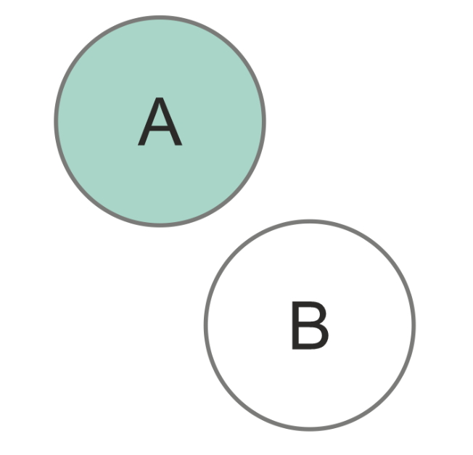
Crosses | T*T******  0********
Within | T*F**F***
Contains | ??
Overlaps | T*T***T**
Equals | TFFFTFFFT
Covers | ??
Software libraries implement these predicates alongside additional ones as boolean functions, such as modified formulations (e. g. contains_properly in Shapely library) or inverse relationships (e. g. covered_by in Shapely). Custom spatial queries can be formalized by defining the flattened DE9-IM string (e. g. relate in Shapely, ST_relate in PostGIS). Topological relationships derived from DE-9IM are the underlying framework for many spatial operations including overlay analysis, contiguity detection, and topology validation.
Because contiguity detection relies directly on the topological properties of a polygonal dataset, these spatial relationships can be rigorously defined using the DE-9IM. In libraries such as libpysal, contiguity is established by evaluating this topological matrix. For instance, Queen contiguity satisfies the standard touches spatial predicate. Rook contiguity is defined by the DE-9IM string F***1****, which mandates that the intersection of the two polygon boundaries must be exactly 1-dimensional (a shared edge).

Topological validity and polygonal coverage
Spatial data often suffers from errors from a variety of sources. These inaccuracies are typically introduced during manual vectorization or data entry, data transfer, geometric editing operations (such as simplification or reprojection), or the integration of heterogeneous datasets of varying ages Servigne et al. (2000).
Servigne et al. (2000) categorizes spatial consistency errors into three primary types:
- Structural errors: Arising when the chosen data structure cannot adequately accommodate the data model.
- Geometric errors: Conceptually invalid geometry (e. g. self-intersecting polygons).
- Topo-semantic errors: Occurring when the geometric representation violates real-world logical constraints (e.g., a single building footprint incorrectly intersecting two distinct parcels).
Geometric and topo-semantic errors are particularly problematic when detecting topological relationships, as they are not immediately noticable. The most commonly used data structures in modern GIS are “spaghetti” models (e.g., GeoJSON, Shapefile, Parquet, and GeoPackage). These models store each geometry as an isolated record with no information about their mutual relationships, therefore they need to be derived from the geometry (vertices). In presence of geometrical inaccuracies, accurate detection of topological relationships is impossible.
According to Ubeda and Egenhofer (1997), the topology error correction process consists of three steps: definition, checking, and correction. Definitions of the errors is esentially establishing the spatial constraints input data must satisfy. These user-defined constraints are derived from formal spatial predicates. Many of these rules are explicitely implemented as ready-to-use topology checkers in desktop GIS software like QGIS and ArcGIS Pro (e. g. must not have dangles for line features, must not overlap for line or polygonal features).

Polygonal coverage
Polygonal coverage, or also planar enforcement, is a specific selection of topology rules. It is a strict requirement for contiguity detection (S. J. Rey et al. 2022). Geoplanar (S. Rey 2026), a python package developed for planar enforcement of Geopandas datasets, considers five planar enforcement violations, see table/fig.
-fig violations and names
Overlaps occur when two polygons share part of their interior. They are identified using the overlaps spatial predicate, which returns an array of index pairs corresponding to overlapping geometries. The violation can be resolved either by trimming one of the polygons to remove the shared area, or by merging the two polygons into one.
Gaps are detected by converting polygon boundaries to linestrings and exploiting a key property of planar enforcement: when two polygons share an edge perfectly, their coincident boundaries merge into a single linestring after union_all. Where a gap exists, the edges do not coincide and remain as separate LineStrings, enclosing the void between them. polygonize then reconstructs every closed face from this line network, producing both the original polygons and any gap polygons as closed faces. The resulting set is filtered against the original GeoDataFrame using the covers predicate — gap polygons are not covered by any input polygon, since no input geometry claims that space.
Omitted interiors arise when a polygon lies entirely within another polygon, meaning the larger polygon should contain a hole, but none is encoded in its geometry. They are identified using the contains spatial predicate. The violation is corrected by subtracting the smaller polygon from the larger one, leaving a correctly encoded hole in the larger geometry.
In presence of non-planar edges and touches, contiguity detection is compromised. Rook contiguity considers two polygons neighbours if they share at least two consecutive vertices, and those vertices must be explicitly present and encoded in both polygons, stricter than a pure spatial predicate testing for overlapping boundaries. Queen contiguity similarly requires a shared vertex to exist in both geometries. Geoplanar detects violations by subtracting a Queen contiguity graph from a fuzzy contiguity graph, where fuzzy contiguity captures geometrically adjacent pairs regardless of shared vertex encoding. Pairs that appear in the fuzzy graph but not in the Queen graph are flagged as non-planar. The violation is corrected by inserting additional vertices into the relevant geometries, ensuring that every shared edge is encoded with a consistent set of vertices on both sides.
In addition to Geoplanar, several other tools address topology checking. JTS Topology Suite (JTS) Jts (2022), an open source Java software library, can evaluate an entire polygonal coverage, returning error strings with the specific coordinates of violations. Desktop software like QGIS and ArcGIS Pro evaluate the selected topology rules (i. e. for polygonal coverage must not overlap and must not have gaps) and visually highlight every error on the map. Mapshaper temporarily converts the spaghetti model into an explicit topological data structure. Instead of storing independent geometries in rows, Mapshaper decomposes a polygonal dataset into an arc-node graph: creating edges (arcs) for boundaries and nodes where three or more polygons intersect. Polygons are then defined mathematically through sequences of these shared arcs, eliminating coordinate redundancy. In this explicit topological structure, the information detailing which polygons neighbor each other is inherently stored within the data model itself.
As an alternative to strict topological contiguity, (S. J. Rey et al. 2022) implement Fuzzy contiguity as part of PySAL. It doesn’t change the geometry of polygons, but it is a tool to generate $W$ without requiring strict topological relationships. By default, it creates a buffer (automatic or user-specified) around the polygonal geometries. Buffered polygons, that meet the spatial predicate intersects (by default) are then considered to be neighbours and this relationship is denoted in $W$.
-diagram pro premka
Even though tools to refine topology or build contiguity without strict topological requirements exist, in practice such checking is often omitted, or, if performed, carried out by users without formal GIS training who may not recognize such phenomena. As a result, spatial datasets used in downstream analysis frequently retain unresolved topological errors. Since contiguity $W$ directly rely on the topological relationships between polygons, the errors propagate into $W$ itself and from there to any analysis, that relies on it. This thesis investigates what consequences follow for spatial autocorrelation and regionalization outcomes specifically.

Erroneous datasets??

Related work
A critical gap in the current literature is the lack of research explicitly isolating the direct impact of topological errors on spatial statistical methods. This literature review chapter is dedicated to conceptually and methodologically similar studies. First, it introduces the broader landscape of spatial data uncertainty and errors, and their impact. Next, it discusses the specification of spatial weights matrices and Modifiable Area Unit Problem and its impacts on spatial analysis. Lastly, it focuses on graph degradation, which in the context of spatial weights is omitted in the literature, however, it is used in simulating transport network disruption among others.

Data uncertainty
Fisher (1999) distinguishes three primary forms of uncertainty in spatial data: error, vagueness, and ambiguity. While vagueness and ambiguity reflect uncertain properties of the phenomenon itself, error occurs when a well-defined object’s position or attribute deviates from the ground truth. This thesis is concerned with a specific form of the latter: positional error in boundaries, resulting in incorrectly built spatial weight matrix. Standard spatial analytical workflows assume that input geometries and the adjacency relations derived from them are exact, therefore it is often not taken in account for.
One way to approach positional uncertainty of boundaries (line segments) is a band around the line derived through a specific statistical or mathematical procedure. An overview of band-based approaches can be found in Tong and Shi (2010). The simplest of these is the epsilon band (Perkal 1956; Chrisman 1982), a deterministic uniform buffer drawn along the line under the assumption that the true line lies entirely within it. One application of this model is the detection of sliver polygons in temporal land-use data: Mas (2005) uses the epsilon band to classify change polygons as false change when they fall entirely within the boundary uncertainty zone, while Delafontaine et al. (2009) develop a broader semi-automated method for sliver assessment in overlaid vector layers, demonstrating that these spurious polygons are a direct and measurable consequence of positional error in map overlaying.
The impact of such positional error on spatial optimization has been explicitly tested by Wei and Murray (2012b) and Wei and Murray (2012a). The latter applies this logic to forest harvest scheduling via the Unit Restriction Model (URM), in which no two spatially adjacent harvest units may be cut simultaneously. Since adjacency is determined from polygon boundaries, positional error in those boundaries can possibly corrupt the adjacency set on which the entire model depends. Wei and Murray (2012a) partition each unit’s adjacency set into certain and possible neighbors using an epsilon-based boundary uncertainty estimate. The results reveal that the error-blind model identifies a single deterministic solution, while incorporating boundary uncertainty expands this to a wide range of possible outcomes, spanning a reduction of nearly 5% in the conservative case to an increase of over 17% in the most aggressive. Wei and Murray (2012a) conclude that ignoring spatial uncertainty risks producing solutions that are erroneous, biased, or misguided.
Alongside band-based approaches, Monte Carlo simulation offers a practical alternative that generates an ensemble of stochastic realizations rather than a single geometric representation of the error zone. De Clercq, Clement, and De Wulf (2009) apply this logic directly to positional error in historical forest vector maps, generating the sliver polygons that result from overlaying misregistered map pairs. The choice of simulation over a simple linear shift or uniform error model is explicitly motivated by the non-linear, spatially heterogeneous nature of real positional error, demonstrating boundary corruption is governed by landscape geometry, identifying edge density and the number of patches as the primary drivers of vulnerability.
While the studies above focus on positional error, spatial data is also subject to attribute uncertainty, where recorded values deviate from the true characteristics of a unit rather than its position. Wei, Rey, and Grubesic (2022) develop the uncertain-max-$p$-regions problem (see Section 2.1.3.5 for context) to incorporate attribute uncertainty into contiguity-constrained regionalization, demonstrating that regionalization outputs are sensitive to data uncertainty. Crucially, the authors note that positional error also may effect the outcomes of regionalization algorithms and that there is the need to address these.

MAUP
Another related phenomena leading to bias in spatial data analysis is the Modifiable Area Unit Problem (MAUP). Established by Gehlke and Biehl (1934) and further described in S. Openshaw (1983), it concerns the aggregation of spatial units and how that influences the summary statistics. S. Openshaw (1983) decomposes the problem into two sub-effects: a scale effect, arising from the number of areal units a region is partitioned into, and a zoning effect, arising from how those units are grouped at a fixed count. MAUP’s effect has been studied on a range of spatial analytical techniques including multiple and spatial econometric regression (Fotheringham and Wong 1991; Arbia and Petrarca 2011), geographically weighted regression (Murakami and Tsutsumi 2015), geostatistical interpolation (Kyriakidis 2004; Kyriakidis and Yoo 2005; Atkinson and Tate 2000), and also addressed in regionalization techniques (Juan C. Duque, Anselin, and Rey 2012; Bradley, Wikle, and Holan 2017).
MAUP also influences outcomes of spatial autocorrelation statistics. Amrhein and Reynolds (1997) show that a modified Getis statistic correlates strongly with aggregation-induced variance change across census variables, and that this relationship is significantly weaker and less predictable when aggregation is performed hierarchically rather than independently at each scale. B. Zhang et al. (2019) quantify this relationship further, finding that Moran’s I decays with aggregation level according to a consistent negative logarithmic function across 30 independent study areas, with the rate of decay significantly correlated to the spatial complexity of the underlying geometry.
Lee et al. (2019) specifically isolate the scale and zoning effects by generating spatially autocorrelated surfaces at controlled initial autocorrelation levels and aggregating them across multiple scales, testing the resulting mean, variance, and Global Moran’s $I$ at each combination. The results show that Global Moran’s $I$ itself is shaped by both effects in ways that depend critically on the initial autocorrelation level: values computed from very different starting points converge toward a common value as aggregation increases, but this convergence is asymmetric between positive and negative autocorrelation. Data with extreme positive autocorrelation retain a high Global Moran’s $I$ through most aggregation levels before dropping sharply only at the coarsest scales, whereas data with extreme negative autocorrelation change rapidly at the start and stabilize earlier. The zoning effect is larger under negative autocorrelation, with greater variability across random zonations at a given aggregation level than under positive autocorrelation. This asymmetry is most pronounced at the extremes of the autocorrelation spectrum, while surfaces with near-zero initial autocorrelation behave symmetrically around the convergence point.

Specification of weight matrix
Althought the behaviour of spatial statistics on corrupted $W$ has not been properly researched, various studies exist regarding the $W$ specification. That is, the consequences of choosing differently among valid representations of spatial relationships. Misspecification in the traditional sense treats $W$ as a modelling choice where different legitimate options exist, whereas this thesis treats $W$ as a quantity with a ground truth that topological error can silently corrupt. This existing literature provides both conceptual and methodological similarities to this thesis.
A first cluster of studies, which rely on regular lattices and simulated rather than empirical data, established that the density and configuration of $W$ affects both test power and parameter recovery (Stetzer 1982; Anselin and Rey 1991; Florax and Rey 1995; Kelejian and Robinson 1998; Griffith and Lagona 1998; Smith 2009). Across this literature, denser and more highly connected matrices consistently reduced test power and biased the spatial dependence parameter downward, while a mismatch between the $W$ used to generate the data and the $W$ used to test or estimate the model degraded both.
Farber, Páez, and Volz (2009) argued that real geographic systems occupy a narrow, specific region of topological space distinct from artificial grids, and, generating synthetic networks with independently tunable degree distribution and clustering, found that degree remained a strong predictor of test power while clustering did not. Stakhovych and Bijmolt (2009) adopted this critique methodologically, re-running the classical sensitivity question on irregular Voronoi tessellations.

Graph degradation
Corrupting $W$ by removing edges to asses the robustness of spatial statistical methods has not been yet employed, however, methodologically similar studies exist within the field of transport network analysis (Cohen et al. 2000; Latora and Marchiori 2001, 2005; Jenelius and Mattsson 2012; Duan and Lu 2014; Mattsson and Jenelius 2015; X. Zhang, Miller-Hooks, and Denny 2015; Wang et al. 2019; Dong et al. 2019) with an applicable design: random or specifically targeted edges or nodes are removed and some measure of vulnerability is being tested.
The consistent finding is that random removal is comparatively harmless while removal guided by structural importance or spatial concentration is more damaging. Han and Liu (2009) and Berche et al. (2009) reach this conclusion comparing random removal against centrality-based attack strategies on public transport networks and Berezin et al. (2015) show that a geographically localized attack can trigger complete collapse, whereas the same networks can survive random failure of a comparable or even much larger extent.

Methodology
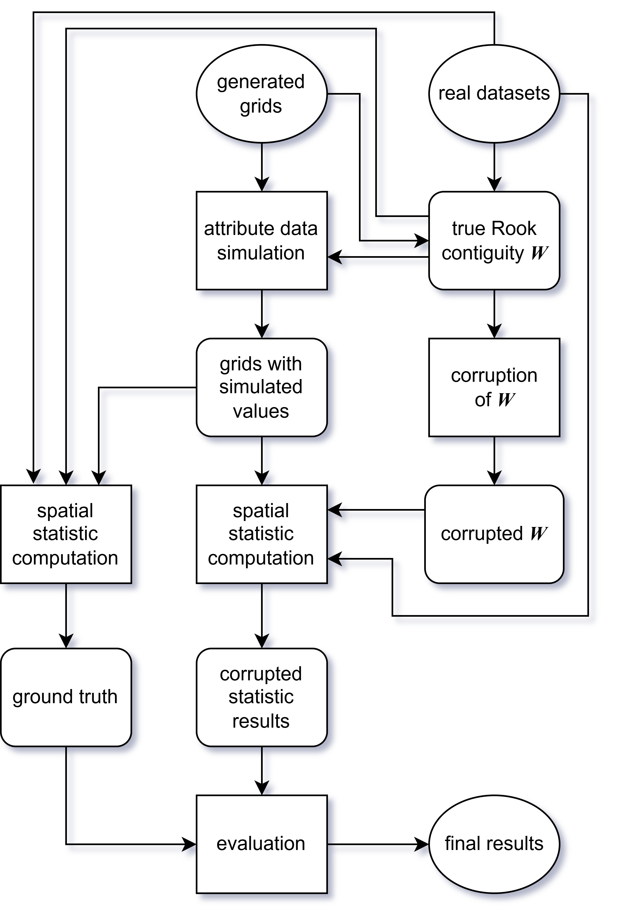
Figure 7: Methology pipeline.

Grid generation
To test robustness of spatial statistics under supervised conditions, three lattice geometries were considered - square, pentagonal (A5) and hexagonal (H3). Lattice geometry influences the number of average number of neigbours per observation. All three geometries were generated in three different dataset sizes - $n=25$ (5×5 grid), $n=100$ (10×10 grid), and $n=400$ (20×20 grid).
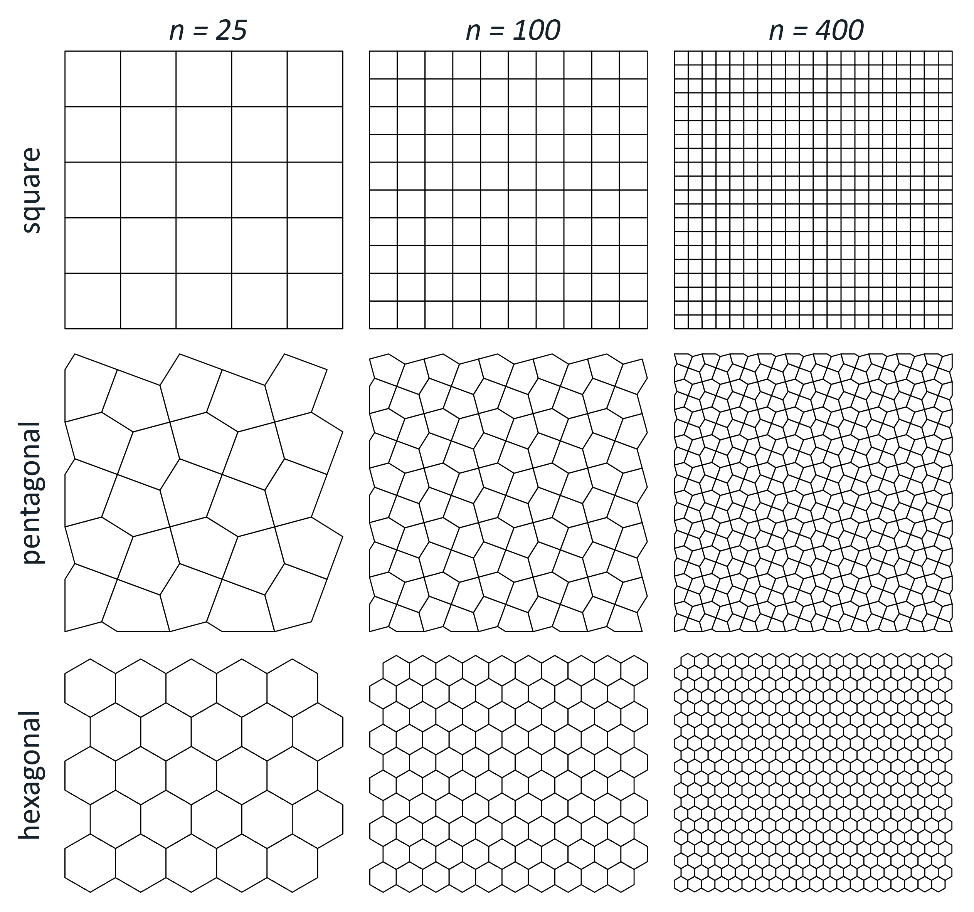
Figure 8: Simulated data spatial configurations.

Synthetic region delineation
Regions were predefined on all three geometries at two dataset sizes: $n=100$ and $n=400$, giving six spatial configurations in total. For each spatial configuration, five polygons were randomly selected as seeds, which grow into spatially connected regions, folowing the procedure of H. Guo, Python, and Liu (2023). The process was repeated 10 times per configuration, producing 10 distinct zonations. The minimum region size was set to 12 polygons for $n=100$ and 48 polygons for $n=400$. These zonations are utilized in contiguity corruption parametrization and they provide the basis for generating synthetic attribute data for the regionalization experiment.

Contiguity corruption
To simulate the effect of topological errors on spatial analysis, a controlled procedure for corrupting the Rook contiguity spatial weights matrix $W$ was developed. Starting from a topologically valid graph, edges (i.e., adjacency relationships between polygons) are iteratively removed to progressively degrade the spatial neighbourhood structure. Missing adjacencies are distributed spatially according to three distinct patterns:
- Randomly: Edges are removed uniformly at random across the entire graph, representing spatially unpatterned errors with no particular spatial structure.
- Region borders: Only edges crossing the boundary between two predefined regions can be removed, simulating errors arising from the integration of independently digitised datasets.
- Local: Edges within or immediately adjacent to a single predefined region are targeted, representing localised digitisation or editing errors.
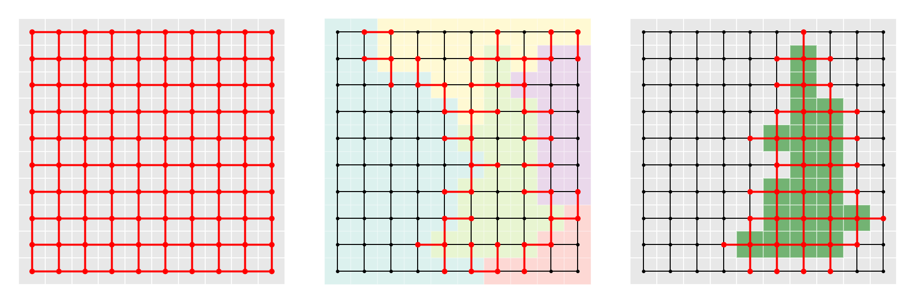
Figure 9: Deletable edges (highlighted in red): random (left), region borders (center), local (right)
Since spatial autocorrelation measures aren’t explicitely defined for observations with no neighbours (isolates), their occurence has to be prevented while corrupting $W$. If at least one of two observations connected by an edge has a node degree of 1 (has only 1 neigbour), the edge is not eligible for removal. Similarly, regionalization algorithms require a single connected component, edges whose removal would disconnect the graph, referred to as bridges, cannot be removed.
-maximally corrupted graph no isolates/mst
At each iteration, the set of removable edges is computed as the intersection of the method-eligible and constraint-eligible subgraphs. One edge is removed, the constraint set is recomputed, and the process repeats until no further deletions are possible. From this sequence, 19 graphs were selected to represent a linear progression of missing edges, culminating in the maximally corrupted graph. Each sequence is repeated 10 times, yielding 190 corrupted graphs per corruption method. For the region borders and local corruption methods, each of the 10 repetitions is paired with a distinct zonation.
To avoid circularity in the regionalization evaluation, any corrupted graph derived from a given zonation is excluded from experiments if the input data were generated based on the same zonation.

Spatial autocorrelation workflow

Synthetic data
Attribute values were generated through a pure spatial autoregressive (SAR) process, following the procedure in Florax and Rey (1995):
$$y={\left(I−ρW\right)}^{−1}ϵ$$
where $y$ is the resulting vector of generated attribute values, $I$ is a identity matrix, $ρ$ is the spatial autoregressive parameter, $W$ is row-standartized Rook contiguity spatial weight matrix derived from each spatial configuration and $ϵ$ is random normal error vector. The parameter $ρ$ was varied from -0.9 to 0.9 in increments of 0.1, with 10 independent draws of $ϵ$ per value of $ρ$. This produced 190 unique value datasets per spatial configuration representing a wide spectrum differently spatially autocorrelated datasets (see examples in Figure 10).
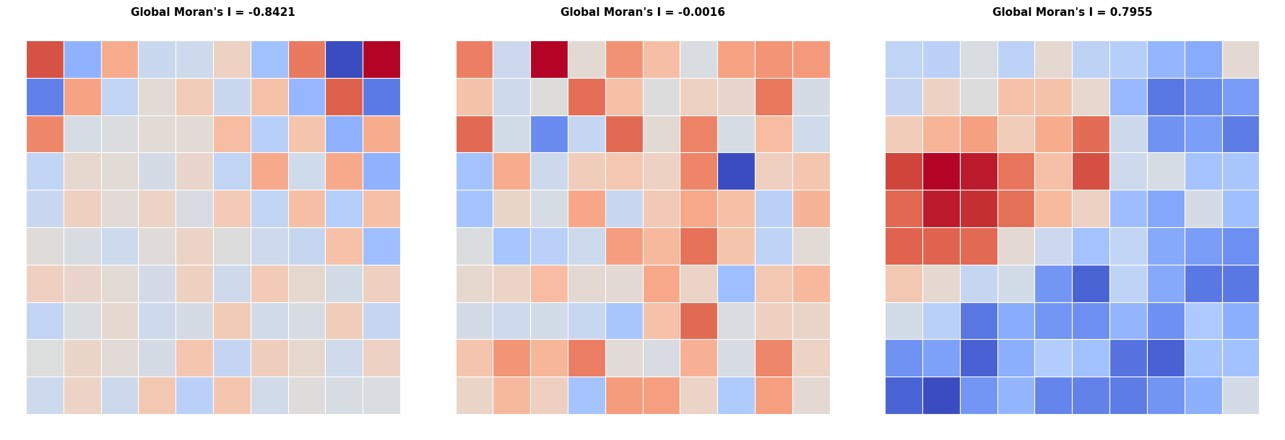
Figure 10: Examples of generated SAR data.

Real data
-us election counties (3k)
-guerry (85)
-sacramento1 (403)

Computation

Evaluation

Regionalization workflow

Synthetic data
Tgenerated to exhibit strict stratified heterogeneity, meaning that true regression coefficients are constant within each predefined region but differ across regions. The underlying data-generating process follows a simple linear regression model used in H. Guo, Python, and Liu (2023):
$$y=β_{0}+β_{1}x_{1}+β_{2}x_{2}+ϵ$$
where $x_{1},x_{2}∼U[0,1)$ are independent covariates drawn i.i.d. from a uniform distribution, $ϵ∼N\left(0,σ^{2}\right)$ is a random error term with $σ=0.1$, and $β_{0}$, $β_{1}$, $β_{2}$ are region-specific regression coefficients. Within each of the five predefined regions, $β_{1}$ and $β_{2}$ take distinct values drawn from $\{−2,−1,0,1,2\}$, while $β_{0}=0$ in all regions.
For each zonation, five independent sets of attribute values were generated following this process and subsequently used as input to the regionalization algorithms.

Real data
-ceara zika (184)
-chicago airbnb (77)
-south (1k+)

Computation

Evaluation
-ARI
-FN/FP counts?

Results

Spatial autocorrelation

Global
-poster

Local
-ubytek lisa clusteru?

Regionalization
-skater je vic sensitive u synthetic dat, ale u real je to dost random
-borders seem to delat vetsi mess

Discussion
Amrhein, Carl, and Harold Reynolds. 1997. “USING THE GETIS STATISTIC TO EXPLORE AGGREGATION EFFECTS IN METROPOLITAN TORONTO CENSUS DATA.” Canadian Geographies / Géographies Canadiennes 41 (2): 137–49. https://doi.org/10.1111/j.1541-0064.1997.tb01154.x.
Anselin, Luc. 2024. An Introduction to Spatial Data Science with GeoDa: Volume 2: Clustering Spatial Data. 1st ed. Boca Raton: Chapman; Hall/CRC. https://doi.org/10.1201/9781032713175.
Anselin, Luc, and Serge Rey. 1991. “Properties of Tests for Spatial Dependence in Linear Regression Models.” Geographical Analysis 23 (2): 112–31. https://doi.org/10.1111/j.1538-4632.1991.tb00228.x.
Anselin, Luc, Ibnu Syabri, and Youngihn Kho. 2006. “GeoDa : An Introduction to Spatial Data Analysis.” Geographical Analysis 38 (1): 5–22. https://doi.org/10.1111/j.0016-7363.2005.00671.x.
Appel, Kenneth, and Wolfgang Haken. 1977. “Every Planar Map Is Four Colorable. Part I: Discharging.” Illinois Journal of Mathematics 21 (3): 429–90. https://doi.org/10.1215/ijm/1256049011.
Arbia, Giuseppe, and Francesca Petrarca. 2011. “Effects of MAUP on Spatial Econometric Models.” Letters in Spatial and Resource Sciences 4 (3): 173–85. https://doi.org/10.1007/s12076-011-0065-9.
AssunÇão, R. M., M. C. Neves, G. Câmara, and C. Da Costa Freitas. 2006. “Efficient Regionalization Techniques for Socio‐economic Geographical Units Using Minimum Spanning Trees.” International Journal of Geographical Information Science 20 (7): 797–811. https://doi.org/10.1080/13658810600665111.
Atkinson, Peter M., and Nicholas J. Tate. 2000. “Spatial Scale Problems and Geostatistical Solutions: A Review.” The Professional Geographer 52 (4): 607–23. https://doi.org/10.1111/0033-0124.00250.
Berche, B., C. Von Ferber, T. Holovatch, and Yu. Holovatch. 2009. “Resilience of Public Transport Networks Against Attacks.” The European Physical Journal B 71 (1): 125–37. https://doi.org/10.1140/epjb/e2009-00291-3.
Berezin, Yehiel, Amir Bashan, Michael M. Danziger, Daqing Li, and Shlomo Havlin. 2015. “Localized Attacks on Spatially Embedded Networks with Dependencies.” Scientific Reports 5 (1): 8934. https://doi.org/10.1038/srep08934.
Bivand, Roger. 2022. “R Packages for Analyzing Spatial Data: A Comparative Case Study with Areal Data.” Geographical Analysis 54 (3): 488–518. https://doi.org/10.1111/gean.12319.
Bradley, Jonathan R., Christopher K. Wikle, and Scott H. Holan. 2017. “Regionalization of Multiscale Spatial Processes by Using a Criterion for Spatial Aggregation Error.” Journal of the Royal Statistical Society Series B: Statistical Methodology 79 (3): 815–32. https://doi.org/10.1111/rssb.12179.
Cantor, Georg. 1874. “Ueber Eine Eigenschaft Des Inbegriffs Aller Reellen Algebraischen Zahlen.” Journal Für Die Reine Und Angewandte Mathematik (Crelles Journal) 1874 (77): 258–62. https://doi.org/10.1515/crll.1874.77.258.
Chrisman, Nicholas. 1982. “A Theory of Cartographic Error and Its Measurement in Digital Data Bases.”
Clementini, Eliseo, Paolino Di Felice, and Peter Van Oosterom. 1993. “A Small Set of Formal Topological Relationships Suitable for End-User Interaction.” In Advances in Spatial Databases, edited by G. Goos, J. Hartmanis, David Abel, and Beng Chin Ooi, 692:277–95. Berlin, Heidelberg: Springer Berlin Heidelberg. https://doi.org/10.1007/3-540-56869-7_16.
Cohen, Reuven, Keren Erez, Daniel ben-Avraham, and Shlomo Havlin. 2000. “Resilience of the Internet to Random Breakdowns.” https://doi.org/10.48550/ARXIV.COND-MAT/0007048.
De Clercq, Eva M., Lieven Clement, and Robert R. De Wulf. 2009. “Monte Carlo Simulation of False Change in the Overlay of Misregistered Forest Vector Maps.” Landscape and Urban Planning 91 (1): 36–45. https://doi.org/10.1016/j.landurbplan.2008.11.009.
Delafontaine, M., G. Nolf, N. Van De Weghe, M. Antrop, and Ph. De Maeyer. 2009. “Assessment of Sliver Polygons in Geographical Vector Data.” International Journal of Geographical Information Science 23 (6): 719–35. https://doi.org/10.1080/13658810701694838.
Dong, Shangjia, Haizhong Wang, Ali Mostafavi, and Jianxi Gao. 2019. “Robust Component: A Robustness Measure That Incorporates Access to Critical Facilities Under Disruptions.” Journal of The Royal Society Interface 16 (157): 20190149. https://doi.org/10.1098/rsif.2019.0149.
Duan, Yingying, and Feng Lu. 2014. “Robustness of City Road Networks at Different Granularities.” Physica A: Statistical Mechanics and Its Applications 411 (October): 21–34. https://doi.org/10.1016/j.physa.2014.05.073.
Duque, Juan C., Luc Anselin, and Sergio J. Rey. 2012. “THE MAX- P -REGIONS PROBLEM*.” Journal of Regional Science 52 (3): 397–419. https://doi.org/10.1111/j.1467-9787.2011.00743.x.
Duque, Juan Carlos, Raúl Ramos, and Jordi Suriñach. 2007. “Supervised Regionalization Methods: A Survey.” International Regional Science Review 30 (3): 195–220. https://doi.org/10.1177/0160017607301605.
Egenhofer, Max J., and Robert D. Franzosa. 1991. “Point-Set Topological Spatial Relations.” International Journal of Geographical Information Systems 5 (2): 161–74. https://doi.org/10.1080/02693799108927841.
Farber, Steven, Antonio Páez, and Erik Volz. 2009. “Topology and Dependency Tests in Spatial and Network Autoregressive Models.” Geographical Analysis 41 (2): 158–80. https://doi.org/10.1111/j.1538-4632.2009.00751.x.
Fischer, Manfred M., and Arthur Getis, eds. 2010. Handbook of Applied Spatial Analysis: Software Tools, Methods and Applications. Berlin, Heidelberg: Springer Berlin Heidelberg. https://doi.org/10.1007/978-3-642-03647-7.
Fisher, Peter F. 1999. “Models of Uncertainty in Spatial Data.” In Geographical Information Systems: Principles, Techniques, Management and Applications, edited by Paul A. Longley, Michael F. Goodchild, David J. Maguire, and David W. Rhind, 1:191–205. New York: John Wiley & Sons. https://ed.ac.uk.
Florax, Raymond J. G. M., and Serge Rey. 1995. “The Impacts of Misspecified Spatial Interaction in Linear Regression Models.” In New Directions in Spatial Econometrics, edited by Luc Anselin and Raymond J. G. M. Florax, 111–35. Berlin, Heidelberg: Springer Berlin Heidelberg. https://doi.org/10.1007/978-3-642-79877-1_5.
Fotheringham, A S, and D W S Wong. 1991. “The Modifiable Areal Unit Problem in Multivariate Statistical Analysis.” Environment and Planning A: Economy and Space 23 (7): 1025–44. https://doi.org/10.1068/a231025.
Geary, R. C. 1954. “The Contiguity Ratio and Statistical Mapping.” The Incorporated Statistician 5 (3): 115–46. http://www.jstor.org/stable/2986645.
Gehlke, C. E., and Katherine Biehl. 1934. “Certain Effects of Grouping Upon the Size of the Correlation Coefficient in Census Tract Material.” Journal of the American Statistical Association 29 (185A): 169–70. https://doi.org/10.1080/01621459.1934.10506247.
GEOS contributors. 2025. GEOS Computational Geometry Library. Open Source Geospatial Foundation. https://doi.org/10.5281/zenodo.11396894.
Getis, Arthur, and J. K. Ord. 1992. “The Analysis of Spatial Association by Use of Distance Statistics.” Geographical Analysis 24 (3): 189–206. https://doi.org/10.1111/j.1538-4632.1992.tb00261.x.
GIS Geography. 2024. “How to Fix Digitizing Errors with Topology Rules.” https://gisgeography.com/topology-rules-arcgis/.
Goodchild, Michael F. 1992. “Geographical Information Science.” International Journal of Geographical Information Systems 6 (1): 31–45. https://doi.org/10.1080/02693799208901893.
Griffith, Daniel A., and Francesco Lagona. 1998. “On the Quality of Likelihood-Based Estimators in Spatial Autoregressive Models When the Data Dependence Structure Is Misspecified.” Journal of Statistical Planning and Inference 69 (1): 153–74. https://doi.org/10.1016/S0378-3758(97)00156-0.
Guo, D. 2008. “Regionalization with Dynamically Constrained Agglomerative Clustering and Partitioning (REDCAP).” International Journal of Geographical Information Science 22 (7): 801–23. https://doi.org/10.1080/13658810701674970.
Guo, Hao, Andre Python, and Yu Liu. 2023. “Extending Regionalization Algorithms to Explore Spatial Process Heterogeneity.” International Journal of Geographical Information Science 37 (11): 2319–44. https://doi.org/10.1080/13658816.2023.2266493.
Han, Chuanfeng, and Liang Liu. 2009. “2009 International Conference on Management and Service Science (MASS).” In, 1–4. Beijing, China: IEEE. https://doi.org/10.1109/ICMSS.2009.5302491.
Hausdorff, Felix. 1914. Grundzüge Der Mengenlehre. Leipzig: Veit & Comp. https://archive.org/details/grundzgedermen00hausuoft.
Jenelius, Erik, and Lars-Göran Mattsson. 2012. “Road Network Vulnerability Analysis of Area-Covering Disruptions: A Grid-Based Approach with Case Study.” Transportation Research Part A: Policy and Practice 46 (5): 746–60. https://doi.org/10.1016/j.tra.2012.02.003.
Jts, Dr. 2022. “Lin.ear Th.inking: Polygonal Coverages and Operations in JTS.” Lin.ear Th.inking.
Kelejian, Harry H., and Dennis P. Robinson. 1998. “A Suggested Test for Spatial Autocorrelation and/or Heteroskedasticity and Corresponding Monte Carlo Results.” Regional Science and Urban Economics 28 (4): 389–417. https://doi.org/10.1016/S0166-0462(98)00007-6.
Kyriakidis, Phaedon C. 2004. “A Geostatistical Framework for Area-to-Point Spatial Interpolation.” Geographical Analysis 36 (3): 259–89. https://doi.org/10.1111/j.1538-4632.2004.tb01135.x.
Kyriakidis, Phaedon C., and Eun-Hye Yoo. 2005. “Geostatistical Prediction and Simulation of Point Values from Areal Data.” Geographical Analysis 37 (2): 124–51. https://doi.org/10.1111/j.1538-4632.2005.00633.x.
Latora, Vito, and Massimo Marchiori. 2001. “Efficient Behavior of Small-World Networks.” Physical Review Letters 87 (19): 198701. https://doi.org/10.1103/PhysRevLett.87.198701.
———. 2005. “Vulnerability and Protection of Infrastructure Networks.” Physical Review E 71 (1): 015103. https://doi.org/10.1103/PhysRevE.71.015103.
Lee, Sang-Il, Monghyeon Lee, Yongwan Chun, and Daniel A. Griffith. 2019. “Uncertainty in the Effects of the Modifiable Areal Unit Problem Under Different Levels of Spatial Autocorrelation: A Simulation Study.” International Journal of Geographical Information Science 33 (6): 1135–54. https://doi.org/10.1080/13658816.2018.1542699.
Mas, J. F. 2005. “Change Estimates by Map Comparison: A Method to Reduce Erroneous Changes Due to Positional Error.” Transactions in GIS 9 (4): 619–29. https://doi.org/10.1111/j.1467-9671.2005.00238.x.
Mattsson, Lars-Göran, and Erik Jenelius. 2015. “Vulnerability and Resilience of Transport Systems A Discussion of Recent Research.” Transportation Research Part A: Policy and Practice 81 (November): 16–34. https://doi.org/10.1016/j.tra.2015.06.002.
Metropolis, Nicholas, Arianna W. Rosenbluth, Marshall N. Rosenbluth, Augusta H. Teller, and Edward Teller. 1953. “Equation of State Calculations by Fast Computing Machines.” The Journal of Chemical Physics 21 (6): 1087–92. https://doi.org/10.1063/1.1699114.
Moran, P. A. P. 1950. “Notes on Continuous Stochastic Phenomena.” Biometrika 37 (1/2): 17. https://doi.org/10.2307/2332142.
Murakami, Daisuke, and Morito Tsutsumi. 2015. “Area-to-Point Parameter Estimation with Geographically Weighted Regression.” Journal of Geographical Systems 17 (3): 207–25. https://doi.org/10.1007/s10109-015-0212-8.
Openshaw, S. 1977. “A Geographical Solution to Scale and Aggregation Problems in Region-Building, Partitioning and Spatial Modelling.” Transactions of the Institute of British Geographers 2 (4): 459–72. https://doi.org/10.2307/622300.
———. 1983. The Modifiable Areal Unit Problem. Concepts and Techniques in Modern Geography. Geo Books. https://books.google.cz/books?id=OJbgswEACAAJ.
Openshaw, S, and L Rao. 1995. “Algorithms for Reengineering 1991 Census Geography.” Environment and Planning A: Economy and Space 27 (3): 425–46. https://doi.org/10.1068/a270425.
Papadimitriou, Fivos. 2023. Geo-Topology: Theory, Models and Applications. Vol. 133. GeoJournal Library. Cham: Springer Nature Switzerland. https://doi.org/10.1007/978-3-031-48185-7.
Perkal, J. 1956. “On Epsilon Length.” Bulletin de l’académie Polonaise Des Sciences 4 (3): 399–403.
Pilz, Jürgen. 2025. “Spatial Statistics.” In, edited by Miodrag Lovric, 2392–99. Berlin, Heidelberg: Springer Berlin Heidelberg. https://doi.org/10.1007/978-3-662-69359-9_587.
Rey, Serge. 2026. Geopandas/Geoplanar: V0.6.0. Zenodo. https://doi.org/10.5281/ZENODO.20050007.
Rey, Sergio J., Luc Anselin, Pedro Amaral, Dani Arribas-Bel, Renan Xavier Cortes, James David Gaboardi, Wei Kang, Elijah Knaap, Ziqi Li, and Stefanie Lumnitz. 2022. “The PySAL Ecosystem: Philosophy and Implementation.” Geographical Analysis 54 (3): 467–87. https://doi.org/10.1111/gean.12276.
Ripley, Brian D. 1981. Spatial Statistics. 1st ed. Wiley Series in Probability and Statistics. Wiley. https://doi.org/10.1002/0471725218.
Servigne, Sylvie, Thierry Ubeda, Alain Puricelli, and Robert Laurini. 2000. “A Methodology for Spatial Consistency Improvement of Geographic Databases.” GeoInformatica 4 (1): 7–34. https://doi.org/10.1023/A:1009824308542.
Smith, Tony E. 2009. “Estimation Bias in Spatial Models with Strongly Connected Weight Matrices.” Geographical Analysis 41 (3): 307–32. https://doi.org/10.1111/j.1538-4632.2009.00758.x.
Spatial Eye. 2025. “Topology Rules in GIS Data Management.” https://spatial-eye.com/blog/spatial-analysis/topology-rules-in-gis-data-management/.
Stakhovych, Stanislav, and Tammo H. A. Bijmolt. 2009. “Specification of Spatial Models: A Simulation Study on Weights Matrices.” Papers in Regional Science 88 (2): 389–409. https://doi.org/10.1111/j.1435-5957.2008.00213.x.
Stetzer, F. 1982. “Specifying Weights in Spatial Forecasting Models: The Results of Some Experiments.” Environment and Planning A: Economy and Space 14 (5): 571–84. https://doi.org/10.1068/a140571.
Tong, Xiaohua, and Wenzhong Shi. 2010. “Measuring Positional Error of Circular Curve Features in Geographic Information Systems (GIS).” Computers & Geosciences 36 (7): 861–70. https://doi.org/10.1016/j.cageo.2009.11.009.
Ubeda, Thierry, and Max J. Egenhofer. 1997. “Topological Error Correcting in GIS.” In Advances in Spatial Databases, edited by Gerhard Goos, Juris Hartmanis, Jan Leeuwen, Michel Scholl, and Agnès Voisard, 1262:281–97. Berlin, Heidelberg: Springer Berlin Heidelberg. https://doi.org/10.1007/3-540-63238-7_35.
University of Waterloo. 2024. “What Is Topology?” Department of Pure Mathematics. https://uwaterloo.ca/pure-mathematics/about-pure-math/what-is-pure-math/what-is-topology.
Wang, Weiping, Saini Yang, H. Eugene Stanley, and Jianxi Gao. 2019. “Local Floods Induce Large-Scale Abrupt Failures of Road Networks.” Nature Communications 10 (1): 2114. https://doi.org/10.1038/s41467-019-10063-w.
Ward, Joe H. 1963. “Hierarchical Grouping to Optimize an Objective Function.” Journal of the American Statistical Association 58 (301): 236–44. https://doi.org/10.1080/01621459.1963.10500845.
Wei, Ran, and Alan T. Murray. 2012a. “Spatial Uncertainty in Harvest Scheduling.” Annals of Operations Research, June. https://doi.org/10.1007/s10479-012-1178-2.
———. 2012b. “An Integrated Approach for Addressing Geographic Uncertainty in Spatial Optimization.” International Journal of Geographical Information Science 26 (7): 1231–49. https://doi.org/10.1080/13658816.2011.633918.
Wei, Ran, Sergio Rey, and Tony H. Grubesic. 2022. “A Probabilistic Approach to Address Data Uncertainty in Regionalization.” Geographical Analysis 54 (2): 405–26. https://doi.org/10.1111/gean.12282.
Zhang, Boen, Gang Xu, Limin Jiao, Jiafeng Liu, Ting Dong, Zehui Li, Xiaoping Liu, and Yaolin Liu. 2019. “The Scale Effects of the Spatial Autocorrelation Measurement: Aggregation Level and Spatial Resolution.” International Journal of Geographical Information Science 33 (5): 945–66. https://doi.org/10.1080/13658816.2018.1564316.
Zhang, X., E. Miller-Hooks, and K. Denny. 2015. “Assessing the Role of Network Topology in Transportation Network Resilience.” Journal of Transport Geography 46 (June): 35–45. https://doi.org/10.1016/j.jtrangeo.2015.05.006.

