**Ten steps to choosing your perfect chicken egg incubator.**

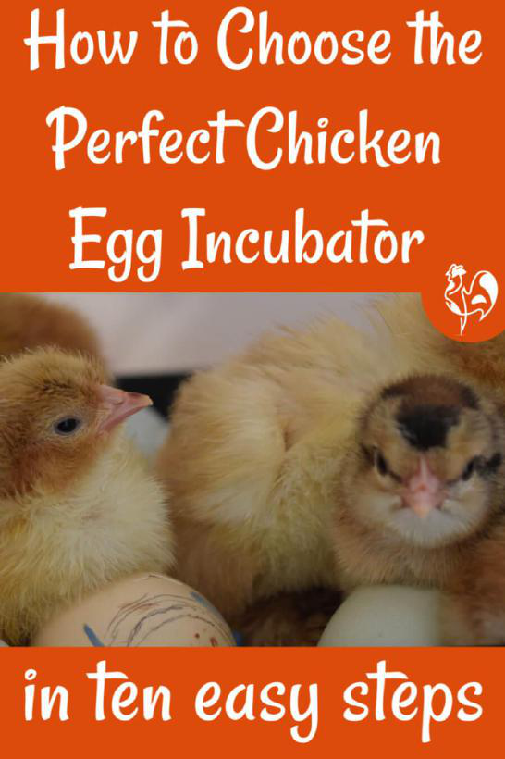

**[7](https://www.pinterest.com/pin/create/button/?guid=bou72HtUomuE-1&url=http%3A%2F%2Fwww.raising-happy-chickens.com%2Fchicken-egg-incubator.html&media=https%3A%2F%2Fwww.raising-happy-chickens.com%2Fimages%2Fpoultry-incubators.jpg&description=Ten%20easy%20steps%20to%20help%20you%20decide%20which%20is%20the%20best%20chicken%20egg%20incubator%20to%20suit%20your%20plans%20and%20your%20budget.%20%23incubatorsforchickeneggs%20%23incubatordesign%20%23hatchingchicks%20%23incubation%20%23hatchingchickeneggs)**[Save](https://www.pinterest.com/pin/create/button/?guid=bou72HtUomuE-1&url=http%3A%2F%2Fwww.raising-happy-chickens.com%2Fchicken-egg-incubator.html&media=https%3A%2F%2Fwww.raising-happy-chickens.com%2Fimages%2Fpoultry-incubators.jpg&description=Ten%20easy%20steps%20to%20help%20you%20decide%20which%20is%20the%20best%20chicken%20egg%20incubator%20to%20suit%20your%20plans%20and%20your%20budget.%20%23incubatorsforchickeneggs%20%23incubatordesign%20%23hatchingchicks%20%23incubation%20%23hatchingchickeneggs)

When you're hatching chicken eggs there's really only one "must have" item if you don't have a broody hen: a reliable incubator.

In this article I'm going to share with you the lessons I learned when choosing my incubators to help you decide which would be the ideal chicken egg incubator for your individual situation.