# GridLAB-D Tutorial Exercises – October 18, 2016

# Example 1: one load and one line

1. Open “example1.glm” in a text editor and read through it.
2. In a terminal, navigate to the location of the example1 file, e.g.:

cd Documents/gridlabd

1. Run the example1 file with GridLAB-D, producing the file “example1.xml” as output:

gridlabd -o example1.xml example1.glm

1. Examining the output xml file:
   1. Open “example1.xml” in your text editor.
   2. Take a few minutes to scroll through and see what it looks like.
   3. Find results for Node 1 by searching for <node_list>. Confirm that the voltage is correct according to the description in the glm file, and see that Node 1 was classified as the swing bus.
   4. Find results for Line 12 by searching for <overhead_line_list>. Scroll down to find <power_in>, which is the power entering the line from Node 1. This should make sense given the description of Load 2 in the glm file. A few lines below that, find <power_losses>, which should be very small by comparison.
   5. Find results for Load 2 by searching for <load_list>. Scroll down to find <voltage_A>, which should be very slightly less than the voltage at Node 1.
2. Some experiments in changing system parameters:
   1. Double base_power_A, to 40 kW. What do you think will happen to the real power loss in the line? Compare the value of <power_losses> in the xml file.
   2. At Node 1, change voltage_A to 11.8 kV to represent conservation voltage reduction. What happens to the <power_in> entering the line? Does this make sense?
   3. Change the load from constant power to constant current. Now how does the <power in> compare for Node 1 voltages of 12 kV and 11.8 kV?
   4. Change the constant current power factor of the load from 1 to 0.9. How does this change the real, reactive, and apparent power entering the line?
   5. Change the load to match the 70W incandescent light bulb of the PNNL study. Compare the power with Node 1 voltages of 12 kV and 10 kV. How does this match the power at 120 V and 100 V reported in the graph?

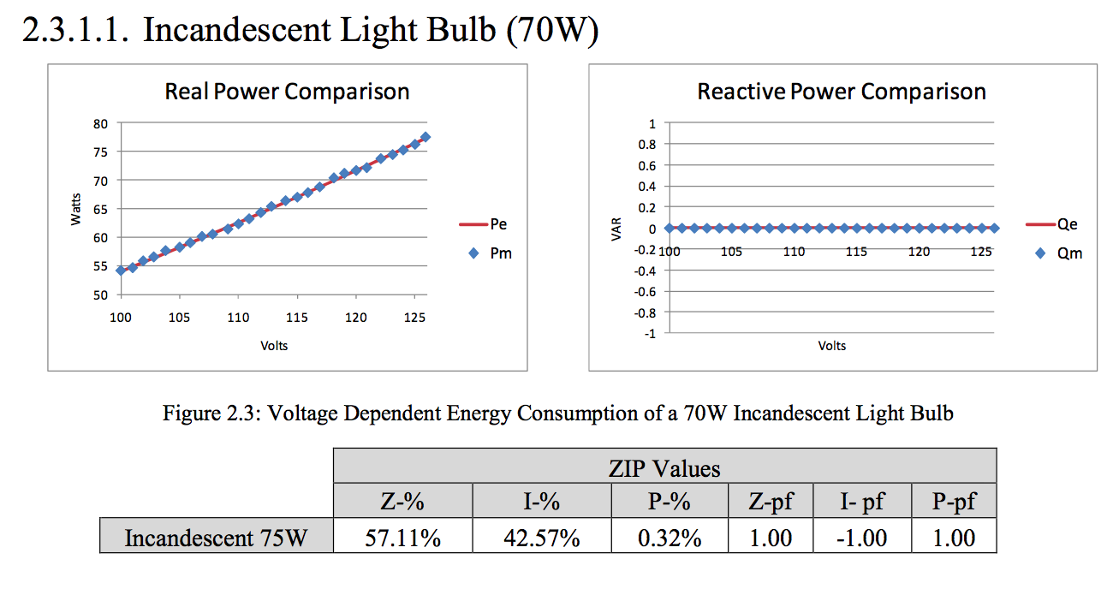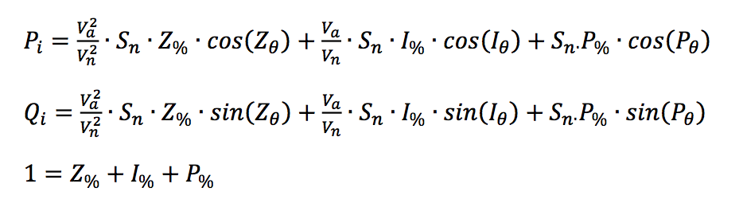

# Example 2: players and recorders

1. Open “example2.glm” and read through it. What is different from example 1?
2. Open “example2_load.csv” and read through it. What might you conclude about this distribution circuit based on its load profile?
3. Run the example2 file with GridLAB-D, producing the file “example2.xml” as output:

gridlabd -o example2.xml example2.glm

1. Look at “example2.xml” in the text editor. Why do we need recorders?
2. Open “example2_recorder.csv”. Read through and/or plot the results. Discuss what you notice about the results and how they relate to the load profile.
3. Compare the csv and xml output files. Verify that the xml output matches one of the entries in the csv file. Which one? What differences do you see?

# Example 3: build a model from scratch

1. Build the model described in the IEEE 4 Node Test Feeder document. Refer to the PowerFlow user guide as needed (<http://gridlab-d.sourceforge.net/wiki/index.php/Power_Flow_User_Guide>).
2. First, configure the model for balanced loading with step-down delta-delta transformer. Validate your model by comparing the results with the solutions on page 6 of the pdf.
3. Then, re-configure the model for unbalanced loading with step-down grounded Y – grounded Y transformer. Validate your model using the solutions on page 7. Take note of what you had to change in the model for the new configuration.

# Example 4: model validation puzzle

The example4.glm file is supposed to model the IEEE 13 Node Test Feeder described in the example4 pdf. But there is a mistake in it somewhere. Compare the glm and resulting xml files against the feeder description in the pdf to locate the mistake.