Evaluation of +S2 sea ice forecast and some other better title
Abstract
The abstract goes here. It can also be on multiple lines.

Introduction
Unlike Arctic sea ice, which has been steadily retreating at least since the start of satellite records in the early 80s, Antarctic sea ice has experienced a slightly increasing trend up to 2015. This trend puzzled researchers and was not reproduced by models (W. R. Hobbs et al. 2016). Then, in 2016 Antarctic sea ice extent dropped precipitously (Turner et al. 2017) and has been at low and record low levels since (Purich and Doddridge 2023; W. Hobbs et al. 2024; Gilbert and Holmes 2024; Josey et al. 2024), even more highlighting our lack of understanding of Antarctic sea ice variability and long-term change (Espinosa, Blanchard-Wrigglesworth, and Bitz 2024).
Antarctic sea ice covers the polar ocean, yet the potential impacts of its variability extend far into the mid and lower latitudes, affecting the circulation of both the ocean and the atmosphere, ocean carbon uptake and biological processes Swadling et al. (2023). In coupled climate model experiments, a reduction in sea ice extent has been shown to reduce the meridional temperature gradient, in turn reducing the eddy-driven jet strength and shifting it equatorward (M. England, Polvani, and Sun 2018; M. R. England et al. 2020; H. c. Ayres and Screen 2019; H. C. Ayres et al. 2022) and vice versa for an increase in sea ice (Raphael 2003; Raphael, Hobbs, and Wainer 2011), which is a crucial control on extratropical weather. In the Northern Hemisphere, it has been hypothesised that the reduction in Arctic sea ice has led to a weaker, wavier jet, increasing the frequency of extreme events (Barnes and Screen 2015; Smith et al. 2022). There is some evidence of this effect in the Southern Hemisphere. For example, model simulations show a weakened vortex in the middle atmosphere, increased vertical wave flux and greater zonal wave 1 amplitude in austral spring following lower than average sea ice extent in early winter Song et al. (2025). But models disagree on the exact phase of the zonal wave response, and observations do not show a clear signal (Rea et al. 2024). The magnitude of the eddy-driven jet response to sea ice loss has been shown to be model dependent, and is sensitive to its climatological location (H. c. Ayres and Screen 2019). Further, sea ice induced changes in the jet have been found to be relatively small compared with the jet-response to the direct effect of CO2 increase and global sea surface temperature (SST) warming (H. C. Ayres et al. 2022).
Correctly modelling Antarctic sea ice is essential for understanding processes and improving climate projections to inform adaptation strategies. Accurate seasonal to sub-seasonal forecasts are also crucial for operations in and around the Antarctic continent, including scientific missions, fisheries, and tourism (De Silva et al. 2020; Wagner et al. 2020). However, producing accurate Antarctic sea ice forecasts has been challenging due to model biases, inherent large variability and complexity, and it has lagged behind Arctic sea ice forecasts (Zampieri, Goessling, and Jung 2019). Dynamical seasonal forecasts of summer Antarctic sea ice have been shown to perform worse than relatively simple statistical methods (Massonnet et al. 2023), which also underscores the need for better understanding of sea ice dynamics, and drivers.
In this work we evaluate sea ice forecasts produced by the Australian Community Climate and Earth System Simulator – seasonal version2 (ACCESS-S2), which is the Australian Bureau of Meteorology (BoM)’s current operational subseasonal-to-seasonal prediction system, and compare its forecast skill with that of the former system ACCESS-S1. This evaluation will inform future work with the prediction system as a research tool and explore the potential of using its sea-ice forecasts for decision-making.

Data and methods

ACCESS-S2
ACCESS-S2 (Wedd et al. 2022) became operational in October 2021 by replacing the ACCESS-S1 system (Hudson et al. 2017).. The model components of both ACCESS-S2 and ACCESS-S1 consist of the Global Atmosphere 6.0 (GA6) (Williams et al. 2015; J. Waters et al. 2017), Global Land 6.0 (Best et al. 2011; J. Waters et al. 2017), Global Ocean 5.0 (Gurvan et al. 2013; Megann et al. 2014) and Global Sea Ice 6.0 [CICE; Rae et al. (2015)]. The atmosphere has a N216 horizontal resolution (~60km in the mid-latitudes) with 85 vertical levels. The land model uses the same horizontal grid with 4 soil levels. The ocean component has a 1/4º resolution with 75 vertical levels. The sea ice component, based on CICE version 4.1, has the same resolution as the ocean and 5 sea ice categories as well as an open water category.
Both systems take atmospheric initial conditions derived from ERA-interim (Dee et al. 2011) for their hindcasts and from the Bureau’s operational analysis for real-time forecasts. The main difference between the two are the ocean and sea ice initial conditions. ACCESS-S1 ocean initial conditions come from the Met Office FOAM system, which uses a multivariate, incremental three-dimensional variational (3D-Var), first-guess-at-appropriate-time (FGAT) data assimilation scheme (Jennifer Waters et al. 2015) and assimilates sea surface temperature (SST), sea surface height (SSH), in situ temperature and salinity profiles, and sea ice concentration. ACCESS-S2, on the other hand, runs from initial conditions generated by the BoM data assimilation scheme described in Wedd et al. (2022). This scheme is a weakly coupled ensemble optimal interpolation method and assimilates temperature and salinity profiles from EN4 (Good, Martin, and Rayner 2013) for the hindcasts and from the WMO Global Telecommunication System (GTS) and the Coriolis and USGODAE Global Data Assembly Centers (GDACs) for the real-time forecasts. SSTs are nudged to Reynolds OISSTv2.1 (Reynolds et al. 2007) for the hindcasts and to the Global Australian Multi-Sensor SST Analysis (GAMSSA; Zhong and Beggs 2008) for the real-time forecasts in areas where SSTs are over 0ºC. Relevant for this work, sea ice concentrations are not assimilated in ACCESS-S2.
The ACCESS-S2 hindcast used in this study runs for the period 1981–2018. Each forecast consists of 9 ensemble members built from three consecutive 3-member forecasts initialised at the first of every month and the two previous days and run from 279 days. The ACCESS-S1 hindcast is built in the same manner (albeit with 217-day runs) for the period 1990–2012.
Anomalies for each hindcast are taken with respect to a climatology specific to each initalisation date for the period 1990–2012. This serves as a first-order correction of model drift.

Verification datasets
For verification we use satellite-derived estimates of sea ice concentration, which estimates the proportion of each grid area that is covered with ice. Different datasets derived using different algorithms provide different estimates, each with their own biases and uncertainties. Meier and Stewart (2019) estimated that the inter-product uncertainty of sea ice extent is of the order of 1 million $km^{2}$. As will be shown below, this spread is minimal compared with the typical errors in the ACCESS-S2 and ACCESS-S1 forecasts, so the conclusions are independent of the dataset used.
We use NOAA/NSIDC’s Climate Data Record V4 [CDR; Meier et al. (2014)] as the primary verification dataset. It takes the maximum value of the NASA Team (Cavalieri, Gloersen, and Campbell 1984) and NASA Bootstrap (Comiso 2023) sea ice concentration products to reduce their low concentration bias (Meier et al. 2014; Meier et al. 2021). Both source algorithms use data from the Scanning Multichannel Microwave Radiometer (SMMR) on the Nimbus-7 satellite and from the Special Sensor Microwave/Imager (SSM/I) sensors on the Defense Meteorological Satellite Program’s (DMSP) -F8, -F11, and -F13 satellites. The data has a resolution of 25 by 25 km and daily from 1978 onwards.
The European Organisation for the Exploitation of Meteorological Satellites (EUMETSAT) Ocean and Sea Ice Satellite Application Facility (OSI SAF) (EUMETSAT Ocean and Sea Ice Satellite Application Facility n.d.) is another satellite-derived sea ice concentration product. It is based on mostly the same sensors as the NOAA CDR but computed independently using different algorithms. Figures prepared with this dataset are provided in the supplementary material and don’t differ significantly from the ones prepared using CDR.

Error measures
For evaluation purposes, we use a series of measures.
Sea-ice extent is defined as the area of the ocean covered with at least 15% ice. This threshold is motivated by the limitations in satellite retrieval, which is increasingly unreliable for lower sea ice conditions (cite – probably something from NSIDC).
Pan-Antarctic (net) sea ice extent serves as a rough hemispheric measure of the amount of sea ice, but it does not take into account the spatial distribution. A model could have a relatively accurate extent of the net ice but with different regional distributions. To account for location errors, we computed the Root Mean Squared Error (RMSE) of sea ice concentration anomalies and the Integrated Ice Edge Error [IIEE; Goessling et al. (2016)].
We compute RMSE as the square root of the average squared differences between forecasted and observed sea ice concentration anomalies. We compute a pan-Antarctic RMSE by averaging over the whole NOAA/NSIDC CDRV4 southern hemisphere domain, and also a zonally-varying RMSE computed over twenty-four 15° longitude slices around Antarctica.
The IIEE is defined as the area where the model miss-predicts sea ice concentration being above or below 15% ice. That is, dichotomise sea ice concentration into areas with more and less than 15% sea ice both in the forecast and observations.
All error measures were computed on the NOAA/NSIDC CDRV4 domain grid and projection to which model output was bilinearly interpolated.

Results and discussion

Bias
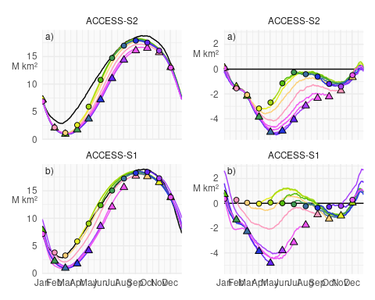
Figure 1: Pan-Antarctic median sea ice extent for al hindcasts initialised the first of the month for ACCESS-S2 and ACCESS-S1 in colours representing the start month with the median sea ice extent of NOAA/NSIDC CDRV4 in the left column and the median difference in the right column. The NOAA/NSIDC CDRV4 climatology is computed in the period corresponding to each hindcast. Circles represent the initial conditions at the first of every month and triangles represent the median value at the first of every month forecasted with the largest possible lead time. Colours indicate the initialisation month of the forecast.
Figure 1 a shows the median sea ice extent (left column) and median difference with respect of NOAA/NSIDC CDRV4 for the ACCESS-S2 and ACCESS-S1 hindcasts (right column). Median extent of initial conditions at the first of every month are indicated with circles, while median extent at the same date but forecasted with the largest lead time possible for each model (between 274 and 277 days for ACCESS-S2 and between 213 and 216 days for ACCESS-S1). At this large lead time, the the information of the initial conditions is essentially lost and the forecast reverts to each model’s preferred equilibrium state.
ACCESS-S2 initial conditions (circles) show an overall negative bias, especially in the late summer-early autumn, while ACCESS-S1 initial conditions are very close to observations. Both models’ equilibrium state (triangles) show a negative bias of sea ice extent, particularly in the late-autumn and winter months. This is due primarily to faster melt during a longer melt season between January and March and slower growth during March and April. This is then partially balanced with faster growth between May and July (Fig. 2). Many sea ice models exhibit this systematic underestimation during the sea ice minimum and early freezing season (Massonnet et al. 2023) and could indicate problems in the representation of thermodynamics in the model (Zampieri, Goessling, and Jung 2019). It is not surprising that both forecasting systems converge to a similar climatology because they share the same model formulation.
The difference between the initial conditions and the model preferred state can be attributed to the effect of data assimilation, which in ACCESS-S2 is due solely to atmospheric and oceanic data assimilation. From June to October, in ACCESS-S2 circles are closer to observations than to the triangles, indicating that the information from the ocean and atmosphere data assimilation is affecting sea ice and improving the initial conditions. The rest of the year there is little if any difference between circles and triangles in ACCESS-S2, indicating that the ocean and atmosphere data assimilation is not affecting sea ice and that this component of the model is virtually free-running.
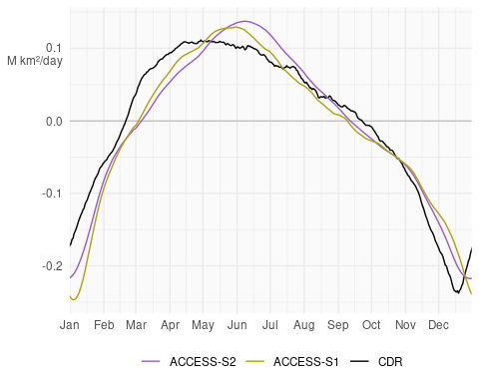
Figure 2: Median daily sea ice extent growth of ACCESS-S1 and ACCESS-S2 hindcasts and observations computed as the median daily differences in sea ice extent for each date and all lead times. Values are smoothed with a 11-day running mean.
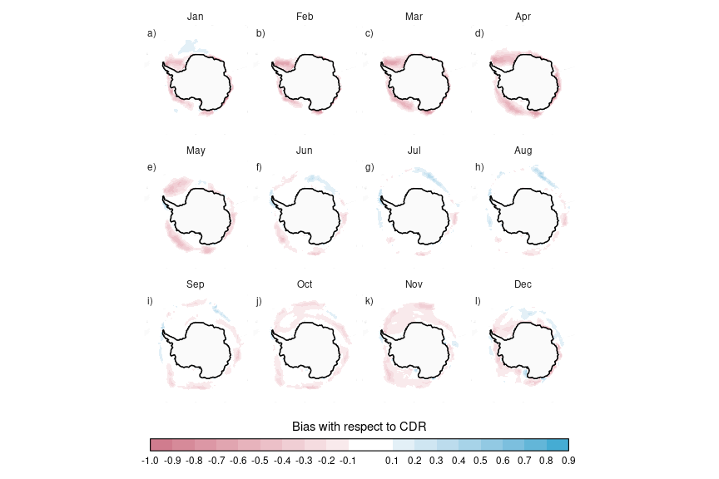
Figure 3: Mean difference between monthly sea ice concentrations at 0-month lead time ACCESS-S2 forecast and observations.
Figure 3 shows the difference of monthly mean sea ice concentrations between NOAA/NSIDC CDRV4 and ACCESS-S2 hindcasts at the shortest lead time From October to May, the model underestimates sea ice concentrations in most regions except for the inner Weddell Sea in April and May, where sea ice concentrations saturate to 1 both in the observations and forecasts. In winter, the differences are mostly on the sea ice edge with light positive bias in the African sector of East Antarctica and negative bias around the Indian Ocean sector which partially compensate, resulting in the near-zero extent bias seen in those months (Fig. 1).

RMSE
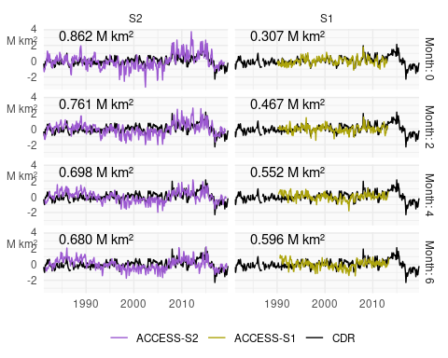
Figure 4: Monthly mean sea ice extent anomalies for ACCESS-S1 and ACCESS-S2 and observations (black) forecasted at selected lead times. The RMSE during the overlapping period (1990–2013) is shown on the top left.
Figure 4 shows monthly sea ice extent anomalies forecasted at selected lead times. Compared with ACCESS-S1, ACCESS-S2 anomaly forecast is relatively poor even in the first month, which stays relatively skilful even at a lead time of 3 months. ACCESS-S2 shows much bigger variability than observations, with dramatic lows between 1995 and 2007 and highs between 2007 and 2015.
To assess ACCESS-S2 forecasts quantitatively, we compute error measures for all hindcasts started on the 1st of every month.
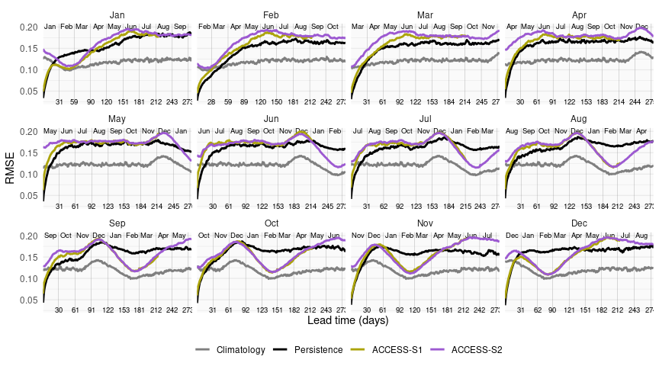
Figure 5: Median RMSE of sea ice concentration anomalies as a function of forecast lead time for all forecast initialised on the first of each month compared with a reference forecast of persistence of anomalies (black) and climatology (gray).
Figure 5 shows the median RMSE of sea ice concentration anomalies for ACCESS-S2 and ACCESS-S1 hindcasts compared with a benchmark of persistence and climatology. Due to errors in the initial conditions, it is expected that a persistence forecast would be better than the model forecast at very short lead times, but that the persistence forecast errors would grow faster and eventually surpass the model forecast, after when the model is statistically useful. Here the persistence errors are almost always lower than the ACCESS-S2 forecast, indicating that the model does not have skill at any lead time and in any month. The only exception is around February, where the model has lower RMSE than the persistence forecast at virtually every lead time.
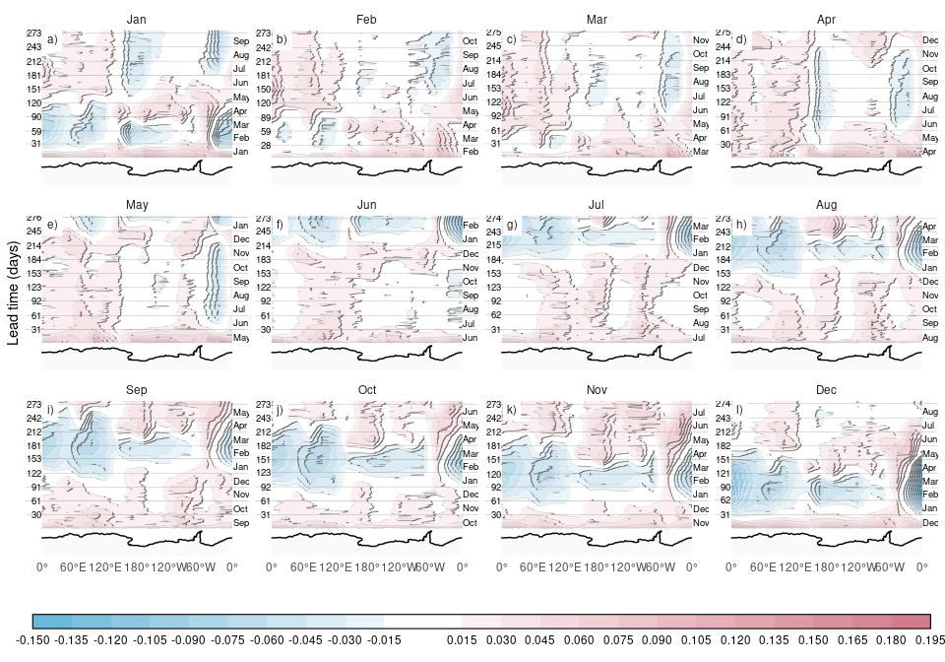
Figure 6: Median difference between RMSE of ACCESS-S2 forecasts and persistence forecast computed on r uniqueN(rmse_lon_mean$lon) meridional slices r diff(unique(rmse_lon_mean$lon))[1]º wide. Antarctica’s coastline is shown at the bottom of each panel for reference.
Even though ACCESS-S2 is no better than persistence at forecasting pan-Antarctic sea ice concentration anomalies, the quality of the forecast might vary between regions. To analyse the spatial distribution of the model error, we computed sea ice concentration anomalies RMSE on 15 meridional slices 24º wide. The median difference between the forecast and persistence RMSE is shown on Figure 6, where negative values indicate that the model has lower RMSE than the benchmark.
The skill shown by ACCESS-S2 at February-March forecasts is observed
by a band of negative values across almost all longitudes. The only region where February-March sea ice is not well forecasted is east of the Antarctic Peninsula, which is the only region with consistent summer sea ice. This suggests that the positive skill around the summer minimum comes from the model correctly forecasting no ice where no ice is ever found. However, there are other regions of skilful forecasts.
Forecasts initialised on January 1st (Fig. 6 panel a) show RMSE values below persistence at lead times larger than 180 days (corresponding to July through September) in the Ross and Weddell Sea. These two regions are also relatively well forecasted from other months. Notably, May forecasts of Weddell sea ice concentration anomalies (Fig. 6 panel e) are skilful after about 20 days and remain so until December. The Weddell Sea is also the region with the maximum error –around June regardless of initialisation date.

Comparison with S1
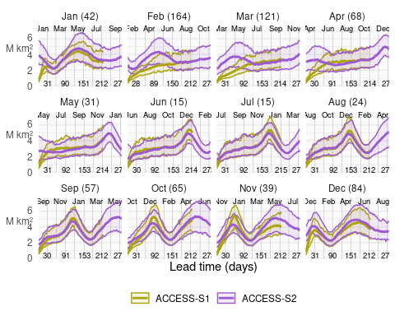
Figure 7: Median and 95% coverage of Integrated Ice Edge Error as a function of forecast lead time for all forecast initialised on the first of each month for ACCESS-S1 and ACCESS-S2 hindcasts. For each month, the number in parenthesis indicates the minimum lead time at which the mean error of each model is not statistically significant at a 1% level using a two-sided t-test.
To compare ACCESS-S2 with ACCESS-S1, we computed the IIEE for both models. This error measure is shown in Figure 7 for forecasts initialised at the first of every month at all lead times. ACCESS-S1 has lower error at lead times up to 60 days at all months, with the errors converging to ACCESS-S2 as the forecast goes on. The time to convergence depends on the month and it can be as short as two weeks June and July to as long as 160 days for forecasts initialised in February. Since the only difference between these forecasts are the initial conditions, this timescale is an indication of the memory of sea ice to initial conditions –at least from October to March when the data assimilated from the other components has little to no influence on sea ice.
Also evident in Figure 7 is the difference in the error spread at short lead times between ACCESS-S2 and ACCESS-S1. In all months ACCESS-S1 has much narrower error spread at the first day of the forecasts. The error in the initial conditions is not only small, but also fairly constant. This spread then grows towards a climatological spread as errors accumulate differently in different forecasts. For ACCESS-S2, this is true only between July and October. For all other months, the error spread is more or less stable throughout the forecast window, indicating that not only the initial error is high, but it is not constant.
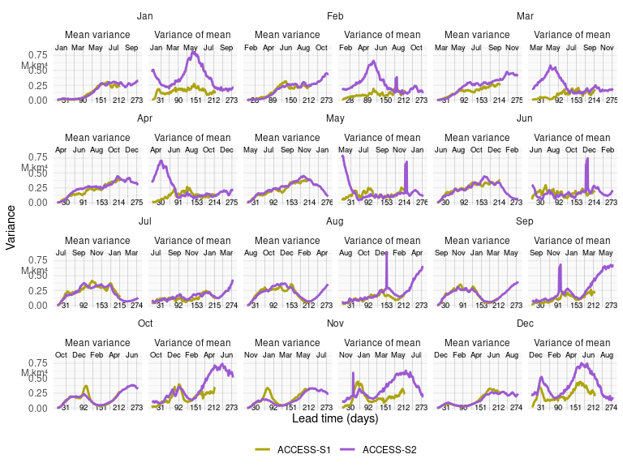
Figure 8: Mean spread of IIEE at different lead times for different models.
The large initial error spread could be due either to large spread of ensemble members or to large spread of individual forecasts. Figure 8 splits the IIEE variance for each lead time into the mean variance of each individual forecast and the variance of the mean error of each individual forecast, which adds up to the total variance. The average variance of each forecast is almost identical between the two forecast systems in all months. This shows that the ensemble spread of individual forecasts evolves identically, which, again, is not unexpected because both systems share the same model formulation. This also shows that the perturbation scheme in ACCESS-S2 is comparable to the one in ACCESS-S1.
On the other hand, the spread of the mean error is always larger in ACCESS-S2 than ACCESS-S1. The difference is particularly large at short lead times in some months, which coincide with the ones in which the data assimilation scheme is not influencing sea ice initial conditions.

Conclusions
Sea ice forecasts from the ACCESS-S2 model show a significant low extent bias, particularly during late summer and early autumn. This bias is attributed to a faster and longer melt season between January and March, and slower growth between March and April. This underestimation during the minimum and early freezing season is a common issue in many seasonal-to-subseasonal (S2S) systems, suggesting potential problems either with the model’s thermodynamic representation or with short wave radiation forcing, as shown in other climate models (Zampieri, Goessling, and Jung 2019; Roach et al. 2020). Even though ACCESS-S2 shares the same model formulation with ACCESS-S1, the latter does not suffer from this bias. This is due to the assimilation of sea ice concentrations into the initial conditions, which successfully corrects for the negative bias in the model. Our analysis suggests that the data assimilation system in ACCESS-S2 is only effectively influencing sea ice initial conditions from June to October, while the rest of the year, the sea ice component runs virtually free, reverting to its biased equilibrium state.
Analysis of the error spread shows that ACCESS-S2 initial conditions from December to May not only have large errors, but that the initial error spread is very large compared with ACCESS-S1. This spread is not due to the perturbation scheme, since the mean error variance for individual forecasts is low and comparable with ACCESS-S1. Instead, it is due to large variance of the mean error of individual forecasts, which is comparable to the climatology spread. This is further evidence that individual initial conditions are not being affected by the data assimilation scheme.
Based on the observation that ACCESS-S2 sea ice initial conditions are essentially not initialised, comparing its forecasts with ACCESS-S1’s allows us to estimate the time-scale for which initial conditions are important. This highlights February initial conditions as crucial for determining sea ice evolution at least up to late June. Arctic sea ice forecasts also show greater sensitivity to initial conditions in boreal summer compared with boreal winter (Day, Hawkins, and Tietsche 2014; Bunzel et al. 2016), so a similar mechanism might be playing a role.
Although forecasts are not skilful for forecasting pan-Antarctic sea ice concentrations, there are some areas where the model does show skill. The Weddell Sea, and the Ross Sea to a lesser extent are particularly well forecasted between June and November for forecasts initialised from January to June. These regions have been recognised as a region of high predictability thanks to persistent and eastwardly advected upper ocean heat content anomalies (Bushuk et al. 2021). Sea surface temperatures are assimilated by ACCESS-S2 only in areas with temperatures greater than 0°C and errors don’t show a clear easterly-propagating signal, so it is not clear if ACCESS-S2 is leveraging the same source of predictability..

References
Ayres, H.c., and J.a. Screen. 2019. “Multimodel Analysis of the Atmospheric Response to Antarctic Sea Ice Loss at Quadrupled CO2.” Geophysical Research Letters 46 (16): 9861–69. https://doi.org/10.1029/2019GL083653.
Ayres, Holly C., James A. Screen, Edward W. Blockley, and Thomas J. Bracegirdle. 2022. “The Coupled Atmosphere–Ocean Response to Antarctic Sea Ice Loss.” Journal of Climate 35 (14): 4665–85. https://doi.org/10.1175/JCLI-D-21-0918.1.
Barnes, Elizabeth A, and James A Screen. 2015. “The Impact of Arctic Warming on the Midlatitude Jet-Stream: Can It? Has It? Will It?” WIREs Climate Change 6 (3): 277–86. https://doi.org/10.1002/wcc.337.
Best, M. J., M. Pryor, D. B. Clark, G. G. Rooney, R. L. H. Essery, C. B. Ménard, J. M. Edwards, et al. 2011. “The Joint UK Land Environment Simulator (JULES), Model Description – Part 1: Energy and Water Fluxes.” Geoscientific Model Development 4 (3): 677–99. https://doi.org/10.5194/gmd-4-677-2011.
Bunzel, Felix, Dirk Notz, Johanna Baehr, Wolfgang A. Müller, and Kristina Fröhlich. 2016. “Seasonal Climate Forecasts Significantly Affected by Observational Uncertainty of Arctic Sea Ice Concentration.” Geophysical Research Letters 43 (2): 852–59. https://doi.org/10.1002/2015GL066928.
Bushuk, Mitchell, Michael Winton, F. Alexander Haumann, Thomas Delworth, Feiyu Lu, Yongfei Zhang, Liwei Jia, et al. 2021. “Seasonal Prediction and Predictability of Regional Antarctic Sea Ice.” Journal of Climate 34 (15): 6207–33. https://doi.org/10.1175/JCLI-D-20-0965.1.
Cavalieri, D. J., P. Gloersen, and W. J. Campbell. 1984. “Determination of Sea Ice Parameters with the NIMBUS 7 SMMR.” Journal of Geophysical Research: Atmospheres 89 (D4): 5355–69. https://doi.org/10.1029/JD089iD04p05355.
Comiso, J. 2023. “Bootstrap Sea Ice Concentrations from Nimbus-7 SMMR and DMSP SSM/I-SSMIS. (NSIDC-0079, Version 4).” Boulder, Colorado USA.: NASA National Snow and Ice Data Center Distributed Active Archive Center. https://doi.org/10.5067/X5LG68MH013O.
Day, J. J., E. Hawkins, and S. Tietsche. 2014. “Will Arctic Sea Ice Thickness Initialization Improve Seasonal Forecast Skill?” Geophysical Research Letters 41 (21): 7566–75. https://doi.org/10.1002/2014GL061694.
De Silva, Liyanarachchi Waruna Arampath, Jun Inoue, Hajime Yamaguchi, and Takeshi Terui. 2020. “Medium Range Sea Ice Prediction in Support of Japanese Research Vessel MIRAI’s Expedition Cruise in 2018.” Polar Geography 43 (2-3): 223–39. https://doi.org/10.1080/1088937X.2019.1707317.
Dee, D. P., S. M. Uppala, A. J. Simmons, P. Berrisford, P. Poli, S. Kobayashi, U. Andrae, et al. 2011. “The ERA-Interim Reanalysis: Configuration and Performance of the Data Assimilation System.” Quarterly Journal of the Royal Meteorological Society 137 (656): 553–97. https://doi.org/10.1002/qj.828.
England, Mark R., Lorenzo M. Polvani, Lantao Sun, and Clara Deser. 2020. “Tropical Climate Responses to Projected Arctic and Antarctic Sea-Ice Loss.” Nature Geoscience 13 (4): 275–81. https://doi.org/10.1038/s41561-020-0546-9.
England, Mark, Lorenzo Polvani, and Lantao Sun. 2018. “Contrasting the Antarctic and Arctic Atmospheric Responses to Projected Sea Ice Loss in the Late Twenty-First Century.” Journal of Climate 31 (16): 6353–70. https://doi.org/10.1175/JCLI-D-17-0666.1.
Espinosa, Zachary I., Edward Blanchard-Wrigglesworth, and Cecilia M. Bitz. 2024. “Understanding the Drivers and Predictability of Record Low Antarctic Sea Ice in Austral Winter 2023.” Communications Earth & Environment 5 (1): 1–9. https://doi.org/10.1038/s43247-024-01772-2.
EUMETSAT Ocean and Sea Ice Satellite Application Facility. n.d. “Global Sea Ice Concentration Climate Data Record 1978-2020 (V3.0, 2022), OSI-450-a.” https://cds.climate.copernicus.eu/cdsapp#!/dataset/satellite-sea-ice-concentration. Accessed November 1, 2024.
Fogwill, C. J., C. S. M. Turney, L. Menviel, A. Baker, M. E. Weber, B. Ellis, Z. A. Thomas, et al. 2020. “Southern Ocean Carbon Sink Enhanced by Sea-Ice Feedbacks at the Antarctic Cold Reversal.” Nature Geoscience 13 (7): 489–97. https://doi.org/10.1038/s41561-020-0587-0.
Gilbert, Ella, and Caroline Holmes. 2024. “2023’s Antarctic Sea Ice Extent Is the Lowest on Record.” Weather 79 (2): 46–51. https://doi.org/10.1002/wea.4518.
Goessling, H. F., S. Tietsche, J. J. Day, E. Hawkins, and T. Jung. 2016. “Predictability of the Arctic Sea Ice Edge.” Geophysical Research Letters 43 (4): 1642–50. https://doi.org/10.1002/2015GL067232.
Good, Simon A., Matthew J. Martin, and Nick A. Rayner. 2013. “EN4: Quality Controlled Ocean Temperature and Salinity Profiles and Monthly Objective Analyses with Uncertainty Estimates.” Journal of Geophysical Research: Oceans 118 (12): 6704–16. https://doi.org/10.1002/2013JC009067.
Gurvan, Madec, Romain Bourdallé-Badie, Pierre-Antoine Bouttier, Clément Bricaud, Diego Bruciaferri, Daley Calvert, Jérôme Chanut, et al. 2013. “NEMO Ocean Engine,” February. https://doi.org/10.5281/zenodo.1475234.
Hobbs, William R., Rob Massom, Sharon Stammerjohn, Phillip Reid, Guy Williams, and Walter Meier. 2016. “A Review of Recent Changes in Southern Ocean Sea Ice, Their Drivers and Forcings.” Global and Planetary Change 143 (August): 228–50. https://doi.org/10.1016/j.gloplacha.2016.06.008.
Hobbs, Will, Paul Spence, Amelie Meyer, Serena Schroeter, Alexander D. Fraser, Philip Reid, Tian R. Tian, et al. 2024. “Observational Evidence for a Regime Shift in Summer Antarctic Sea Ice.” Journal of Climate 37 (7): 2263–75. https://doi.org/10.1175/JCLI-D-23-0479.1.
Hudson, Debra, Oscar Alves, Harry H. Hendon, Eun-Pa Lim, Guoqiang Liu, Jing-Jia Luo, Craig MacLachlan, et al. 2017. “ACCESS-S1 The New Bureau of Meteorology Multi-Week to Seasonal Prediction System.” Journal of Southern Hemisphere Earth Systems Science 67 (3): 132–59. https://doi.org/10.1071/es17009.
Josey, Simon A., Andrew J. S. Meijers, Adam T. Blaker, Jeremy P. Grist, Jenny Mecking, and Holly C. Ayres. 2024. “Record-Low Antarctic Sea Ice in 2023 Increased Ocean Heat Loss and Storms.” Nature 636 (8043): 635–39. https://doi.org/10.1038/s41586-024-08368-y.
Massonnet, François, Sandra Barreira, Antoine Barthélemy, Roberto Bilbao, Edward Blanchard-Wrigglesworth, Ed Blockley, David H. Bromwich, et al. 2023. “SIPN South: Six Years of Coordinated Seasonal Antarctic Sea Ice Predictions.” Frontiers in Marine Science 10 (May). https://doi.org/10.3389/fmars.2023.1148899.
Megann, A., D. Storkey, Y. Aksenov, S. Alderson, D. Calvert, T. Graham, P. Hyder, J. Siddorn, and B. Sinha. 2014. “GO5.0: The Joint NERC–Met Office NEMO Global Ocean Model for Use in Coupled and Forced Applications.” Geoscientific Model Development 7 (3): 1069–92. https://doi.org/10.5194/gmd-7-1069-2014.
Meier, Walter N., F Fetterer, A. K. Windnagel, and J. Scott Stewart. 2021. “NOAA/NSIDC Climate Data Record of Passive Microwave Sea Ice Concentration.” Boulder, Colorado USA: National Snow and Ice Data Center. https://doi.org/10.7265/efmz-2t65.
Meier, Walter N., Ge Peng, Donna J. Scott, and Matt H. Savoie. 2014. “Verification of a New NOAA/NSIDC Passive Microwave Sea-Ice Concentration Climate Record.” Polar Research, December. https://doi.org/10.3402/polar.v33.21004.
Meier, Walter N., and J. Scott Stewart. 2019. “Assessing Uncertainties in Sea Ice Extent Climate Indicators.” Environmental Research Letters 14 (3): 035005. https://doi.org/10.1088/1748-9326/aaf52c.
Purich, Ariaan, and Edward W. Doddridge. 2023. “Record Low Antarctic Sea Ice Coverage Indicates a New Sea Ice State.” Communications Earth & Environment 4 (1): 1–9. https://doi.org/10.1038/s43247-023-00961-9.
Rae, J. G. L., H. T. Hewitt, A. B. Keen, J. K. Ridley, A. E. West, C. M. Harris, E. C. Hunke, and D. N. Walters. 2015. “Development of the Global Sea Ice 6.0 CICE Configuration for the Met Office Global Coupled Model.” Geoscientific Model Development 8 (7): 2221–30. https://doi.org/10.5194/gmd-8-2221-2015.
Raphael, M. N. 2003. “Impact of Observed Sea-Ice Concentration on the Southern Hemisphere Extratropical Atmospheric Circulation in Summer.” Journal of Geophysical Research: Atmospheres 108 (D22). https://doi.org/10.1029/2002JD003308.
Raphael, M. N., W. Hobbs, and I. Wainer. 2011. “The Effect of Antarctic Sea Ice on the Southern Hemisphere Atmosphere During the Southern Summer.” Climate Dynamics 36 (7): 1403–17. https://doi.org/10.1007/s00382-010-0892-1.
Rea, Divya, Dillon Elsbury, Amy H. Butler, Lantao Sun, Yannick Peings, and Gudrun Magnusdottir. 2024. “Interannual Influence of Antarctic Sea Ice on Southern Hemisphere Stratosphere-Troposphere Coupling.” Geophysical Research Letters 51 (15): e2023GL107478. https://doi.org/10.1029/2023GL107478.
Reynolds, Richard W., Thomas M. Smith, Chunying Liu, Dudley B. Chelton, Kenneth S. Casey, and Michael G. Schlax. 2007. “Daily High-Resolution-Blended Analyses for Sea Surface Temperature.” Journal of Climate 20 (22): 5473–96. https://doi.org/10.1175/2007JCLI1824.1.
Roach, Lettie A., Jakob Dörr, Caroline R. Holmes, François Massonnet, Edward W. Blockley, Dirk Notz, Thomas Rackow, et al. 2020. “Antarctic Sea Ice Area in CMIP6.” Geophysical Research Letters 47 (9): e2019GL086729. https://doi.org/10.1029/2019GL086729.
Smith, D. M., R. Eade, M. B. Andrews, H. Ayres, A. Clark, S. Chripko, C. Deser, et al. 2022. “Robust but Weak Winter Atmospheric Circulation Response to Future Arctic Sea Ice Loss.” Nature Communications 13 (1): 727. https://doi.org/10.1038/s41467-022-28283-y.
Song, Jibin, Jiankai Zhang, Shihang Du, Mian Xu, and Siyi Zhao. 2025. “Impact of Early Winter Antarctic Sea Ice Reduction on Antarctic Stratospheric Polar Vortex.” Journal of Geophysical Research: Atmospheres 130 (3): e2024JD041831. https://doi.org/10.1029/2024JD041831.
Swadling, Kerrie M., Andrew J. Constable, Alexander D. Fraser, Robert A. Massom, Melanie D. Borup, Laura Ghigliotti, Antonia Granata, et al. 2023. “Biological Responses to Change in Antarctic Sea Ice Habitats.” Frontiers in Ecology and Evolution 10 (January). https://doi.org/10.3389/fevo.2022.1073823.
Turner, John, Tony Phillips, Gareth J. Marshall, J. Scott Hosking, James O. Pope, Thomas J. Bracegirdle, and Pranab Deb. 2017. “Unprecedented Springtime Retreat of Antarctic Sea Ice in 2016.” Geophysical Research Letters 44 (13): 6868–75. https://doi.org/10.1002/2017GL073656.
Wagner, Penelope Mae, Nick Hughes, Pascale Bourbonnais, Julienne Stroeve, Lasse Rabenstein, Uma Bhatt, Joe Little, Helen Wiggins, and Andrew Fleming. 2020. “Sea-Ice Information and Forecast Needs for Industry Maritime Stakeholders.” Polar Geography 43 (2-3): 160–87. https://doi.org/10.1080/1088937X.2020.1766592.
Waters, J., M. J. Bell, M. J. Martin, and D. J. Lea. 2017. “Reducing Ocean Model Imbalances in the Equatorial Region Caused by Data Assimilation.” Quarterly Journal of the Royal Meteorological Society 143 (702): 195–208. https://doi.org/10.1002/qj.2912.
Waters, Jennifer, Daniel J. Lea, Matthew J. Martin, Isabelle Mirouze, Anthony Weaver, and James While. 2015. “Implementing a Variational Data Assimilation System in an Operational 1/4 Degree Global Ocean Model.” Quarterly Journal of the Royal Meteorological Society 141 (687): 333–49. https://doi.org/10.1002/qj.2388.
Wedd, Robin, Oscar Alves, Catherine de Burgh-Day, Christopher Down, Morwenna Griffiths, Harry H. Hendon, Debra Hudson, et al. 2022. “ACCESS-S2: The Upgraded Bureau of Meteorology Multi-Week to Seasonal Prediction System.” Journal of Southern Hemisphere Earth Systems Science 72 (3): 218–42. https://doi.org/10.1071/ES22026.
Williams, K. D., C. M. Harris, A. Bodas-Salcedo, J. Camp, R. E. Comer, D. Copsey, D. Fereday, et al. 2015. “The Met Office Global Coupled Model 2.0 (GC2) Configuration.” Geoscientific Model Development 8 (5): 1509–24. https://doi.org/10.5194/gmd-8-1509-2015.
Zampieri, Lorenzo, Helge F. Goessling, and Thomas Jung. 2019. “Predictability of Antarctic Sea Ice Edge on Subseasonal Time Scales.” Geophysical Research Letters 46 (16): 9719–27. https://doi.org/10.1029/2019GL084096.

Supplementary figures

