Title Goes Here

Myfirstname Mylastname1,✉, and Yourfirstname Yourlastname2

25 June, 2020

Text of abstract

1 University of One Place  
2 University of Another Place

✉ Correspondence: [Myfirstname Mylastname <[fl@oneplace.edu](mailto:fl@oneplace.edu)>](mailto:fl@oneplace.edu)

Keywords: keyword 1; keyword 2; keyword 3

Highlights: These are the highlights.

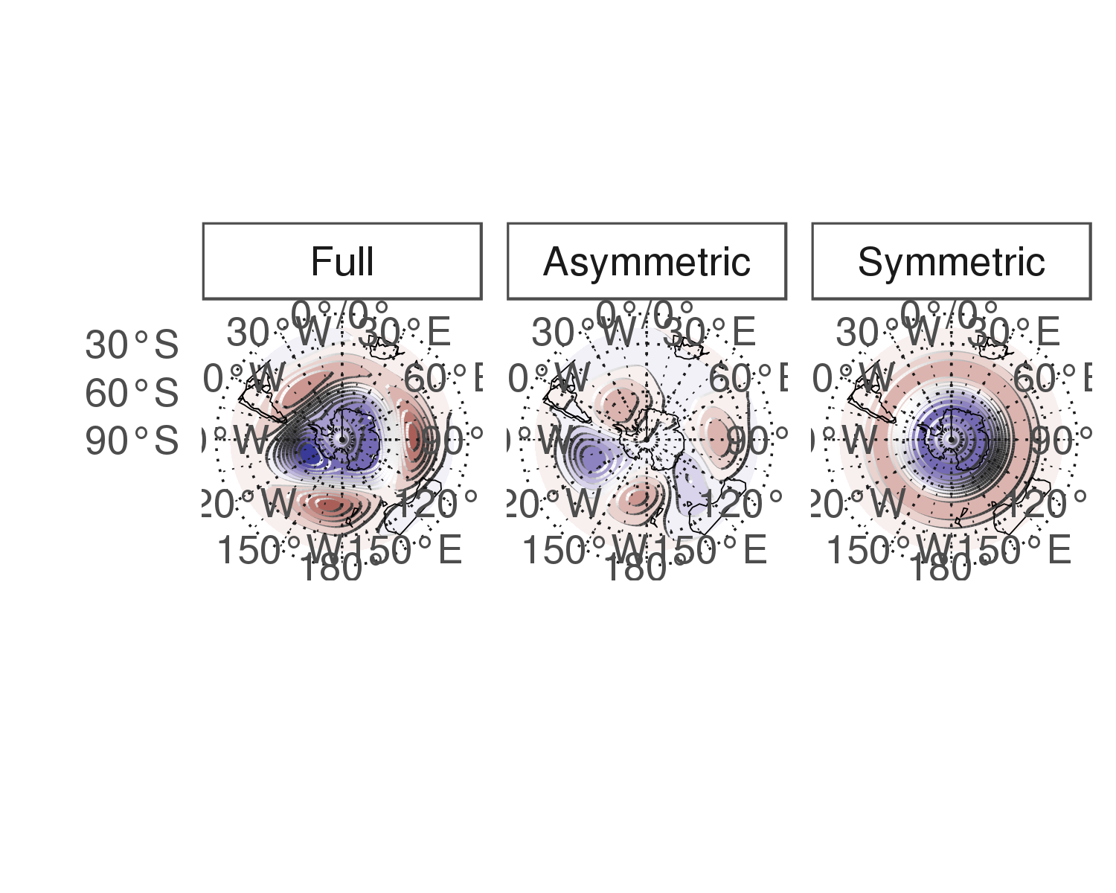

Figure 1: Spatial patterns of the first EOF of 700 hPa geopotential height. Full field (left), zonally asymmetric component (middle) and zonally symmetric component (right). Arbitrary units.

# Introduction

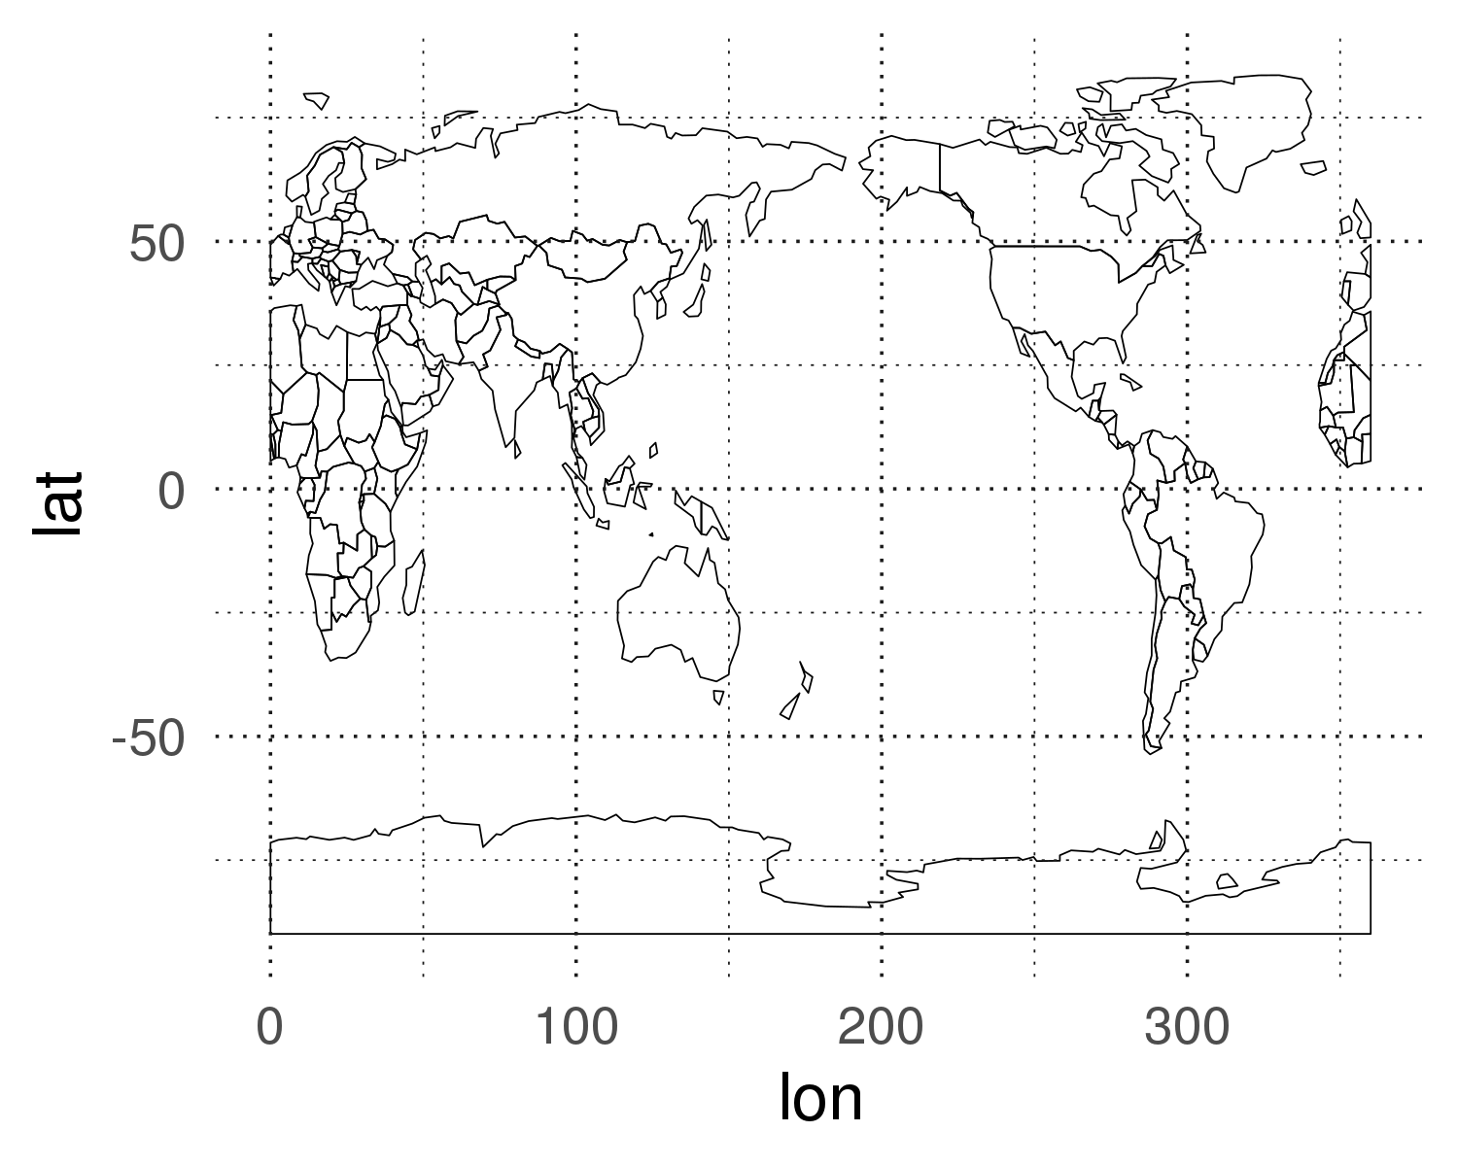

Here is a citation (Marwick, 2017)

# Background

# Methods

# Results

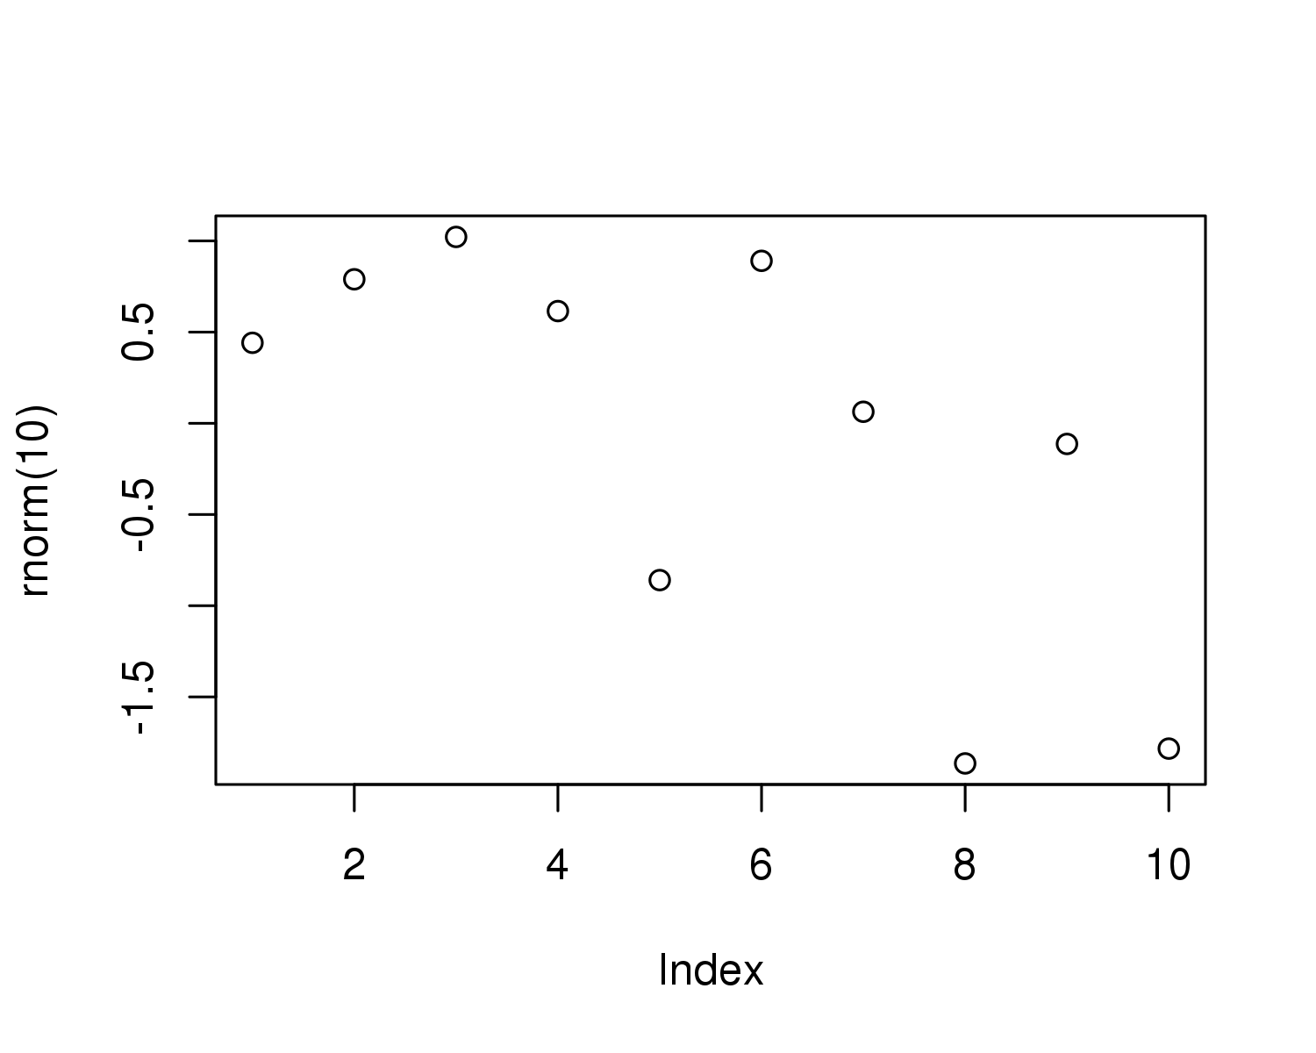

Figure 2: A plot of random numbers

Figure 2 shows how we can have a caption and cross-reference for a plot

Here is an example of inline code 3.14 in the middle of a sentence.

# Discussion

# Conclusion

# Acknowledgements

# References

Marwick, B., 2017. Computational reproducibility in archaeological research: Basic principles and a case study of their implementation. Journal of Archaeological Method and Theory 24, 424–450. <https://doi.org/10.1007/s10816-015-9272-9>

### Colophon

This report was generated on 2020-06-25 18:10:19 using the following computational environment and dependencies:

#> ─ Session info ───────────────────────────────────────────────────────────────  
#> setting value   
#> version R version 3.5.3 (2019-03-11)   
#> os Debian GNU/Linux 9 (stretch)   
#> system x86_64, linux-gnu   
#> ui X11   
#> language (EN)   
#> collate en_US.UTF-8   
#> ctype en_US.UTF-8   
#> tz America/Argentina/Buenos_Aires  
#> date 2020-06-25   
#>   
#> ─ Packages ───────────────────────────────────────────────────────────────────  
#> package * version date lib source   
#> assertthat 0.2.1 2019-03-21 [1] CRAN (R 3.5.3)   
#> asymsam * 0.0.0.9000 2020-06-25 [1] local   
#> backports 1.1.8 2020-06-17 [1] CRAN (R 3.5.3)   
#> bitops 1.0-6 2013-08-17 [1] CRAN (R 3.5.3)   
#> bookdown 0.20 2020-06-23 [1] CRAN (R 3.5.3)   
#> callr 3.4.3 2020-03-28 [1] CRAN (R 3.5.3)   
#> checkmate 2.0.0 2020-02-06 [1] CRAN (R 3.5.3)   
#> class 7.3-15 2019-01-01 [4] CRAN (R 3.5.3)   
#> classInt 0.4-2 2019-10-17 [1] CRAN (R 3.5.3)   
#> cli 2.0.2 2020-02-28 [1] CRAN (R 3.5.3)   
#> clisymbols 1.2.0 2017-05-21 [1] CRAN (R 3.5.3)   
#> colorspace 1.4-1 2019-03-18 [1] CRAN (R 3.5.3)   
#> crayon 1.3.4 2017-09-16 [1] CRAN (R 3.5.3)   
#> crul 0.9.0 2019-11-06 [1] CRAN (R 3.5.3)   
#> curl 4.3 2019-12-02 [1] CRAN (R 3.5.3)   
#> data.table * 1.12.8 2019-12-09 [1] CRAN (R 3.5.3)   
#> DBI 1.1.0 2019-12-15 [1] CRAN (R 3.5.3)   
#> desc 1.2.0 2018-05-01 [1] CRAN (R 3.5.3)   
#> devtools 2.3.0 2020-04-10 [1] CRAN (R 3.5.3)   
#> digest 0.6.25 2020-02-23 [1] CRAN (R 3.5.3)   
#> dplyr 1.0.0 2020-05-29 [1] CRAN (R 3.5.3)   
#> e1071 1.7-3 2019-11-26 [1] CRAN (R 3.5.3)   
#> ellipsis 0.3.1 2020-05-15 [1] CRAN (R 3.5.3)   
#> evaluate 0.14 2019-05-28 [1] CRAN (R 3.5.3)   
#> fansi 0.4.1 2020-01-08 [1] CRAN (R 3.5.3)   
#> farver 2.0.3 2020-01-16 [1] CRAN (R 3.5.3)   
#> foreign 0.8-71 2018-07-20 [4] CRAN (R 3.5.2)   
#> fs 1.4.1 2020-04-04 [1] CRAN (R 3.5.3)   
#> generics 0.0.2 2018-11-29 [1] CRAN (R 3.5.3)   
#> geojson 0.3.2 2019-01-31 [1] CRAN (R 3.5.3)   
#> geojsonio 0.9.0 2020-02-13 [1] CRAN (R 3.5.3)   
#> geojsonlint 0.4.0 2020-02-13 [1] CRAN (R 3.5.3)   
#> ggh4x * 0.1.1 2020-03-24 [1] Github (teunbrand/ggh4x@1a547cc)   
#> ggperiodic * 1.0.0 2019-03-12 [1] CRAN (R 3.5.3)   
#> ggplot2 * 3.3.2.9000 2020-06-25 [1] Github (tidyverse/ggplot2@ccd94e1)   
#> glue 1.4.1 2020-05-13 [1] CRAN (R 3.5.3)   
#> gtable 0.3.0 2019-03-25 [1] CRAN (R 3.5.3)   
#> here 0.1 2017-05-28 [1] CRAN (R 3.5.3)   
#> highr 0.8 2019-03-20 [1] CRAN (R 3.5.3)   
#> hms 0.5.3 2020-01-08 [1] CRAN (R 3.5.3)   
#> htmltools 0.5.0 2020-06-16 [1] CRAN (R 3.5.3)   
#> httpcode 0.3.0 2020-04-10 [1] CRAN (R 3.5.3)   
#> irlba 2.3.3 2019-02-05 [1] CRAN (R 3.5.3)   
#> jqr 1.1.0 2018-10-22 [1] CRAN (R 3.5.3)   
#> jsonlite 1.6.1 2020-02-02 [1] CRAN (R 3.5.3)   
#> jsonvalidate 1.1.0 2019-06-25 [1] CRAN (R 3.5.3)   
#> KernSmooth 2.23-15 2015-06-29 [4] CRAN (R 3.5.2)   
#> knitr 1.29 2020-06-23 [1] CRAN (R 3.5.3)   
#> labeling 0.3 2014-08-23 [1] CRAN (R 3.5.3)   
#> lattice 0.20-38 2018-11-04 [4] CRAN (R 3.5.2)   
#> lazyeval 0.2.2 2019-03-15 [1] CRAN (R 3.5.3)   
#> lifecycle 0.2.0 2020-03-06 [1] CRAN (R 3.5.3)   
#> lubridate 1.7.9 2020-06-08 [1] CRAN (R 3.5.3)   
#> magrittr * 1.5 2014-11-22 [1] CRAN (R 3.5.3)   
#> maps 3.3.0 2018-04-03 [1] CRAN (R 3.5.3)   
#> maptools 0.9-9 2019-12-01 [1] CRAN (R 3.5.3)   
#> Matrix 1.2-16 2019-03-08 [4] CRAN (R 3.5.3)   
#> memoise 1.1.0 2017-04-21 [1] CRAN (R 3.5.3)   
#> metR * 0.7.0 2020-04-21 [1] Github (eliocamp/metR@fa7ae32)   
#> munsell 0.5.0 2018-06-12 [1] CRAN (R 3.5.3)   
#> ncdf4 1.17 2019-10-23 [1] CRAN (R 3.5.3)   
#> pillar 1.4.4 2020-05-05 [1] CRAN (R 3.5.3)   
#> pkgbuild 1.0.8 2020-05-07 [1] CRAN (R 3.5.3)   
#> pkgconfig 2.0.3 2019-09-22 [1] CRAN (R 3.5.3)   
#> pkgload 1.1.0 2020-05-29 [1] CRAN (R 3.5.3)   
#> plyr 1.8.6 2020-03-03 [1] CRAN (R 3.5.3)   
#> prettyunits 1.1.1 2020-01-24 [1] CRAN (R 3.5.3)   
#> processx 3.4.2 2020-02-09 [1] CRAN (R 3.5.3)   
#> prompt 1.0.0 2020-01-17 [1] Github (gaborcsardi/prompt@b332c42)  
#> ps 1.3.3 2020-05-08 [1] CRAN (R 3.5.3)   
#> purrr 0.3.4 2020-04-17 [1] CRAN (R 3.5.3)   
#> R6 2.4.1 2019-11-12 [1] CRAN (R 3.5.3)   
#> Rcpp 1.0.4.6 2020-04-09 [1] CRAN (R 3.5.3)   
#> RCurl 1.98-1.2 2020-04-18 [1] CRAN (R 3.5.3)   
#> readr 1.3.1 2018-12-21 [1] CRAN (R 3.5.3)   
#> remotes 2.1.1 2020-02-15 [1] CRAN (R 3.5.3)   
#> rgdal 1.4-8 2019-11-27 [1] CRAN (R 3.5.3)   
#> rgeos 0.5-2 2019-10-03 [1] CRAN (R 3.5.3)   
#> rlang 0.4.6 2020-05-02 [1] CRAN (R 3.5.3)   
#> rmapshaper 0.4.3 2020-01-28 [1] CRAN (R 3.5.3)   
#> rmarkdown 2.3 2020-06-18 [1] CRAN (R 3.5.3)   
#> rprojroot 1.3-2 2018-01-03 [1] CRAN (R 3.5.3)   
#> rstudioapi 0.11 2020-02-07 [1] CRAN (R 3.5.3)   
#> scales 1.1.1 2020-05-11 [1] CRAN (R 3.5.3)   
#> sessioninfo 1.1.1 2018-11-05 [1] CRAN (R 3.5.3)   
#> sf 0.9-0 2020-03-24 [1] CRAN (R 3.5.3)   
#> sp 1.4-1 2020-02-28 [1] CRAN (R 3.5.3)   
#> sticky 0.5.6.1 2020-03-16 [1] CRAN (R 3.5.3)   
#> stringi 1.4.6 2020-02-17 [1] CRAN (R 3.5.3)   
#> stringr 1.4.0 2019-02-10 [1] CRAN (R 3.5.3)   
#> testthat 2.3.2 2020-03-02 [1] CRAN (R 3.5.3)   
#> tibble 3.0.1 2020-04-20 [1] CRAN (R 3.5.3)   
#> tidyselect 1.1.0 2020-05-11 [1] CRAN (R 3.5.3)   
#> udunits2 0.13 2016-11-17 [1] CRAN (R 3.5.3)   
#> units 0.6-6 2020-03-16 [1] CRAN (R 3.5.3)   
#> usethis 1.6.1 2020-04-29 [1] CRAN (R 3.5.3)   
#> V8 3.0.2 2020-03-14 [1] CRAN (R 3.5.3)   
#> vctrs 0.3.1 2020-06-05 [1] CRAN (R 3.5.3)   
#> withr 2.2.0 2020-04-20 [1] CRAN (R 3.5.3)   
#> xfun 0.15 2020-06-21 [1] CRAN (R 3.5.3)   
#> yaml 2.2.1 2020-02-01 [1] CRAN (R 3.5.3)   
#>   
#> [1] /home/elio.campitelli/R/x86_64-pc-linux-gnu-library/3.5  
#> [2] /usr/local/lib/R/site-library  
#> [3] /usr/lib/R/site-library  
#> [4] /usr/lib/R/library

The current Git commit details are:

#> Local: master /home/elio.campitelli/asymsam  
#> Remote: master @ origin (https://github.com/eliocamp/asymsam.git)  
#> Head: [ec4b4f0] 2020-06-25: LFS won't work