How stationary are planetary waves in the Southern Hemisphere?

In the meteorological literature the analysis of the zonally asymmetric it is very common to analyse

# Introduction

Zonal waves, also called planetary waves, that can develop in the extratropical latitudes of the Southern Hemisphere (SH), have received some attention by the scientific community because of its role in modulating weather systems and regional climate (xxREF). They are typically characterized by applying Fourier decomposition to hemispheric anomalies of sea-level pressure of geopotential heights. On the other hand, “stationary waves” or “quasi-stationary waves” are terms generally reserved in the literature to the zonal asymmetries of the time mean field (). These terms are sometimes used interchangeably in the SH circulation related studies (e.g. Rao, Fernandez, and Franchito 2004; Raphael 2004; Kravchenko et al. 2012; Irving and Simmonds 2015; Turner et al. 2017; Lastovicka, Krizan, and Kozubek 2018).

*xx me parece que la explicación de cada uno tiene que venir después de las definiciones de la siguiente sección*

However, it is not evident from the current knowledge, how “stationary” or “quasi-stationary” the zonal waves are in the SH. The focus of this study is then to assess the xx…me preocupa que haya papers olvidados sobre este tema.

# Zonal waves and quasi-stationary waves

In this study we define *planetary waves* as waves that encompass a full latitude circle. Planetary waves of the “instantaneous” fields will be called *zonal waves* (ZW) and the ones of the field mean will be called *quasi-stationary waves* (QS). They are characterised by their wavenumber, amplitude and phase such that

where is the wavenumber, the longitude, and and , the amplitude and phase of each wave, respectively. Note that is made expressly dependent on time, while is not. Furthermore, from the properties of wave superposition it can be seen that, in general, does not equal an that will always be less or equal than (Pain 2005).

While these definitions depend on which are the “instantaneous field” in question (monthly, daily, sub daily, etc…) and the averaging time scale, they illustrate that ZW are properties of the *elements* of the set, while QS are properties of the set as a whole. This is an important distinction with theoretical and methodological implications that is not always differentiated in the literature.

For example, while Quintanar and Mechoso (1995) use the term “quasi-stationary waves (QS)” to refer to geopotential QS as defined by Equation , Raphael (2004) developed an index of QS3 but uses the term “zonal wave (ZW)” in her description. This change in naming convention is not recognized by Irving and Simmonds (2015), who compare Raphael (2004)’s QS index with their own index of southern hemisphere ZW amplitude.

Rao, Fernandez, and Franchito (2004), on the other hand, follow the nomenclature from Quintanar and Mechoso (1995) for QS, but in their exploration of its climatology, they use instead of . Kravchenko et al. (2012) do the same in the context of air temperature. Turner et al. (2017) use the terms “planetary wave *k*”, “quasi-stationary wave *k*” and “wave number *k*” to refer to , but they analyse and . Finally, Lastovicka, Krizan, and Kozubek (2018) study QS and ZW but they use the term “stationary planetary wave (SPW)” to refer to both.

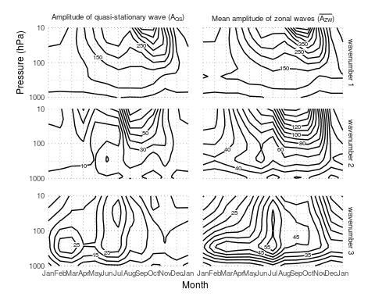

Seasonal cycle of amplitude of the geopotential planetary waves 1 to 3 at 60S computed as the amplitude of the mean wave () and as the mean amplitude of the monthly waves ().

Figure shows the seasonal cycle of the amplitude of planetary waves at 60S using monthly fields from the NCEP/NCAR reanalysis (Kalnay et al. 1996) between 1950 and 1998. The left column () is computed by taking the amplitude of the averaged geopotential field for each month, level and wavenumber. The right column () is computed by taking the average amplitude of the 49 individual ZW.

Figure shows that both amplitudes have different annual cycles and vertical structures. has a strong minimum in the low stratosphere during the austral autumn that is not apparent in . Similarly, the austral winter mid-tropospheric maximum is very well defined in but not so in . The relative individual contribution of each wavenumber is also different. fields shows a preponderance of wave 2 over 3 in almost every level and month. However, is larger than in the first half of the year. In contrast with wavenumbers 2 and 3, and fields are very similar.

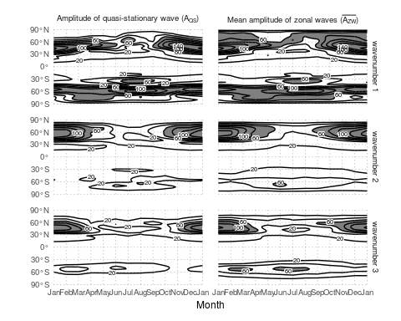

Seasonal cycle of amplitude of the geopotential planetary waves 2 at 300hPa computed as the amplitude of the mean wave () and as the mean amplitude of the monthly waves ().

These differences are location-dependent. Figure show the horizontal distribution of and at 300hPa, for the three wavenumbers considered. In the northern hemisphere there is a strong seasonal cycle of that is matched by the seasonal cycle of for all wavenumbers. In contrast, in the southern hemisphere the seasonal cycles of and are similar only for wavenumber 1. Wavenumbers 2 and 3 have much lower than .

## Stationarity Index

Loon and Jenne (1972) recognised the distinction between and and, deduced that “the daily phases of waves 2 and 4-6 at 50S must therefore be random since the waves almost cancel themselves when added, whereas 1 and 3 must recur consistently in certain longitudes since they are significantly large in the climatological mean”. This observation motivates that stationary conditions in the circulation of the SH could be measured using the quotient between the two quantities. As an analogy with the constancy of the wind (Singer 1967), the stationarity of the QS can be estimated as

It can be shown that for completely stationary waves. On the other hand, it can be demonstrated that the expected amplitude of the sum of waves with random phases and mean amplitude is (Pain 2005). Thus, for completely non stationary waves, the expected value of is .

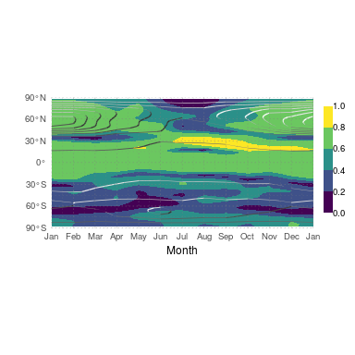

Seasonal cycle of stationarity of the 300hPa geopotential QS2 computed using Equation (shaded) and (contours). From monthly NCEP/NCAR Reanalysis, 1958 to 2017.

As an example, Figure shows for QS2 computed using Equation . At the northern mid latitudes the seasonal cycle of stationarity is similar to that described by (Figure ) with maximum values in boreal summer and minimum in the boreal winter. On the other hand, the SH circulation shows a lower degree of QS2 stationarity than that of the northern hemisphere or the tropics. At the SH is no clear annual cycle and, even more, at 60S, stationarity and appear to be anticorrelated.

can equivalently be mathematically defined as

The numerator is the sum of the projections of each onto the direction of the . Equation has some advantages over Equation . First, it makes is clear that stationarity is a mixture of a phase effect and an amplitude effect. Secondly, one can, in principle, replace with any direction of interest, allowing to evaluate . This can also be useful for removing variability due to the seasonal cycle. The position of the monthly QS3 has a shift of about 15between January and July (Loon and Jenne 1972), so by replacing with (one for each month) one can evaluate stationarity with respect to the seasonal changing position of the mean wave. Finally, it is possible to transform the sums into running sums with window and obtain and analyse variations of stationarity with time.

While is used –sometimes as (Singer 1967)– in the meteorological literature in the context of wind steadiness, to our knowledge this is the first time it has been applied to the study of atmospheric waves. However, its statistical properties are not well studied. One problem with is that, as seen above, its estimation from a finite sample has a positive bias, but its convergence properties are not explored.

## Considerations about phase

For defining local impacts, the phase of planetary waves is as important as their amplitude if not more. One way of dealing with the phase of ZW is to fix it. Yuan and Li (2008) use Principal Component Analysis on the meridional wind field to obtain a spatial pattern of the leading mode that is very similar to the QS3. The timeseries associated to this mode is, then, an indication of the intensity of the ZW3 that is similar to the QS3. A more direct approach is the index created by Raphael (2004). Since it is based on the geopotential height anomalies at the maximums of the QS3, it is sensitive to ZW3 patterns with phase close to the stationary phase. An almost mathematically equivalent approach (with correlation = 0.98) is to compute the projection of each onto the direction of the (i.e. the expression inside the sum of the numerator in Equation ). This methodology has fewer constrains in that the phase of interest can be changed depending on the application.

# Conclusions

The fact that zonal waves (ZW) and quasi-stationary waves (QS) are two distinct but related phenomena has both practical and theoretical implications.

First, researchers should be aware of which phenomena they want to study and use the appropriate methods. The mean amplitude of the ZW could be appropriate to study the vertical propagation of Rossby waves, for example. But ZW amplitude could lead to misleading results if used as the basis of local impacts studies because they are probably more influenced by phase effects.

Secondly, comparison between results should also be made having this issues in mind. For instance, Irving and Simmonds (2015) compare their planetary wave activity index with Raphael (2004)’s wave 3 index and conclude that the later cannot account for events with waves far removed from their climatological position. However, in light of the discussion in Section , this limitation becomes a feature, not a bug.

Although having a consistent nomenclature across papers is desirable, we believe that this problems can be ameliorated by researchers detailing their definitions and methodology. This is also good for clarity and reproducibility. Since planetary waves are generally more stationary in the northern hemisphere, these issues are more critical for studies of the southern hemisphere.

Thirdly, the explorations of both ZW and QS can lead to novel levels of analysis. Here, we showed it can be used to define a metric of stationarity of quasi-stationary waves, but other applications are also possible. Smith and Kushner (2012) used the phase relationship between ZW1 and QS1 to show that linear interference between the QS1 and ZW1 was related to vertical wave activity transport at the tropopause.

*xx me falta un final acá xx*

Irving, Damien, and Ian Simmonds. 2015. “A novel approach to diagnosing Southern Hemisphere planetary wave activity and its influence on regional climate variability.” *Journal of Climate* 28 (23): 9041–57. <https://doi.org/10.1175/JCLI-D-15-0287.1>.

Kalnay, E, M Kanamitsu, R Kistler, W Collins, D Deaven, L Gandin, M Iredell, et al. 1996. “The NCEP/NCAR 40-year reanalysis project.” *Bulletin of the American Meteorological Society* 77 (3): 437–71. <https://doi.org/10.1175/1520-0477(1996)077<0437:TNYRP>2.0.CO;2>.

Kravchenko, V O, O M Evtushevsky, A V Grytsai, A R Klekociuk, G P Milinevsky, and Z I Grytsai. 2012. “Quasi-stationary planetary waves in late winter Antarctic stratosphere temperature as a possible indicator of spring total ozone.” *Atmospheric Chemistry and Physics* 12 (6): 2865–79. <https://doi.org/10.5194/acp-12-2865-2012>.

Lastovicka, Jan, Peter Krizan, and Michal Kozubek. 2018. “Longitudinal structure of stationary planetary waves in the middle atmosphere - Extraordinary years.” *Annales Geophysicae* 36 (1): 181–92. <https://doi.org/10.5194/angeo-36-181-2018>.

Loon, Harry van, and Roy L Jenne. 1972. “The Zonal Harmonic Standing Waves in the Southern Hemisphe.” *Journal of Geophysical Research* 77 (6): 992–1003.

Pain, H.J. 2005. “Simple Harmonic Motion.” In *The Physics of Vibrations and Waves*, 570. <https://doi.org/10.1002/0470016957>.

Quintanar, Arturo I, and Carlos R Mechoso. 1995. “Quasi-stationary waves in the Southern Hemisphere. Part I: observational data.” *Journal of Climate* 8 (11): 2659–72. <https://doi.org/10.1175/1520-0442(1995)008<2659:QSWITS>2.0.CO;2>.

Rao, V. Brahmananda, J. P. R. Fernandez, and S. H. Franchito. 2004. “Quasi-stationary waves in the southern hemisphere during El Nina and La Nina events.” *Annales Geophysicae* 22 (3): 789–806.

Raphael, Marilyn N. 2004. “A zonal wave 3 index for the Southern Hemisphere.” *Geophysical Research Letters* 31 (23): 1–4. <https://doi.org/10.1029/2004GL020365>.

Singer, Irving A. 1967. “Steadiness of the Wind.” *Journal of Applied Meteorology* 6 (6): 1033–8. <https://doi.org/10.1175/1520-0450(1967)006<1033:sotw>2.0.co;2>.

Smith, Karen L., and Paul J. Kushner. 2012. “Linear interference and the initiation of extratropical stratosphere-troposphere interactions.” *Journal of Geophysical Research Atmospheres* 117 (13): 1–16. <https://doi.org/10.1029/2012JD017587,2012>.

Turner, John, J. Scott Hosking, Thomas J. Bracegirdle, Tony Phillips, and Gareth J. Marshall. 2017. “Variability and trends in the Southern Hemisphere high latitude, quasi-stationary planetary waves.” *International Journal of Climatology* 37 (5): 2325–36. <https://doi.org/10.1002/joc.4848>.

Yuan, Xiaojun, and Cuihua Li. 2008. “Climate modes in southern high latitudes and their impacts on Antarctic sea ice.” *Journal of Geophysical Research: Oceans* 113 (6): 1–13. <https://doi.org/10.1029/2006JC004067>.