Title Goes Here

Myfirstname Mylastname1,✉, and Yourfirstname Yourlastname2

28 octubre, 2020

Text of abstract

1 University of One Place  
2 University of Another Place

✉ Correspondence: [Myfirstname Mylastname <[fl@oneplace.edu](mailto:fl@oneplace.edu)>](mailto:fl@oneplace.edu)

Keywords: keyword 1; keyword 2; keyword 3

Highlights: These are the highlights.

##   
## Attaching package: 'ggperiodic'

## The following object is masked from 'package:stats':  
##   
## filter

##   
## Attaching package: 'shceof'

## The following object is masked from 'package:metR':  
##   
## WaveFlux

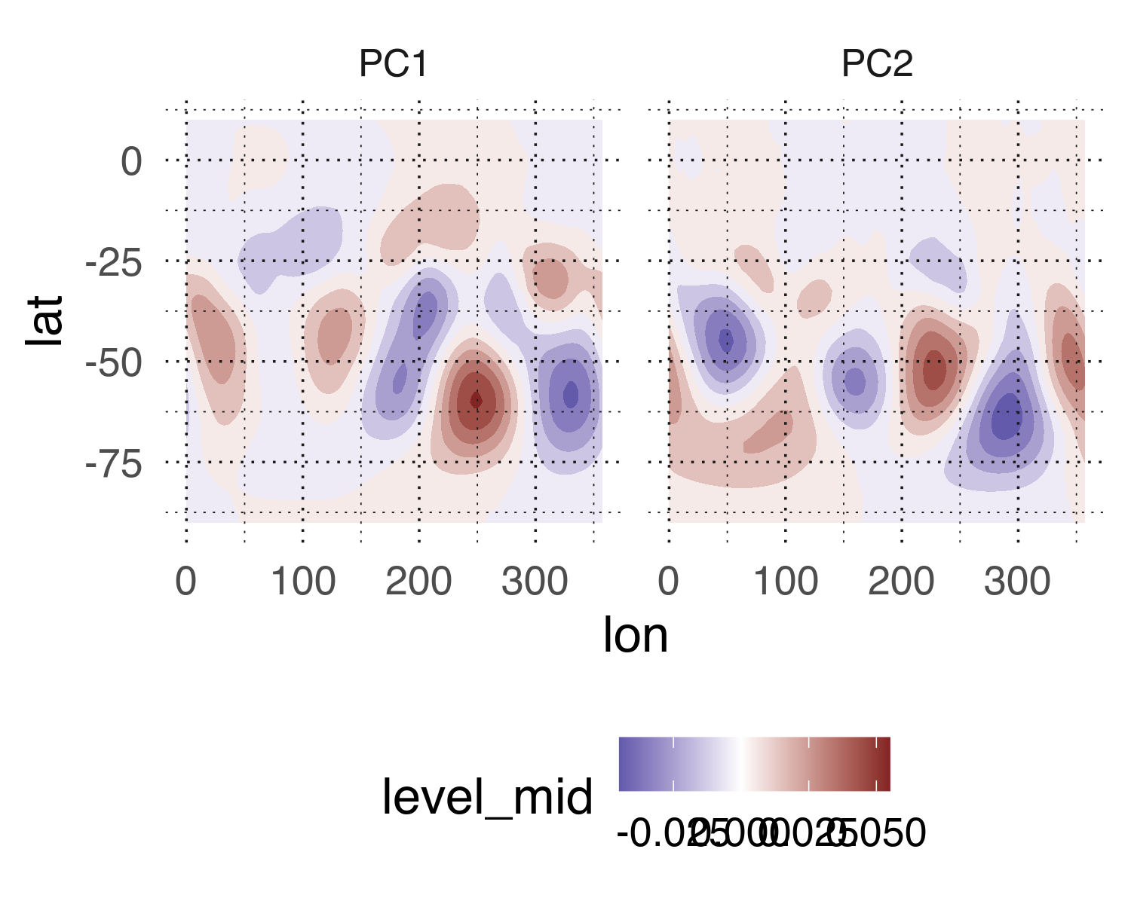

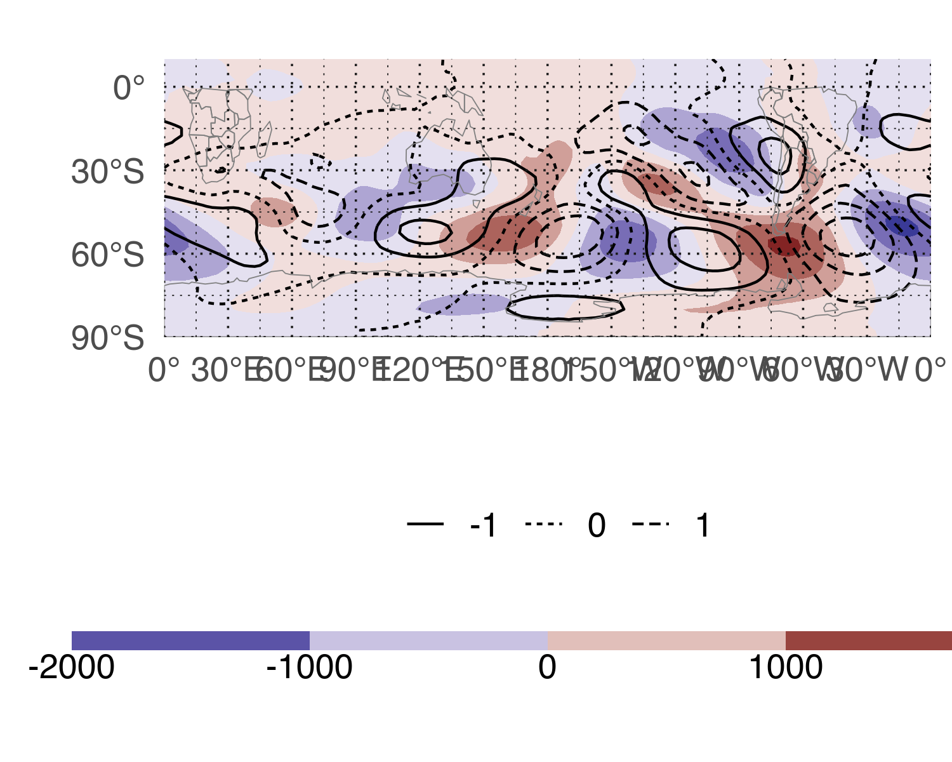

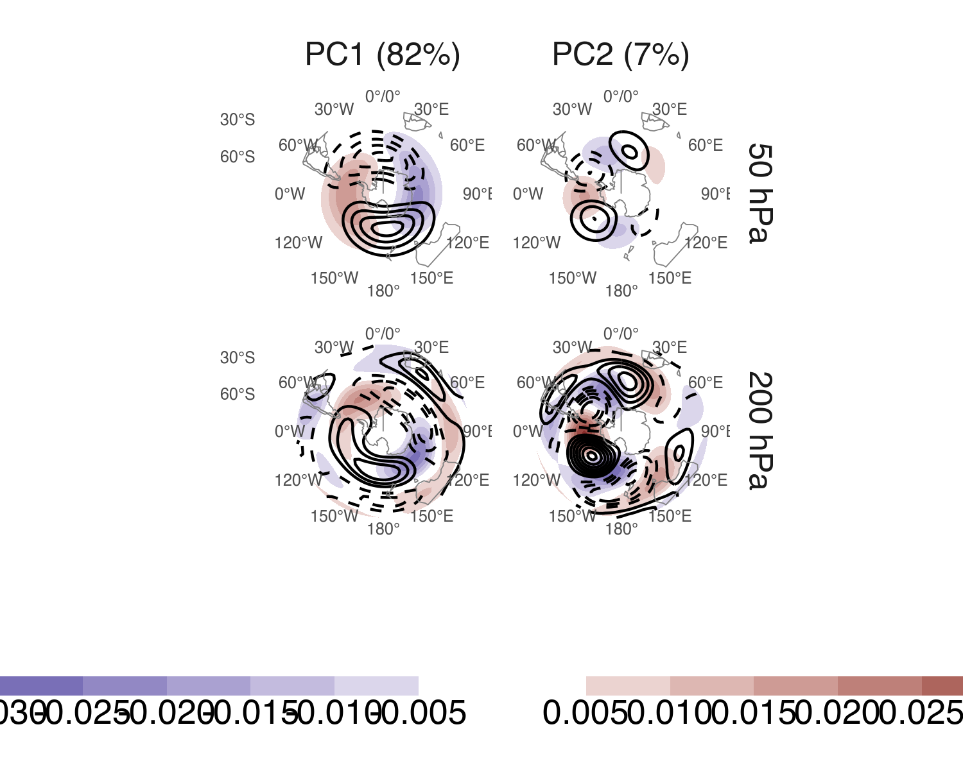

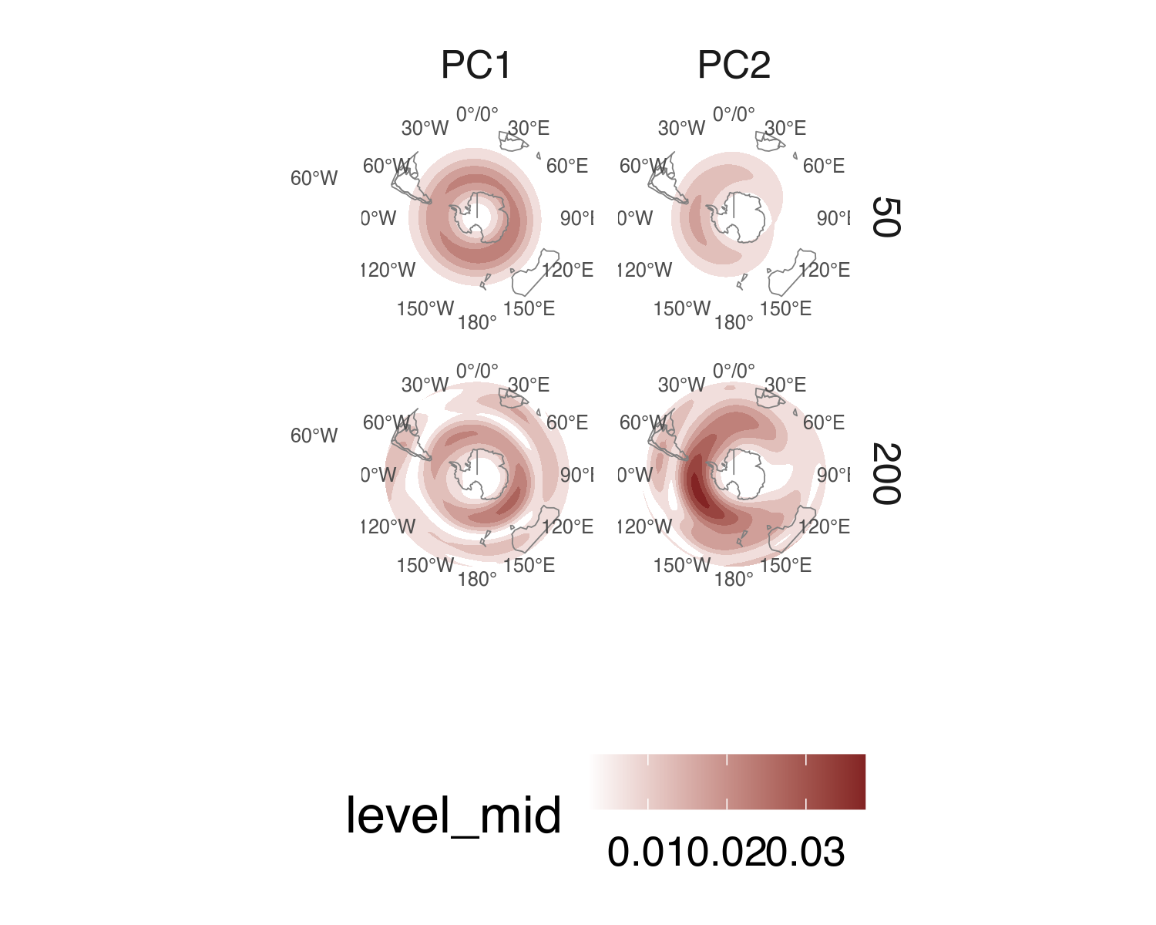

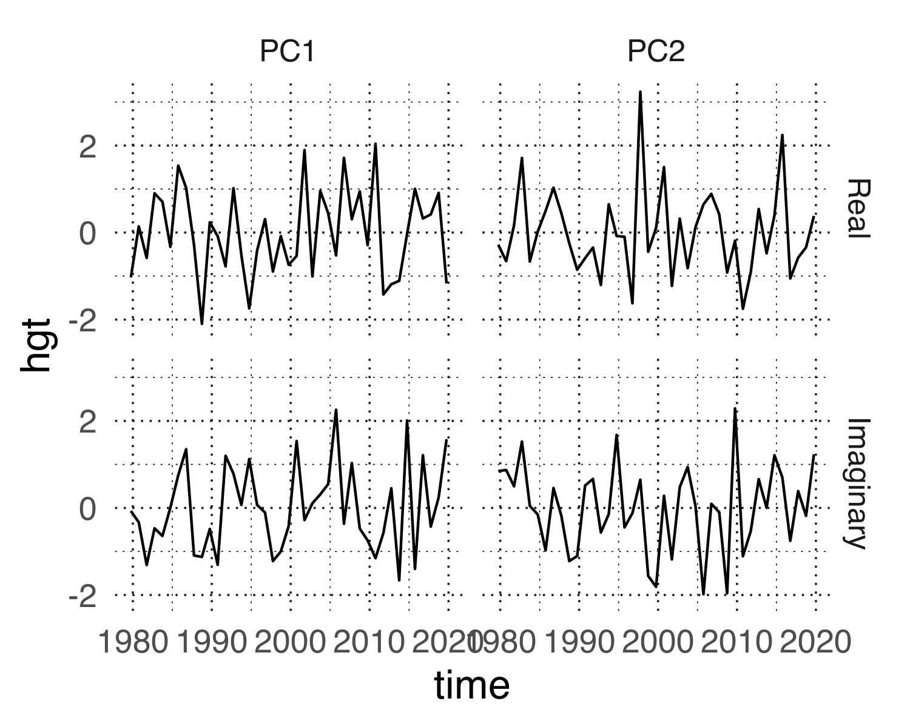

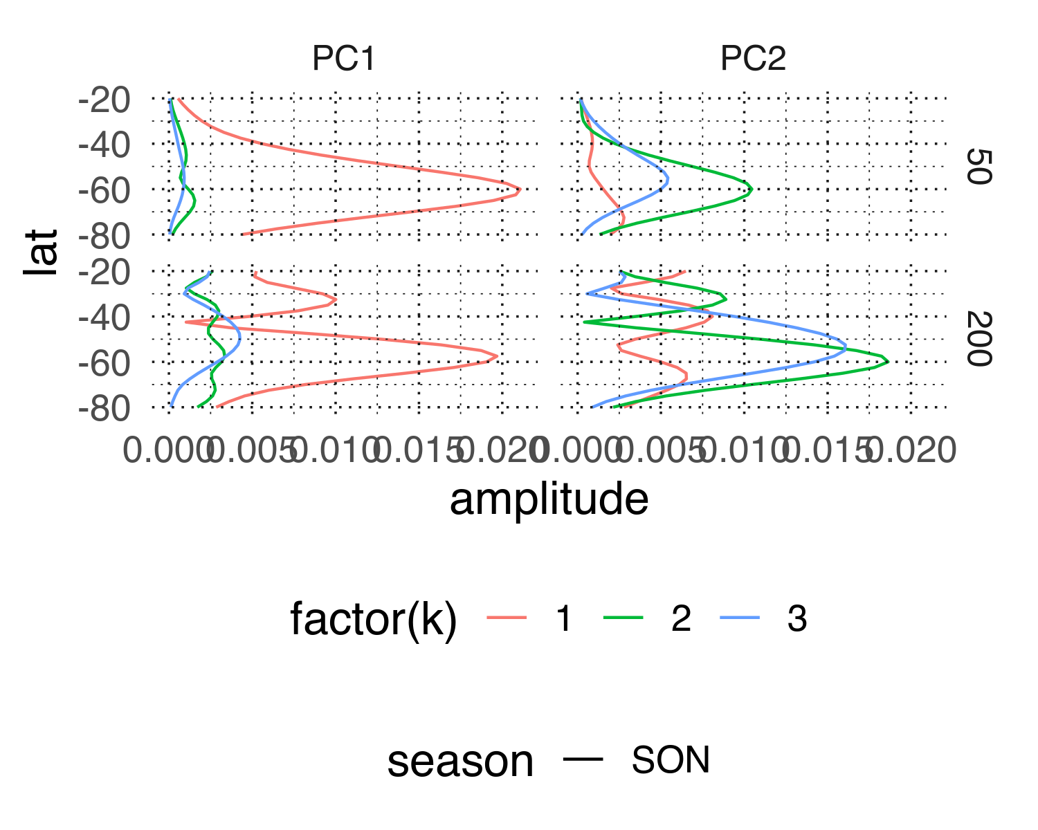

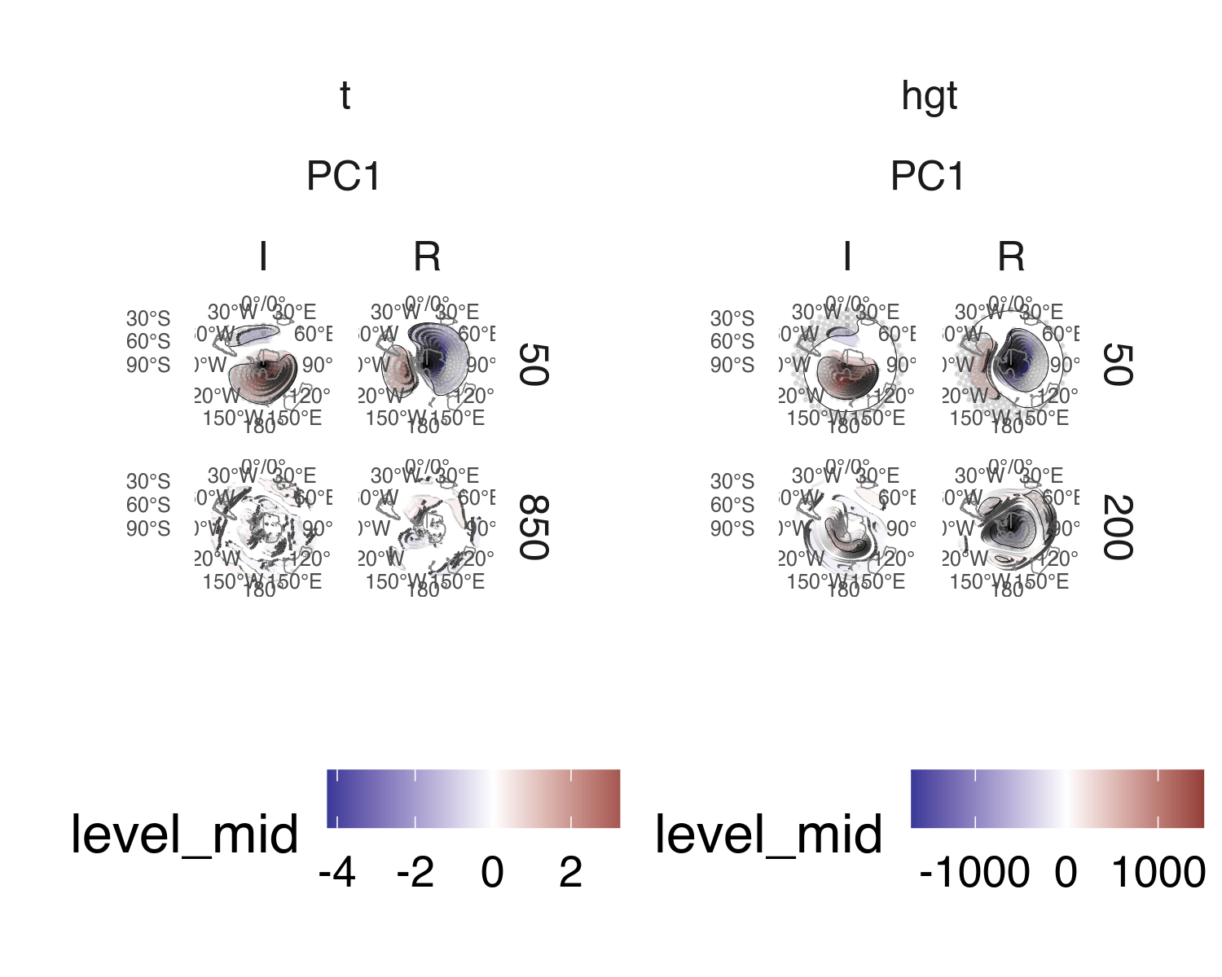

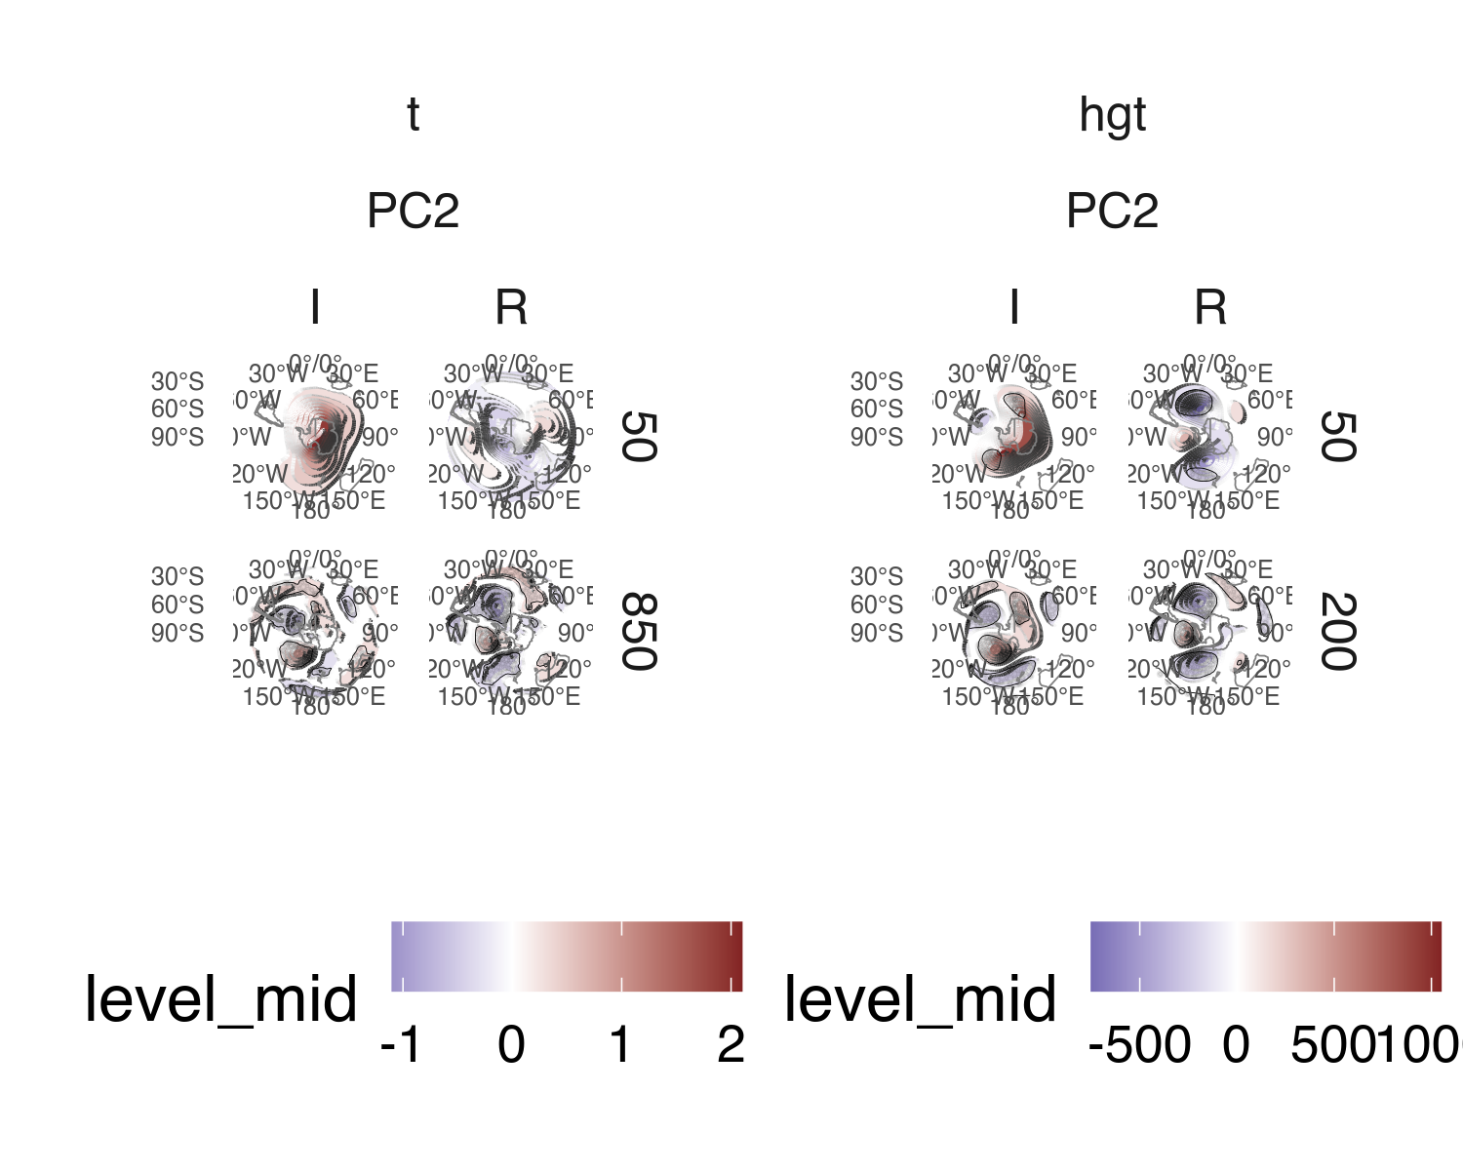

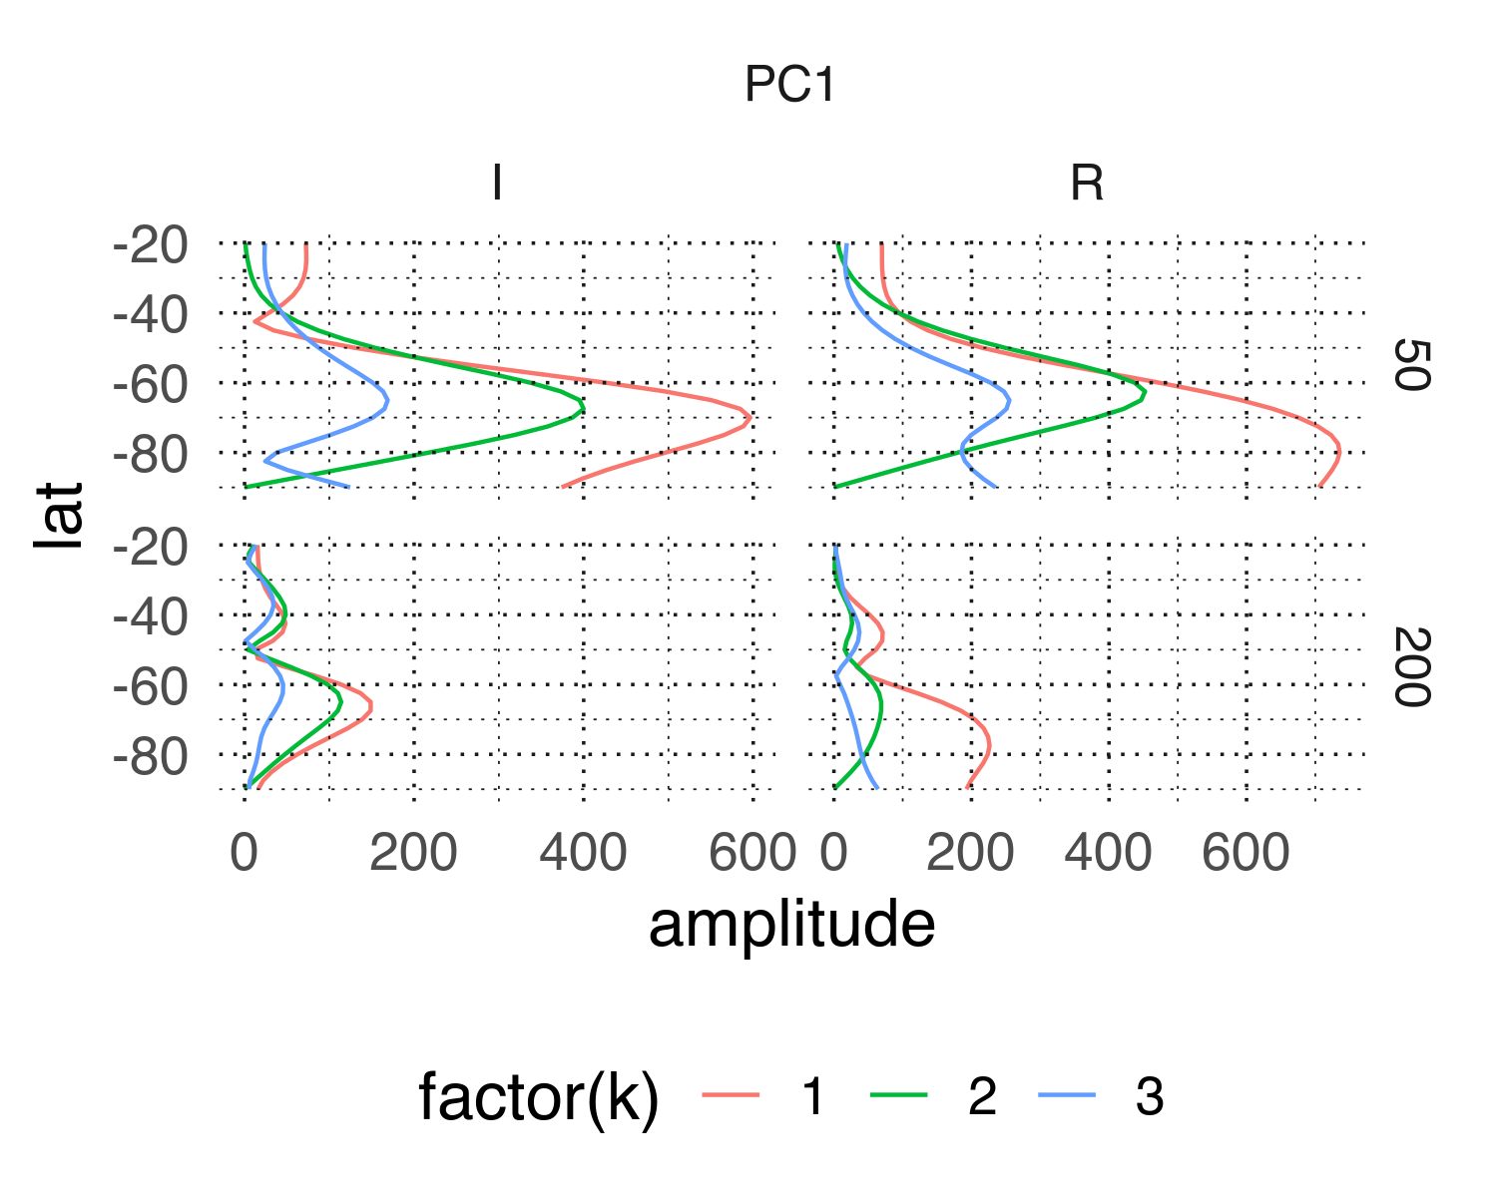

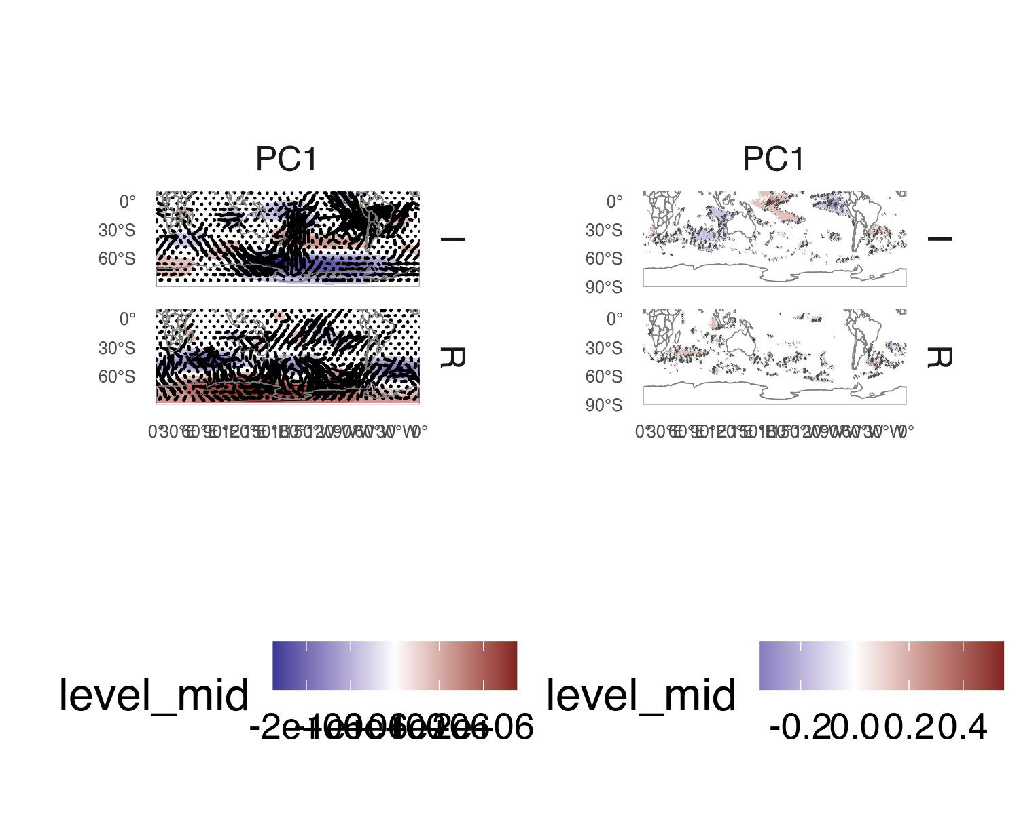

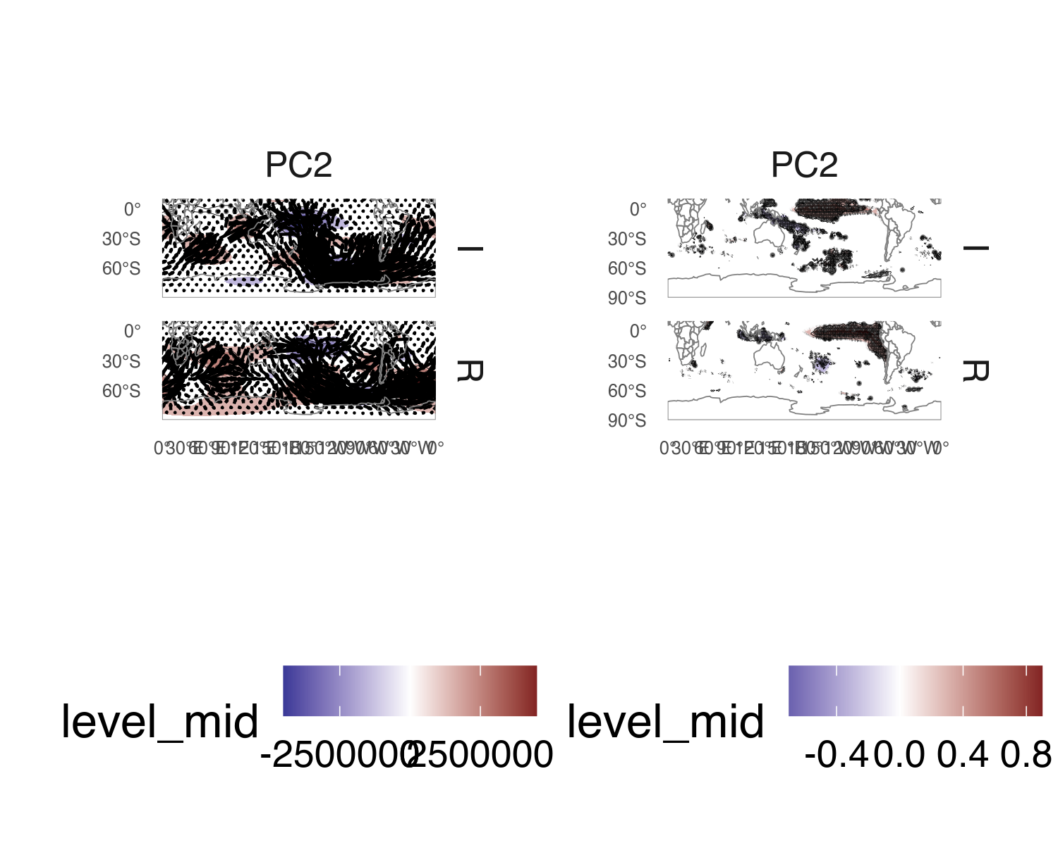

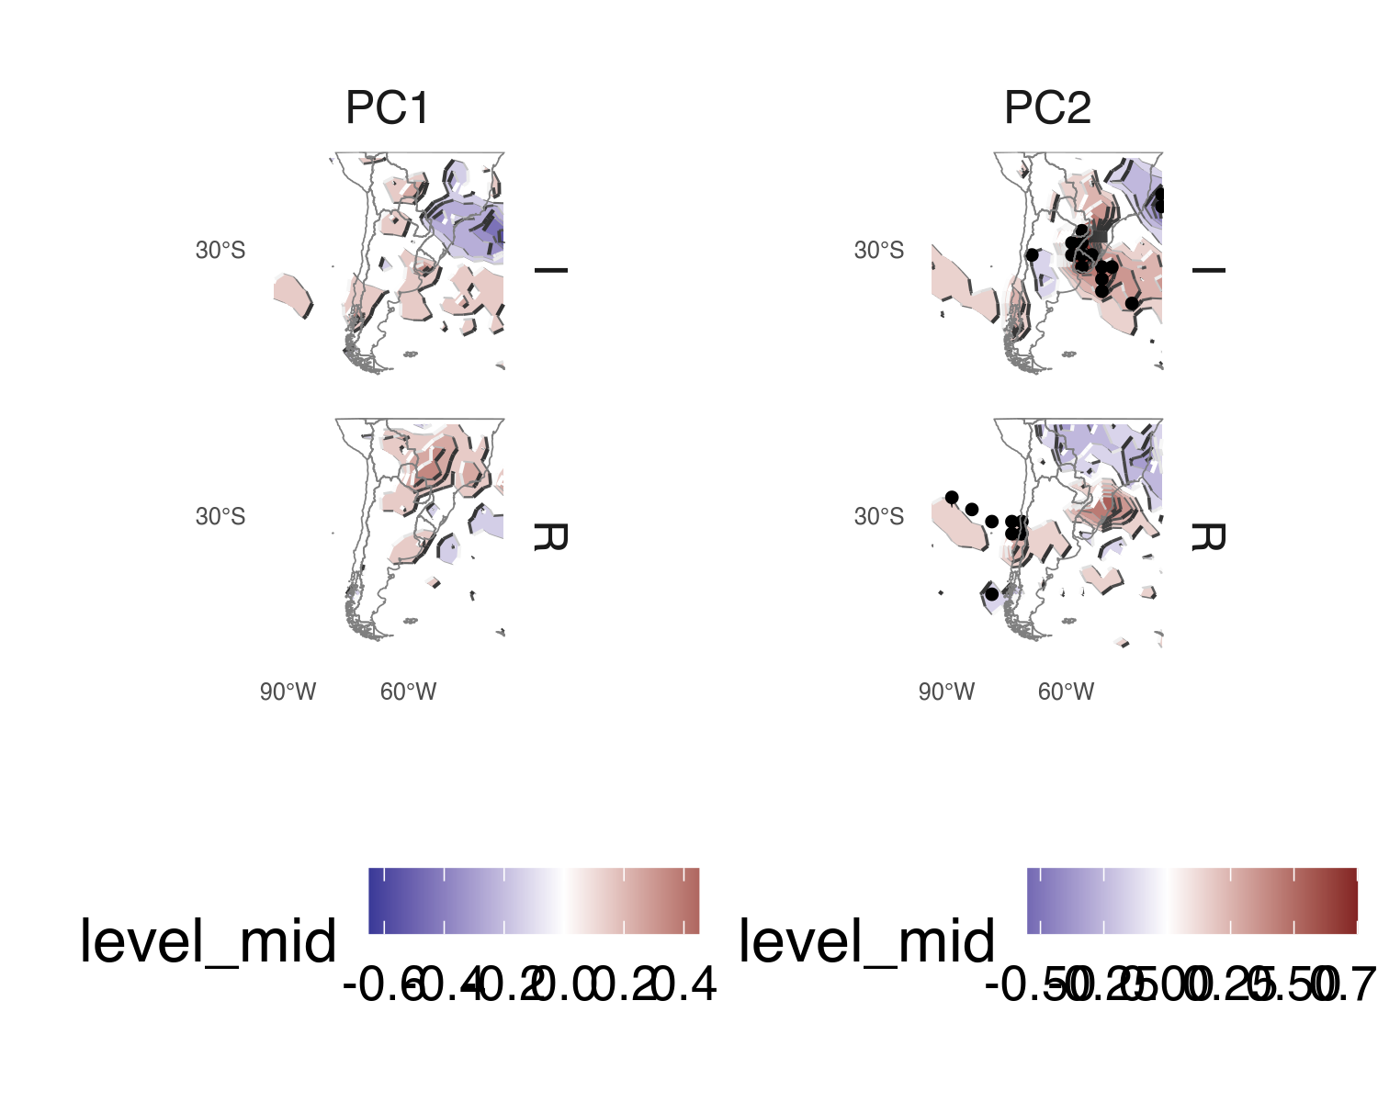

# 1 References

### 1.0.1 Colophon

This report was generated on 2020-10-28 18:07:39 using the following computational environment and dependencies:

#> ─ Session info ───────────────────────────────────────────────────────────────  
#> setting value   
#> version R version 4.0.3 (2020-10-10)   
#> os elementary OS 5.1.7 Hera   
#> system x86_64, linux-gnu   
#> ui X11   
#> language en_GB:en   
#> collate en_GB.UTF-8   
#> ctype en_GB.UTF-8   
#> tz America/Argentina/Buenos_Aires  
#> date 2020-10-28   
#>   
#> ─ Packages ───────────────────────────────────────────────────────────────────  
#> package * version date lib  
#> assertthat 0.2.1 2019-03-21 [1]  
#> backports 1.1.10 2020-09-15 [1]  
#> bitops 1.0-6 2013-08-17 [1]  
#> bookdown 0.21 2020-10-13 [1]  
#> callr 3.5.1 2020-10-13 [1]  
#> checkmate 2.0.0 2020-02-06 [1]  
#> class 7.3-17 2020-04-26 [4]  
#> classInt 0.4-3 2020-04-07 [1]  
#> cli 2.1.0 2020-10-12 [1]  
#> colorspace 1.4-1 2019-03-18 [1]  
#> crayon 1.3.4.9000 2020-10-02 [1]  
#> crul 1.0.0 2020-07-30 [1]  
#> curl 4.3 2019-12-02 [1]  
#> data.table * 1.13.2 2020-10-19 [1]  
#> DBI 1.1.0 2019-12-15 [1]  
#> desc 1.2.0 2018-05-01 [1]  
#> devtools 2.3.2 2020-09-18 [1]  
#> digest 0.6.27 2020-10-24 [1]  
#> dplyr 1.0.2 2020-08-18 [1]  
#> e1071 1.7-4 2020-10-14 [1]  
#> ellipsis 0.3.1 2020-05-15 [1]  
#> evaluate 0.14 2019-05-28 [1]  
#> fansi 0.4.1 2020-01-08 [1]  
#> farver 2.0.3 2020-01-16 [1]  
#> foreign 0.8-79 2020-04-26 [4]  
#> Formula 1.2-4 2020-10-16 [1]  
#> formula.tools 1.7.1 2018-03-01 [1]  
#> fs 1.5.0 2020-07-31 [1]  
#> generics 0.0.2 2018-11-29 [1]  
#> geojson 0.3.4 2020-06-23 [1]  
#> geojsonio 0.9.2 2020-04-07 [1]  
#> geojsonlint 0.4.0 2020-02-13 [1]  
#> ggh4x 0.1.0.9000 2020-10-27 [1]  
#> ggpattern 0.1.3 2020-10-23 [1]  
#> ggperiodic * 1.0.0 2019-03-12 [1]  
#> ggplot2 * 3.3.2 2020-06-19 [1]  
#> glue 1.4.2 2020-08-27 [1]  
#> gridGeometry 0.2-0 2019-05-03 [1]  
#> gtable 0.3.0 2019-03-25 [1]  
#> here 0.1 2017-05-28 [1]  
#> hms 0.5.3 2020-01-08 [1]  
#> htmltools 0.5.0.9002 2020-10-26 [1]  
#> httpcode 0.3.0 2020-04-10 [1]  
#> irlba 2.3.3 2019-02-05 [1]  
#> isoband 0.2.2 2020-06-20 [1]  
#> jqr 1.1.0 2018-10-22 [1]  
#> jsonlite 1.7.1 2020-09-07 [1]  
#> jsonvalidate 1.1.0 2019-06-25 [1]  
#> KernSmooth 2.23-17 2020-04-26 [1]  
#> knitr 1.30.2 2020-10-26 [1]  
#> labeling 0.4.2 2020-10-20 [1]  
#> lattice 0.20-41 2020-04-02 [1]  
#> lazyeval 0.2.2 2019-03-15 [1]  
#> lifecycle 0.2.0 2020-03-06 [1]  
#> lubridate 1.7.9 2020-06-08 [1]  
#> magick 2.5.0 2020-10-16 [1]  
#> magrittr * 1.5 2014-11-22 [1]  
#> maps 3.3.0 2018-04-03 [1]  
#> maptools 1.0-2 2020-08-24 [1]  
#> Matrix 1.2-18 2019-11-27 [4]  
#> memoise 1.1.0 2017-04-21 [1]  
#> metR * 0.8.0 2020-10-22 [1]  
#> munsell 0.5.0 2018-06-12 [1]  
#> ncdf4 1.17 2019-10-23 [1]  
#> operator.tools 1.6.3 2017-02-28 [1]  
#> patchwork * 1.0.1 2020-06-22 [1]  
#> pillar 1.4.6 2020-07-10 [1]  
#> pkgbuild 1.1.0 2020-07-13 [1]  
#> pkgconfig 2.0.3 2019-09-22 [1]  
#> pkgload 1.1.0 2020-05-29 [1]  
#> plotrix 3.7-8 2020-04-16 [1]  
#> plyr 1.8.6 2020-03-03 [1]  
#> png 0.1-7 2013-12-03 [1]  
#> polyclip 1.10-0 2019-03-14 [1]  
#> prettyunits 1.1.1 2020-01-24 [1]  
#> processx 3.4.4 2020-09-03 [1]  
#> ps 1.4.0 2020-10-07 [1]  
#> purrr 0.3.4 2020-04-17 [1]  
#> R6 2.4.1 2019-11-12 [1]  
#> rasterImage 0.4.0 2019-10-14 [1]  
#> Rcpp 1.0.5 2020-07-06 [1]  
#> RCurl 1.98-1.2 2020-04-18 [1]  
#> readr 1.4.0 2020-10-05 [1]  
#> remotes 2.2.0 2020-07-21 [1]  
#> rgdal 1.5-18 2020-10-13 [1]  
#> rgeos 0.5-5 2020-09-07 [1]  
#> rlang 0.4.8 2020-10-08 [1]  
#> rmapshaper 0.4.4 2020-04-01 [1]  
#> rmarkdown 2.5 2020-10-21 [1]  
#> rprojroot 1.3-2 2018-01-03 [1]  
#> scales 1.1.1 2020-05-11 [1]  
#> sessioninfo 1.1.1 2018-11-05 [1]  
#> sf 0.9-6 2020-09-13 [1]  
#> shceof * 0.1.0 2020-10-28 [1]  
#> sp 1.4-4 2020-10-07 [1]  
#> spectral 1.3 2019-06-03 [1]  
#> sticky 0.5.6.1 2020-03-16 [1]  
#> stringi 1.5.3 2020-09-09 [1]  
#> stringr 1.4.0 2019-02-10 [1]  
#> tagger * 0.0.0.9000 2020-09-16 [1]  
#> testthat 2.3.2 2020-03-02 [1]  
#> tibble 3.0.4 2020-10-12 [1]  
#> tidyr 1.1.2 2020-08-27 [1]  
#> tidyselect 1.1.0 2020-05-11 [1]  
#> udunits2 0.13 2016-11-17 [1]  
#> units 0.6-7 2020-06-13 [1]  
#> usethis 1.6.3 2020-09-17 [1]  
#> V8 3.2.0 2020-06-19 [1]  
#> vctrs 0.3.4 2020-08-29 [1]  
#> withr 2.3.0 2020-09-22 [1]  
#> xfun 0.18 2020-09-29 [1]  
#> yaml 2.2.1 2020-02-01 [1]  
#> source   
#> CRAN (R 4.0.2)   
#> CRAN (R 4.0.2)   
#> RSPM (R 4.0.2)   
#> CRAN (R 4.0.3)   
#> CRAN (R 4.0.3)   
#> RSPM (R 4.0.2)   
#> CRAN (R 4.0.0)   
#> RSPM (R 4.0.2)   
#> CRAN (R 4.0.3)   
#> CRAN (R 4.0.2)   
#> Github (r-lib/crayon@6b3f0c6)   
#> CRAN (R 4.0.2)   
#> CRAN (R 4.0.2)   
#> CRAN (R 4.0.3)   
#> RSPM (R 4.0.2)   
#> CRAN (R 4.0.2)   
#> CRAN (R 4.0.2)   
#> CRAN (R 4.0.3)   
#> CRAN (R 4.0.2)   
#> CRAN (R 4.0.3)   
#> RSPM (R 4.0.2)   
#> CRAN (R 4.0.2)   
#> CRAN (R 4.0.2)   
#> RSPM (R 4.0.2)   
#> CRAN (R 4.0.0)   
#> CRAN (R 4.0.3)   
#> RSPM (R 4.0.2)   
#> CRAN (R 4.0.2)   
#> RSPM (R 4.0.2)   
#> RSPM (R 4.0.2)   
#> RSPM (R 4.0.2)   
#> RSPM (R 4.0.2)   
#> Github (teunbrand/ggh4x@0edf548)   
#> Github (coolbutuseless/ggpattern@8c5abf9)  
#> RSPM (R 4.0.2)   
#> CRAN (R 4.0.2)   
#> CRAN (R 4.0.2)   
#> CRAN (R 4.0.3)   
#> RSPM (R 4.0.2)   
#> RSPM (R 4.0.2)   
#> RSPM (R 4.0.2)   
#> Github (rstudio/htmltools@079503c)   
#> RSPM (R 4.0.2)   
#> CRAN (R 4.0.2)   
#> RSPM (R 4.0.2)   
#> RSPM (R 4.0.2)   
#> CRAN (R 4.0.2)   
#> RSPM (R 4.0.2)   
#> RSPM (R 4.0.2)   
#> Github (yihui/knitr@f409cd9)   
#> CRAN (R 4.0.3)   
#> RSPM (R 4.0.2)   
#> CRAN (R 4.0.2)   
#> CRAN (R 4.0.2)   
#> RSPM (R 4.0.2)   
#> CRAN (R 4.0.3)   
#> CRAN (R 4.0.2)   
#> RSPM (R 4.0.2)   
#> CRAN (R 4.0.2)   
#> CRAN (R 4.0.0)   
#> CRAN (R 4.0.2)   
#> local   
#> RSPM (R 4.0.2)   
#> CRAN (R 4.0.2)   
#> RSPM (R 4.0.2)   
#> CRAN (R 4.0.2)   
#> CRAN (R 4.0.2)   
#> CRAN (R 4.0.2)   
#> CRAN (R 4.0.2)   
#> CRAN (R 4.0.2)   
#> CRAN (R 4.0.3)   
#> RSPM (R 4.0.2)   
#> RSPM (R 4.0.2)   
#> CRAN (R 4.0.2)   
#> CRAN (R 4.0.2)   
#> CRAN (R 4.0.2)   
#> CRAN (R 4.0.3)   
#> CRAN (R 4.0.2)   
#> RSPM (R 4.0.2)   
#> CRAN (R 4.0.3)   
#> CRAN (R 4.0.2)   
#> RSPM (R 4.0.2)   
#> CRAN (R 4.0.3)   
#> CRAN (R 4.0.2)   
#> CRAN (R 4.0.3)   
#> CRAN (R 4.0.2)   
#> CRAN (R 4.0.3)   
#> RSPM (R 4.0.2)   
#> CRAN (R 4.0.3)   
#> CRAN (R 4.0.2)   
#> RSPM (R 4.0.2)   
#> CRAN (R 4.0.2)   
#> CRAN (R 4.0.2)   
#> local   
#> CRAN (R 4.0.3)   
#> CRAN (R 4.0.3)   
#> RSPM (R 4.0.2)   
#> CRAN (R 4.0.2)   
#> CRAN (R 4.0.2)   
#> local   
#> CRAN (R 4.0.2)   
#> CRAN (R 4.0.3)   
#> CRAN (R 4.0.2)   
#> RSPM (R 4.0.2)   
#> CRAN (R 4.0.2)   
#> RSPM (R 4.0.2)   
#> CRAN (R 4.0.2)   
#> RSPM (R 4.0.2)   
#> CRAN (R 4.0.2)   
#> CRAN (R 4.0.3)   
#> CRAN (R 4.0.2)   
#> CRAN (R 4.0.2)   
#>   
#> [1] /home/elio/R/x86_64-pc-linux-gnu-library/4.0  
#> [2] /usr/local/lib/R/site-library  
#> [3] /usr/lib/R/site-library  
#> [4] /usr/lib/R/library

The current Git commit details are: