|  |
| --- |
| **PROJECT 1 DESIGN DOCUMENT** |
|  |
| CS 5610  **John Alexis Guerra Gomez**  **Authored by: Elliot Khouri** |

TABLE OF CONTENTS

**SECTION 1 PROJECT DESCRIPTION** 3

**SECTION 2 USER PERSONAS** 4

**SECTION 3 USER STORIES** 6

**SECTION 4 DESIGN MOCKUPS** 7

# **SECTION 1 PROJECT DESCRIPTION**

My name is Elio Khouri and this is my first foray into front end web development...

I decided to create a personal homepage that housed my resume, contact information, skills, education, hobbies and more, I tried to include anything that a potential recruiter would like to know about me. As a computer science student, one of my main objectives is to eventually transition out of the class room and into the workforce, and part of this process includes sharing my profile (who I am and what my background is) and selling myself as an attractive potential hire. This webpage is a barebones sales catalog of “Elio Khouri”, it contains all the pertinent information about me, however it will evolve over time, either as it becomes a more encompassing webpage about me or as a framework/guideline used to build a version 2.0.

# **SECTION 2 USER PERSONAS**

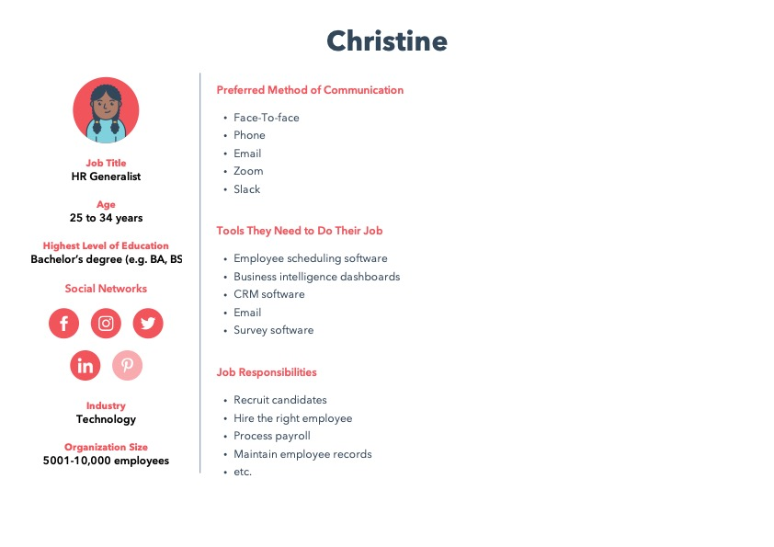

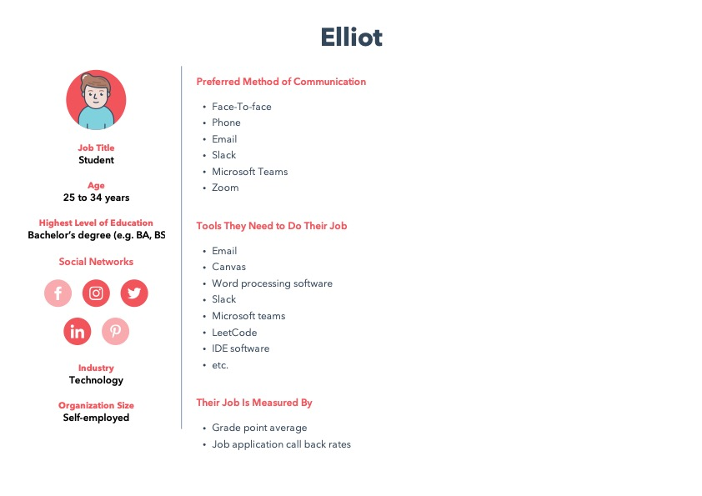

# **SECTION 3 USER STORIES**

* As a HR generalist recruiter, Christine has found Elio Khouri’s LinkedIn profile and would like to know more about him, she decides to visit his personal webpage to find out more about his skills and education.
* As a hiring manager, Michael is interested in the technical skills that Elio Khouri has to offer, he decides to visit his personal homepage, where he finds his GitHub account. He can then view all of Elio Khouri’s work on his GitHub.
* As computer science student, Elio Khouri is trying to get his foot in the door at a company, he attends networking events where he shares his business card (that has his website on it) with contacts that he would like to follow-up with.
* As a computer science student, Elio Khouri would like to show off his personal side projects and experience on LinkedIn, he decides to link his personal website so that potential recruiters can view more about his work.
* As a computer science student, Vanessa would like to see more about Elio’s background and projects so that she can build up her own repertoire. She visits his webpage and uses it for inspiration.
* As an instructor, John Alexis Guerra Gómez, would like to feature his past student’s work on his own materials as an example to current students. He includes Elio Khouri’s work on his materials as a reference point for his current students.
* These are just a few of the main user stories that are related to this project.

# **SECTION 4 DESIGN MOCKUPS**

