INTRO TO TROJAN - Challenges:

- Access the simulator using the following link [https://elior2000.github.io/Intro_to_Trojans_Simulator/], complete Mission 1, and submit the code displayed upon successful completion.

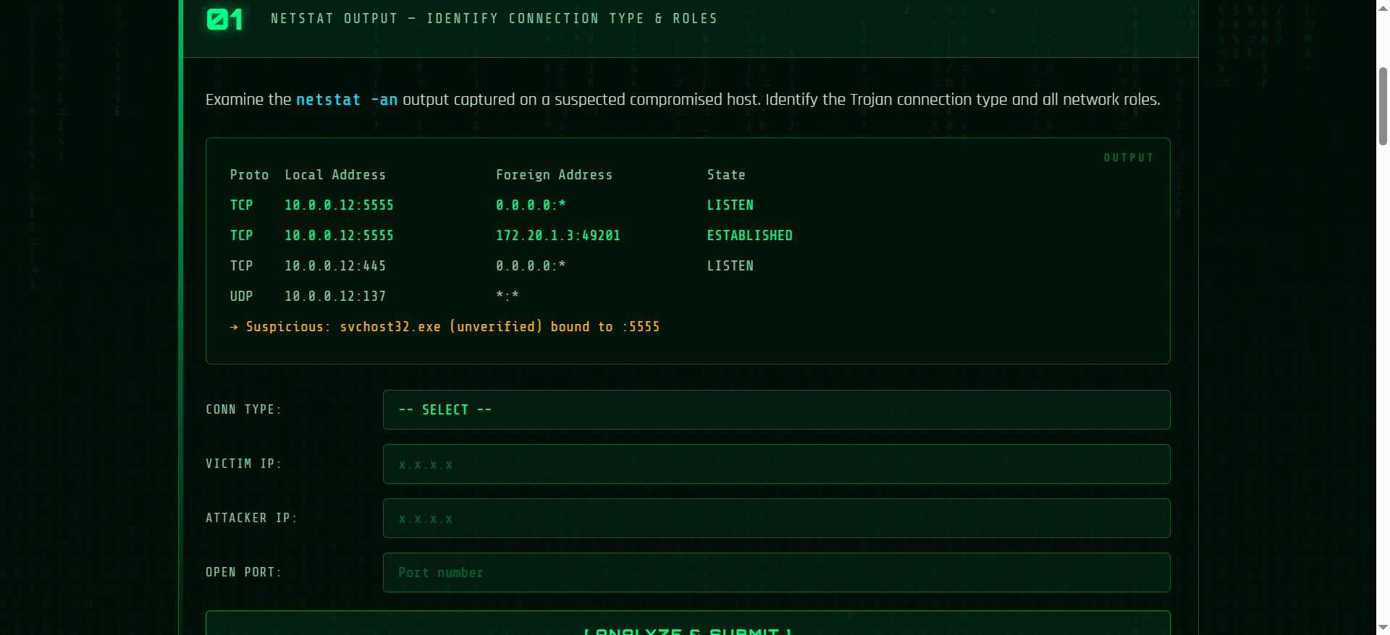

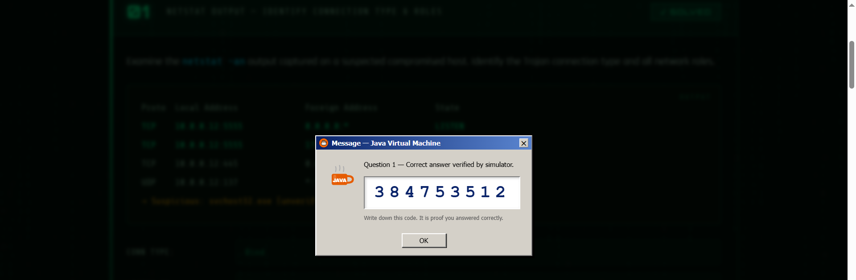

384753512

- In the simulator, complete Mission 2, and submit the code displayed upon successful completion.

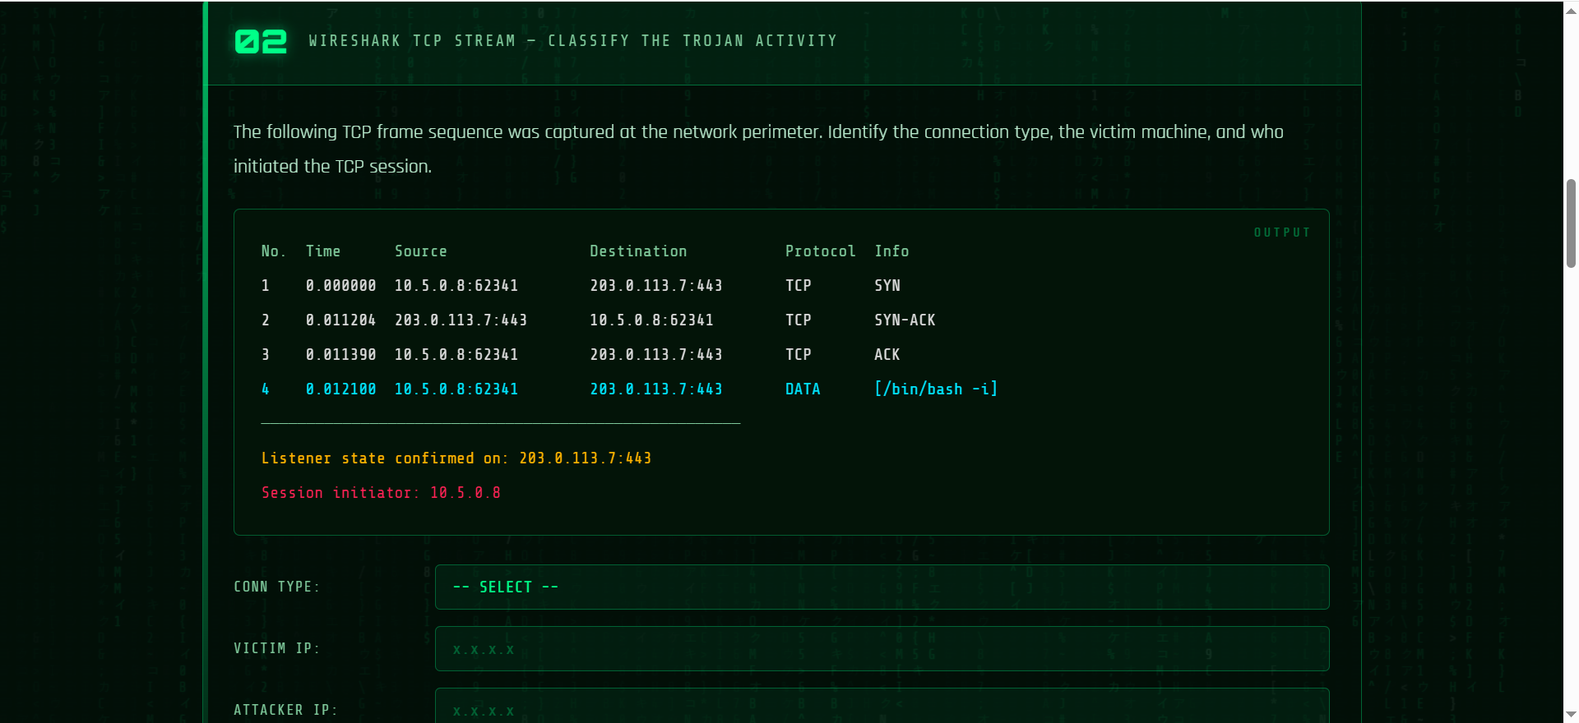



729167209

- Complete Mission 3 in the simulator and submit the code displayed upon successful completion.

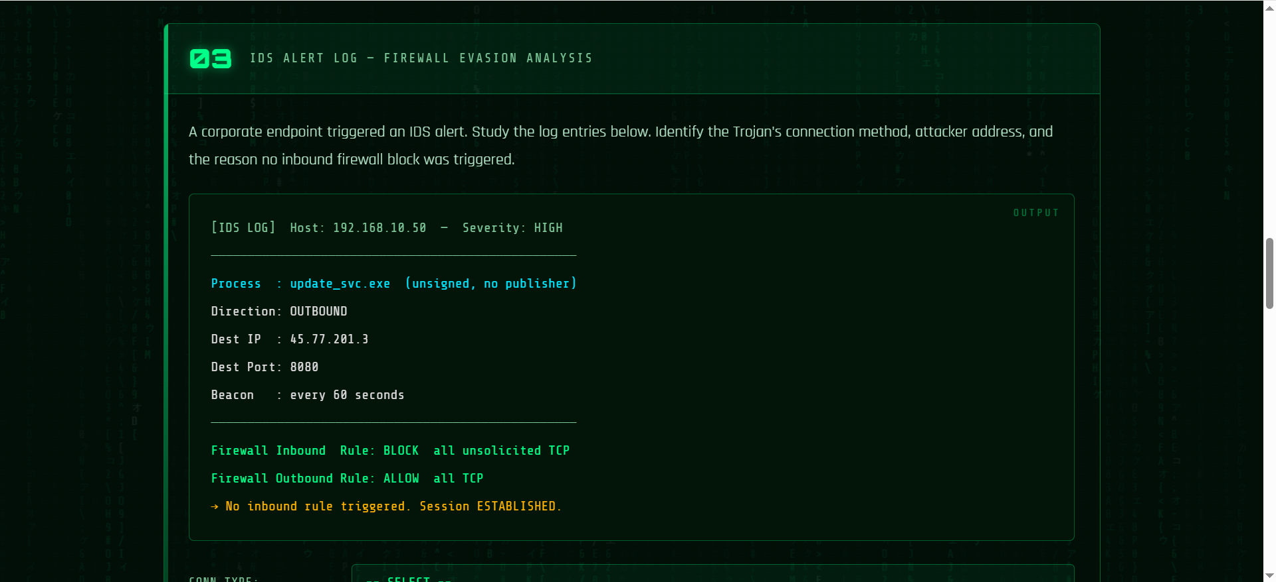



516398825

- Complete Mission 4 in the simulator and submit the code displayed upon successful completion.

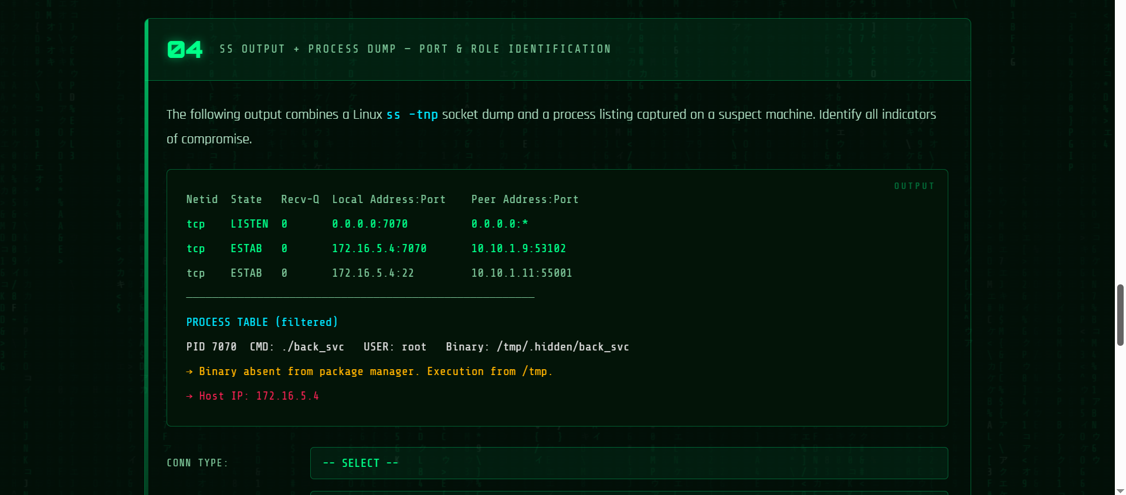



902477720

- Complete Mission 5 in the simulator and submit the code displayed upon successful completion.

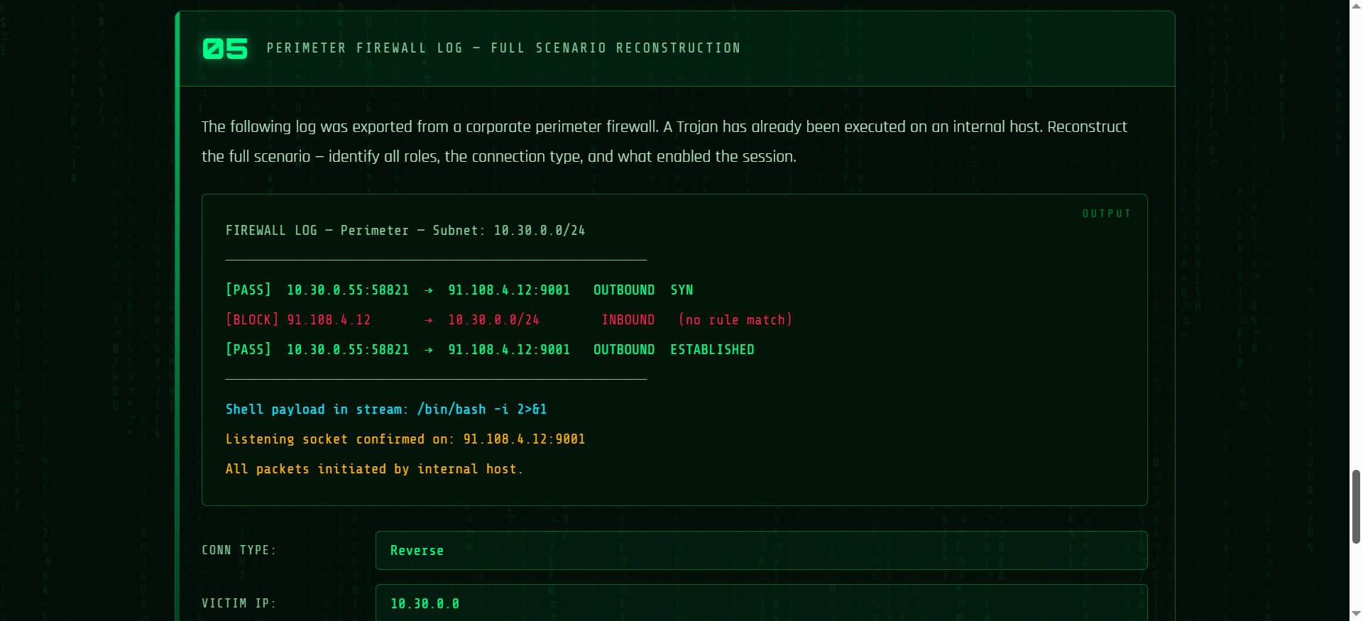



675801633

