The OSI Model - Challenge:
- Download the PCAP file, and find what protocol is shown under the application layer in every packet.
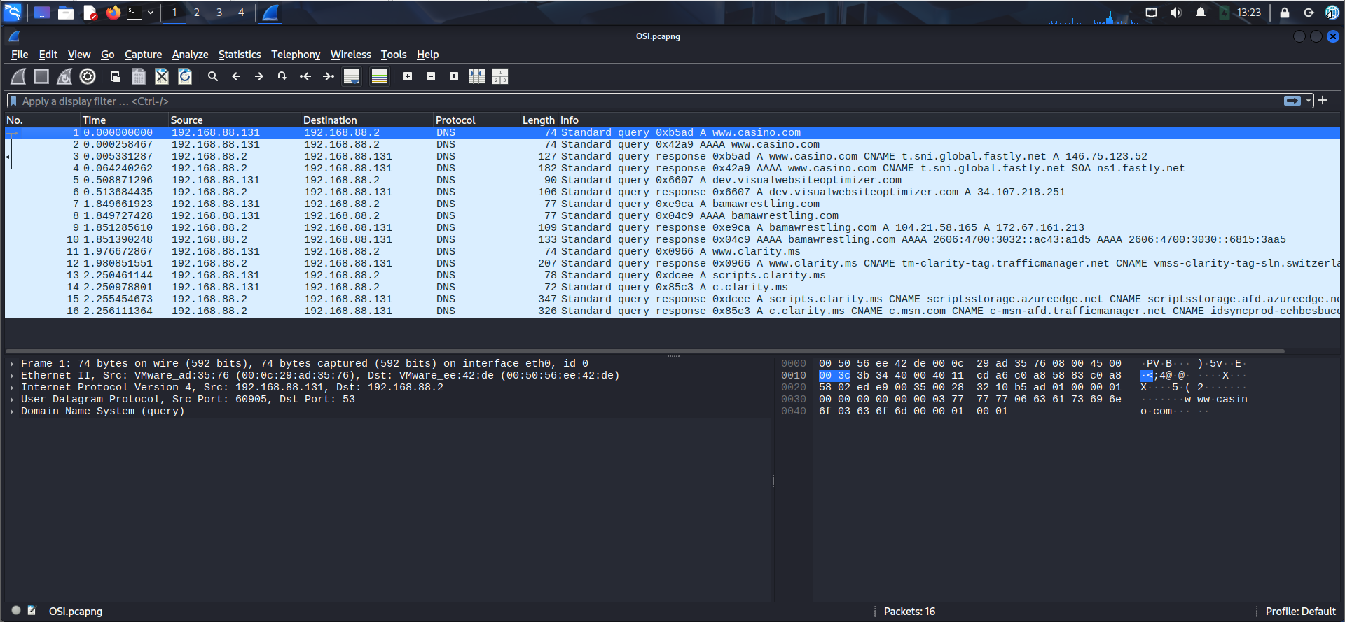

DNS

- Investigate the first packet and find the MAC address of the local host.

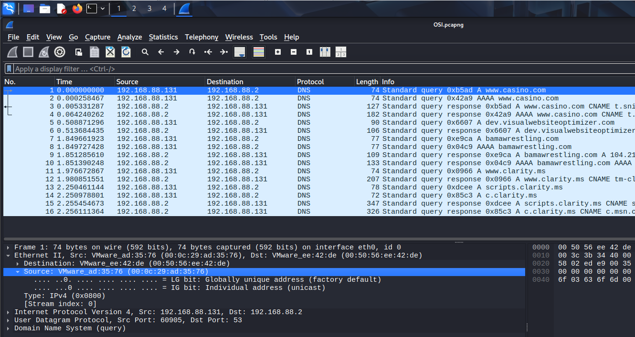

00:0c:29:ad:35:76
- Investigate the first packet, and find the transport layer protocol used.

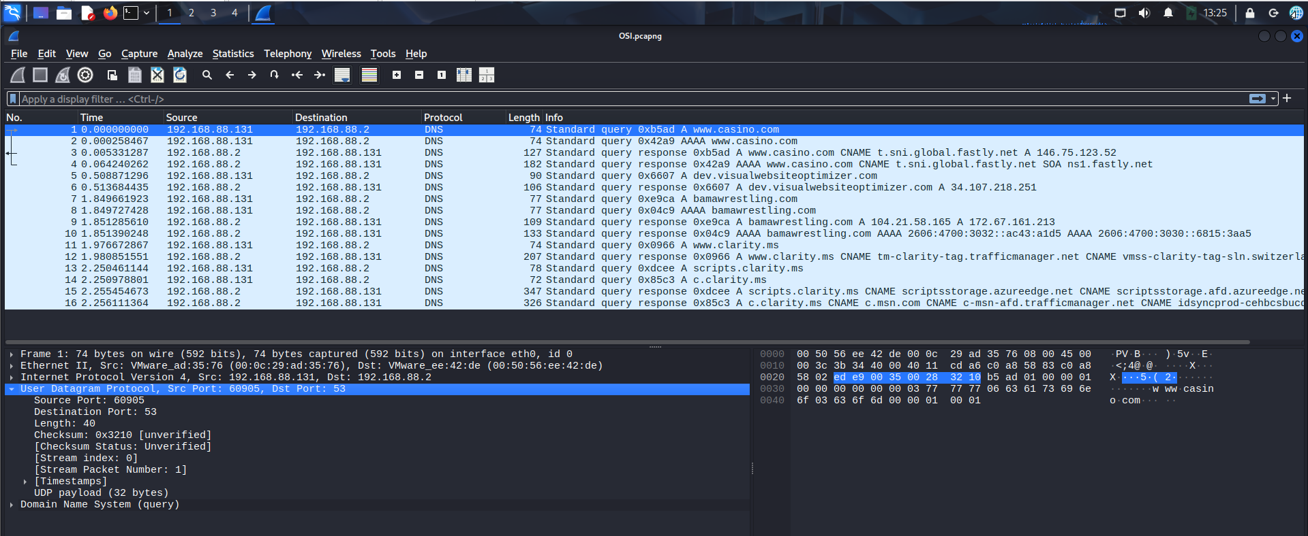

UDP

- Investigate the first packet and find how many layers are there based on the OSI model.

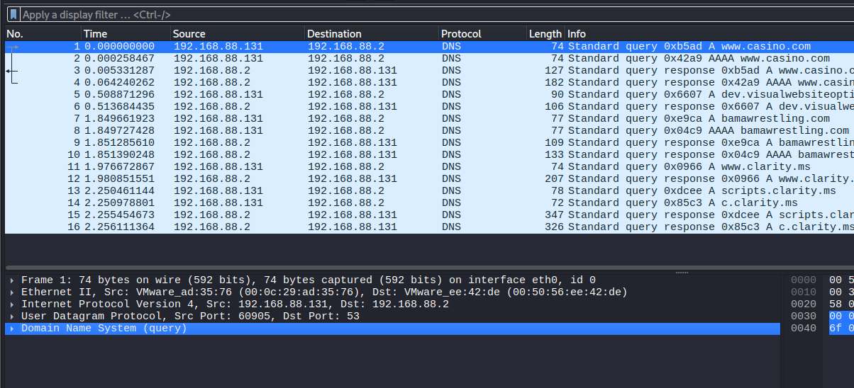

4

