Storm 1811 CTI Report Mapping
  - Lab 1 | CTI analysis and SOC investigation

Selected Report
Microsoft Threat Intelligence. Threat actors misusing Quick Assist in social engineering attacks leading to ransomware. Published 15 May 2024; updated June 2024.
Original CTI report

Attack Description
Microsoft Threat Intelligence describes activity by Storm-1811, a financially motivated threat actor using social engineering to gain access to user devices and organizational networks. The reported activity was observed from mid-April 2024 and, in several cases, led to deployment of Black Basta ransomware.
In some cases, attackers flood a user's inbox with email, then call while impersonating technical support. They offer to resolve the spam problem and persuade the user to grant access through Quick Assist, a legitimate remote assistance tool. After the user approves control of the device, the attackers use cURL to download scripts and other files.
The report describes remote access tools including ScreenConnect and NetSupport Manager, alongside malicious tooling such as Qakbot and Cobalt Strike. Following initial access, further activity includes domain enumeration and lateral movement. In several cases, attackers use PsExec to deploy ransomware throughout the network.
The report presents multiple variations of this activity. The tools and stages should therefore not be treated as a single sequence observed in every incident. This analysis focuses on explicitly documented behaviors.

Attack Flow
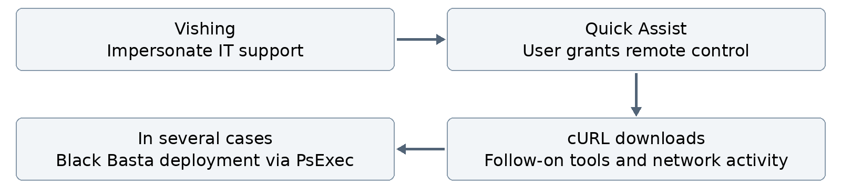
Reported pathway, not a single reconstructed incident. The order of actions within follow-on activity is not fully specified.

Uncertain Mapping
The report states domain enumeration without specifying the target. Discovery is supported, but Remote System Discovery (T1018) and Account Discovery: Domain Account (T1087.002) remain alternatives. Commands, query targets, or saved output showing computers versus accounts would resolve the choice. Neither is confirmed here.
Peer review: discuss this uncertainty with another group or the instructor, then record the reviewer, date, and decision. This discussion is still pending.

Tactics Techniques and SOC Investigation
Evidence in the Microsoft report: Social engineering covers calls and Quick Assist; Follow-on activity leading to Black Basta ransomware covers downloads and PsExec. SOC entries are proposed checks, assuming the relevant telemetry is collected.
Observed behavior | Tactic | Technique and ID | Evidence and rationale | SOC telemetry and investigation
Fake IT support call | Initial  Access | Phishing:  Spearphishing Voice  T1566.004 | The attacker uses a voice call to persuade the victim to grant access. Explicit evidence supports the voice sub-technique. | Call records and the user's description; verify against approved support activity.
Remote control through Quick Assist | Command  and Control | Remote Access Tools:  Remote Desktop Software  T1219.002 | The victim approves control through legitimate support software. Our mapping covers the interactive control channel. | Telemetry: process and network records; EDR alerts.  Tier 1: verify user, time, and support approval.  Tier 2: reconstruct session activity and identify downloaded files or additional tools.
Batch and ZIP downloads using cURL | Command  and Control | Ingress Tool Transfer  T1105  No sub-techniques | The report explicitly describes transferring files into the compromised environment after control is granted. | Telemetry: command line, parent process, connections, and file creation.  Tier 1: inspect source, path, and initiating process.  Tier 2: correlate events, check later execution, and search other devices.
Black Basta deployment using PsExec | Execution | System Services:  Service Execution  T1569.002 | PsExec use is explicit. Service execution is a technical inference from its mechanism; service records would directly confirm it. | Telemetry: process, service, and authentication records.  Tier 1: verify source, account, targets, and approved administration.  Tier 2: link service to payload and process; assess spread and actual ransomware execution.

Escalate unexplained or suspicious activity from Tier 1 to Tier 2. Legitimate tool use alone does not prove malicious intent, and a download does not prove execution.
MITRE ATT&CK mappings checked on 18 October 2026. Technique IDs link directly to their definitions.

