Part1: Vanilla Options
Weather Derivatives are priced on the P probability measure and so we only need historical to price them.
- Create an API to query historical weather data: https://open-meteo.com/en/docs/historical-weather-api
  - First by one single point; the function that you use for one point should start like this :
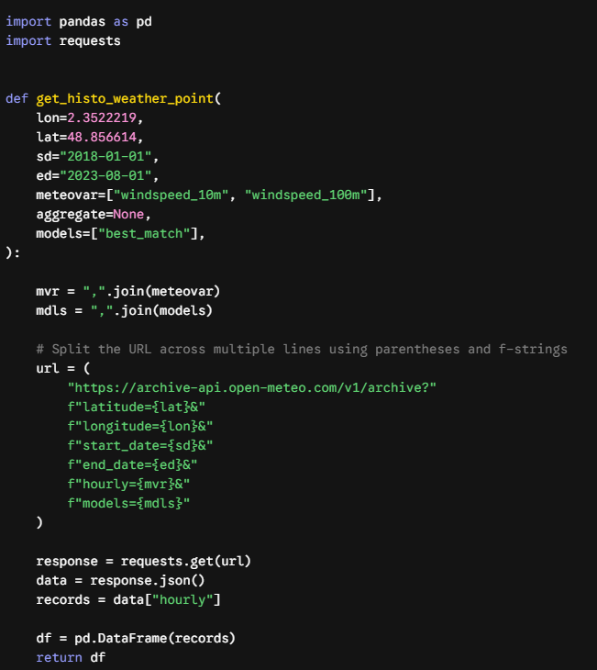
  - Add a “d24” aggregation in the function since this is hourly data to get a daily aggregation and then add a “gasday” aggregation as well
  - Make sure you can query Temperature (2 m), Wind Speed (100 m) correctly. This is what is needed in this project
  - Create a get_histo_multi_point function that takes as input multiple grid points as dictionaries for example:
get_histo_weather_multi_points(pts = {"Paris" : [2.349014, 48.864716], "Marseille":[5.36978, 43.296482]}, sd = "2018-01-01", ed = "2023-08-01", meteovar = ["windspeed_10m","windspeed_100m"], aggregate = None, models = ["best_match"])
- Query the temperature data over the last 10 complete years (2015-2025) for the stations in the gas_stations_file and weight them as a function of what exists in the ratio column to create a single hourly temperature index for France
  - Aggregate this index by gas day
  - What do we notice temperature is doing? we do something about it There are 2 ways to handle this:
    - Acting on the strike
    - Acting on the underlying
    - Explain and write a function for both
  - Calculate an HDD vector which is simply
  - Price a call option on this HDD vector on q1:
    - For each Q1 of each year get the sum of the HDD vector you should have 10 HDD Q1 values, 1 for every year, we call this I_year
    - Consider a notional of 1000 € and a payoff defined as:
$$\text{Payoff}=\max\left(0,I_{\text{year}}-K\right)×\text{Notional}$$
    - How much does this call option on HDD cost if we consider a strike of 30 days, 35 days ? Consider the price as being:
$$\text{Burn Analysis Value}=\overline{X}+0.2×σ_{X}$$
Where:
- $\overline{X}$ is the average past payoff calculated over historical observation windows, here i is the number of periods so the number of quarters and so the number of years so 10:
$$\overline{X}=\frac{1}{n}\sum_{i=1}^{n}{{\text{Payoff}}_{i}}$$
- $σ_{X}$ is the volatility of past payoffs (measured as the standard deviation of historical payoffs):
$$σ_{X}=\sqrt{\frac{1}{n-1}\sum_{i=1}^{n}{{\left({\text{Payoff}}_{i}-\overline{X}\right)}^{2}}}$$

    - What is your payoff in q1 25 if you had bought this call option? Was it worth it ?
- Query the wind data over the last 10 complete years (2015-2025) for the stations in the French_wind_power distribution file and weight them as a function of what exists in the ratio column to create a single hourly temperature index for France
  - Aggregate this index by day
  - Calculate an Wind vector which is simply
(For example, $WS_{\text{threshold}}=8\text{ m/s}$
  - Price a put option on this Wind I vector on the whole year:
    - You set the strike so that it paysoff 30 % of the years so 3 years / 10 in the past an amount for this exercise, choose 500k
    - Would it have paid off in 2026?
- Create a class called vanilla_weather_derivatives that initiates with:
  - a dictionary of locations, an NY to represent years in the past needed, a vol multiplication factor set by default to 0.2 and that is a private attribute
  - Create methods to query different meteo_variables
  - Create a method to assess trend existence
  - Create a method to price calls and puts
    - Be sure to have one method to price with a fixed strike set by the user and another that is optimized based on the level of payout needed
    - Be sure to add a toggle to handle trends in 2 different ways

Part2: Quanto Pricing Bootstrap Monte-Carlo:
To price a quanto simply and efficiently, you would do a burn analysis on the realized. Also, you would take PnL per month (or week) in the past and do different combinations. So for example, if you have a quanto on Q1 26, you would take the PnL of Jan 2019, Feb 2015, Mar 2017 and do multiple such combinations to create fake year payoff and get an average price from the fake years payoff+ the real year payoffs, and then you + k std(payoffs). This would permit you to not do a monte-carlo and to assume a correlation matrix between price and temperature. This also assumes that your correlation between months is non-existent, which is not true but still acceptable as an assumption.
Plot the prices in the peg_spot file. What do you notice?
Now using the peg_spot file structure 2 quanto weather derivatives
- A quanto weather derivative is a product that has both a price index and a temperature index.
- The quanto I want you to structure is one based on the temperature index and the prices
- I want a payoff in winter (q4-q1) when both temperatures are low and gas prices are high. Where the notional is 10k
$$\text{Payoff}=N×\max\left(K_{T}-T,0\right)×\max\left(P-K_{P},0\right)$$
  - $T$: Realized temperature (where lower values indicate colder weather).
  - $K_{T}$: Temperature strike threshold. Payoff increases as $T$ falls further below $K_{T}$.
  - $P$: Realized market price (e.g., French PEG gas price).
  - $K_{P}$: Price strike threshold. Payoff increases as $P$ rises further above $K_{P}$.
  - $N$: Notional multiplier per unit
- In summer (Q2 / Q3) I want when both temperatures are high and gas prices are low. Where my notional is 10k
$$\text{Payoff}=N×\max\left(T-K_{T} ,0\right)×\max\left(K_{P}- P,0\right)$$

- Strikes in these structures are daily. So for each day of the year you have one temperature strike and one price strike. To set these strikes you have to set a premium level that you would think the client would be willing to pay. You have to create an optimisation function to set these strikes
  - How are you going to deal with the price jumps year over year?
  - Price using a normal burn analysis
  - Price using a bootstrap Montecarlo method
- Create a class that is called quanto_weather_derivatives that has an optim method for the strikes, burn analysis method and bootstrap monte-carlo price method
  - Since prices come here from a csv file, you only need an optim for the weather variable and the prices should be inputed from a DataFrame with only 2 columns: datetime and price

