Natural Gas Market:

Basics on Natural Gas:
- Gas that we use is CH4 (methane)
- It comes mainly from the transformation of organic matter under pressure (takes millions of years) in underground pockets. It can exist in the same pockets as oil (called associated gas – burned in the past, but now it is illegal to burn it away) and sometimes even water. It is lighter than oil so it floats on top of it.
- If methane is found alone we call it dry methane if it is mixed with butane and propane or other gases we call it wet and thus the gases have to be separated through chemical processes
- Methane is a potent greenhouse toxic gas so it needs to be handled with care, but burning it does not emit as much CO2 as burning other fossil fuels like oil.
- Two other sources of natural gas are (minimal supply, but good to know for the future):
  - bio or green gas which comes from methanization of solid waste
  - power to gas technologies where excess power in the system is used to split water molecules and cause the hydrogen atoms obtained to mix with carbon atoms to create the CH4 molecule
- Top producers of gas in the world: US, Russia, Iran, Qatar, Canada, China, Norway
- Gas can be liquefied and transported with boats (LNG) or transported with pipes
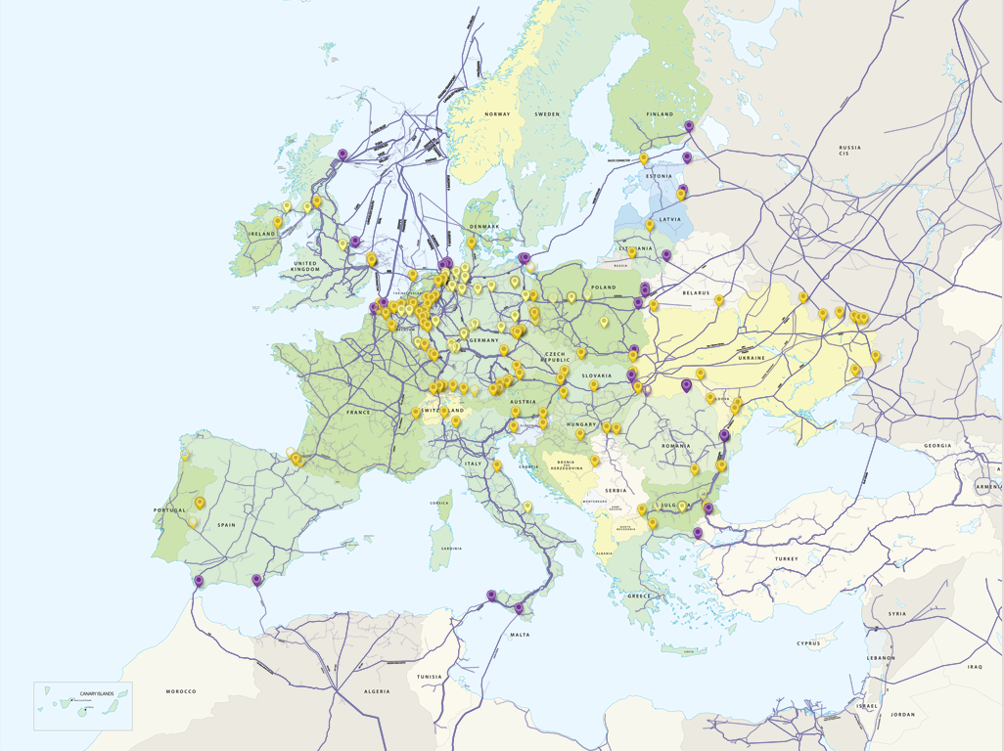
https://transparency.entsog.eu/

NWE market fundamentals:
- The NWE market is Germany, France, The UK, Benelux
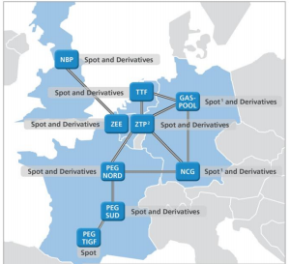

http://www.eex.com/blob/7404/3ba553de3235ca9559c03b668948bb49/20150227-stellungnahme-monopolkommission-sondergutachten-2015-eex-epex-spot-data.pdf

- The most important equation to look at to take a position in the energy market is:
$Supply-Demand= ∆ Stock$
This can be re written as:
$Supply+old Stock-Demand=New Stock$
- Let’s examine the sources of supply:
  - Imports (through pipes and LNG boats)
  - Internal Production
- Let us examine the sources of demand:
  - Industrial demand (40%)
  - Residential Demand (20%)
  - Gas to Power demand (to generate electricity – CCGT or any other thermal plant) (20%)
- Finally old stock which is technically a source of supply is the gas that exists in reservoirs (underground porous rocks). This gas is purposely injected/withdrawn by a storage system operator at the demand of the company that own rights to the storage (to the porous rock)
- Let us look at the equation and its elements more in depth:
  - Except for some particular outages or issues, imports are constant since they are based on long term contracts
  - Local production follows the same rule
  - Industrial demand is constant might fluctuate with temperature and other weather phenomena but is plant and equipment dependent and very rare
  - Residential demand is very variable and is primarily a function of temperature. In fact, 80% of residential demand fluctuation can be explained by temperature fluctuations. In France, residents rely more on electric heating; this is however not at all the case in Germany and the UK.
  - Gas to power is a function of electricity supply and demand. In fact, it is what is used to keep the balance as gas fired power plants are very flexible (can fire up, cool down very quickly as opposed to for example Nuclear Plants, or Renewable Energy). In other words, when there is a lack of power supply we fire up gas plants to balance the electricity markets, but this in turn “imbalances” the gas market as it suddenly creates a demand for gas. This is a big intersection between the gas and power markets. However, this intersection is not in the short term markets, since people do not stock up on gas only one week before they think they might use it.
  - Stock is the only source of supply that is variable (if we do not take into account outages and technical problems that might impact the others). It is here to balance supply and demand that exist in the gas markets.

VTPs (Local Markets), Prices and short term vs long term trading:
- A VTP is a virtual trading point. Each VTP has a different price indexed to it. The end goal of the EU and its one market one price rule is to transform the EU zone one big VTP with only one price
- A country can have multiple trading points, France used to have 3, as of 2019 however it has only one. Belgium has 2, one with a price in Euro and the other in GBP. Lastly, Germany has 2 and the Netherlands and the UK 1.
- The Dutch VTP is the one that is the most liquid, meaning it is the one that is the most traded. It is called TTF which is short for Title Transfer Facility. Germany’s 2 markets are NCG (Net Connect Germany) and GPL (Gaspool).
- Gas is always traded in units of energy which are supposed to represent a volume. If a trader trades 1 MWh of gas he is trading the volume of gas that is needed to generate 1 MWh of energy.
  - Gas is traded in Euro/MWh or in pence/Therm (1 pence = 0.01 GBP)
  - Gas can be bought sold, for the next day, next weekend, next week , next week only business days (short term market) or for next month, quarter, season, year, year after next year (Long Term Market)
  - Weather, Supply and Demand these are the fundamentals that set the prices for the short term market
  - Other commodity prices (coal, electricity, CO2, Oil) as well as policies
- Products function as follows:
  - Buying 1 MW @ 20 € for the next day means you are buying 1 MWh for each hour of next day so technically you are buying 24 MWh of volumes of gas. So you pay 20*24 € for this product
  - Buying 1 MW for the next year means you are buying 1 MWh for each hour of next year so technically you are buying 24 * 365 MWh of volumes of gas. So you pay 20*24 * 365 € for this product
- Anyone active on the markets might buy/sell on another VTP (also called hub) or at another time if it will allow him to make/save money
- Settlement prices for the Day Ahead product (the one we are most interested in) are given the day before delivery at 17:30. Actually we have a forward curve of prices that give settlement prices for all products until 3 years in advance. If gets too complicated explain to them what a forward curve (tell them only about daily to not make it complicated to them)
Storages:
- Storages have different activities in the summer and in the winter. The primary activity in the summer is to fill up the storage, when prices are low, and then to empty the storage in the winter, when prices are high.
- Withdrawal/injection rate is a physical constraint to the volume of gas one can withdraw/inject.
- Because of regulatory issues, varying withdrawal/injection rates and fears of warm spells storages aim to be filled at 80--85 \% before the beginning of the withdrawal period in October. After this level, a storage operator needs very high economic incentive to continue injecting gas. For the same reasons, they don't want to be at a lower level than 20 \% until March.
- Storage owners try to make money by arbitraging different spreads. For this project we will focus on location spreads.

