**Waste Management System with CLAY GO for Nueva Ecija University of Science and Technology Off-campus Program – General Tinio (Papaya)**

The waste management system in schools incorporates the **CLAY** **GO** (Clean-As-You-Go) approach, which promotes immediate waste disposal and cleanliness practices among students, teachers, and staff. This overview provides a brief summary of the waste management system in schools that emphasizes the CLAY GO principle.

|  |  |
| --- | --- |
| **Description** | **Objectives** |
| **CLAY** **GO**  Principles | The CLAY GO approach emphasizes the importance of cleaning up and disposing of waste immediately after use.  By adopting CLAY GO principles, NEUST Papaya aim to instill habits of cleanliness, waste segregation, and proper waste disposal among students. |
| Waste Classification and Segregation | NEUST Papaya implement waste classification systems that categorize waste into general waste, recyclables, and organic waste.  Students are educated about the different waste categories and encouraged to dispose of their waste in the appropriate bins following the CLAY GO approach. |
| Waste Disposal | Non-recyclable and non-compostable waste are collected and disposed of according to local waste management regulations and practices.  NEUST Papaya often collaborate with waste management of LGU for the timely and proper disposal of general waste. |
| Awareness and Education | NEUST Papaya conduct awareness campaigns and educational programs to promote the CLAY GO approach and waste management practices.  Students, teachers, and staff are provided with guidelines and resources to understand the importance of immediate waste disposal, waste segregation, and responsible waste management.  These initiatives help foster a culture of cleanliness and environmental stewardship among the school community. |

**Waste Classification**

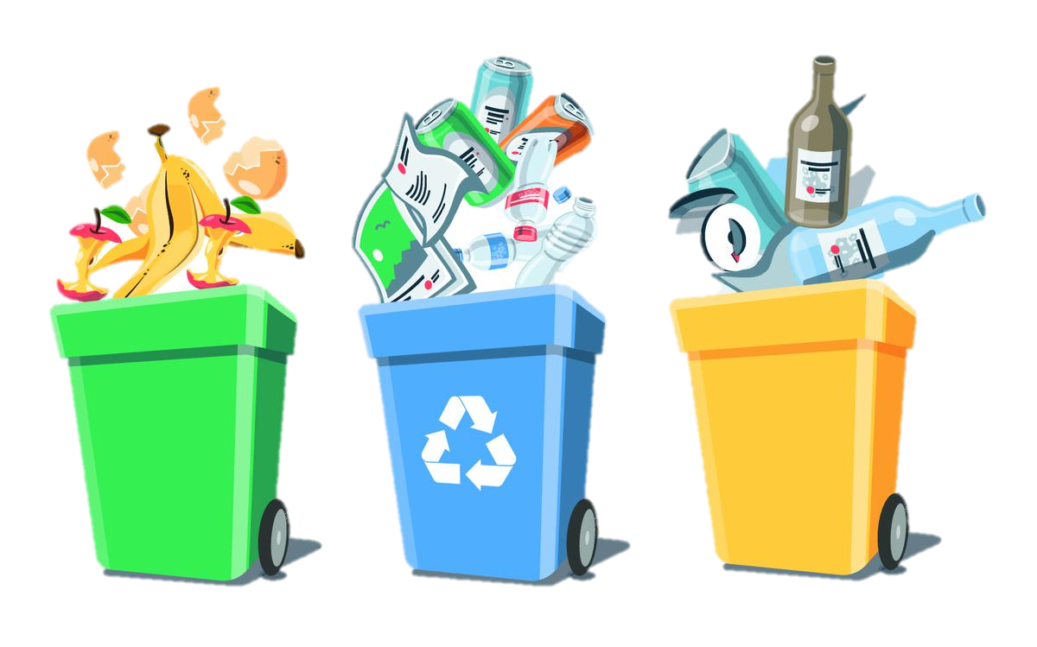

**1. Organic Waste:**

**Definition:** Organic waste consists of biodegradable materials derived from living organisms.

Examples: Food scraps, fruit and vegetable peels, tea bags, coffee grounds, plant trimmings, and garden waste.

**2. General Waste:**

**Definition:** General waste refers to non-recyclable and non-compostable waste that cannot be readily reused or repurposed.

Examples: Food wrappers, broken or unusable items, Styrofoam, tissues, and other non-recyclable plastics.

**3. Recyclable Waste:**

**Definition**: Recyclable waste refers to materials that can be processed and reused to create new products. These materials have the potential to undergo recycling processes and be transformed into raw materials for manufacturing.

Examples: papers, plastics, glass, metal, cardboard, clothing and beverage containers.

**Waste Collection Process**

**1. Placement of Waste Bins:**

Strategically place waste bins throughout the campus premises in easily accessible locations, such as classrooms, sport gymnasium, common areas, and outdoor spaces.

Ensure appropriate waste bins are available for each waste category, including general waste, recyclables, organic waste, and hazardous waste (if applicable).

**2. Clear Signage and Labeling:**

Attach clear and visible signage or labels to each waste bin, indicating the waste category and appropriate items to be disposed of in each bin.

Use color-coded bins or labels to aid in waste segregation and facilitate easy identification of the different waste types.

**3. Education and Training:**

Conduct regular education and training sessions to educate students, teachers, and staff about the waste collection process and the importance of proper waste disposal.

Explain the significance of waste segregation, recycling, and composting, and provide guidelines on what items should go in each waste bin.

**4. Collection of General and Organic Waste:**

Ensure the waste collection process adheres to hygiene standards and is carried out safely, considering the use of gloves and other personal protective equipment (PPE) when necessary.

**5. Collection of Recyclables:**

Collect recyclable materials from the designated recycling bins and containers and separate the recyclables based on their respective waste categories, such as paper, plastics, glass, and metals.

Ensure recyclables are kept clean and free from contamination to maintain their value for recycling processes.

**6. Regular Waste Collection Schedule:**

Establish a regular waste collection schedule to ensure timely removal of waste from the campus premises.

Coordinate with LGU to schedule waste collection based on the schedule of garbage collection within the premises of respected Barangay.

Prepared by:

**CHRISTIAN B. PEÑA KEVIN P. DALANGIN, LPT**

Coordinator, NSTP Adviser, Local Student Council

Approved by:

**ALBERT C. BULAWAT, EdD**

College Department Head

**GERARDA R. RIVERA, DPA**

College Administrator