Replace me with your project title
Alexandra Nickel ^{1,}, Elliot Raynor ¹, Alex Vogel ¹
¹ School of Biomedical Engineering, Drexel University, USA

Course : BMES 550-Advanced Biocomputational Languages
Instructor: Ahmet Sacan
Date : YYYY-mm-dd

abstract
Accurately tracking neonatal infant health and communicating concerns between parents and clinicians is challenging during the early months of life. There is a clear need for an application that reduces reliance on parental memory and offers both clinicians and families a longitudinal view of an infant’s well-being. The proposed system is a web based application with an SQL backend, an HTML front end, and Python services handling background processing and decision support logic. Each infant has a profile that aggregates clinician entered vitals (such as weight and other health metrics) with parent entered observations like sleep and feeding times, as well as flagged concerns. Core features include role based logins for parents and doctors, time-series tracking of vital and behavioral data, automatic flagging of patterns that may indicate risk, integrated messaging to facilitate timely communication, and decision support components that compares reported issues against a database of common conditions to help distinguish normal variation from potential problems.

introduction

Neonatal care during the first six months of life presents significant challenges for both parents and healthcare providers. New parents often struggle to accurately track and recall critical health metrics that are essential for identifying potential health concerns. However, current clinical workflows rely heavily on sporadic office visits and parental recall, introducing substantial gaps in health data collection and increasing the risk of missed warning signs. Parents also experience heightened anxiety during this vulnerable period, often uncertain whether observed behaviors or symptoms represent normal developmental variation or signs of genuine medical concern. The fragmented nature of current health monitoring where critical information exists only in clinical notes or fragmented parental memory creates a barrier to optimal care coordination and timely intervention.

To address these challenges, we have developed a web-based interface that centralizes neonatal health monitoring through collaboration between parents and healthcare providers. The platform features a dual-login system with distinct interfaces for parents and doctors, enabling real-time data sharing while maintaining role-appropriate access controls. Parents can easily log daily observations including feeding times and duration, sleep patterns, and notable behavioral changes through an data entry system. Doctors access a comprehensive dashboard displaying clinical vitals, parental observations, and a history of reported issues. The interface incorporates data processing, powered by a Python backend analyzing patterns from a database of common neonatal issues from the first six months of life that provides parents with preliminary assessments of whether observed symptoms align with typical development or warrant medical attention. Automatic flagging mechanisms identify potentially dangerous conditions based on configurable clinical thresholds, ensuring that serious concerns are immediately elevated for provider review. This implementation is built on a SQL database for secure data management, HTML frontend for responsive user experience, and Python for background analytics. The web interface will transform fragmented health observations into a coherent health record accessible to both the healthcare providers and parents.

This interface aims to improve the accuracy of neonatal health monitoring, reducing parental anxiety through informed self-assessment and direct provider communication channels, and enabling healthcare providers to deliver more personalized care. The primary end users are parents navigating the critical neonatal period, who seek both practical tools to organize daily health observations and reassurance regarding normal development and pediatricians and neonatal specialists who require real-time health data to make informed clinical decisions. The interface is particularly valuable in scenarios where parents cannot attend frequent clinic visits and during periods of high parental uncertainty or anxiety where evidence based reassurance is beneficial. By bridging the information gap between home and clinic, this system empowers both parents and providers to work collaboratively toward optimal neonatal health outcomes while reducing preventable complications and unnecessary emergency interventions.

Dataset
* If you are using a dataset, describe the experiment(s) that produced the datasets you are analyzing in your project. What are the experimental groups? How was the data collected?

methods and IMplementation
* Describe the methods and software you used. Cite any third party software or library you utilized.
* Describe your analysis workflow. e.g, normalization, types of statistical tests, thresholds, etc.
* Give implementation details (programming language, operating system, etc.)
* Provide a high-level description of your implementation. A flowchart is recommended to summarize the workflow and implementation.
* If you create and utilize a database, include an ER diagram of your database schema. Where the database tables are not self-explanatory, describe details of what is stored and the relationship constraints.
* If you used code developed by others, provide reference. Describe how you modified/improved/adapted their code.

Experiments and REsults
* Describe one or more sample use cases.
* Include snapshots of your application and the results it produces.
* Describe main options and parameters for your application.
* If applicable, compare your results to those from related work.
* Prefer figures (e.g., bar charts) over tables to present your results.

* If you use tables to report your results, use References->Insert Caption->Table,OnlyLabel&Number to insert cross-reference to tables. E.g., See Table 1).

* Have something intelligible to say about each figure/table you include.

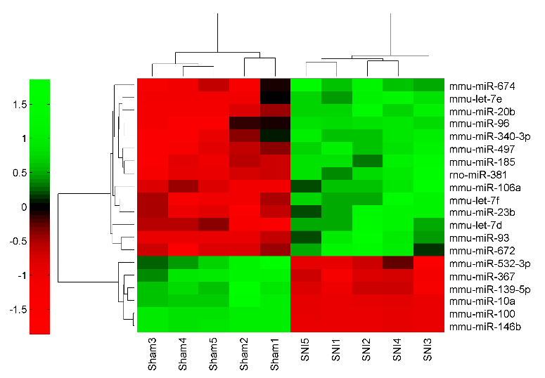
Figure 1. This is an example figure. Each figure must have a title (Use References -> Insert Caption in MS Word) and additional text describing what the figure shows. When referring to a figure in the text, always use References->Cross-reference. Do not manually write the figure number. If the text in the figure is not too small to read, consider making the figure larger, to span the width of page.

Name | Fold Change | p-value
hsa-miR-25# | -3.9 | 1.1E-06
hsa-let-7c | -2.5 | 2.1E-05
hsa-miR-939 | -4.6 | 5.6E-06
hsa-let-7a | -2.5 | 0.002
hsa-let-7b | -2.4 | 5.5E-05
Table 1. Top-5 most significantly differentially expressed miRNAs. Each table must have a title. Use References -> Insert Caption in MS Word to insert the caption. Provide additional text describing what the table shows. Make the table appear close to its cross-reference, but move it around to avoid spanning multiple pages.

DISCUSSION
* Summarize/discuss your results, without repeating verbatim what you already have in the Abstract or Results.
* Do your results make sense biologically? Find studies that support your findings. (E.g., you found 10 genes in your Alzheimer's dataset analysis, check literature to see if these genes are known for their involvement in Alzheimer's).
* What are the limitations of your study?
* What follow up studies can be performed to improve upon your findings?
* Describe future work. How can your application be extended/improved?

References

1. Sacan, A., I.H. Toroslu, and H. Ferhatosmanoglu, Integrated search and alignment of protein structures. Bioinformatics, 2008. 24(24): p. 2872-9.

Avoid using identical title to any other publication. Scholarly articles are supposed to be unique identifiers and you do not want your report to appear as a version of the original appear on search engines. If your project is based on a paper, use a title that reflects what you did. Remove this footnote.

