Neonatal Web Interface
Alexandra Nickel ^{1,}, Eliot Raynor ¹, Alex Vogel ¹
¹ School of Biomedical Engineering, Drexel University, USA

Course : BMES 550-Advanced Biocomputational Languages
Instructor : Ahmet Sacan
Date : 2025-12-10

*abstract
Accurately tracking neonatal infant health and communicating concerns between parents and clinicians is challenging during the early months of life. There is a clear need for an application that reduces reliance on parental memory and offers both clinicians and families a longitudinal view of an infant’s well-being. The proposed system is a web-based application with an SQL backend, an HTML front end, and Python backend handling SQL queries and decision support logic. Each infant has a profile that aggregates clinician entered vitals with parent entered observations like sleep and feeding times as well as flagged concerns. Core features include role-based logins for parents and doctors, time-series tracking of vital and behavioral data, automatic flagging of patterns that may indicate risk, integrated messaging to facilitate timely communication, and decision support components that compares reported issues against a database of common conditions to help distinguish normal variation from potential problems.

introduction

Neonatal care during the first four weeks of life presents significant challenges for both parents and healthcare providers. New parents often struggle to accurately track and recall critical health metrics that are essential for identifying potential health concerns. Current clinical workflows rely heavily on irregular office visits and parental recall which introduces substantial gaps in health data collection and increasing the risk of missed warning signs. Parents also experience heightened anxiety during this period of caring for infants, often uncertain whether observed behaviors or symptoms represent normal developmental variation or signs of genuine medical concern. The fragmented nature of current health monitoring where critical information exists only in clinical notes or fragmented parental memory creates a barrier to optimal care coordination and timely intervention.

To address these challenges, we have developed a web-based interface that centralizes neonatal health monitoring through collaboration between parents and healthcare providers. The platform features a dual-login system with distinct interfaces for parents and doctors, enabling real-time data sharing while maintaining role-appropriate access controls. Parents can easily log daily observations including feeding times and duration, sleep patterns, and notable behavioral changes through a data entry system. Doctors access a comprehensive dashboard displaying clinical vitals, parental observations, and a history of reported issues. The interface incorporates data processing, powered by a Python backend analyzing patterns from a database of common neonatal issues from the first six months of life that provides parents with preliminary assessments of whether observed symptoms align with typical development or warrant medical attention. Automatic flagging mechanisms identify potentially dangerous conditions based on configurable clinical thresholds, ensuring that serious concerns are immediately elevated for provider review. This implementation is built on a SQL database for secure data management, HTML frontend for responsive user experience, and Python for background analytics. The web interface will transform fragmented health observations into a coherent health record accessible to both the healthcare providers and parents.

This interface aims to improve the accuracy of neonatal health monitoring by reducing parental anxiety through informed self-assessment and direct provider communication channels. The primary end users are parents navigating the critical neonatal period, who seek both practical tools to organize daily health observations and reassurance regarding normal development and pediatricians and neonatal specialists who require real-time health data to make informed clinical decisions. The interface is particularly valuable in scenarios where parents cannot attend frequent clinic visits and during periods of high parental uncertainty or anxiety where evidence-based reassurance is beneficial. By bridging the information gap between home and clinic, this system empowers both parents and providers to work collaboratively toward optimal neonatal health outcomes while reducing preventable complications and unnecessary emergency interventions.

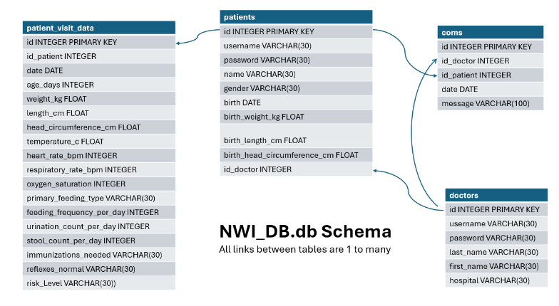
Dataset
Figure 1: ER Database Schema for the NWI_DB database. Depicts the connections between the different tables in the database. All of the links are 1 to many connections.

The dataset used for the project is called “NWI_DB” and is randomly generated specifically for this project. It contains the following tables: “patients”, “patient_visit_data”, “doctors”, and “comms”. The “patients” table stores all the non-changing information about the patient, which includes their associated username and password, birth information, and id associated with their doctor. The “patient_visit_data” table stores all of the information inputted from either at doctor visits or by the parents. Each entry gets its own row and tracks what information was updated as well as for which patient. The “doctors” table is fairly straightforward, as it stores the information about the doctor such as name, id, and hospital where they work. Finally, the “comms” table stores the messages sent back and forth between the doctor and the patient. This table stores the date of the message, the message correspondents, as well as the message itself. All of the connections in the database are one to many links.

methods and IMplementation
The website runs through a local python server created by the Flask library. Code is routed through template HTML files, which utilize HTML, CSS, JavaScript, and Flask variables to call on external python files to run logic. These files, stored directly in the src folder are routed through the main logic code app.py, which handles all communication within the server. Additional files such as images are stored in the static subfolder. The server and webpage are started through start_interface.ipynb, which runs app.py in a terminal, creates a sample database, and opens a browser.

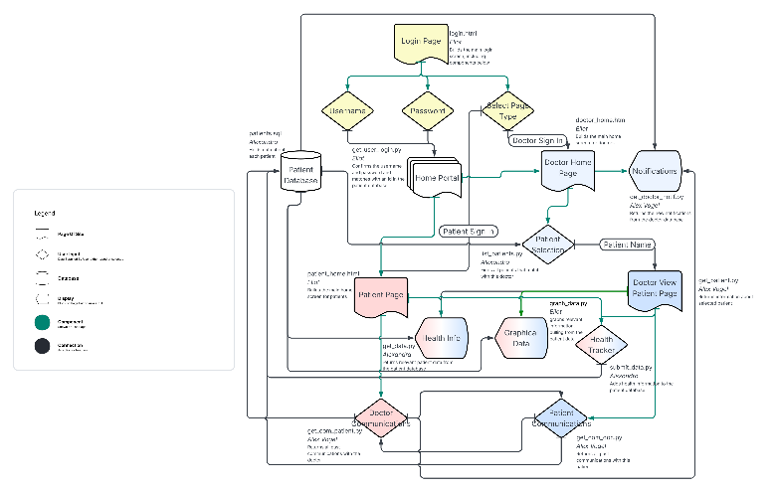
In addition to Flask, the webpage also utilizes the python libraries of sqlite3 (for database integration), hashlib (for password encryption), and datetime (for time recording outside of JavaScript. The JavaScript libraries jQuery (for form handling) and Chart (for building the graphs).

Figure 2: Flowchart describing the interactions between different functions in the project.

The project starts with a login screen, where the user chooses what type of account they are entering (doctor or patient) and then submits their username and password which get sent into get_user_login.py. Encrypted hashes of the sum of the username and password are stored in place of passwords in the database, so it is not feasible to login to an account whose password you do not know even with full read access to the database.

On login, the doctor is brought to a home page, and the patient is brought to their main page. At the top of the patient’s main screen is their user information: name and id. In the top right is a “Sign Out” button that brings them back to the login page. There are 4 sections below, each with associated capabilities. The first, “Health Tracker” allows for entry of data into the patient’s database. Non-entered values are stored as Null in the database and will be ignored in later queries. When submitted, the form sends the user id along with the array of data to submit_health.py, which sends the data to the database and returns any warnings about possibly dangerous values that were entered. If any warnings are returned, a popup banner will list them at the top of the page in red. This popup can be closed if desired. After the form has been successfully submitted, text appears below it giving the time that the submission took place at. The second section, “Health Info”, simply lists out relevant information about the patient. On page-load, the user id is sent through get_patient.py and returns this data, which is printed in the health info box. The third section, “Ask Doctor” provides an interface to direct-message with the doctor directly. On page-load, the user id is sent through get_comm_doc.py, which returns an array of dictionaries, each containing the message content and date. These messages are displayed under “Past Messages:”. There is also a variable-size message box that will add messages to the comms database when submitted. The fourth section, “Graphical Data” contains a drop-down menu to select which type of data that should be displayed, which is sent to graph_data.py along with the user id, returning the x and y information to then be displayed using JavaScript.

The doctor’s home page contains two boxes. The first, “notifications” contains all messages from all patients that the doctor is in charge of as read-only. The second lists all patients the doctor is in charge of, allowing to select between them in a drop down. Upon selecting one, the doctor is redirected to a page very similar to the patient’s home, with small nomenclature differences to distinguish it. From here, the doctor may access all of the patient’s information and communicate with them, before hitting the “Back” button in the top right and returning to their home page.

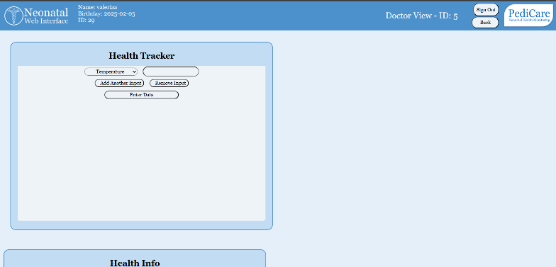
The Flask implementation used is heavily structured from the https://www.geeksforgeeks.org/python/ [1] flask series, although this was adapted significantly for the project’s needs. Additionally, this post was used to implement the start-up sequence and open the browser safely: https://stackoverflow.com/questions/5423534-7/open-browser-automatically-when-python-code-is-executed/54235461#54235461. [2] Several other features were inspired by solutions from Stack Exchange, which are credited in the code where relevant. Perplexity.ai was also utilized several times, and whose conversations can be found in the ai_conversations folder of the main directory.
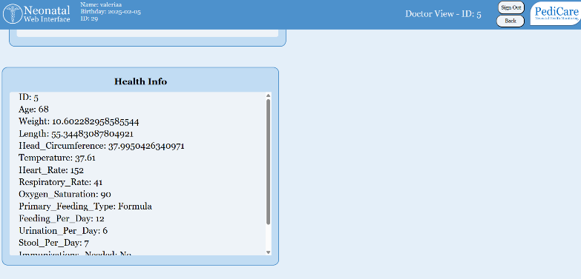

Experiments and REsults
All experiments start with downloading the src folder and then running the first block of start_interface.ipynb.

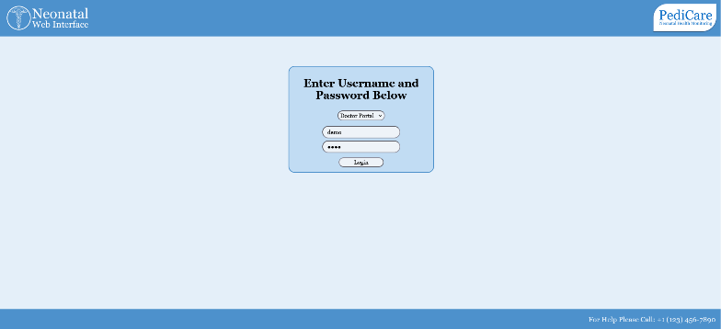
A doctor will log in by selecting “Doctor Portal” from the drop-down menu and entering their username and password.

After logging in, they will be redirected to their home page, where they can view all open conversations with patients, along with a list of patients to view.
Figure 3 Image of the demo login page for the website.
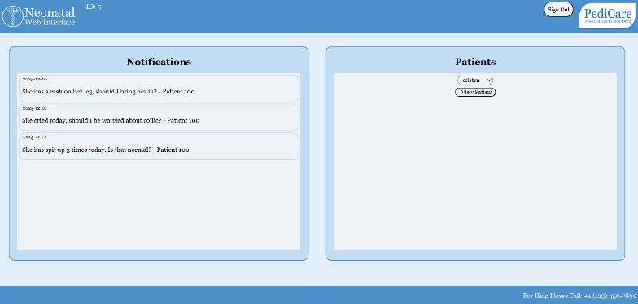
Figure 4 Image of the demo doctor home page for the website.

Selecting a patient and hitting enter will bring the doctor to a new page, where they can see everything that that patient can on their own page. This includes a health tracker, most recent information, message board, and graphical data representation.
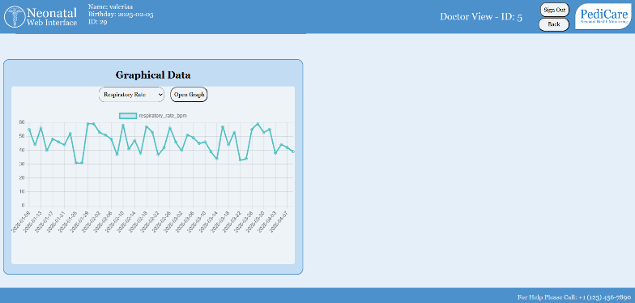
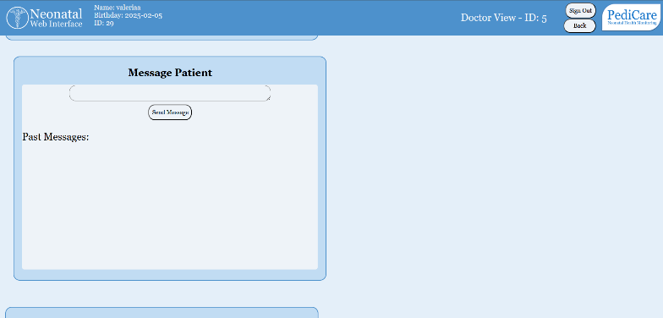
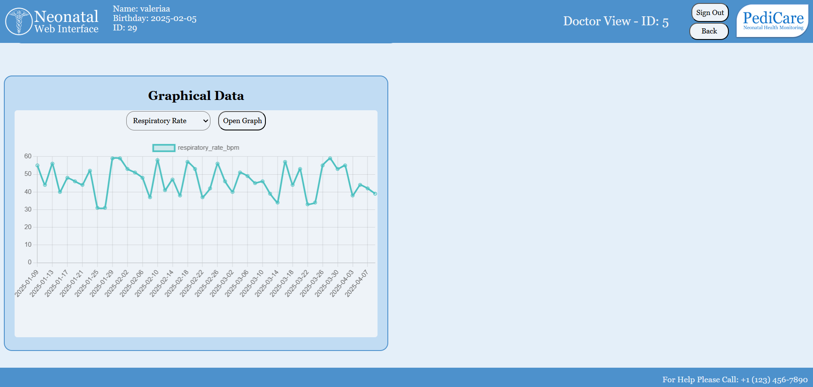
Figure 5-8 Images of the demo doctor patient page for the website.

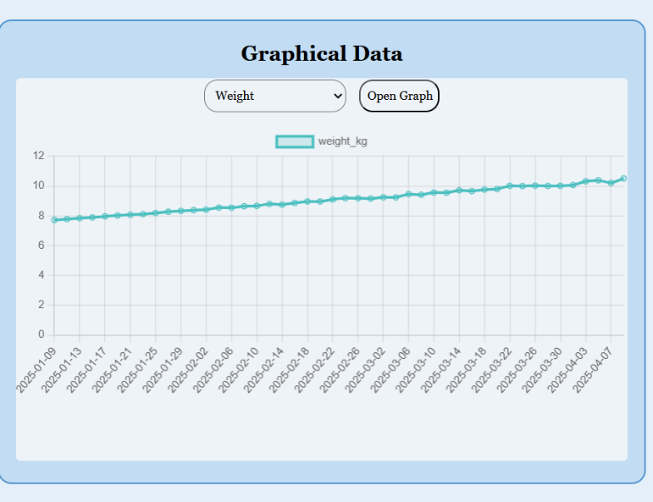
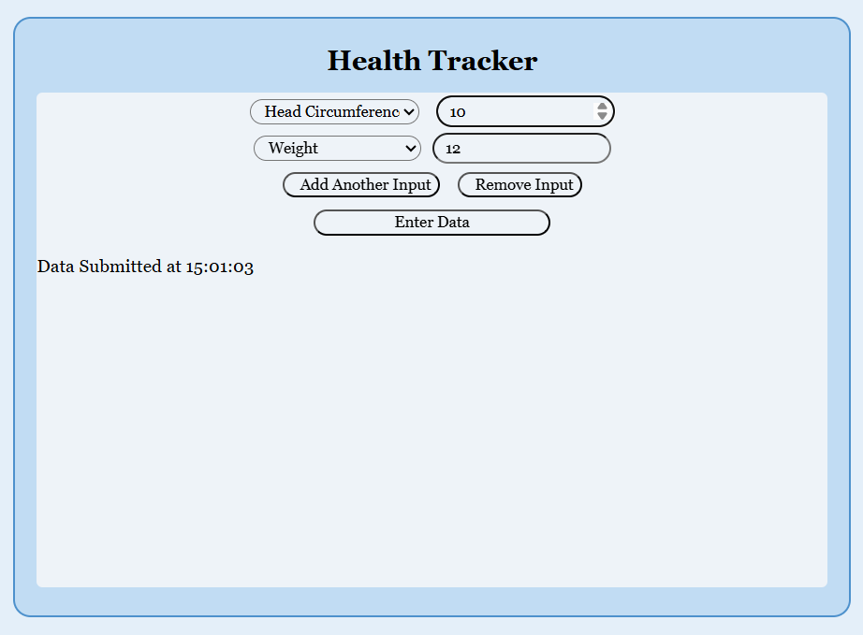
The health tracker allows the doctor to submit data to the patient database. A variable number of entries can be created and used, with the rest auto filled to `None`. Clicking on “Add Another Input” creates a new box to write in, with the type of data entered being chosen in the dropdown. Clicking “Remove Input” gets rid of the last box created. Hitting “Enter Data” submits the form and stores it in the database. All entered values must be numbers.
Figure 9 Sample Health tracker input and response.

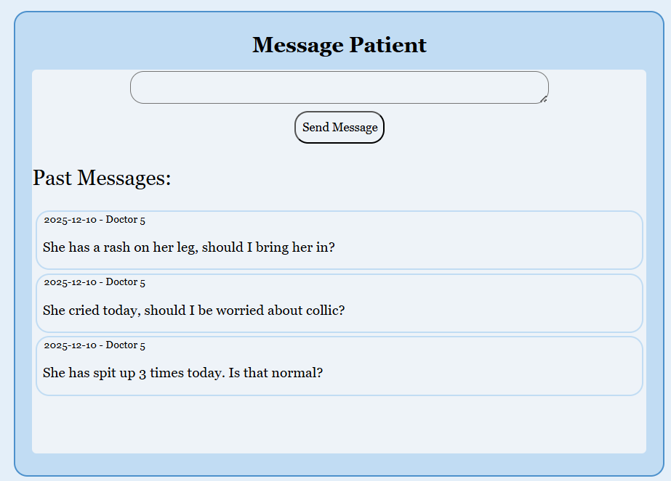
The message doctor/patient allows for a single-thread response to questions posed by the patient’s parents. A message is typed into the message box, and “Send Message” sends it to the database. In the current implementation, the page must be reloaded to show this message in the “Past Messages” section.
Figure 9 Sample message patient input

The graphical data allows for easy observation of trending for the patient’s conditions. Select the data to view in the dropdown menu, then hit “Open Graph” to see that data over time.
Figure 9 Sample Graphical data

The doctor can now hit “Back” to return to their home page and select a new patient, or “Sign Out” to return to the login page.

DISCUSSION
The goal of the project was to create a website to track infant data during some of the most critical months of life. The website is a tool to quickly and efficiently view and edit patient data, get much more frequent updates, and check in with parents.
Currently, the project is limited in several ways. The project has to be run on a computer, which means that it is not currently possible for it to be edited by multiple people working from separate devices. The project also has a comparatively low number of data types that are tracked. In addition, there is currently no way to add a new patient or doctor to the database as it only works with existing users.
There are several improvements and future work to be done for this project. The website would be hosted by a private server so that the database can be updated on multiple devices. Another future implementation would be to be able to run it in conjunction with hospital servers and on a much wider scale. The next step for this project is to implement a wider range of possible patient data to be monitored and to work on polishing the website design.

References

. Average baby weight: Chart and development. (2019, July 2). https://www.medicalnewstoday.com/articles/325630
2. What is the average baby length? Growth chart by month. (2019, March 18). https://www.medicalnewstoday.com/articles/324728
3. Average newborn head circumference. (n.d.). BabyCenter. Retrieved December 10, 2025, from https://www.babycenter.com/baby/baby-development/baby-head-circumference_40009394
4. A guide to your kid’s vital signs. (n.d.). Cleveland Clinic. Retrieved December 10, 2025, from https://health.clevelandclinic.org/pediatric-vital-signs
5. Thilo, E. H., Park, C. K., & Sedaghat, V. S. (1991). Oxygen saturation by pulse oximetry in healthy infants at an altitude of 1610 meters. American Journal of Diseases of Children, 145(10), 1137–1140. https://jamanetwork.com/journals/jamapediatrics/fullarticle/515871
6. Drakeford, K., MA, RD, CSP, LD, & CLC. (n.d.). Here’s a handy feeding chart for newborns and babies. Parents. Retrieved December 10, 2025, from https://www.parents.com/baby/feeding/baby-feeding-chart-how-much-and-when-to-feed-infants-the-first-year/
7. Garbi, L. & MD. (n.d.). Does your baby have enough wet diapers? Parents. Retrieved December 10, 2025, from https://www.parents.com/breastfeeding-and-wet-diapers-whats-normal-431621
8. Baby poop guide. (n.d.). Retrieved December 10, 2025, from https://www.childrenscolorado.org/just-ask-childrens/articles/baby-poop-guide/
9. Geeksforgeeks | quiz hub: Test your knowledge. (n.d.). GeeksforGeeks. Retrieved December 10, 2025, from https://www.geeksforgeeks.org/quizzes/.
10. Goyal, S. (2019, January 17). Open browser automatically when Python code is executed [Online forum post]. Stack Overflow. https://stackoverflow.com/questions/54235347/open-browser-automatically-when-python-code-is-executed/54235461#5423546

