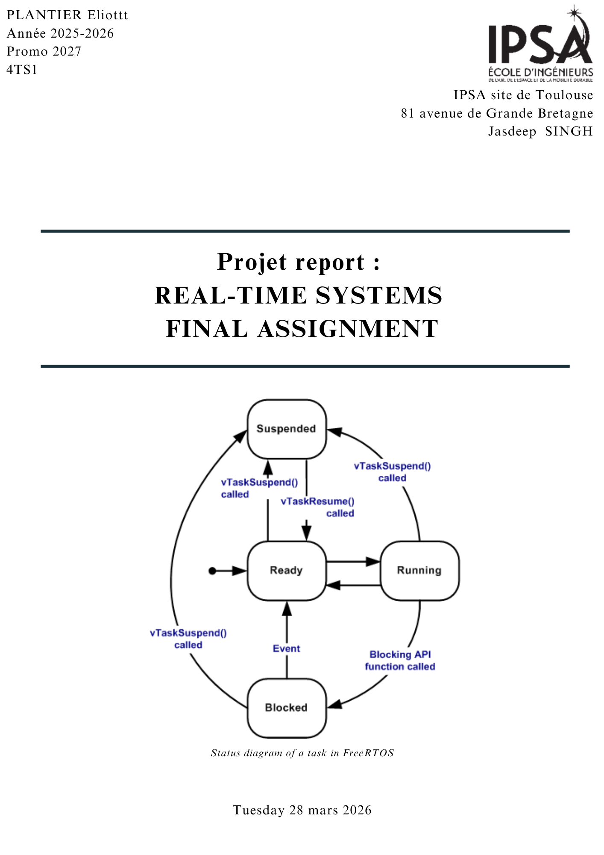
Table des matières
Non-Preemptive Scheduling and WCET Analysis 3
1. Introduction 3
2. WCET Estimation 3
3. Task Set 3
4. Hyperperiod 4
5. Job Generation 4
6. Schedulability 4
7. Scheduling Results 4
8. Selected Solution 4
9. Relaxed Constraint (τ5) 4
10. Complexity 5
11. Conclusion 5

Non-Preemptive Scheduling and WCET Analysis

1. Introduction
This project addresses scheduling of periodic real-time tasks under non-preemptive constraints.
Objectives:
- WCET estimation
- Schedulability verification
- Non-preemptive scheduling
- Waiting time minimization
- Constraint relaxation analysis

2. WCET Estimation
The execution time is non-deterministic due to hardware and operating system variability.
Therefore, multiple measurements were performed to obtain a representative distribution.
Task τ1 execution was measured 1000 times using C++ and Python.
Results:
Min: 0.0103 s
Q1: 0.0111 s
Median: 0.0114 s
Q3: 0.0118 s
Max: 0.4259 s
WCET = Max × 1.2 ≈ 0.52 s
Final: C1 = 0.52
A pessimistic approach was adopted by selecting the maximum observed execution time and applying a safety margin of 20%, in accordance with real-time system design principles. The execution time was measured using an external timing method. This includes some operating system overhead such as process creation and scheduling.
Although less precise than internal timing, repeated measurements and the addition of a safety margin ensure a safe upper bound for the WCET. Since the task set does not specify explicit time units, all execution times were normalized to ensure consistency across tasks.

3. Task Set
τ1: C=0.52, T=10
τ2: C=3, T=10
τ3: C=2, T=20
τ4: C=2, T=20
τ5: C=2, T=40
τ6: C=2, T=40
τ7: C=3, T=80

4. Hyperperiod
LCM(10,20,40,80)=80

5. Job Generation
Total jobs: 29
Each job defined by release, deadline, execution time

6. Schedulability
Utilization U ≈ 0.69 < 1 → schedulable
Since the total utilization is less than 1, the system is theoretically schedulable.
However, this condition alone is not sufficient, and a scheduling simulation is required to confirm feasibility.

7. Scheduling Results
Different scheduling heuristics were evaluated to compare performance and feasibility.
EDF: waiting=95.52, misses=0 (valid)
SJF: waiting=83.52, misses=2 (invalid)
LLF: waiting=115.36, misses=0 (inefficient)
EDF provides a feasible schedule with zero deadline misses while maintaining a relatively low total waiting time.
Although SJF reduces the total waiting time, it introduces deadline misses, making it unsuitable for real-time constraints.
LLF ensures schedulability but results in higher waiting time, making it less efficient compared to EDF.

8. Selected Solution
EDF chosen as best valid schedule
EDF was selected as the optimal scheduling strategy because it guarantees zero deadline misses while providing the best performance among all valid solutions.

9. Relaxed Constraint (τ5)
Allowing τ5 misses does not improve performance.
EDF remains optimal
When relaxing the deadline constraint for task τ5, an attempt was made to reduce total waiting time by lowering its priority.
However, the resulting schedule did not improve performance. Instead, the total waiting time increased.
This demonstrates that EDF already provides a well-balanced schedule and that relaxing constraints does not necessarily lead to better performance.

10. Complexity
O(n^2)
The algorithm iteratively selects the next job among available jobs, leading to a quadratic time complexity in the worst case.

11. Conclusion
EDF provides best valid scheduling solution under constraints
This project highlights the importance of accurate WCET estimation and the impact of scheduling strategies in real-time systems.
The results show that while some heuristics may improve performance metrics such as waiting time, they may violate critical real-time constraints.
EDF was identified as the most suitable scheduling strategy, providing a reliable balance between performance and feasibility.

