### Programming Lab: Aliens

**RAM Memory**: 4 MiB  
**Time**: 0.1 seconds **Input**: aliens.in  
**Output**: aliens.out

#### Description

In 2020 humans sent an autonomous robot *Perseverance* to Mars. (“*The Mars 2020 mission is delivering the Perseverance rover to the Red Planet as part of NASA’s Mars Exploration Program. The program’s ongoing series of missions is helping us answer key questions about the potential for life on Mars. While previous missions have helped us look for signs of habitable conditions in ancient times, Perseverance will take it one step further by searching for signs of past microbial life itself.*”)

Soon *Perseverance* noticed various signs of life on Mars. On their images there were green creatures who could change their location. After trying to hide for some time, the green creatures (subsequently called *aliens*) decided to communicate with our civilization. The humans on Earth (called *earthlings*) found that they are not dangerous, and decided to maintain good relations with aliens and get access to their technologies.

To address culture differences and avoid misunderstandings, earthlings became interested in the everyday life of aliens. As they found out, aliens have asexual reproduction: every alien can have no more than two children. Every child is either left-handed or right-handed. Additionally, if an alien has two children, then one of them is necessarily left-handed, and the other one is right-handed. Rerproduction can happen soon after birth, many generations can live simultaneously. Since aliens have very large families, their most favoured relationships are with no more than 2 of their relatives.

Earthlings studied the question: How to identify the two (or less) favorite relatives for every alien. First, we pick some alien without living parent. Then draw the family tree (the tree of parent-child relationships with the given alien as the root), then every alien in this family tree has two favorite relatives immediately preceding him and immediately following him in the *inorder* DFS traversal of that tree. Left-handed aliens are shown to the left of their parent, the right-hinded ones - to the right.

Your task is to build an efficient program that receives the genealogy data for a single family tree, and it should find the two favorite relative aliens for any given alien upon receiving a query.

It is known that a single extended family has no more than $10 000$ aliens that are currently alive. Every alien has a unique number $[1..10 000]$.

An efficient solution for an input having just up to 100 aliens would get about 8 points. If it handles up to 1000 aliens, then it gets about 9 points.

#### Input:

The first line contains the number for the alien that is the *main living ancestor* of the given family tree. All the remaining lines of the input file contains one of these four commands that build the genealogy tree:

1. Specify the left-handed child for a parent.
2. Specify the right-handed child for a parent.
3. Query for the favorite relatives of a given alien.
4. Finish your work.

Ancestor  
...  
L Parent Child  
...  
R Parent Child  
...  
? Alien  
...  
F

* Ancestor is the number for an alien that is the *main living ancestor* of the whole family tree.
* L is the command to specify the left-handed child for a parent.
* R is the command to specify the right-handed child for a parent.
* Parent is the number for an alien that will get a new child (the identificator for a an alien is within these boundaries: $[1..10 000])$
* Child is the child to the parent Parent, (the identificator is in the interval $[1..10 000])$
* Alien is the alien identificator in the request to find the favorite relatives (the identificator is in the interval $[1..10 000])$

If the commands L or R succeed, new nodes are appended to the genealogy tree.

The input data is valid - regarding the format and the limitations defined above.

#### Output:

Depending on the input file the output file contains output for every query command and also every command that ends in failure:

Prev Next  
...  
error0  
...  
error1  
...  
error2  
...  
error3  
...  
error4  
...  
error5

* Prev is the immediately preceding alien (in *inorder* traversal order) for the given alien Alien, when we run the command ? Alien. If there is no previous alien, output 0.
* Next is the immediately following alien (in *inorder* traversal order) for the given alien Alien, when we run the command ? Alien. If there is no next alien, output 0.
* error0 - alien with identification number Alien does not exist in the family tree, when we run the command ? Alien.
* error1 - Parent and Child are the same.
* error2 - Parent does not exist in the family tree.
* error3 - Child is already used in the family tree.
* error4 - Parent already has a left-handed child in the family tree.
* error5 - Parent already has a right-handed chlid in the family tree.

If a command causes multiple errors at once, print the one with the smallest number.

#### Example:

An input file aliens.in:

7  
L 7 2  
R 7 9  
L 9 5  
? 2  
R 5 6  
L 2 4  
L 5 1  
? 5  
? 8  
L 1 4  
F

An output file aliens.out:

0 7  
1 6  
error0  
error3

The family tree right before the command **? 2**

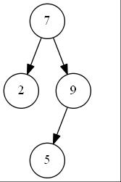

alt text

The family tree right before the command **? 5**

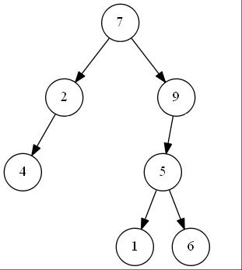

alt text