CALIFORNIA STATE UNIVERSITY, LONG BEACH

**IS 445/545 – Internet Application Development**

## Fall 2020 Term – Section 01 (#7818/7354) – Individual Assignment #8

## Due: November 3, 2020

**Notes:**

* You will create a web site using tutorial 4 lab as a template
* **Submission requirements.**   
  A zipped file containing the following:

1. Web site directory containing all your code
2. A file containing the following:
   1. Links to your GitHub repository and to your Netlify application.   
      For example (below are not valid, use your own):

[https://github.com/ashercsulb/hw](https://github.com/ashercsulb/hw4)4

<https://asherhw5.netlify.app>

* 1. Solution to questions following the programming exercises

Name the file as follows:

1. yourLastNmae_hw8.zip (e.g. asher_hw8.zip)

* Complete Tutorial 8 hands on lab – Do not turn it in.

**Programming Assignment**

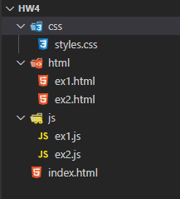The programming assignment requires you to create solutions to several exercises below. Use tutorial 4 lab as a template (see image to the right as an example with two solutions), that is

* Create the directory structure as in tutorial 4 (html, js, and css)
* Create an index.html file
  + It will have links to the solution for each exercise
* For each exercise, create two files (replace # with the exercise number)
  + ex#.js (placed in js directory)
    - Contains JavaScript code
  + ex#.html (placed in html directory)
    - Runs the JavaScript code
    - Contains link back to index.html
* styles.css (optional)
  + Optional style sheet

**Answer the following**

What are the links to your web site?

* 1. GitHub URL: https://github.com/eliphu/phung_hw8.git
  2. Netlify URL: [https://practical-clarke-6901a8.netlify.app](https://practical-clarke-6901a8.netlify.app/)

**Chapter 21 – Query a Web Server**

1. Famous Paintings (end of chapter assignment / modified table requirements)

In this exercise, you'll show information about some famous paintings on a web page table. Information about the paintings is located at URL:

<https://raw.githubusercontent.com/bpesquet/thejsway/master/resources/paintings.json>

It has the following content.

[

{

"name": "The Starry Night",

"year": "1889",

"artist": "Vincent Van Gogh"

},

{

"name": "The Scream",

"year": "1893",

"artist": "Edvard Munch"

},

{

"name": "Guernica",

"year": "1937",

"artist": "Pablo Picasso"

}

]

Start from the following HTML code.

<h2>Some famous paintings</h2>

<table id="paintings">

<tr>

<th>Name</th>

<th>Year</th>

<th>Artist</th>

</tr>

</table>

Write the JavaScript code that fills a table with details about the paintings.

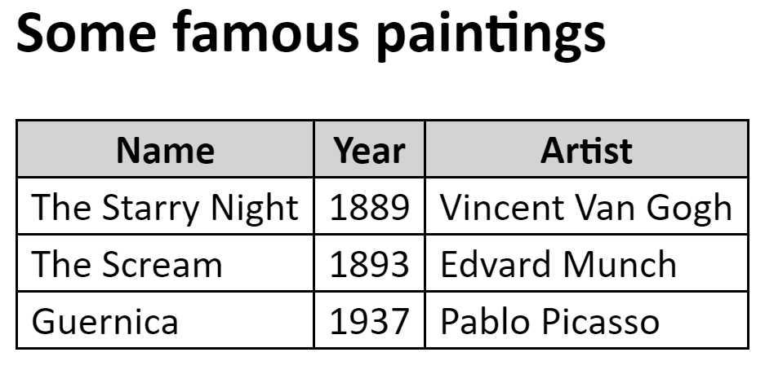

Table/Other Requirements (recommend using CSS, will use for additional exercises)

1. Border: 1px solid black
2. Collapse the border
3. Left and right padding: 5px
4. Table header background color: lightgray
5. Font: Calibri (can use that for the entire document)
6. Include a "catch" method. It's OK to write errors to the console (instead of HTML page)

**Chapter 22 – Using Web APIs**

1. GitHub Profile (end of chapter assignment / modified)

The ubiquitous code sharing platform [GitHub](https://github.com/) has a public API. The goal of this exercise is to display some information about a GitHub user, identified by his login. The API documentation is available [here](https://docs.github.com/v3/users/) (updated link).

Use this API to show the profile picture, name, blog website address, and when the account was created of a GitHub user whose login is entered in a text box.

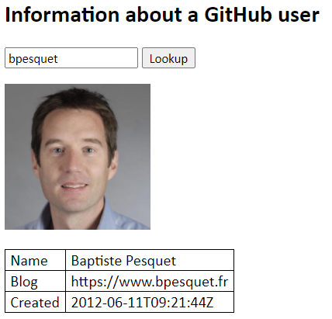

Requirements

1. Display name, blog site, and when the account was created in a table. Use same table properties from previous exercise (recommend using CSS)
2. Place picture in a Paragraph tag
3. Include a "catch" method. It's OK to write errors to the console (instead of HTML page)

Hints / Other

1. Review the API documentation link.
   * Click on "Get a user"
2. Try the URL in your browser to see the results
3. You do not have to check for valid picture, name, or blog. Example below is OK:

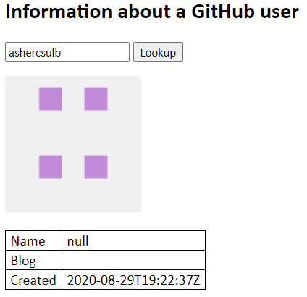

1. You can test your code by using the GitHub logins of prominent JS community members like brendaneich (JavaScript's father), douglascrockford or vjeux.

**Chapter 23 – Send data to a web server**

1. Visited Countries (end of chapter assignment)

The goal of this exercise is to send your traveling info to a server. Data is expected as a JSON object containing two fields:

* A name field representing your name. Its value is a string.
* A countries field representing the countries you already visited. Its value is an array of objects. Each object has a name field (string) for the country name, and a year field (integer) for the year you last visited it.

This data must be sent to the URL https://thejsway-server.herokuapp.com/api/countries. You should receive a confirmation message from the server and display it in the console.

[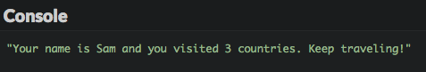](https://github.com/ashercsulb/thejsway/blob/master/manuscript/images/chapter23-06.png)

Note:

Although we'll be primarily using forms to send data to the server, this is a good exercise creating using JSON data.

1. FormData Key/Value Pair Values

The objective is to create a FormData object from a form, then display the key/value pairs in a table. Create an HTML page containing a form as shown below (drop down shown with all values):

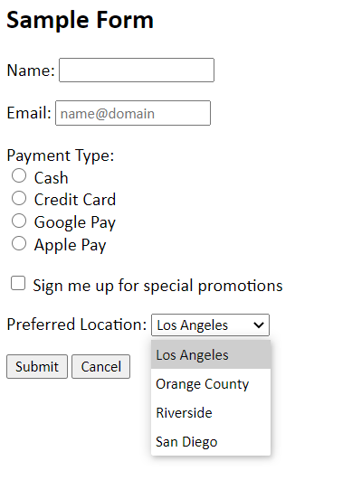

Code

When the user clicks submit, display the key/value pairs in a table as shown below.  
Use the same table properties used in previous exercises (recommend using CSS).

