Road traffic fatalities by light conditions: a comparative analysis between the US and the UK

# Introduction

The number of pedestrian fatalities in the US has risen steadily since 2009 (Sanders, Schneider, and Proulx 2022; Ferenchak, Gutierrez, and Singleton 2022; Wang and Cicchino 2020). A key risk factor in these pedestrian fatalities appears to be darkness. Despite there being less pedestrian flow at night, three-quarters of pedestrian fatalities in the US occur in the dark. Also the rate of pedestrian deaths in the dark in the US is increasing (Sanders, Schneider, and Proulx 2022).

This study aims to answer the following questions:

* Is the increase in pedestrian fatalities and in the dark a unique trend in the US or is it happening also in other Westerns countries like the UK? to what extent is it riskier to walk at night in the US and the UK?
* Which aspects could explain these trends and potential differences?
* The trend of fatalities and the influence of darkness on other vulnerable road users, such as cyclists, has been less studied. Is the number of cyclists killed on the road also increasing? Is darkness as important a factor for cyclists as it is for pedestrians?

# Data and method

## Data

#### Road safety data (numerator)

* US Fatality Analysis Reporting System (FARS) data - National Highway Traffic Safety Administration (NHTSA)
* UK Road Safety Data (STATS19) – Department for Transport (DfT)

#### Travel data (denominator)

* US National Household Travel Survey – Federal Highway Administration
* UK National Travel Survey – Department for Transport

## Method

# Results

## Road traffic fatalities by light conditions and type

### US 2011-2020 (FARS data)

Table 1. Road traffic fatalities by light conditions and type, US 2011-2020

| Type | Light conditions | Light conditions in detail | Num. | % |
| --- | --- | --- | --- | --- |
| Pedestrians | Daylight | Daylight | 7676 | 20.96 |
| Pedestrians | Dark | Dark - Lighted | 14316 | 39.09 |
| Pedestrians | Dark | Dark - Not Lighted | 12821 | 35.00 |
| Pedestrians | Dark | Dark - Unknown Lighting | 472 | 1.29 |
| Pedestrians | Dark | Dawn | 603 | 1.65 |
| Pedestrians | Dark | Dusk | 739 | 2.02 |
| Cyclists | Daylight | Daylight | 2482 | 48.33 |
| Cyclists | Dark | Dark - Lighted | 1257 | 24.47 |
| Cyclists | Dark | Dark - Not Lighted | 1110 | 21.61 |
| Cyclists | Dark | Dark - Unknown Lighting | 43 | 0.84 |
| Cyclists | Dark | Dawn | 103 | 2.01 |
| Cyclists | Dark | Dusk | 141 | 2.75 |
| Others | Daylight | Daylight | 94891 | 52.80 |
| Others | Dark | Dark - Lighted | 27897 | 15.52 |
| Others | Dark | Dark - Not Lighted | 47816 | 26.61 |
| Others | Dark | Dark - Unknown Lighting | 1092 | 0.61 |
| Others | Dark | Dawn | 3527 | 1.96 |
| Others | Dark | Dusk | 4495 | 2.50 |

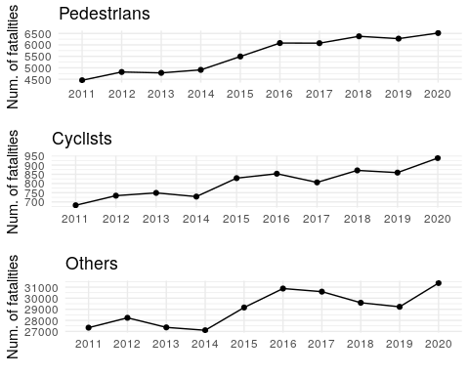

Figure 1. Road traffic fatalities by year and type, US 2011-2020

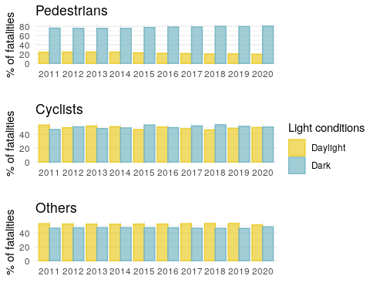

Figure 2. % of road traffic fatalities by light conditions, year, and type, US 2011-2020

### UK 2011-2020 (STATS19 data)

Table 2. Road traffic fatalities by light conditions and type, UK 2011-2020

| Type | Light conditions | Light conditions in detail | Num. | % |
| --- | --- | --- | --- | --- |
| Pedestrians | Daylight | Daylight | 1985 | 46.00 |
| Pedestrians | Dark | Darkness - lights lit | 1466 | 33.97 |
| Pedestrians | Dark | Darkness - lights unlit | 79 | 1.83 |
| Pedestrians | Dark | Darkness - no lighting | 705 | 16.34 |
| Pedestrians | Dark | Darkness - lighting unknown | 80 | 1.85 |
| Cyclists | Daylight | Daylight | 808 | 74.13 |
| Cyclists | Dark | Darkness - lights lit | 157 | 14.40 |
| Cyclists | Dark | Darkness - lights unlit | 10 | 0.92 |
| Cyclists | Dark | Darkness - no lighting | 110 | 10.09 |
| Cyclists | Dark | Darkness - lighting unknown | 5 | 0.46 |
| Others | Daylight | Daylight | 7446 | 61.81 |
| Others | Dark | Darkness - lights lit | 1859 | 15.43 |
| Others | Dark | Darkness - lights unlit | 93 | 0.77 |
| Others | Dark | Darkness - no lighting | 2450 | 20.34 |
| Others | Dark | Darkness - lighting unknown | 199 | 1.65 |

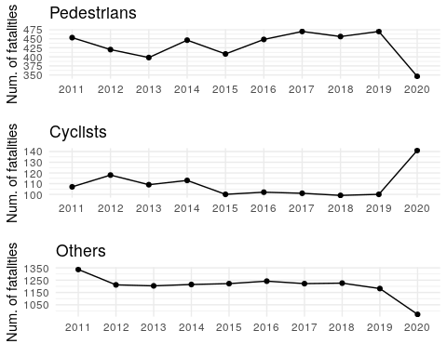

Figure 3. Road traffic fatalities by year and type, UK 2011-2020

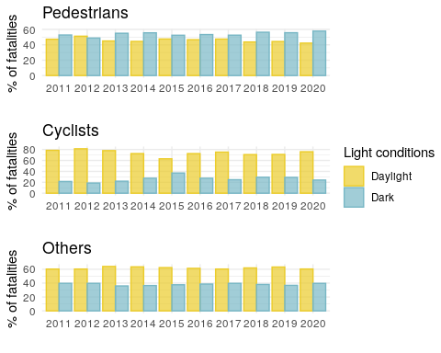

Figure 4. UK % of road traffic fatalities by light conditions, year, and type, UK 2011-2020

# Dicusssion

# Conclusions

# References

Ferenchak, Nicholas N., Risa E. Gutierrez, and Patrick A. Singleton. 2022. “Shedding Light on the Pedestrian Safety Crisis: An Analysis Across the Injury Severity Spectrum by Lighting Condition.” *Traffic Injury Prevention* 23 (7): 434–39. <https://doi.org/10.1080/15389588.2022.2100362>.

Sanders, Rebecca L., Robert J. Schneider, and Frank R. Proulx. 2022. “Pedestrian Fatalities in Darkness: What Do We Know, and What Can Be Done?” *Transport Policy* 120 (May): 23–39. <https://doi.org/10.1016/j.tranpol.2022.02.010>.

Wang, Jin, and Jessica B. Cicchino. 2020. “Fatal Pedestrian Crashes on Interstates and Other Freeways in the United States.” *Journal of Safety Research* 74 (September): 1–7. <https://doi.org/10.1016/j.jsr.2020.04.009>.