The Glory of the Cross at Sunset
The cross stands as the supreme monument of God’s love, humility, and redemption. As the sun sets and the sky is painted in majestic blazing hues, we are reminded of both the darkness that fell over the land at Calvary and the glorious light of the resurrection that broke the power of death forever.
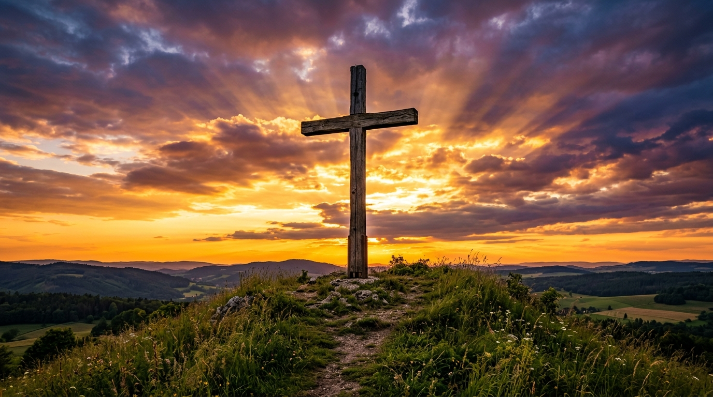
A Majestic Cross on a Hill at Sunset

📖 Scriptural Foundations of the Cross
As the Verse Scripter, I present the following true, unparaphrased, and powerful words from the Holy Scriptures:

1. The Cross as Our Sole Glory and Boast
[!NOTE] The world boasts in strength, status, and self-achievement, but the believer’s only boast is in the grace of Christ crucified.
Galatians 6:14 (NET) > But may I never boast except in the cross of our Lord Jesus Christ, through which the world has been crucified to me, and I to the world.

2. The Ultimate Humility of Christ
[!IMPORTANT] The cross was a symbol of shame and curse, yet Jesus willingly took it upon Himself, showing the absolute depth of His love.
Philippians 2:8 (NET) > He humbled himself, by becoming obedient to the point of death – even death on a cross!

3. Victory and Redemption Nailed to the Cross
[!TIP] On the cross, Jesus didn’t just suffer; He triumphed, cancelling our record of debt and nailing it out of sight forever.
Colossians 2:14 (NET) > He has destroyed what was against us, a certificate of indebtedness expressed in decrees opposed to us. He has taken it away by nailing it to the cross.

4. Patiently Enduring the Cross for Eternal Joy
[!NOTE] Looking to Jesus is our strength to run the race, remembering that He looked past the shame of the cross to the joy of our salvation.
Hebrews 12:2 (NET) > keeping our eyes fixed on Jesus, the pioneer and perfecter of our faith. For the joy set out for him he endured the cross, disregarding its shame, and has taken his seat at the right hand of the throne of God.

5. Taking Up Our Cross Daily
[!WARNING] Following Christ is a daily call to surrender our own desires, put our flesh to death, and live fully devoted to Him.
Luke 9:23 (NET) > Then he said to them all, “If anyone wants to become my follower, he must deny himself, take up his cross daily, and follow me.

[!TIP] May this majestic depiction of the cross of Jesus Christ encourage your heart today, pointing you to the eternal hope and victory found only in Him!

