Correlated time series

elisabeth wolfert

2/13/2021

## R Markdown

This is an R Markdown document. Markdown is a simple formatting syntax for authoring HTML, PDF, and MS Word documents. For more details on using R Markdown see <http://rmarkdown.rstudio.com>.

When you click the **Knit** button a document will be generated that includes both content as well as the output of any embedded R code chunks within the document. You can embed an R code chunk like this:

# Load libraries for data test.  
  
library("car")

library("dplyr")

library("ggplot2")  
library("ggpubr")  
library("tidyverse")

library("broom")  
library("AICcmodavg")  
library("gplots")

library("multcompView")  
library("BSDA")

library("DescTools")

library("effsize")  
library("coin")

## Loading required package: survival

library("rcompanion")

#Load Data File and Filter to Pull Required Data for the data test.  
  
SolarWind = read.csv("DateWindSolarTime.csv",header = TRUE)

#Display Data in Dataframe again showing more values.  
  
str(SolarWind)

## 'data.frame': 5488 obs. of 3 variables:  
## $ Date_Elec : chr "1/1/2011" "1/1/2011" "1/1/2011" "1/1/2011" ...  
## $ total_cust_photo: int 28 79 4719 46576 1070 269 294 746 1930 145 ...  
## $ total_cust_wind : int 63 7 108 402 26 1 0 27 20 0 ...

#Summary of Data Frame  
  
summary(SolarWind)

## Date_Elec total_cust_photo total_cust_wind   
## Length:5488 Min. : 0.0 Min. : 0.00   
## Class :character 1st Qu.: 372.5 1st Qu.: 21.00   
## Mode :character Median : 1784.0 Median : 54.50   
## Mean : 18864.8 Mean : 92.59   
## 3rd Qu.: 8413.8 3rd Qu.:128.00   
## Max. :1069003.0 Max. :609.00

## Including Plots

You can also embed plots, for example:

#Display Data in Data frame again showing photo(solar) values.  
  
str(SolarWind$total_cust_photo)

## int [1:5488] 28 79 4719 46576 1070 269 294 746 1930 145 ...

#Display Data in Data frame again showing Wind values.  
  
str(SolarWind$total_cust_wind)

## int [1:5488] 63 7 108 402 26 1 0 27 20 0 ...

#Plot Data in Data frame again showing wind chart.  
  
plot.ts(SolarWind$total_cust_wind)

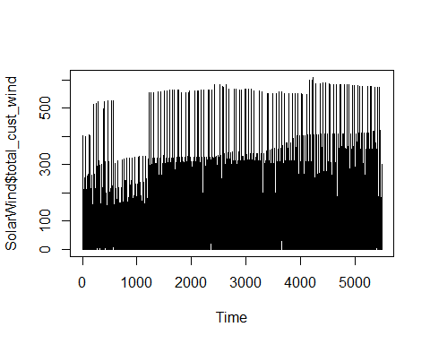

#Plot Data in Data frame again showing photo(solar) chart.  
  
plot.ts(SolarWind$total_cust_photo)

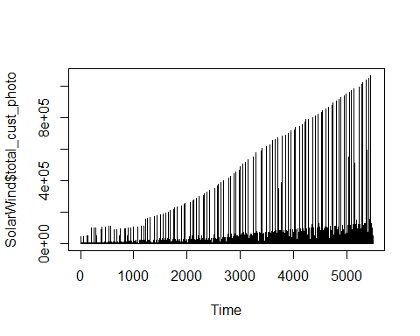

#Create a time series data chart from in Data frame again showing wind data.  
  
timeseries.ws.name <- ts(SolarWind, 2011, 2019, 12)  
plot(timeseries.ws.name)

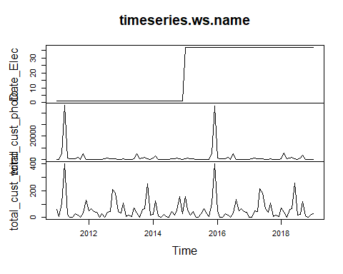

#Create a variable with wind time series data.  
  
wind <- c(38723, 41551, 59835, 61195, 62994, 63055, 59377, 60220, 61198  
)

#Create a variable with solar time series data.  
  
solar <- c(1593860, 2347514, 4610973, 6692424, 9808340, 14091612, 17881589, 21350503, 25153052)

#Create a plot of the variable with wind time series data. The plot shows the growth of the wind data.  
  
plot.ts(wind)

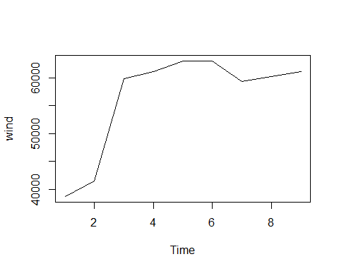

#Create a plot of the variable with solar time series data. The plot shows the growth of the solar data at a faster rate.  
  
plot.ts(solar)

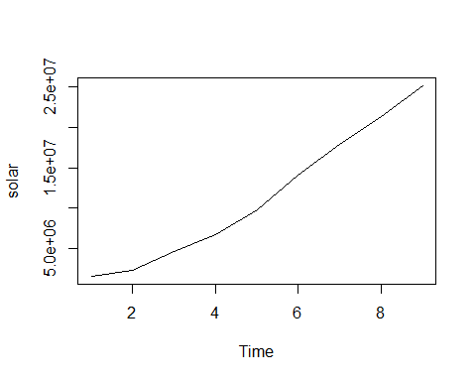

#Combine the plots of the variables for wind and solar time series data.  
  
combined.solar_wind <- matrix(c(solar,wind),nrow = 18)

#Run a time series test of data.  
  
solar_wind.timeseries <- ts(combined.solar_wind,start = c(2011,18),frequency = 18)

#Print the results of the time series test.  
  
png(file = "rainfall_combined.png")

#Print the data from the combined time series data.  
  
print(solar_wind.timeseries)

## Time Series:  
## Start = c(2011, 18)   
## End = c(2012, 17)   
## Frequency = 18   
## Series 1  
## [1,] 1593860  
## [2,] 2347514  
## [3,] 4610973  
## [4,] 6692424  
## [5,] 9808340  
## [6,] 14091612  
## [7,] 17881589  
## [8,] 21350503  
## [9,] 25153052  
## [10,] 38723  
## [11,] 41551  
## [12,] 59835  
## [13,] 61195  
## [14,] 62994  
## [15,] 63055  
## [16,] 59377  
## [17,] 60220  
## [18,] 61198

#Show the results in a plot of the combined wind and solar data in a plot. The plot shows an irregular result showing that the combined data for wind a solar does not have a correlated significance.  
  
plot(solar_wind.timeseries, main = "Multiple Time Series")

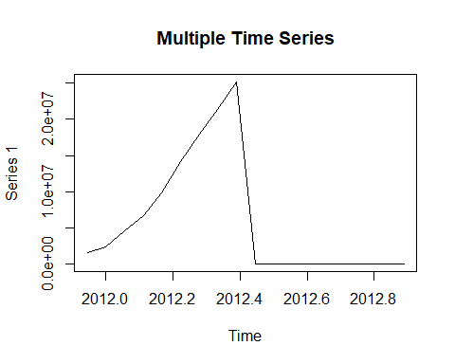

Note that the echo = FALSE parameter was added to the code chunk to prevent printing of the R code that generated the plot.