Developer Manual for Crane Position Visualizer (CPV)

Version: 2017 / 01

Content
Mission Statement 2
What is this project about? 2
Who are the users? 2
What is the use for the users 2
Where is the software installed, where is it used? 2
Architectural overview 3
Components (derived from the architectural overview) 3
Uses technologies 4
Development Process 6
Concepts 6
Validation Concept 6
Test concept: What is tested where and how? 6

This document intends to offer an overview over Crane Position Visualizer <<CPV>> and the technical concepts applied during its creation.

Mission Statement

What is this project about?

Crane Position Visualizer (CPV) is a desktop application that supports the Künz commissioning engineers during the crane software development process. In a first step, the tool supports the development and testing of a new crane. To this the tool connects to the plc and reads out a special DB where the positions of different elements are listed and simply displays this like shapes in a desktop-application.

As this tool is just for “in-house” usage we do not focus on multi-language-support nor different unit-systems.

Who are the users?

User are commissioning engineers engineering our cranes.

What is the use for the users

In a first version the «CPV» provides graphical information about the crane and its surroundings. With the aid of this representation, the crane movement and also the movements in the vicinity of the crane can be simple visualized.

Where is the software installed, where is it used?

«KTC» is installed on the individual laptop of a user.

Architectural overview
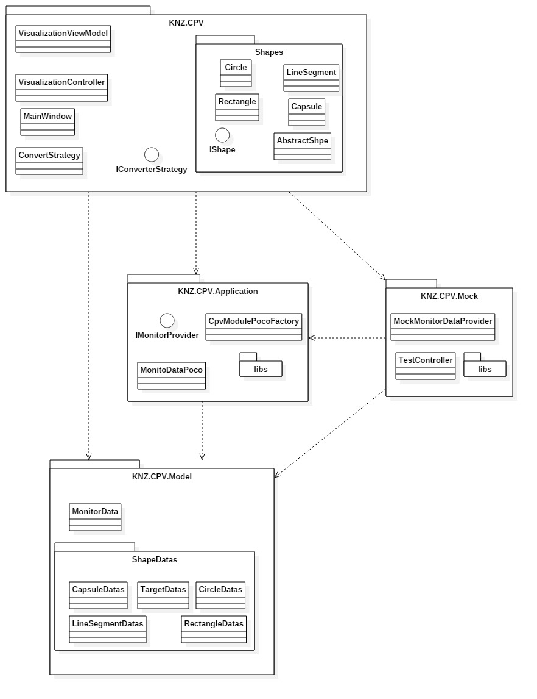
The Desktop Application conceptually follows a n-tier architecture and the presentation tier the Model-View-ViewModel pattern. The most central component to the application is the View.
The application tier, the logical level is extracted from the presentation series and controls the functionality of an application as a separate layer through detailed processing. This application tier is responsible for the connection to the Plc and for reading the Database.
The data tier includes the data persistence mechanisms and the PLC access layer that encapsulates the persistence mechanisms and exposes the data.
The mock layer simulate dates to represent in the view, because there is no interface defined to PLC at the moment.

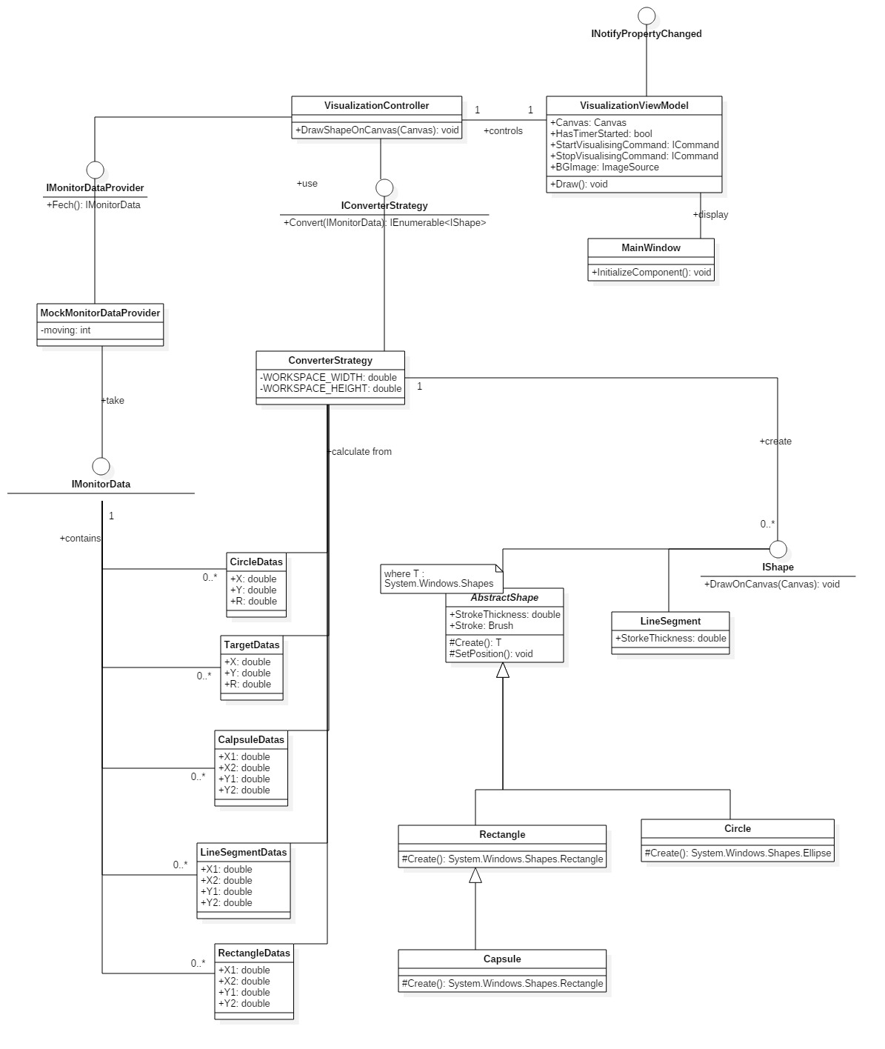
The library used to implement the shapes and to display them graphically has forced this implementation. The System.Windows.Shapes implements Rectangle, Ellipse with the characteristics, height, and the position with the distance to the left or right and to top or bottom edge. In the another hand the System.Windows.Shapes.Line have the two Points as attribute. That’s the reason, while AbstractShape do not implement LineSegment. That why IShape was necessary.
The use of IConverterStrategy and IMonitordata is that in the future will possible IShapes nonparallel to axes to draw. It decouples presentation and calculation of the shapes.

Components (derived from the architectural overview)
This section describes the projects (Application, Domain…) of the KTC. It should give a rough overview where what kind of functionality is implemented.

After cloning the repository the following Project-Tree should exist in VS:
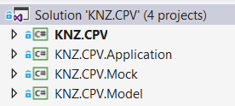
The purpose of each project is described in the following.

Project | Description
KNZ.CPV | This project implements the UI and the data binding, and convert the plc dates to IShape element.
KNZ.KTC.Application | This project is responsible for the plc communication and to read the dates.
KNZ.KTC.Model | In this project holds classes (models) needed in several projects (e.g. MonitorData).
KNZ.KCT.Plc.Mock | This project simulates data from Plc

Uses technologies

This section describes the used technologies and list links to additional information.

Technology | Description
WPF | Windows Presentation Foundation (or WPF) is a graphical subsystem by Microsoft for rendering user interfaces in Windows-based applications.  License: MIT License  Advantages:  - Künz developers know WPF well.  - Resolution independence - WPF let shrink or enlarge elements on the screen, independent of the screen's resolution. It uses vector graphics to make the applications resolution-independent.  - Hardware acceleration - WPF is built on top of Direct3D, which offloads work to graphics processing units (GPUs) instead of central processor units (CPUs).  - Culturally aware controls - static text in controls and the return data for the String function are modified according to the culture and language specified by the end user's operating system.

Development Process

Based on the written requirements. Requirements have been revised several time(HAE). The code check followed by a second person (BT, MMU).

