**Project:** Computer Vision-Based Roll Call System using Python

Task: Create a vision-based roll-call system.

Getting Started

1. In a new Python file named “main.py,” create two classes based on the definitions below:

|  |  |  |  |
| --- | --- | --- | --- |
| **Name** | **Initialization** | **Class Attributes** | **Class Functions** |
| Class | Takes in a *name* and *professor* | Name (string), professor (string), students (array) | getName – returns class name  setName – sets class name to a new name  getProfessor – returns class professor  setProfessor – sets class professor to a new professor  getStudents – returns the list of students in a class  addStudent – adds a student to a class  removeStudent – removes a student from a class  printSummary – prints the class name, class professor, number of students, and a list of students |
| Student | Takes in a *name* | Name (string),  Absent (Boolean),  Sample (array) | getName – returns student name  setName – sets student name to a new name  isAbsent – returns if student is absent or not  set_present – sets Absent attribute to false  set_absent – sets Absent attribute to true |

1. In main.py, define a *main* function that creates a “Biology” class with “Mr. Smith” as the professor.
2. Run the printSummary function on your new class. It should print the following:

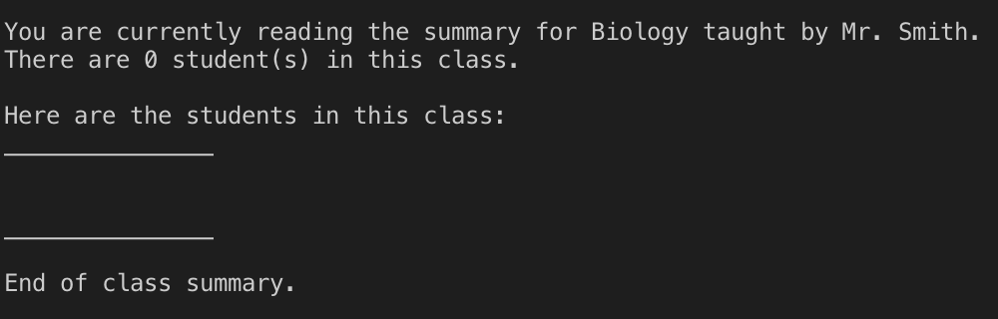

1. Create a student with your name and add it to the class.
2. Run the printSummary function on your class. It should print the following:

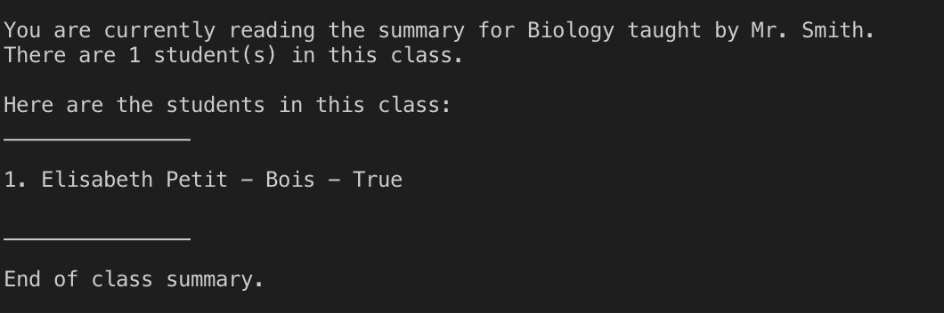

1. Change the name of the class to “Mathematics” and the professor to “Mr. Walker.”
2. Run the printSummary function on your class. It should print the following:

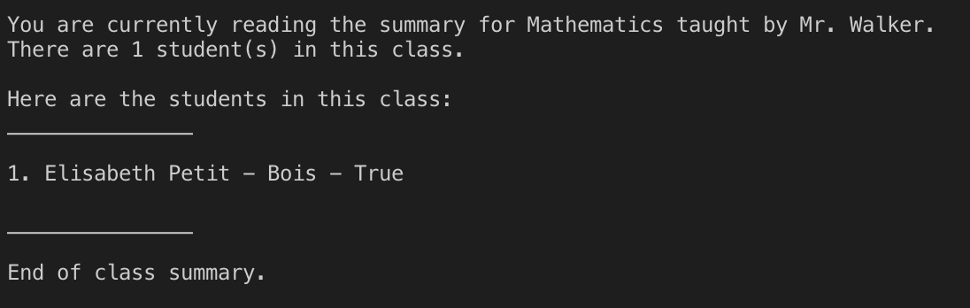

1. Change the name of the student in your class to “Student Number 1.”
2. Run the printSummary function on your new class. It should print the following:

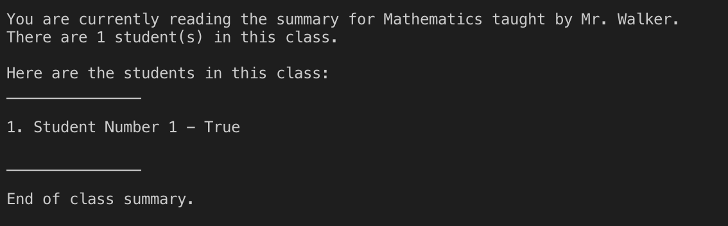

1. Create “Student Number 2” and add it to the class.
2. Run the printSummary function on your class. It should print the following:

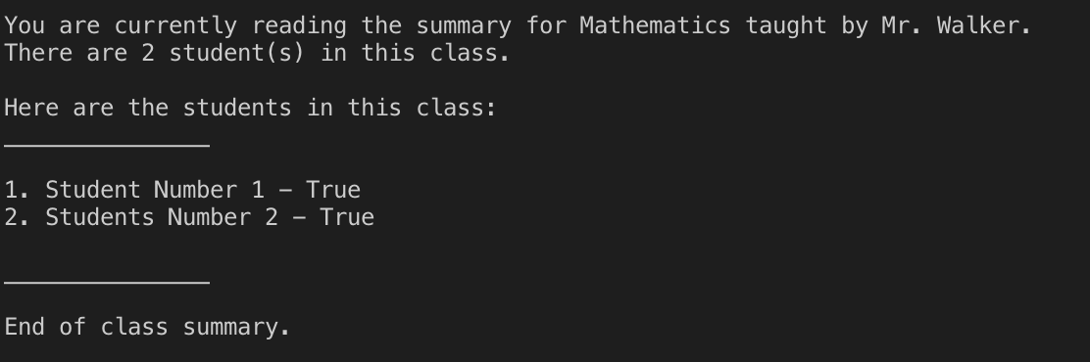

1. Remove “Student Number 1” from the class.
2. Run the printSummary function on your class. It should print the following:

