This program was created to track grocery items and count how often each item is purchased. It reads from a text file that contains a list of items and uses a map to store and count how many times each item appears. This makes it easy to organize and display the data.
Figure 1: Program Menu
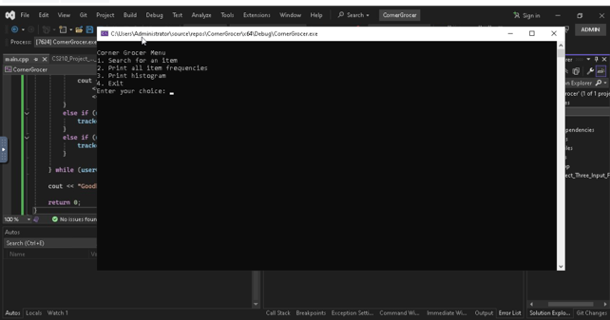
This screenshot shows the main menu of the program. It gives the user four options to choose from, like searching for an item, printing all item frequencies, showing a histogram, or exiting the program. The menu makes the program easy to use.
Figure 2: Item Frequency Output
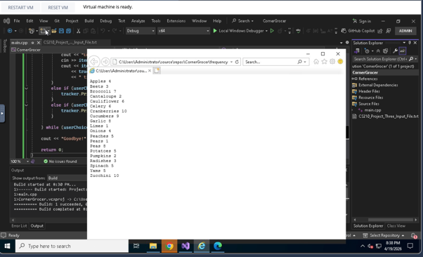
This screenshot shows the list of all grocery items and how many times each one was purchased. The program reads the input file and counts how many times each item appears, then prints the results clearly.
Figure 3: Histogram Output
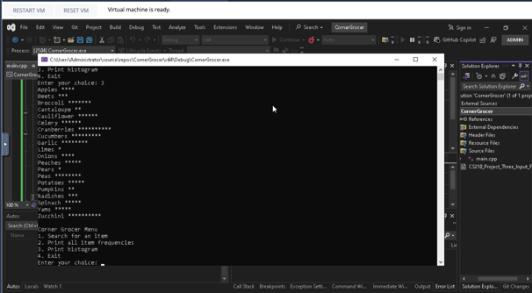
This screenshot shows the histogram version of the data. Instead of just numbers, the program uses asterisks to represent how many times each item was purchased. This makes it easier to visually compare the items.
AI Usage Statement
I used ChatGPT to help guide me through setting up my program, understanding the assignment requirements, and troubleshooting issues in Visual Studio. The tool also helped me understand how to organize my code and complete the documentation. All final work was reviewed, understood, and completed by me.

