Source Data Mapping Approach to CDMV5.3

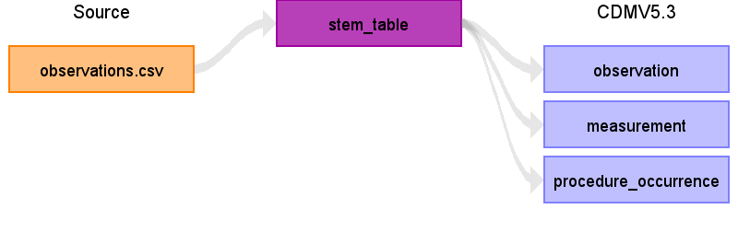

Table name: stem_table

Reading from observations.csv

- only mapping if status = "final" or "unknown"

- Mapping from Non-Standard-Concept (LOINC) to Standard-Concept available: use domain from Standard-Concept

- Mapping from Non-Standard-Concept (LOINC) to Standard-Concept not available or mapping from Non-Standard-Concept (LOINC) to Standard-Concept is invalid: use domain from Non-Standard-Concept

- Mapping to Non-Standard-Concept not available: use domain of Observation

- Implementation in fhir-to-omop/src/main/java/org/miracum/etl/fhirtoomop/mapper/ObservationMapper.java

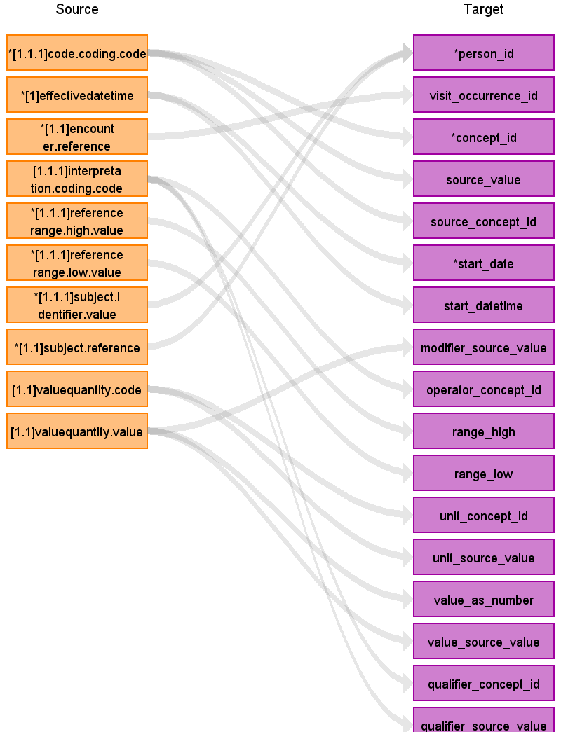

|  |  |  |  |
| --- | --- | --- | --- |
| Destination Field | Source Field | Logic | Comment |
| domain_id |  |  |  |
| person_id | [1.1.1]subject.identifier.value  [1.1]subject.reference | - person_id via search of subject.identifier.value in person.person_source_value  - Formatting required  -> separation prefix ("Patient/") and identifier  - person_id via search of separated subject.reference in person.person_source_value | Example:  FHIR: 100  OMOP: 1  Example:  FHIR: Patient/100  OMOP: 1 |
| visit_occurrence_id | [1.1]encounter.reference | - Formatting required  -> separation prefix ("Encounter/") and identifier  - visit_occurrence_id via search of separated encounter.reference in visit_occurrence.visit_source_value | Example:  FHIR: Encounter/200  OMOP: 1 |
| visit_detail_id |  |  |  |
| provider_id |  |  |  |
| id |  |  | generated automatically |
| concept_id | [1.1.1]code.coding.code | - Mapping from code.coding.code to concept_id (Standard-Concept) in loinc_standard_lookup  -> corresponding code.coding.system = "http://loinc.org"  - concept_id = 0, if no Standard-Concept was found or if mapping from Non-Standard-Concept to Standard-Concept is invalid | Example:  FHIR: 87422-2  OMOP: 36304599 |
| source_value | [1.1.1]code.coding.code |  | Example:  FHIR: 87422-2  OMOP: 87422-2 |
| source_concept_id | [1.1.1]code.coding.code | - Mapping from code.coding.code to concept_id (Non-Standard-Concept) in loinc_standard_lookup  -> corresponding code.coding.system = "http://loinc.org"  - concept_id = 0, if no Non-Standard-Concept was found | Example:  FHIR: 87422-2  OMOP: 36304599 |
| type_concept_id |  |  | - concept_id = 32817 (EHR) |
| start_date | [1]effectivedatetime | - Formatting required | Example:  FHIR: 2013-10-07T14:54:27Z  OMOP: 2013-10-07 |
| start_datetime | [1]effectivedatetime | - Formatting required | Example:  FHIR: 2013-10-07T14:54:27Z  OMOP: 2013-10-07 14:54:27 |
| end_date |  |  |  |
| end_datetime |  |  |  |
| verbatim_end_date |  |  |  |
| days_supply |  |  |  |
| dose_unit_source_value |  |  |  |
| lot_number |  |  |  |
| modifier_concept_id |  |  |  |
| modifier_source_value | [1.1]valuequantity.value |  | Example:  FHIR: 26.5  OMOP: 26.5 |
| operator_concept_id | [1.1.1]interpretation.coding.code | - Mapping from interpretation.coding.code to concept_id in source_to_concept_map via source_vocabulary_id = "Lab Interpretation"  -> concept_id = 0, if no mapping was found | Example:  FHIR: A  OMOP: 4088483 |
| quantity |  |  |  |
| range_high | [1.1.1]referencerange.high.value |  | Example:  FHIR: 25.0  OMOP: 25.0 |
| range_low | [1.1.1]referencerange.low.value |  | Example:  FHIR: 18.0  OMOP: 18.0 |
| refills |  |  |  |
| route_concept_id |  |  |  |
| route_source_value |  |  |  |
| sig |  |  |  |
| stop_reason |  |  |  |
| unique_device_id |  |  |  |
| unit_concept_id | [1.1]valuequantity.code | - Mapping from valueQuantity.code to concept_id (Standard-Concept) in ucum_standard_lookup  -> corresponding valueQuantity.system = "http://unitsofmeasure.org"  - concept_id = 0, if no Standard-Concept was found or if mapping from Non-Standard-Concept to Standard-Concept is invalid | Example:  FHIR: mmol/L  OMOP: 8753 |
| unit_source_value | [1.1]valuequantity.code |  | Example:  FHIR: mmol/L  OMOP: mmol/L |
| value_as_concept_id |  |  |  |
| value_as_number | [1.1]valuequantity.value |  | Example:  FHIR: 26.5  OMOP: 26.5 |
| value_as_string |  |  |  |
| value_source_value | [1.1]valuequantity.value |  | Example:  FHIR: 26.5  OMOP: 26.5 |
| anatomic_site_concept_id |  |  |  |
| disease_status_concept_id |  |  |  |
| specimen_source_id |  |  |  |
| anatomic_site_source_value |  |  |  |
| disease_status_source_value |  |  |  |
| condition_status_concept_id |  |  |  |
| condition_status_source_value |  |  |  |
| qualifier_concept_id | [1.1.1]interpretation.coding.code | - Mapping from interpretation.coding.code to concept_id in source_to_concept_map via source_vocabulary_id = "Lab Interpretation"  -> concept_id = 0, if no mapping was found | Example:  FHIR: A  OMOP: 4088483 |
| qualifier_source_value | [1.1.1]interpretation.coding.code |  | Example:  FHIR: A  OMOP: A |
| measurement_time |  |  |  |

Table name: observation

Reading from stem_table

- only mapping if status = "final" or "unknown"

- domain_id = "Observation"

- Implementation in fhir-to-omop/src/main/java/org/miracum/etl/fhirtoomop/mapper/ObservationMapper.java

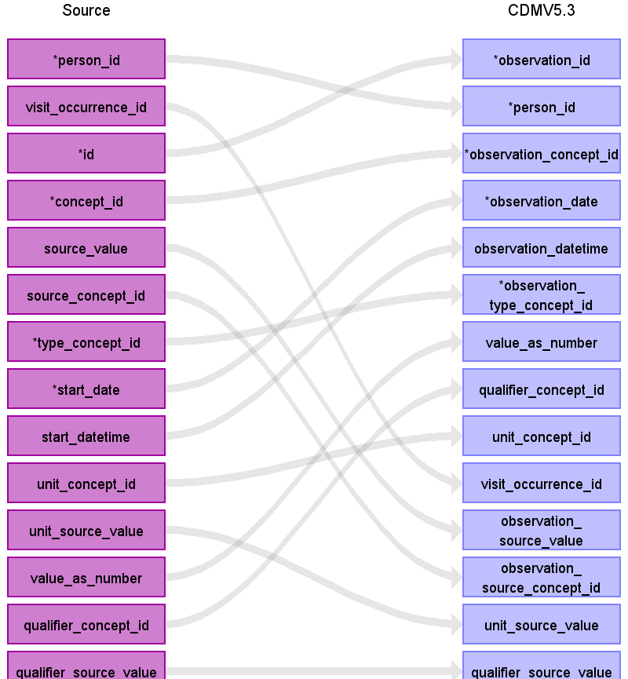

|  |  |  |  |
| --- | --- | --- | --- |
| Destination Field | Source Field | Logic | Comment |
| observation_id | id |  | generated automatically |
| person_id | person_id |  |  |
| observation_concept_id | concept_id |  |  |
| observation_date | start_date |  |  |
| observation_datetime | start_datetime |  |  |
| observation_type_concept_id | type_concept_id |  | - concept_id = 32817 (EHR) |
| value_as_number | value_as_number |  |  |
| value_as_string |  |  |  |
| value_as_concept_id |  |  |  |
| qualifier_concept_id | qualifier_concept_id |  |  |
| unit_concept_id | unit_concept_id |  |  |
| provider_id |  |  |  |
| visit_occurrence_id | visit_occurrence_id |  |  |
| visit_detail_id |  |  |  |
| observation_source_value | source_value |  |  |
| observation_source_concept_id | source_concept_id |  |  |
| unit_source_value | unit_source_value |  |  |
| qualifier_source_value | qualifier_source_value |  |  |

Table name: measurement

Reading from stem_table

- only mapping if status = "final" or "unknown"

- domain_id = "Measurement"

- Implementation in fhir-to-omop/src/main/java/org/miracum/etl/fhirtoomop/mapper/ObservationMapper.java

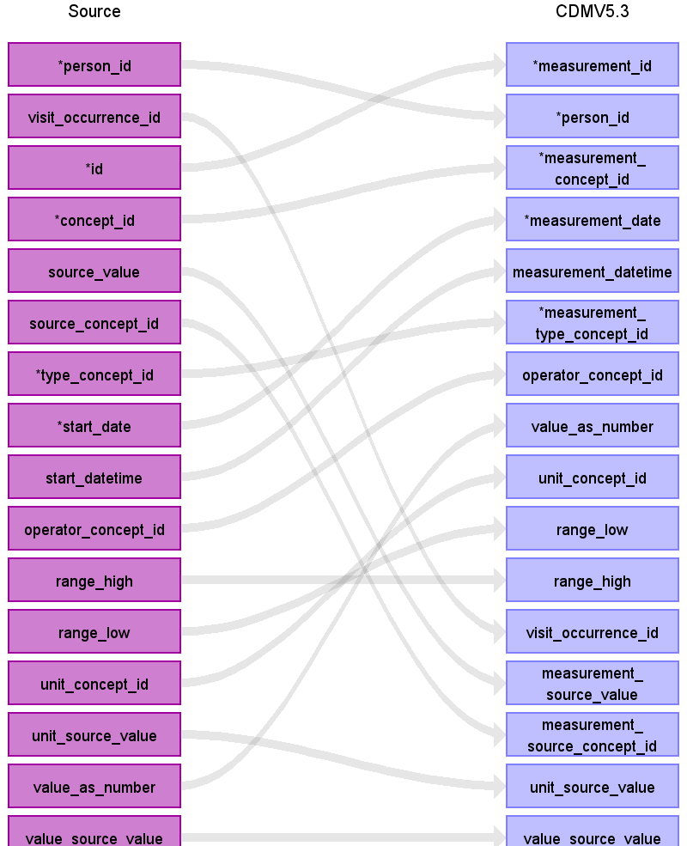

|  |  |  |  |
| --- | --- | --- | --- |
| Destination Field | Source Field | Logic | Comment |
| measurement_id | id |  | generated automatically |
| person_id | person_id |  |  |
| measurement_concept_id | concept_id |  |  |
| measurement_date | start_date |  |  |
| measurement_datetime | start_datetime |  |  |
| measurement_time |  |  |  |
| measurement_type_concept_id | type_concept_id |  | - concept_id = 32817 (EHR) |
| operator_concept_id | operator_concept_id |  |  |
| value_as_number | value_as_number |  |  |
| value_as_concept_id |  |  |  |
| unit_concept_id | unit_concept_id |  |  |
| range_low | range_low |  |  |
| range_high | range_high |  |  |
| provider_id |  |  |  |
| visit_occurrence_id | visit_occurrence_id |  |  |
| visit_detail_id |  |  |  |
| measurement_source_value | source_value |  |  |
| measurement_source_concept_id | source_concept_id |  |  |
| unit_source_value | unit_source_value |  |  |
| value_source_value | value_source_value |  |  |

Table name: procedure_occurrence

Reading from stem_table

- only mapping if status = "final" or "unknown"

- domain_id = "Procedure"

- Implementation in fhir-to-omop/src/main/java/org/miracum/etl/fhirtoomop/mapper/ObservationMapper.java

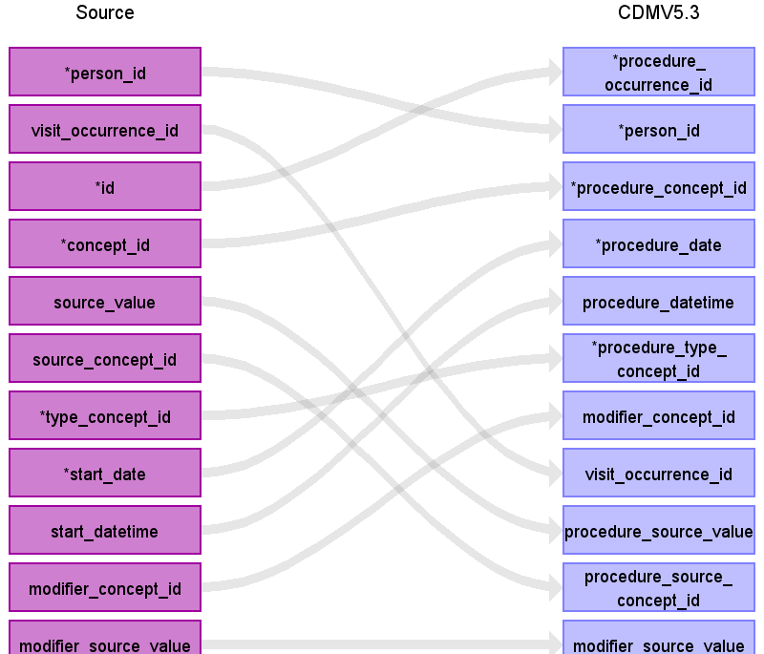

|  |  |  |  |
| --- | --- | --- | --- |
| Destination Field | Source Field | Logic | Comment |
| procedure_occurrence_id | id |  | generated automatically |
| person_id | person_id |  |  |
| procedure_concept_id | concept_id |  |  |
| procedure_date | start_date |  |  |
| procedure_datetime | start_datetime |  |  |
| procedure_type_concept_id | type_concept_id |  | - concept_id = 32817 (EHR) |
| modifier_concept_id | modifier_concept_id |  |  |
| quantity |  |  |  |
| provider_id |  |  |  |
| visit_occurrence_id | visit_occurrence_id |  |  |
| visit_detail_id |  |  |  |
| procedure_source_value | source_value |  |  |
| procedure_source_concept_id | source_concept_id |  |  |
| modifier_source_value | modifier_source_value |  |  |

Table name: condition_occurrence

Table name: death

Table name: device_exposure

Table name: drug_exposure

Table name: fact_relationship

Table name: note

Table name: note_nlp

Table name: observation_period

Table name: person

Table name: specimen

Table name: visit_detail

Table name: visit_occurrence

Table name: cohort

Table name: cohort_attribute

Table name: condition_era

Table name: dose_era

Table name: drug_era

Table name: cost

Table name: payer_plan_period

Table name: care_site

Table name: location

Table name: provider

Table name: cdm_source

Table name: metadata

Table name: attribute_definition

Table name: cohort_definition

Appendix: source tables

Table: stem_table

|  |  |  |  |
| --- | --- | --- | --- |
| Field | Type | Most freq. value | Comment |
| domain_id | CHARACTER VARYING |  |  |
| person_id | INTEGER |  |  |
| visit_occurrence_id | INTEGER |  |  |
| visit_detail_id | INTEGER |  |  |
| provider_id | INTEGER |  |  |
| id | INTEGER |  | generated automatically |
| concept_id | INTEGER |  |  |
| source_value | CHARACTER VARYING |  |  |
| source_concept_id | INTEGER |  |  |
| type_concept_id | INTEGER |  | - concept_id = 32817 (EHR) |
| start_date | DATE |  |  |
| start_datetime | DATETIME |  |  |
| end_date | DATE |  |  |
| end_datetime | DATETIME |  |  |
| verbatim_end_date | DATE |  |  |
| days_supply | INTEGER |  |  |
| dose_unit_source_value | CHARACTER VARYING |  |  |
| lot_number | CHARACTER VARYING |  |  |
| modifier_concept_id | INTEGER |  |  |
| modifier_source_value | CHARACTER VARYING |  |  |
| operator_concept_id | INTEGER |  |  |
| quantity | INTEGER |  |  |
| range_high | FLOAT |  |  |
| range_low | FLOAT |  |  |
| refills | INTEGER |  |  |
| route_concept_id | INTEGER |  |  |
| route_source_value | CHARACTER VARYING |  |  |
| sig | CHARACTER VARYING |  |  |
| stop_reason | CHARACTER VARYING |  |  |
| unique_device_id | CHARACTER VARYING |  |  |
| unit_concept_id | INTEGER |  |  |
| unit_source_value | CHARACTER VARYING |  |  |
| value_as_concept_id | INTEGER |  |  |
| value_as_number | DECIMAL |  |  |
| value_as_string | CHARACTER VARYING |  |  |
| value_source_value | CHARACTER VARYING |  |  |
| anatomic_site_concept_id | INTEGER |  |  |
| disease_status_concept_id | INTEGER |  |  |
| specimen_source_id | INTEGER |  |  |
| anatomic_site_source_value | CHARACTER VARYING |  |  |
| disease_status_source_value | CHARACTER VARYING |  |  |
| condition_status_concept_id | CHARACTER VARYING |  |  |
| condition_status_source_value | INTEGER |  |  |
| qualifier_concept_id | INTEGER |  |  |
| qualifier_source_value | CHARACTER VARYING |  |  |
| measurement_time | CHARACTER VARYING |  |  |

Table: observations.csv

|  |  |  |  |
| --- | --- | --- | --- |
| Field | Type | Most freq. value | Comment |
|  | INT | 3640 |  |
| [1.1.1]category.coding.code | VARCHAR | 26436-6 |  |
| [1.2.1]category.coding.code | VARCHAR | laboratory |  |
| [1.1.1]category.coding.display | VARCHAR | Laboratory studies (set) |  |
| [1.2.1]category.coding.display | VARCHAR | Laboratory |  |
| [1.1.1]category.coding.system | VARCHAR | http://loinc.org/ |  |
| [1.2.1]category.coding.system | VARCHAR | http://terminology.hl7.org/CodeSystem/observation-category |  |
| [1.1.1]code.coding.code | VARCHAR | 86649-1 |  |
| [1.1.1]code.coding.display | VARCHAR | Birth control method at intake Reported --at intake |  |
| [1.1.1]code.coding.system | VARCHAR | http://loinc.org |  |
| [1.1]code.text | VARCHAR | pezm |  |
| [1.1.1]dataabsentreason.coding.code | VARCHAR |  |  |
| [1.1.1]dataabsentreason.coding.display | VARCHAR |  |  |
| [1.1.1]dataabsentreason.coding.system | VARCHAR |  |  |
| [1]effectivedatetime | VARCHAR | 2022-05-05T02:01:47Z |  |
| [1.1]encounter.reference | VARCHAR | Encounter/1771 |  |
| [1]id | INT | 3640 |  |
| [1.1.1.1]identifier.assigner.identifier.system | VARCHAR | https://diz.uniklinikum-dresden.de/fhir/core/NamingSystem/OrganisationId |  |
| [1.1.1.1]identifier.assigner.identifier.value | VARCHAR | UKDD |  |
| [1.1]identifier.system | VARCHAR | https://diz.uniklinikum-dresden.de/fhir/core/NamingSystem/labObservationId |  |
| [1.1.1.1]identifier.type.coding.code | VARCHAR | OBI |  |
| [1.1.1.1]identifier.type.coding.system | VARCHAR | http://terminology.hl7.org/CodeSystem/v2-0203 |  |
| [1.1]identifier.value | INT | 3640 |  |
| [1.1.1]interpretation.coding.code | VARCHAR |  |  |
| [1.1.1]interpretation.coding.display | VARCHAR |  |  |
| [1.1.1]interpretation.coding.system | VARCHAR | http://terminology.hl7.org/CodeSystem/v3-ObservationInterpretation |  |
| [1.1]meta.lastupdated | VARCHAR | 2023-08-15T12:54:15.697Z |  |
| [1.1]meta.profile | VARCHAR | https://www.medizininformatik-initiative.de/fhir/core/modul-labor/StructureDefinition/ObservationLab |  |
| [1.1]meta.source | VARCHAR | https://diz.uniklinikum-dresden.de/information-mart_mii-kds_v001/dwh-to-fhir_v001/ |  |
| [1.1]meta.versionid | INT | 88483 |  |
| [1.1]note.text | VARCHAR |  |  |
| [1.1.1]referencerange.high.value | REAL | 25.0 |  |
| [1.1.1]referencerange.low.value | REAL | 14.0 |  |
| [1]status | VARCHAR | unknown |  |
| [1.1.1]subject.identifier.system | VARCHAR | https://diz.uniklinikum-dresden.de/fhir/core/NamingSystem/PatientId |  |
| [1.1.1]subject.identifier.value | INT | 627 |  |
| [1.1]subject.reference | VARCHAR | Patient/627 |  |
| [1.1]valuequantity.code | VARCHAR |  |  |
| [1.1]valuequantity.system | VARCHAR | http://unitsofmeasure.org |  |
| [1.1]valuequantity.unit | VARCHAR |  |  |
| [1.1]valuequantity.value | REAL |  |  |

Table: patients.csv

|  |  |  |  |
| --- | --- | --- | --- |
| Field | Type | Most freq. value | Comment |
|  | INT | 1220 |  |
| [1.1]address.extension | VARCHAR | http://hl7.org/fhir/StructureDefinition/data-absent-reason |  |
| [1.1.1.1]address.extension.valuecoding.code | VARCHAR | masked |  |
| [1.1.1.1]address.extension.valuecoding.display | VARCHAR | Masked |  |
| [1.1.1.1]address.extension.valuecoding.system | VARCHAR | http://hl7.org/fhir/StructureDefinition/data-absent-reason |  |
| [1]birthdate | DATE | 1982-01-16 |  |
| [1]deceasedboolean | VARCHAR | false |  |
| [1]deceaseddatetime | VARCHAR |  |  |
| [1]gender | VARCHAR | male |  |
| [1]id | INT | 1220 |  |
| [1.1.1.1]identifier.assigner.identifier.system | VARCHAR | https://diz.uniklinikum-dresden.de/fhir/core/NamingSystem/OrganisationId |  |
| [1.1.1.1.1.1]identifier.assigner.identifier.type.coding.code | VARCHAR | XX |  |
| [1.1.1.1.1.1]identifier.assigner.identifier.type.coding.system | VARCHAR | http://terminology.hl7.org/CodeSystem/v2-0203 |  |
| [1.1.1.1]identifier.assigner.identifier.value | VARCHAR | UKDD |  |
| [1.1]identifier.system | VARCHAR | https://diz.uniklinikum-dresden.de/fhir/core/NamingSystem/PatientId |  |
| [1.1.1.1]identifier.type.coding.code | VARCHAR | MR |  |
| [1.1.1.1]identifier.type.coding.system | VARCHAR | http://terminology.hl7.org/CodeSystem/v2-0203 |  |
| [1.1]identifier.use | VARCHAR | usual |  |
| [1.1]identifier.value | INT | 1220 |  |
| [1.1]meta.lastupdated | VARCHAR | 2023-08-15T12:51:50.905Z |  |
| [1.1]meta.profile | VARCHAR | https://www.medizininformatik-initiative.de/fhir/core/modul-person/StructureDefinition/Patient |  |
| [1.1]meta.source | VARCHAR | https://diz.uniklinikum-dresden.de/information-mart_mii-kds_v001/dwh-to-fhir_v001/ |  |
| [1.1]meta.versionid | INT | 85458 |  |
| [1.1]name.extension | VARCHAR | http://hl7.org/fhir/StructureDefinition/data-absent-reason |  |
| [1.1.1.1]name.extension.valuecoding.code | VARCHAR | masked |  |
| [1.1.1.1]name.extension.valuecoding.display | VARCHAR | Masked |  |
| [1.1.1.1]name.extension.valuecoding.system | VARCHAR | http://terminology.hl7.org/CodeSystem/data-absent-reason |  |

Table: encounterek.csv

|  |  |  |  |
| --- | --- | --- | --- |
| Field | Type | Most freq. value | Comment |
|  | INT | 1462 |  |
| [1.1]class.code | VARCHAR | SS |  |
| [1.1]class.display | VARCHAR | short stay |  |
| [1.1]class.system | VARCHAR | http://terminology.hl7.org/CodeSystem/v3-ActCode |  |
| [1.1.1.1]hospitalization.admitsource.coding.code | VARCHAR | G |  |
| [1.1.1.1]hospitalization.admitsource.coding.display | VARCHAR | Geburt |  |
| [1.1.1.1]hospitalization.admitsource.coding.system | VARCHAR | https://www.medizininformatik-initiative.de/fhir/core/modul-fall/CodeSystem/Aufnahmeanlass |  |
| [1.1.1.1]hospitalization.dischargedisposition.coding.code | INT |  |  |
| [1.1.1.1]hospitalization.dischargedisposition.coding.display | VARCHAR |  |  |
| [1.1.1.1]hospitalization.dischargedisposition.coding.system | VARCHAR | https://www.medizininformatik-initiative.de/fhir/core/modul-fall/CodeSystem/Entlassungsgrund |  |
| [1]id | INT | 1462 |  |
| [1.1.1.1]identifier.assigner.identifier.system | VARCHAR | https://diz.uniklinikum-dresden.de/fhir/core/NamingSystem/OrganisationId |  |
| [1.1.1.1]identifier.assigner.identifier.value | VARCHAR | UKDD |  |
| [1.1]identifier.system | VARCHAR | https://diz.uniklinikum-dresden.de/fhir/core/NamingSystem/Encounter/EinrichtungskontaktId |  |
| [1.1.1.1]identifier.type.coding.code | VARCHAR | VN |  |
| [1.1.1.1]identifier.type.coding.system | VARCHAR | http://terminology.hl7.org/CodeSystem/v2-0203 |  |
| [1.1]identifier.value | INT | 1462 |  |
| [1.1]meta.lastupdated | VARCHAR | 2023-10-25T07:32:34.407Z |  |
| [1.1]meta.profile | VARCHAR | https://www.medizininformatik-initiative.de/fhir/core/modul-fall/StructureDefinition/KontaktGesundheitseinrichtung |  |
| [1.1]meta.source | VARCHAR | https://diz.uniklinikum-dresden.de/information-mart_mii-kds_v001/dwh-to-fhir_v001/ |  |
| [1.1]meta.versionid | INT | 370 |  |
| [1.1]period.end | VARCHAR | 2020-02-16T20:43:24Z |  |
| [1.1]period.start | VARCHAR | 2012-11-02T18:15:48Z |  |
| [1.1.1]reasoncode.coding.code | INT | 01 |  |
| [1.1.1]reasoncode.coding.display | VARCHAR | Krankenhausbehandlung, vollstationär |  |
| [1.1.1]reasoncode.coding.system | VARCHAR | https://www.medizininformatik-initiative.de/fhir/modul-fall/core/CodeSystem/Aufnahmegrund |  |
| [1.1.1]serviceprovider.identifier.system | VARCHAR | http://diz.uniklinikum-dresden.de/fhir/core/NamingSystem/OrganisationId |  |
| [1.1.1]serviceprovider.identifier.value | VARCHAR | UKDD |  |
| [1]status | VARCHAR | finished |  |
| [1.1.1]subject.identifier.system | VARCHAR | https://diz.uniklinikum-dresden.de/fhir/core/NamingSystem/PatientId |  |
| [1.1.1]subject.identifier.value | INT | 627 |  |
| [1.1]subject.reference | VARCHAR | Patient/627 |  |
| [1.1.1]type.coding.code | VARCHAR | einrichtungskontakt |  |
| [1.1.1]type.coding.display | VARCHAR | Einrichtungskontakt |  |
| [1.1.1]type.coding.system | VARCHAR | https://www.medizininformatik-initiative.de/fhir/core/modul-fall/CodeSystem/Kontaktebene |  |
| [1.1]type.text | VARCHAR | ambulant |  |

Table: encounterak.csv

|  |  |  |  |
| --- | --- | --- | --- |
| Field | Type | Most freq. value | Comment |
|  | INT | 2306 |  |
| [1.1]class.code | VARCHAR | IMP |  |
| [1.1]class.display | VARCHAR | inpatient encounter |  |
| [1.1]class.system | VARCHAR | http://terminology.hl7.org/CodeSystem/v3-ActCode |  |
| [1]id | INT | 4970 |  |
| [1.1.1.1]identifier.assigner.identifier.system | VARCHAR | https://diz.uniklinikum-dresden.de/fhir/core/NamingSystem/OrganisationId |  |
| [1.1.1.1]identifier.assigner.identifier.value | VARCHAR | UKDD |  |
| [1.1]identifier.system | VARCHAR | https://diz.uniklinikum-dresden.de/fhir/core/NamingSystem/Encounter/AbteilungskontaktId |  |
| [1.1.1.1]identifier.type.coding.code | VARCHAR | VN |  |
| [1.1.1.1]identifier.type.coding.system | VARCHAR | http://terminology.hl7.org/CodeSystem/v2-0203 |  |
| [1.1]identifier.value | INT | 4970 |  |
| [1.1.1.1]location.location.identifier.system | VARCHAR | https://diz.uniklinikum-dresden.de/fhir/CodeSystem/OrganisationAbteilungen |  |
| [1.1.1.1]location.location.identifier.value | VARCHAR | MK-ITS2 |  |
| [1.1.1]location.period.end | VARCHAR | 2018-01-12T17:44:20Z |  |
| [1.1.1]location.period.start | VARCHAR | 2017-09-22T08:31:49Z |  |
| [1.1.1.1]location.physicaltype.coding.code | VARCHAR | wa |  |
| [1.1.1.1]location.physicaltype.coding.display | VARCHAR | Ward |  |
| [1.1.1.1]location.physicaltype.coding.system | VARCHAR | http://terminology.hl7.org/CodeSystem/location-physical-type |  |
| [1.1]location.status | VARCHAR | active |  |
| [1.1]meta.lastupdated | VARCHAR | 2023-08-15T12:55:35.180Z |  |
| [1.1]meta.profile | VARCHAR | https://www.medizininformatik-initiative.de/fhir/core/modul-fall/StructureDefinition/KontaktGesundheitseinrichtung |  |
| [1.1]meta.source | VARCHAR | https://diz.uniklinikum-dresden.de/information-mart_mii-kds_v001/dwh-to-fhir_v001/ |  |
| [1.1]meta.versionid | INT | 92740 |  |
| [1.1]partof.reference | VARCHAR | Encounter/377 |  |
| [1.1]period.end | VARCHAR | 2014-02-18T22:04:00Z |  |
| [1.1]period.start | VARCHAR | 2018-06-30T05:04:15Z |  |
| [1.1.1]serviceprovider.identifier.system | VARCHAR | http://diz.uniklinikum-dresden.de/fhir/core/NamingSystem/OrganisationId |  |
| [1.1.1]serviceprovider.identifier.value | VARCHAR | UKDD |  |
| [1.1.1]servicetype.coding.code | INT | 1028 |  |
| [1.1.1]servicetype.coding.display | VARCHAR | Pädiatrie/Schwerpunkt Kinderneurologie |  |
| [1.1.1]servicetype.coding.system | VARCHAR | https://www.medizininformatik-initiative.de/fhir/core/modul-fall/CodeSystem/Fachabteilungsschluessel |  |
| [1]status | VARCHAR | finished |  |
| [1.1.1]subject.identifier.system | VARCHAR | https://diz.uniklinikum-dresden.de/fhir/core/NamingSystem/PatientId |  |
| [1.1.1]subject.identifier.value | INT | 627 |  |
| [1.1]subject.reference | VARCHAR | Patient/627 |  |
| [1.1.1]type.coding.code | VARCHAR | abteilungskontakt |  |
| [1.1.1]type.coding.display | VARCHAR | Abteilungskontakt |  |
| [1.1.1]type.coding.system | VARCHAR | https://www.medizininformatik-initiative.de/fhir/core/modul-fall/CodeSystem/Kontaktebene |  |
| [1.1]type.text | VARCHAR | teilstationär |  |

Table: procedures.csv

|  |  |  |  |
| --- | --- | --- | --- |
| Field | Type | Most freq. value | Comment |
|  | INT | 4970 |  |
| [1.1.1]category.coding.code | INT | 103693007 |  |
| [1.1.1]category.coding.display | VARCHAR | Diagnostic procedure |  |
| [1.1.1]category.coding.system | VARCHAR | http://snomed.info/sct |  |
| [1.1.1]code.coding.code | VARCHAR | 5-895.37 |  |
| [1.2.1]code.coding.code | INT | 86481000 |  |
| [1.1.1]code.coding.display | VARCHAR | Radikale und ausgedehnte Exzision von erkranktem Gewebe an Haut und Unterhaut: Mit primärem Wundverschluss, histographisch kontrolliert (mikrographische Chirurgie): Oberarm und Ellenbogen |  |
| [1.2.1]code.coding.display | VARCHAR | Laparotomy (procedure) |  |
| [1.1.1]code.coding.extension | VARCHAR | http://fhir.de/StructureDefinition/seitenlokalisation |  |
| [1.1.1.1.1]code.coding.extension.valuecoding.code | VARCHAR | L |  |
| [1.1.1.1.1]code.coding.extension.valuecoding.display | VARCHAR | links |  |
| [1.1.1.1.1]code.coding.extension.valuecoding.system | VARCHAR | https://applications.kbv.de/S_ICD_SEITENLOKALISATION_V1.00.xhtml |  |
| [1.1.1.1.1]code.coding.extension.valuecoding.version | REAL | 1.00 |  |
| [1.1.1]code.coding.system | VARCHAR | http://fhir.de/CodeSystem/dimdi/ops |  |
| [1.2.1]code.coding.system | VARCHAR | http://snomed.info/sct |  |
| [1.1.1]code.coding.version | VARCHAR | ops2019 |  |
| [1.1]encounter.reference | VARCHAR | Encounter/748 |  |
| [1]id | INT | 4970 |  |
| [1.1]identifier.system | VARCHAR | https://diz.uniklinikum-dresden.de/fhir/core/NamingSystem/ProzedurId |  |
| [1.1]identifier.value | INT | 4970 |  |
| [1.1]location.display | VARCHAR | VTG |  |
| [1.1.1]location.identifier.system | VARCHAR | https://diz.uniklinikum-dresden.de/fhir/CodeSystem/OrganisationAbteilungen |  |
| [1.1.1]location.identifier.value | VARCHAR | VTG |  |
| [1.1]meta.lastupdated | VARCHAR | 2023-08-15T12:51:55.360Z |  |
| [1.1]meta.profile | VARCHAR | https://www.medizininformatik-initiative.de/fhir/core/modul-prozedur/StructureDefinition/Procedure |  |
| [1.1]meta.source | VARCHAR | https://diz.uniklinikum-dresden.de/information-mart_mii-kds_v001/dwh-to-fhir_v001/ |  |
| [1.1]meta.versionid | INT | 85539 |  |
| [1]performeddatetime | VARCHAR | 2019-07-22T21:59:23Z |  |
| [1]status | VARCHAR | completed |  |
| [1.1.1]subject.identifier.system | VARCHAR | https://diz.uniklinikum-dresden.de/fhir/core/NamingSystem/PatientId |  |
| [1.1.1]subject.identifier.value | INT | 627 |  |
| [1.1]subject.reference | VARCHAR | Patient/627 |  |

Table: conditions.csv

|  |  |  |  |
| --- | --- | --- | --- |
| Field | Type | Most freq. value | Comment |
|  | INT | 3640 |  |
| [1.1.1]clinicalstatus.coding.code | VARCHAR | active |  |
| [1.1.1]clinicalstatus.coding.system | VARCHAR | http://terminology.hl7.org/CodeSystem/condition-clinical |  |
| [1.1.1]code.coding.code | VARCHAR | J09 U69.21! |  |
| [1.1.1]code.coding.display | VARCHAR | Enzephalopathie nach Strahlenexposition, Enzephalopathie nach Strahlenexposition |  |
| [1.1.1]code.coding.extension | VARCHAR | http://fhir.de/StructureDefinition/icd-10-gm-primaercode |  |
| [1.1.2]code.coding.extension | VARCHAR | http://fhir.de/StructureDefinition/seitenlokalisation |  |
| [1.1.3]code.coding.extension | VARCHAR | http://fhir.de/StructureDefinition/icd-10-gm-diagnosesicherheit |  |
| [1.1.4]code.coding.extension | VARCHAR | http://fhir.de/StructureDefinition/icd-10-gm-ausrufezeichen |  |
| [1.1.1.1.1]code.coding.extension.valuecoding.code | VARCHAR | J09 |  |
| [1.1.2.1.1]code.coding.extension.valuecoding.code | VARCHAR | B |  |
| [1.1.3.1.1]code.coding.extension.valuecoding.code | VARCHAR | Z |  |
| [1.1.4.1.1]code.coding.extension.valuecoding.code | VARCHAR | Y57.9! |  |
| [1.1.1.1.1]code.coding.extension.valuecoding.display | VARCHAR | Enzephalopathie nach Strahlenexposition |  |
| [1.1.2.1.1]code.coding.extension.valuecoding.display | VARCHAR | beiderseits |  |
| [1.1.3.1.1]code.coding.extension.valuecoding.display | VARCHAR | Zustand nach |  |
| [1.1.4.1.1]code.coding.extension.valuecoding.display | VARCHAR | Enzephalopathie nach Strahlenexposition |  |
| [1.1.1.1.1]code.coding.extension.valuecoding.system | VARCHAR | http://fhir.de/CodeSystem/bfarm/icd-10-gm |  |
| [1.1.2.1.1]code.coding.extension.valuecoding.system | VARCHAR | https://fhir.kbv.de/CodeSystem/KBV_CS_SFHIR_ICD_SEITENLOKALISATION |  |
| [1.1.3.1.1]code.coding.extension.valuecoding.system | VARCHAR | https://fhir.kbv.de/CodeSystem/KBV_CS_SFHIR_ICD_DIAGNOSESICHERHEIT |  |
| [1.1.4.1.1]code.coding.extension.valuecoding.system | VARCHAR | http://fhir.de/CodeSystem/bfarm/icd-10-gm |  |
| [1.1.1.1.1]code.coding.extension.valuecoding.version | INT | 2014 |  |
| [1.1.2.1.1]code.coding.extension.valuecoding.version | REAL | 1.00 |  |
| [1.1.3.1.1]code.coding.extension.valuecoding.version | VARCHAR | 1.0.0 |  |
| [1.1.4.1.1]code.coding.extension.valuecoding.version | INT | 2014 |  |
| [1.1.1]code.coding.system | VARCHAR | http://fhir.de/CodeSystem/dimdi/icd-10-gm |  |
| [1.1.1]code.coding.version | INT | 2014 |  |
| [1.1]encounter.reference | VARCHAR | Encounter/1771 |  |
| [1]id | INT | 3640 |  |
| [1.1]identifier.system | VARCHAR | https://diz.uniklinikum-dresden.de/fhir/core/NamingSystem/DiagnoseId |  |
| [1.1]identifier.value | INT | 3640 |  |
| [1.1]meta.lastupdated | VARCHAR | 2023-08-15T12:52:48.096Z |  |
| [1.1]meta.profile | VARCHAR | https://www.medizininformatik-initiative.de/fhir/core/modul-diagnose/StructureDefinition/Diagnose |  |
| [1.1]meta.source | VARCHAR | https://diz.uniklinikum-dresden.de/information-mart_mii-kds_v001/dwh-to-fhir_v001/ |  |
| [1.1]meta.versionid | INT | 88009 |  |
| [1]onsetdatetime | VARCHAR | 2014-07-02T00:09:00Z |  |
| [1]recordeddate | VARCHAR | 2014-07-02T00:09:00Z |  |
| [1.1.1]subject.identifier.system | VARCHAR | https://diz.uniklinikum-dresden.de/fhir/core/NamingSystem/PatientId |  |
| [1.1.1]subject.identifier.value | INT | 627 |  |
| [1.1]subject.reference | VARCHAR | Patient/627 |  |

Table: medications.csv

|  |  |  |  |
| --- | --- | --- | --- |
| Field | Type | Most freq. value | Comment |
|  | INT | 4970 |  |
| [1.1.1]code.coding.code | VARCHAR | J01XX08 |  |
| [1.1.1]code.coding.system | VARCHAR | http://fhir.de/CodeSystem/dimdi/atc |  |
| [1]id | VARCHAR | 2018000D08AC52 |  |
| [1.1]identifier.system | VARCHAR | https://diz.uniklinikum-dresden.de/fhir/core/NamingSystem/MedicationId |  |
| [1.1]identifier.value | VARCHAR | 2018000D08AC52 |  |
| [1.1.1.1]ingredient.itemcodeableconcept.coding.code | INT | 434001 |  |
| [1.1.2.1]ingredient.itemcodeableconcept.coding.code | INT |  |  |
| [1.1.3.1]ingredient.itemcodeableconcept.coding.code | INT |  |  |
| [1.1.4.1]ingredient.itemcodeableconcept.coding.code | INT |  |  |
| [1.1.1.1]ingredient.itemcodeableconcept.coding.system | VARCHAR | http://fhir.de/CodeSystem/ask |  |
| [1.1.2.1]ingredient.itemcodeableconcept.coding.system | VARCHAR |  |  |
| [1.1.3.1]ingredient.itemcodeableconcept.coding.system | VARCHAR |  |  |
| [1.1.4.1]ingredient.itemcodeableconcept.coding.system | VARCHAR |  |  |
| [1.1]meta.lastupdated | VARCHAR | 2023-08-15T12:51:45.593Z |  |
| [1.1]meta.profile | VARCHAR | https://www.medizininformatik-initiative.de/fhir/core/modul-medikation/StructureDefinition/Medication |  |
| [1.1]meta.source | VARCHAR | https://diz.uniklinikum-dresden.de/information-mart_mii-kds_v001/dwh-to-fhir_v001/ |  |
| [1.1]meta.versionid | INT | 85409 |  |

Table: medicationadministrations.csv

|  |  |  |  |
| --- | --- | --- | --- |
| Field | Type | Most freq. value | Comment |
|  | INT | 3640 |  |
| [1.1.1]context.identifier.system | VARCHAR | https://diz.uniklinikum-dresden.de/fhir/core/NamingSystem/Encounter/EinrichtungskontaktId |  |
| [1.1.1]context.identifier.value | INT | 1 |  |
| [1.1]context.reference | VARCHAR | Encounter/748 |  |
| [1.1.1]dosage.dose.system | VARCHAR | http://unitsofmeasure.org/ |  |
| [1.1.1]dosage.dose.unit | VARCHAR | mg |  |
| [1.1.1]dosage.dose.value | REAL | 1.0 |  |
| [1.1.1.1]dosage.rateratio.denominator.code | VARCHAR | h |  |
| [1.1.1.1]dosage.rateratio.denominator.system | VARCHAR | http://unitsofmeasure.org/ |  |
| [1.1.1.1]dosage.rateratio.denominator.unit | VARCHAR | hour |  |
| [1.1.1.1]dosage.rateratio.denominator.value | REAL | 1.0 |  |
| [1.1.1.1]dosage.rateratio.numerator.system | VARCHAR | http://unitsofmeasure.org/ |  |
| [1.1.1.1]dosage.rateratio.numerator.unit | VARCHAR |  |  |
| [1.1.1.1]dosage.rateratio.numerator.value | REAL |  |  |
| [1]effectivedatetime | VARCHAR |  |  |
| [1.1]effectiveperiod.end | VARCHAR |  |  |
| [1.1]effectiveperiod.start | VARCHAR |  |  |
| [1]id | INT | 3640 |  |
| [1.1]identifier.system | VARCHAR | https://diz.uniklinikum-dresden.de/fhir/core/NamingSystem/MedicationAdministrationId |  |
| [1.1]identifier.value | INT | 3640 |  |
| [1.1]medicationreference.reference | VARCHAR | Medication/2016000D07AB03 |  |
| [1.1]meta.lastupdated | VARCHAR | 2023-08-15T12:52:21.021Z |  |
| [1.1]meta.profile | VARCHAR | https://www.medizininformatik-initiative.de/fhir/core/modul-medikation/StructureDefinition/MedicationAdministration |  |
| [1.1]meta.source | VARCHAR | https://diz.uniklinikum-dresden.de/information-mart_mii-kds_v001/dwh-to-fhir_v001/ |  |
| [1.1]meta.versionid | INT | 87151 |  |
| [1]status | VARCHAR | unknown |  |
| [1.1.1]subject.identifier.system | VARCHAR | https://diz.uniklinikum-dresden.de/fhir/core/NamingSystem/PatientId |  |
| [1.1.1]subject.identifier.value | INT | 627 |  |
| [1.1]subject.reference | VARCHAR | Patient/627 |  |