Source Data Mapping Approach to CDMV5.3

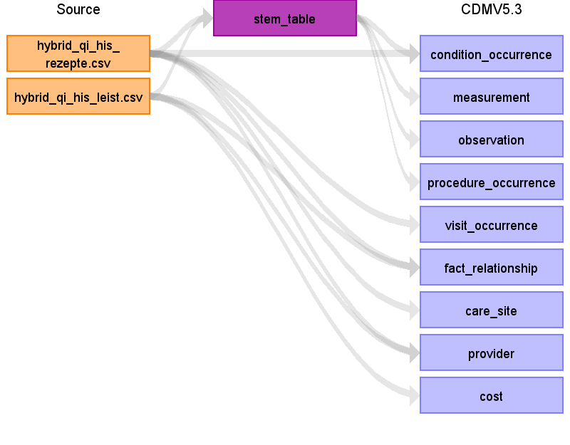

Table name: stem_table

Reading from hybrid_qi_his_rezepte.csv

- Aufsplittung der ICD-Codes in ICD_LIST notwendig

-> Trennzeichen: Leerzeichen

- Mapping von ICD_LIST (je ICD-Code):

- Mapping von Nicht-Standard-Konzept (ICD_LIST) zu Standard-Konzept vorhanden: Domäne von Standard-Konzept entscheidet

- Mapping von Nicht-Standard-Konzept (ICD_LIST) zu Standard-Konzept nicht vorhanden oder Mapping von Nicht-Standard-Konzept (ICD_LIST) zu Standard-Konzept invalide: Domäne von Nicht-Standard-Konzept entscheidet

- Mapping auf Nicht-Standard-Konzept nicht vorhanden: Condition-Domäne

- Implementierung in gkv-to-omop/jobs/302_HIS_REZEPTE/HIS_REZEPTE_Condition.ktr

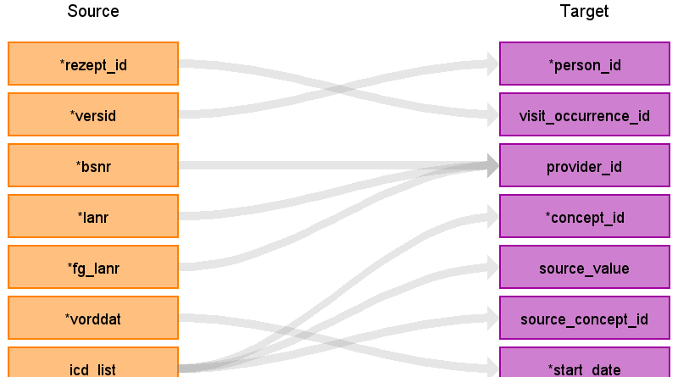

|  |  |  |  |
| --- | --- | --- | --- |
| Destination Field | Source Field | Logic | Comment |
| domain_id |  |  |  |
| person_id | versid | - person_id über Suche von VERSID in person.person_source_value | Beispiel:  GKV: 2042  OMOP: 1 |
| visit_occurrence_id | rezept_id | - visit_occurrence_id über Suche von "his_" + REZEPT_ID in visit_occurrence.visit_source_value | Beispiel:  GKV: 50  OMOP: 5 |
| visit_detail_id |  |  |  |
| provider_id | bsnr  lanr  fg_lanr | - provider_id über Suche von BSNR, LANR und FG_LANR in provider  - provider_id über Suche von BSNR, LANR und FG_LANR in provider  - provider_id über Suche von BSNR, LANR und FG_LANR in provider | Beispiel:  GKV: 19664, 9 und 25202  OMOP: 1  Beispiel:  GKV: 19664, 9 und 25202  OMOP: 1  Beispiel:  GKV: 19664, 9 und 25202  OMOP: 1 |
| id |  |  | automatisch erzeugt |
| concept_id | icd_list | - Mapping von ICD_LIST zu concept_id (Standard-Konzept) in icd10gm_standard_concat  - concept_id = 0, wenn kein Standard-Konzept gefunden werden kann oder wenn Mapping von Nicht-Standard-Konzept auf Standard-Konzept invalide ist | Beispiel:  GKV: I8908  OMOP: 435839 |
| source_value | icd_list |  | Beispiel:  GKV: I8908  OMOP: I8908 |
| source_concept_id | icd_list | - Mapping von ICD_LIST zu concept_id (Nicht-Standard-Konzept) in icd10gm_standard_concat  - concept_id = 0, wenn kein Nicht-Standard-Konzept gefunden werden kann | Beispiel:  GKV: I8908  OMOP: 37084965 |
| type_concept_id |  |  | - concept_id = 32810 (Claim) |
| start_date | vorddat | - Formatierung notwendig | Beispiel:  GKV: 2016.01.28  OMOP: 2016-01-28 |
| start_datetime |  |  |  |
| end_date |  |  |  |
| end_datetime |  |  |  |
| verbatim_end_date |  |  |  |
| days_supply |  |  |  |
| dose_unit_source_value |  |  |  |
| lot_number |  |  |  |
| modifier_concept_id |  |  |  |
| modifier_source_value |  |  |  |
| operator_concept_id |  |  |  |
| quantity |  |  |  |
| range_high |  |  |  |
| range_low |  |  |  |
| refills |  |  |  |
| route_concept_id |  |  |  |
| route_source_value |  |  |  |
| sig |  |  |  |
| stop_reason |  |  |  |
| unique_device_id |  |  |  |
| unit_concept_id |  |  |  |
| unit_source_value |  |  |  |
| value_as_concept_id |  |  |  |
| value_as_number |  |  |  |
| value_as_string |  |  |  |
| value_source_value |  |  |  |
| anatomic_site_concept_id |  |  |  |
| disease_status_concept_id |  |  |  |
| specimen_source_id |  |  |  |
| anatomic_site_source_value |  |  |  |
| disease_status_source_value |  |  |  |
| condition_status_concept_id |  |  |  |
| condition_status_source_value |  |  |  |
| qualifier_concept_id |  |  |  |
| qualifier_source_value |  |  |  |
| measurement_time |  |  |  |

Reading from hybrid_qi_his_leist.csv

- Implementierung in gkv-to-omop/jobs/302_HIS_LEIST/HIS_LEIST_Heilmittel.ktr

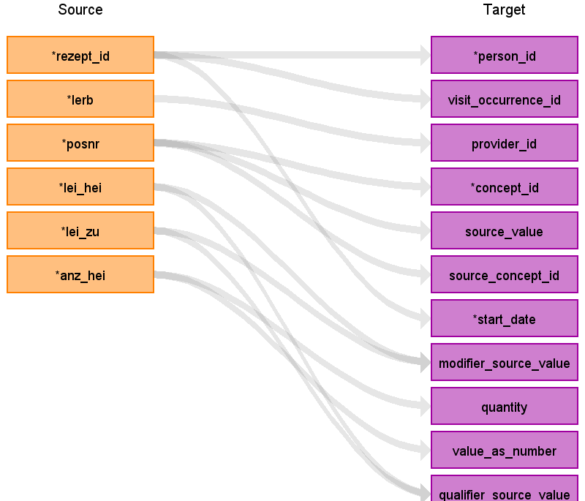

|  |  |  |  |
| --- | --- | --- | --- |
| Destination Field | Source Field | Logic | Comment |
| domain_id |  |  |  |
| person_id | rezept_id | - person_id über Suche von "his_" + REZEPT_ID in visit_occurrence.visit_source_value | Beispiel:  GKV: 50  OMOP: 1 |
| visit_occurrence_id | rezept_id | - visit_occurrence_id über Suche von "his_" + REZEPT_ID in visit_occurrence.visit_source_value | Beispiel:  GKV: 50  OMOP: 5 |
| visit_detail_id |  |  |  |
| provider_id | lerb | - provider_id über Suche von LERB in provider.specialty_source_value, provider.specialty_concept_id = 0 und provider.specialty_source_concept_id über Mapping von LERB zu concept_id in concept über vocabulary_id = "HPNR" AND domain_id = "Provider" (concept_id = 0, wenn kein Mapping gefunden wurde) | Beispiel:  GKV: 1  OMOP: 1 |
| id |  |  | automatisch erzeugt |
| concept_id | posnr | - concept_id = 0 |  |
| source_value | posnr |  | Beispiel:  GKV: 1501  OMOP: 1501 |
| source_concept_id | posnr | - Mapping von POSNR zu concept_id in concept über vocabulary_id = "HPNR" | Beispiel:  GKV: 1501  OMOP: 2000000198 |
| type_concept_id |  |  | - concept_id = 32810 (Claim) |
| start_date | rezept_id | - über Suche von "his_" + REZEPT_ID in visit_occurrence.visit_source_value  -> visit_start_date | Beispiel:  GKV: 50  OMOP: 2016-01-28 |
| start_datetime |  |  |  |
| end_date |  |  |  |
| end_datetime |  |  |  |
| verbatim_end_date |  |  |  |
| days_supply |  |  |  |
| dose_unit_source_value |  |  |  |
| lot_number |  |  |  |
| modifier_concept_id |  |  |  |
| modifier_source_value | lei_hei  lei_zu | - modifier_source_value = "Heilmittelleistung", wenn LEI_HEI = 1  - modifier_source_value = "Zusatzleistung", wenn LEI_ZU = 1 |  |
| operator_concept_id |  |  |  |
| quantity | anz_hei |  | Beispiel:  GKV: 5  OMOP: 5 |
| range_high |  |  |  |
| range_low |  |  |  |
| refills |  |  |  |
| route_concept_id |  |  |  |
| route_source_value |  |  |  |
| sig |  |  |  |
| stop_reason |  |  |  |
| unique_device_id |  |  |  |
| unit_concept_id |  |  |  |
| unit_source_value |  |  |  |
| value_as_concept_id |  |  |  |
| value_as_number | anz_hei |  | Beispiel:  GKV: 5  OMOP: 5 |
| value_as_string |  |  |  |
| value_source_value |  |  |  |
| anatomic_site_concept_id |  |  |  |
| disease_status_concept_id |  |  |  |
| specimen_source_id |  |  |  |
| anatomic_site_source_value |  |  |  |
| disease_status_source_value |  |  |  |
| condition_status_concept_id |  |  |  |
| condition_status_source_value |  |  |  |
| qualifier_concept_id |  |  |  |
| qualifier_source_value | lei_hei  lei_zu | - qualifier_source_value = "Heilmittelleistung", wenn LEI_HEI = 1  - qualifier_source_value = "Zusatzleistung", wenn LEI_ZU = 1 |  |
| measurement_time |  |  |  |

Table name: condition_occurrence

Reading from hybrid_qi_his_rezepte.csv

- Mapping von INDIKATION

- Implementierung in gkv-to-omop/jobs/302_HIS_REZEPTE/HIS_REZEPTE_Indikation.ktr

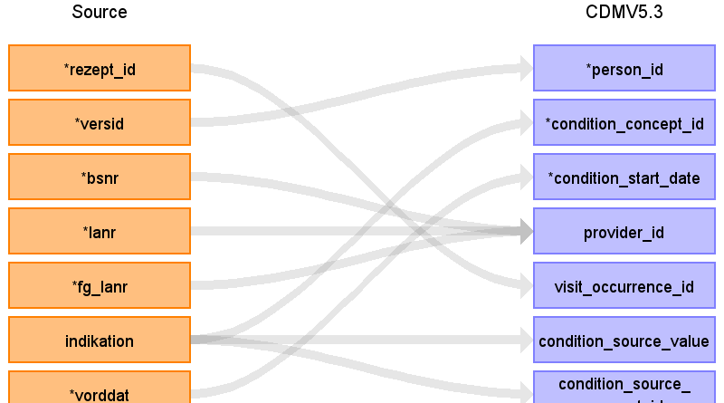

|  |  |  |  |
| --- | --- | --- | --- |
| Destination Field | Source Field | Logic | Comment |
| condition_occurrence_id |  |  | automatisch erzeugt |
| person_id | versid | - person_id über Suche von VERSID in person.person_source_value | Beispiel:  GKV: 2042  OMOP: 1 |
| condition_concept_id | indikation | - concept_id = 0 |  |
| condition_start_date | vorddat | - Formatierung notwendig | Beispiel:  GKV: 2016.01.28  OMOP: 2016-01-28 |
| condition_start_datetime |  |  |  |
| condition_end_date |  |  |  |
| condition_end_datetime |  |  |  |
| condition_type_concept_id |  |  | - concept_id = 32810 (Claim) |
| stop_reason |  |  |  |
| provider_id | bsnr  lanr  fg_lanr | - provider_id über Suche von BSNR, LANR und FG_LANR in provider  - provider_id über Suche von BSNR, LANR und FG_LANR in provider  - provider_id über Suche von BSNR, LANR und FG_LANR in provider | Beispiel:  GKV: 19664, 9 und 25202  OMOP: 1  Beispiel:  GKV: 19664, 9 und 25202  OMOP: 1  Beispiel:  GKV: 19664, 9 und 25202  OMOP: 1 |
| visit_occurrence_id | rezept_id | - visit_occurrence_id über Suche von "his_" + REZEPT_ID in visit_occurrence.visit_source_value | Beispiel:  GKV: 50  OMOP: 5 |
| visit_detail_id |  |  |  |
| condition_source_value | indikation |  | Beispiel:  GKV: CSA  OMOP: CSA |
| condition_source_concept_id | indikation | - Mapping von INDIKATION zu concept_id in concept über vocabulary_id = "HMK" | Beispiel:  GKV: CSA  OMOP: 2000000836 |
| condition_status_source_value |  |  |  |
| condition_status_concept_id |  |  |  |

Reading from stem_table

- Domäne = Condition

- Implementierung in gkv-to-omop/jobs/302_HIS_REZEPTE/HIS_REZEPTE_Condition.ktr

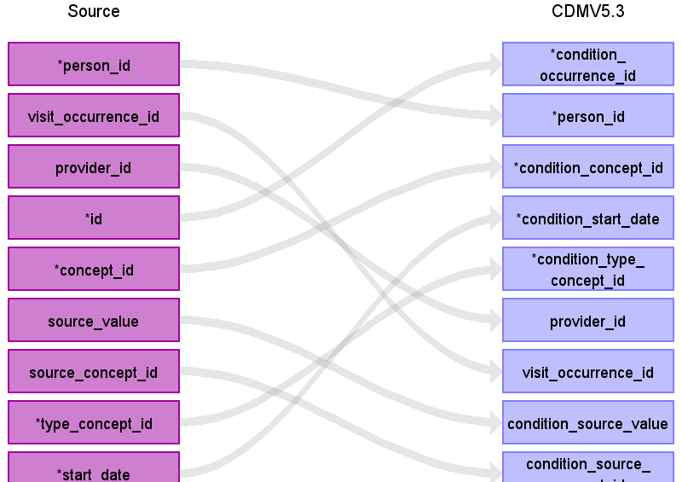

|  |  |  |  |
| --- | --- | --- | --- |
| Destination Field | Source Field | Logic | Comment |
| condition_occurrence_id | id |  | automatisch erzeugt |
| person_id | person_id |  |  |
| condition_concept_id | concept_id |  |  |
| condition_start_date | start_date |  |  |
| condition_start_datetime |  |  |  |
| condition_end_date |  |  |  |
| condition_end_datetime |  |  |  |
| condition_type_concept_id | type_concept_id |  | - concept_id = 32810 (Claim) |
| stop_reason |  |  |  |
| provider_id | provider_id |  |  |
| visit_occurrence_id | visit_occurrence_id |  |  |
| visit_detail_id |  |  |  |
| condition_source_value | source_value |  |  |
| condition_source_concept_id | source_concept_id |  |  |
| condition_status_source_value |  |  |  |
| condition_status_concept_id |  |  |  |

Table name: measurement

Reading from stem_table

- Domäne = Measurement

- Implementierung in gkv-to-omop/jobs/302_HIS_REZEPTE/HIS_REZEPTE_Condition.ktr

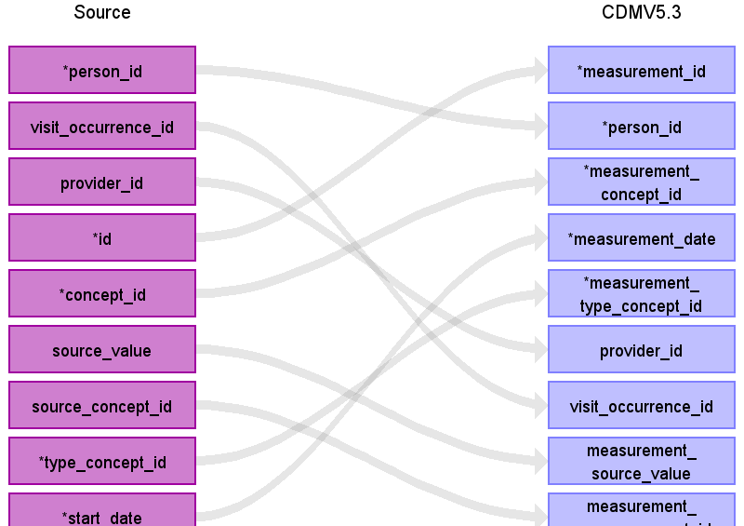

|  |  |  |  |
| --- | --- | --- | --- |
| Destination Field | Source Field | Logic | Comment |
| measurement_id | id |  | automatisch erzeugt |
| person_id | person_id |  |  |
| measurement_concept_id | concept_id |  |  |
| measurement_date | start_date |  |  |
| measurement_datetime |  |  |  |
| measurement_time |  |  |  |
| measurement_type_concept_id | type_concept_id |  | - concept_id = 32810 (Claim) |
| operator_concept_id |  |  |  |
| value_as_number |  |  |  |
| value_as_concept_id |  |  |  |
| unit_concept_id |  |  |  |
| range_low |  |  |  |
| range_high |  |  |  |
| provider_id | provider_id |  |  |
| visit_occurrence_id | visit_occurrence_id |  |  |
| visit_detail_id |  |  |  |
| measurement_source_value | source_value |  |  |
| measurement_source_concept_id | source_concept_id |  |  |
| unit_source_value |  |  |  |
| value_source_value |  |  |  |

Table name: observation

Reading from stem_table

- Domäne = Observation

- Implementierung in gkv-to-omop/jobs/302_HIS_REZEPTE/HIS_REZEPTE_Condition.ktr

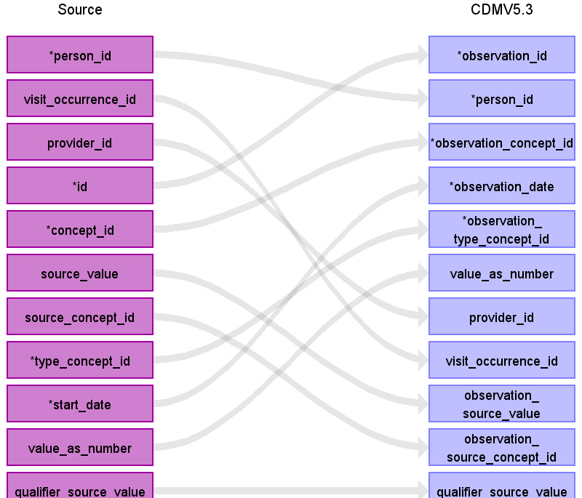

|  |  |  |  |
| --- | --- | --- | --- |
| Destination Field | Source Field | Logic | Comment |
| observation_id | id |  | automatisch erzeugt |
| person_id | person_id |  |  |
| observation_concept_id | concept_id |  |  |
| observation_date | start_date |  |  |
| observation_datetime |  |  |  |
| observation_type_concept_id | type_concept_id |  | - concept_id = 32810 (Claim) |
| value_as_number | value_as_number |  |  |
| value_as_string |  |  |  |
| value_as_concept_id |  |  |  |
| qualifier_concept_id |  |  |  |
| unit_concept_id |  |  |  |
| provider_id | provider_id |  |  |
| visit_occurrence_id | visit_occurrence_id |  |  |
| visit_detail_id |  |  |  |
| observation_source_value | source_value |  |  |
| observation_source_concept_id | source_concept_id |  |  |
| unit_source_value |  |  |  |
| qualifier_source_value | qualifier_source_value |  |  |

Table name: procedure_occurrence

Reading from stem_table

- Domäne = Procedure

- Implementierung in gkv-to-omop/jobs/302_HIS_REZEPTE/HIS_REZEPTE_Condition.ktr

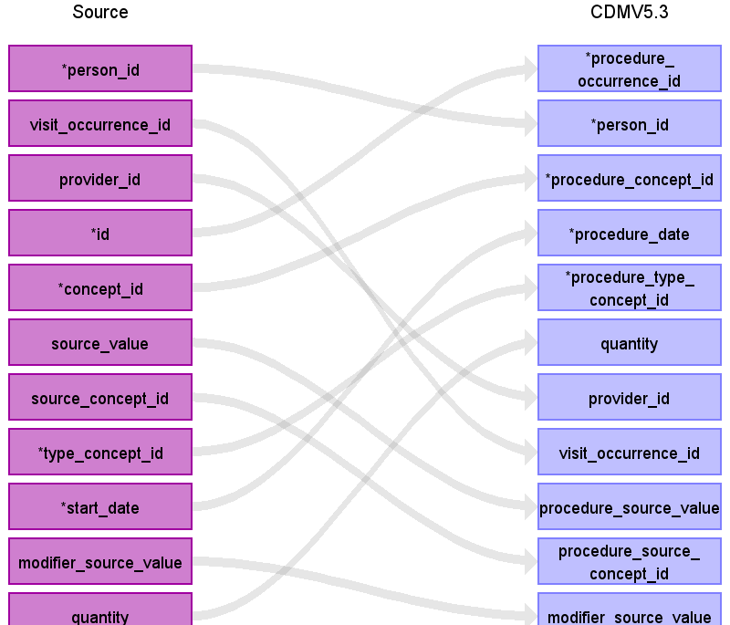

|  |  |  |  |
| --- | --- | --- | --- |
| Destination Field | Source Field | Logic | Comment |
| procedure_occurrence_id | id |  | automatisch erzeugt |
| person_id | person_id |  |  |
| procedure_concept_id | concept_id |  |  |
| procedure_date | start_date |  |  |
| procedure_datetime |  |  |  |
| procedure_type_concept_id | type_concept_id |  | - concept_id = 32810 (Claim) |
| modifier_concept_id |  |  |  |
| quantity | quantity |  |  |
| provider_id | provider_id |  |  |
| visit_occurrence_id | visit_occurrence_id |  |  |
| visit_detail_id |  |  |  |
| procedure_source_value | source_value |  |  |
| procedure_source_concept_id | source_concept_id |  |  |
| modifier_source_value | modifier_source_value |  |  |

Table name: visit_occurrence

Reading from hybrid_qi_his_rezepte.csv

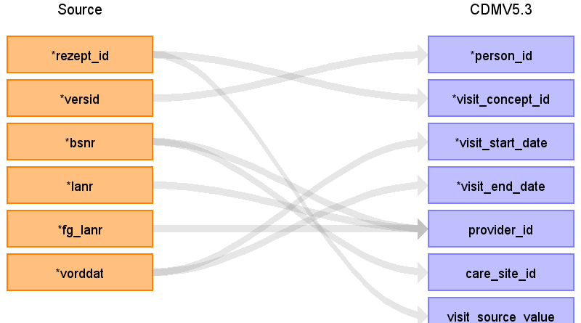

|  |  |  |  |
| --- | --- | --- | --- |
| Destination Field | Source Field | Logic | Comment |
| visit_occurrence_id |  |  | automatisch erzeugt |
| person_id | versid | - person_id über Suche von VERSID in person.person_source_value | Beispiel:  GKV: 2042  OMOP: 1 |
| visit_concept_id | rezept_id | - concept_id = 38004246 (Ambulatory Physical Therapy Clinic / Center) |  |
| visit_start_date | vorddat | - Formatierung notwendig | Beispiel:  GKV: 2016.01.28  OMOP: 2016-01-28 |
| visit_start_datetime |  |  |  |
| visit_end_date | vorddat | - Formatierung notwendig | Beispiel:  GKV: 2016.01.28  OMOP: 2016-01-28 |
| visit_end_datetime |  |  |  |
| visit_type_concept_id |  |  | - concept_id = 32810 (Claim) |
| provider_id | bsnr  lanr  fg_lanr | - provider_id über Suche von BSNR, FG_LANR und LANR in provider  - provider_id über Suche von BSNR, FG_LANR und LANR in provider  - provider_id über Suche von BSNR, FG_LANR und LANR in provider | Beispiel:  GKV: 19664, 9 und 25202  OMOP: 1  Beispiel:  GKV: 19664, 9 und 25202  OMOP: 1  Beispiel:  GKV: 19664, 9 und 25202  OMOP: 1 |
| care_site_id | bsnr | - care_site_id über Suche von BSNR in care_site.care_site_source_value | Beispiel:  GKV: 19664  OMOP: 2 |
| visit_source_value | rezept_id | - Hinzufügen des Präfix "his_" zur eindeutigen Zuordnung | Beispiel:  GKV: 50  OMOP: his_50 |
| visit_source_concept_id |  |  |  |
| admitting_source_concept_id |  |  |  |
| admitting_source_value |  |  |  |
| discharge_to_concept_id |  |  |  |
| discharge_to_source_value |  |  |  |
| preceding_visit_occurrence_id |  |  |  |

Table name: fact_relationship

Reading from hybrid_qi_his_rezepte.csv

- Verknüpfung von ICD_LIST (Heilmittelrezept, je ICD-Code) mit POSNR (Heilmittelleistung)

- Verknüpfung von INDIKATION (Heilmittelrezept) mit POSNR (Heilmittelleistung)

- Implementierung in gkv-to-omop/jobs/302_HIS_REZEPTE/HIS_REZEPTE_SQL_icd_leist_fact_relationship.ktr (ICD_LIST und POSNR)

- Implementierung in gkv-to-omop/jobs/302_HIS_REZEPTE/HIS_REZEPTE_Indikation.ktr (INDIKATION und POSNR)

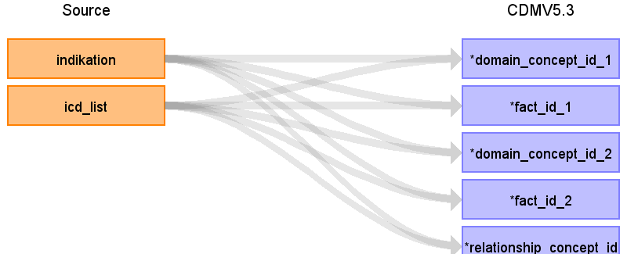

|  |  |  |  |
| --- | --- | --- | --- |
| Destination Field | Source Field | Logic | Comment |
| domain_concept_id_1 | indikation  icd_list | - Domäne von INDIKATION nutzen, wenn sich domain_concept_id_2 auf Domäne der POSNR bezieht  - Domäne von ICD nutzen, wenn sich domain_concept_id_2 auf Domäne der POSNR bezieht |  |
| fact_id_1 | indikation  icd_list | - ID von INDIKATION nutzen, wenn sich fact_id_2 auf ID der POSNR bezieht  - ID von ICD nutzen, wenn sich fact_id_2 auf ID der POSNR bezieht |  |
| domain_concept_id_2 | indikation  icd_list | - Domäne von INDIKATION nutzen, wenn sich domain_concept_id_1 auf Domäne der POSNR bezieht  - Domäne von ICD nutzen, wenn sich domain_concept_id_1 auf Domäne der POSNR bezieht |  |
| fact_id_2 | indikation  icd_list | - ID von INDIKATION nutzen, wenn sich fact_id_1 auf ID der POSNR bezieht  - ID von ICD nutzen, wenn sich fact_id_1 auf ID der POSNR bezieht |  |
| relationship_concept_id | indikation  icd_list | - Beziehung INDIKATION -> POSNR: 44818784 (Has associated procedure (SNOMED))  - Beziehung POSNR -> INDIKATION: 44818882 (Associated procedure of (SNOMED))  - Beziehung ICD -> POSNR: 44818784 (Has associated procedure (SNOMED))  - Beziehung POSNR -> ICD: 44818882 (Associated procedure of (SNOMED)) |  |

Reading from hybrid_qi_his_leist.csv

- Verknüpfung von ICD_LIST (Heilmittelrezept, je ICD-Code) mit POSNR (Heilmittelleistung)

- Verknüpfung von INDIKATION (Heilmittelrezept) mit POSNR (Heilmittelleistung)

- Implementierung in gkv-to-omop/jobs/302_HIS_REZEPTE/HIS_REZEPTE_SQL_icd_leist_fact_relationship.ktr (ICD_LIST und POSNR)

- Implementierung in gkv-to-omop/jobs/302_HIS_REZEPTE/HIS_REZEPTE_Indikation.ktr (INDIKATION und POSNR)

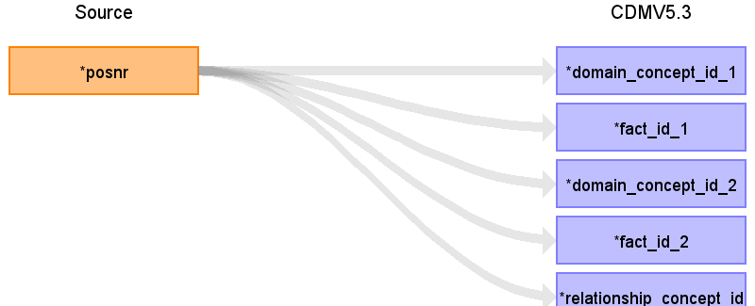

|  |  |  |  |
| --- | --- | --- | --- |
| Destination Field | Source Field | Logic | Comment |
| domain_concept_id_1 | posnr | - Domäne von POSNR nutzen, wenn sich domain_concept_id_2 auf Domäne der INDIKATION oder des ICD bezieht |  |
| fact_id_1 | posnr | - ID von POSNR nutzen, wenn sich fact_id_2 auf ID der INDIKATION oder ICD bezieht |  |
| domain_concept_id_2 | posnr | - Domäne von POSNR nutzen, wenn sich domain_concept_id_1 auf Domäne der INDIKATION oder des ICD bezieht |  |
| fact_id_2 | posnr | - ID von POSNR nutzen, wenn sich fact_id_1 auf ID der INDIKATION oder ICD bezieht |  |
| relationship_concept_id | posnr | - Beziehung ICD -> POSNR: 44818784 (Has associated procedure (SNOMED))  - Beziehung POSNR -> ICD: 44818882 (Associated procedure of (SNOMED))  - Beziehung INDIKATION -> POSNR: 44818784 (Has associated procedure (SNOMED))  - Beziehung POSNR -> INDIKATION: 44818882 (Associated procedure of (SNOMED)) |  |

Table name: care_site

Reading from hybrid_qi_his_rezepte.csv

- Implementierung in gkv-to-omop/jobs/302_HIS_REZEPTE/HIS_REZEPTE_care_site.ktr

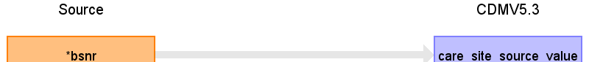

|  |  |  |  |
| --- | --- | --- | --- |
| Destination Field | Source Field | Logic | Comment |
| care_site_id |  |  | automatisch erzeugt |
| care_site_name |  |  |  |
| place_of_service_concept_id |  |  |  |
| location_id |  |  |  |
| care_site_source_value | bsnr |  | Beispiel:  GKV: 19664  OMOP: 19664 |
| place_of_service_source_value |  |  |  |

Table name: provider

Reading from hybrid_qi_his_rezepte.csv

- Implementierung in gkv-to-omop/jobs/302_HIS_REZEPTE/HIS_REZEPTE_provider.ktr

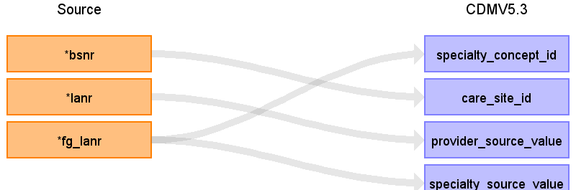

|  |  |  |  |
| --- | --- | --- | --- |
| Destination Field | Source Field | Logic | Comment |
| provider_id |  |  | automatisch erzeugt |
| provider_name |  |  |  |
| npi |  |  |  |
| dea |  |  |  |
| specialty_concept_id | fg_lanr | - Mapping von FG_LANR zu concept_id in source_to_concept_map über source_vocabulary_id = "Provider Specialty"  -> concept_id = 0, wenn kein Mapping gefunden wurde | Beispiel:  GKV: 9  OMOP: 45756819 |
| care_site_id | bsnr | - care_site_id über Suche von BSNR in care_site.care_site_source_value | Beispiel:  GKV: 19664  OMOP: 1 |
| year_of_birth |  |  |  |
| gender_concept_id |  |  |  |
| provider_source_value | lanr |  | Beispiel:  GKV: 25202  OMOP: 25202 |
| specialty_source_value | fg_lanr |  | Beispiel:  GKV: 9  OMOP: 9 |
| specialty_source_concept_id |  |  |  |
| gender_source_value |  |  |  |
| gender_source_concept_id |  |  |  |

Reading from hybrid_qi_his_leist.csv

- Implementierung in gkv-to-omop/jobs/302_HIS_LEIST/HIS_LEIST_provider.ktr

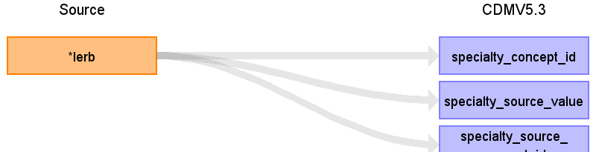

|  |  |  |  |
| --- | --- | --- | --- |
| Destination Field | Source Field | Logic | Comment |
| provider_id |  |  | automatisch erzeugt |
| provider_name |  |  |  |
| npi |  |  |  |
| dea |  |  |  |
| specialty_concept_id | lerb | - concept_id = 0 |  |
| care_site_id |  |  |  |
| year_of_birth |  |  |  |
| gender_concept_id |  |  |  |
| provider_source_value |  |  |  |
| specialty_source_value | lerb |  | Beispiel:  GKV: 1  OMOP: 1 |
| specialty_source_concept_id | lerb | - Mapping von LERB zu concept_id in concept über vocabulary_id = "HPNR" AND domain_id = "Provider"  -> concept_id = 0, wenn kein Mapping gefunden wurde | Beispiel:  GKV: 1  OMOP: 2000004643 |
| gender_source_value |  |  |  |
| gender_source_concept_id |  |  |  |

Table name: cost

Reading from hybrid_qi_his_leist.csv

- Implementierung in gkv-to-omop/jobs/302_HIS_LEIST/HIS_LEIST_cost.ktr

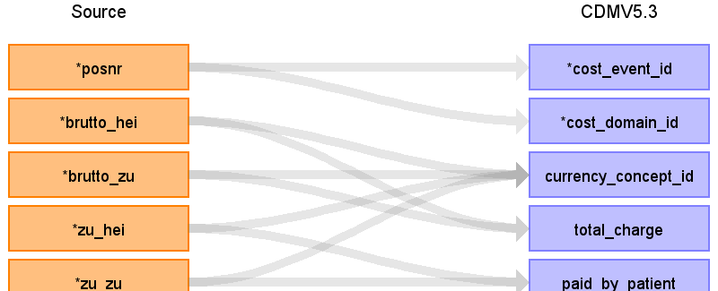

|  |  |  |  |
| --- | --- | --- | --- |
| Destination Field | Source Field | Logic | Comment |
| cost_id |  |  | automatisch erzeugt |
| cost_event_id | posnr | - ID der POSNR in OMOP | Beispiel:  OMOP: 1 |
| cost_domain_id | posnr | - Domäne der POSNR in OMOP | Beispiel:  OMOP: Procedure |
| cost_type_concept_id |  |  | - concept_id = 32810 (Claim) |
| currency_concept_id | brutto_hei  brutto_zu  zu_hei  zu_zu | - concept_id = 44818568 (Euro)  - concept_id = 44818568 (Euro)  - concept_id = 44818568 (Euro)  - concept_id = 44818568 (Euro) |  |
| total_charge | brutto_hei  brutto_zu |  | Beispiel:  GKV: 20,58  OMOP: 20.58  Beispiel:  GKV: 20,58  OMOP: 20.58 |
| total_cost |  |  |  |
| total_paid |  |  |  |
| paid_by_payer |  |  |  |
| paid_by_patient | zu_hei  zu_zu |  | Beispiel:  GKV: 2,04  OMOP: 2.04  Beispiel:  GKV: 2,04  OMOP: 2.04 |
| paid_patient_copay |  |  |  |
| paid_patient_coinsurance |  |  |  |
| paid_patient_deductible |  |  |  |
| paid_by_primary |  |  |  |
| paid_ingredient_cost |  |  |  |
| paid_dispensing_fee |  |  |  |
| payer_plan_period_id |  |  |  |
| amount_allowed |  |  |  |
| revenue_code_concept_id |  |  |  |
| revenue_code_source_value |  |  |  |
| drg_concept_id |  |  |  |
| drg_source_value |  |  |  |

Table name: death

Table name: device_exposure

Table name: drug_exposure

Table name: note

Table name: note_nlp

Table name: observation_period

Table name: person

Table name: specimen

Table name: visit_detail

Table name: cohort

Table name: cohort_attribute

Table name: condition_era

Table name: dose_era

Table name: drug_era

Table name: payer_plan_period

Table name: location

Table name: cdm_source

Table name: metadata

Table name: attribute_definition

Table name: cohort_definition

Appendix: source tables

Table: stem_table

|  |  |  |  |
| --- | --- | --- | --- |
| Field | Type | Most freq. value | Comment |
| domain_id | CHARACTER VARYING |  |  |
| person_id | INTEGER |  |  |
| visit_occurrence_id | INTEGER |  |  |
| visit_detail_id | INTEGER |  |  |
| provider_id | INTEGER |  |  |
| id | INTEGER |  | automatisch erzeugt |
| concept_id | INTEGER |  |  |
| source_value | CHARACTER VARYING |  |  |
| source_concept_id | INTEGER |  |  |
| type_concept_id | INTEGER |  | - concept_id = 32810 (Claim) |
| start_date | DATE |  |  |
| start_datetime | DATETIME |  |  |
| end_date | DATE |  |  |
| end_datetime | DATETIME |  |  |
| verbatim_end_date | DATE |  |  |
| days_supply | INTEGER |  |  |
| dose_unit_source_value | CHARACTER VARYING |  |  |
| lot_number | CHARACTER VARYING |  |  |
| modifier_concept_id | INTEGER |  |  |
| modifier_source_value | CHARACTER VARYING |  |  |
| operator_concept_id | INTEGER |  |  |
| quantity | INTEGER |  |  |
| range_high | FLOAT |  |  |
| range_low | FLOAT |  |  |
| refills | INTEGER |  |  |
| route_concept_id | INTEGER |  |  |
| route_source_value | CHARACTER VARYING |  |  |
| sig | CHARACTER VARYING |  |  |
| stop_reason | CHARACTER VARYING |  |  |
| unique_device_id | CHARACTER VARYING |  |  |
| unit_concept_id | INTEGER |  |  |
| unit_source_value | CHARACTER VARYING |  |  |
| value_as_concept_id | INTEGER |  |  |
| value_as_number | DECIMAL |  |  |
| value_as_string | CHARACTER VARYING |  |  |
| value_source_value | CHARACTER VARYING |  |  |
| anatomic_site_concept_id | INTEGER |  |  |
| disease_status_concept_id | INTEGER |  |  |
| specimen_source_id | INTEGER |  |  |
| anatomic_site_source_value | CHARACTER VARYING |  |  |
| disease_status_source_value | CHARACTER VARYING |  |  |
| condition_status_concept_id | CHARACTER VARYING |  |  |
| condition_status_source_value | INTEGER |  |  |
| qualifier_concept_id | INTEGER |  |  |
| qualifier_source_value | CHARACTER VARYING |  |  |
| measurement_time | CHARACTER VARYING |  |  |

Table: hybrid_qi_his_rezepte.csv

|  |  |  |  |
| --- | --- | --- | --- |
| Field | Type | Most freq. value | Comment |
| jahr | INT | 2019 |  |
| quartal | INT | 3 |  |
| rezept_id | INT | 3640 |  |
| versid | INT | 4818 |  |
| bsnr | INT | 22526 |  |
| lanr | INT | 10281 |  |
| fg_lanr | INT | 1 |  |
| indikation | VARCHAR | EX2A |  |
| vorddat | DATE | 2019.01.07 |  |
| icd_list | VARCHAR | M54 |  |

Table: hybrid_qi_his_leist.csv

|  |  |  |  |
| --- | --- | --- | --- |
| Field | Type | Most freq. value | Comment |
| jahr | INT | 2020 |  |
| quartal | INT | 3 |  |
| rezept_id | INT | 1071 |  |
| lerb | INT | 2 |  |
| posnr | INT | 501 |  |
| lei_hei | INT | 1 |  |
| lei_zu | INT | 0 |  |
| anz_hei | INT | 0 |  |
| brutto_hei | VARCHAR | 0 |  |
| brutto_zu | VARCHAR | 0 |  |
| zu_hei | VARCHAR | 0 |  |
| zu_zu | VARCHAR | 0 |  |

Table: hybrid_qi_stammdaten.csv

|  |  |  |  |
| --- | --- | --- | --- |
| Field | Type | Most freq. value | Comment |
| jahr | INT | 2016 |  |
| quartal | INT | 1 |  |
| versid | INT | 4970 |  |
| gebdat | INT | 193510 |  |
| todtag | DATE |  |  |
| geschl | INT | 2 |  |
| versdauer | INT | 92 |  |
| bl_id | VARCHAR | NI |  |
| dmp_khk | INT | 0 |  |

Table: hybrid_qi_actrapid.csv

|  |  |  |  |
| --- | --- | --- | --- |
| Field | Type | Most freq. value | Comment |
| jahr | INT | 2018 |  |
| quartal | INT | 4 |  |
| versid | INT | 1351 |  |
| lanr | INT | 10281 |  |
| fg | INT | 1 |  |
| pzn | INT | 1798000 |  |
| bruttoeinzelpreis | VARCHAR | 14,15 |  |
| mult | INT | 1 |  |
| datum_vo | DATE | 2018.12.17 |  |
| datum_abgabe | DATE | 2019.12.17 |  |
| atccode | VARCHAR |  |  |
| dddpk | VARCHAR | 100 |  |

Table: hybrid_qi_kh_amb_fall.csv

|  |  |  |  |
| --- | --- | --- | --- |
| Field | Type | Most freq. value | Comment |
| year | INT | 2019 |  |
| quarter | INT | 3 |  |
| id | INT | 4970 |  |
| versid | INT | 9189 |  |
| admit_date | DATE | 2019.10.01 |  |
| discharge_date | DATE | 2019.10.01 |  |
| charges | VARCHAR | 145 |  |
| zuz_betr | INT | 0 |  |
| fallart | VARCHAR | PIA |  |

Table: hybrid_qi_kh_amb_pos.csv

|  |  |  |  |
| --- | --- | --- | --- |
| Field | Type | Most freq. value | Comment |
| year | INT | 2019 |  |
| quarter | INT | 1 |  |
| id | INT | 7431 |  |
| entgart | VARCHAR | 40120 |  |
| beh_tag | DATE | 2019.11.04 |  |
| entg_betr | VARCHAR | ,25 |  |

Table: hybrid_qi_kh_amb_icd.csv

|  |  |  |  |
| --- | --- | --- | --- |
| Field | Type | Most freq. value | Comment |
| year | INT | 2019 |  |
| quarter | INT | 3 |  |
| id | INT | 2645 |  |
| icd_diag | VARCHAR | C20 |  |
| icd_sicherheit | VARCHAR | G |  |
| icd_sek | VARCHAR |  |  |
| icd_sek_sicherheit | VARCHAR |  |  |
| icd_lokalisation | VARCHAR |  |  |
| icd_sek_lokalisation | VARCHAR |  |  |
| icd_diag_art | INT | 13 |  |

Table: hybrid_qi_kh_amb_ops.csv

|  |  |  |  |
| --- | --- | --- | --- |
| Field | Type | Most freq. value | Comment |
| year | INT | 2019 |  |
| quarter | INT | 3 |  |
| id | INT | 2672 |  |
| ops | VARCHAR | PIA002 |  |
| ops_l | VARCHAR |  |  |

Table: hybrid_qi_reha_stat_fall.csv

|  |  |  |  |
| --- | --- | --- | --- |
| Field | Type | Most freq. value | Comment |
| year | INT | 2017 |  |
| quarter | INT | 3 |  |
| id | INT | 1 |  |
| versid | INT | 34 |  |
| admit_date | DATE | 2017.06.01 |  |
| discharge_date | DATE | 2017.10.27 |  |
| charges | VARCHAR | 2150 |  |
| copayment | INT | 0 |  |
| admit_icd | VARCHAR | I639 |  |
| behandlungsart | INT | 9 |  |

Table: hybrid_qi_efn.csv

|  |  |  |  |
| --- | --- | --- | --- |
| Field | Type | Most freq. value | Comment |
| jahr | INT | 2017 |  |
| quartal | INT | 1 |  |
| amb_fallid | INT | 285550 |  |
| versid | INT | 9962 |  |
| bsnr | INT | 3384 |  |
| fg_bsnr_asd | INT | 1 |  |
| dialysesachkosten | VARCHAR | 0 |  |
| behandkost_gesamt | VARCHAR | 0 |  |
| beh_von | DATE | 2019.04.01 |  |
| beh_bis | DATE | 2019.09.30 |  |
| fg_gp_list | VARCHAR | 7 |  |

Table: hybrid_qi_elst.csv

|  |  |  |  |
| --- | --- | --- | --- |
| Field | Type | Most freq. value | Comment |
| jahr | INT | 2017 |  |
| quartal | INT | 1 |  |
| amb_fallid | INT | 198335 |  |
| lanr | INT | 10281 |  |
| fg_lanr_asd | INT | 1 |  |
| gonr | VARCHAR | 32001 |  |
| behandlungsdatum | DATE | 2019.07.01 |  |
| gonr_anz | INT | 1 |  |

Table: hybrid_qi_tdia.csv

|  |  |  |  |
| --- | --- | --- | --- |
| Field | Type | Most freq. value | Comment |
| jahr | INT | 2018 |  |
| quartal | INT | 4 |  |
| amb_fallid | INT | 160393 |  |
| icd_bereinigt | VARCHAR | I1090 |  |
| icd_avzg | VARCHAR | G |  |
| icd_lrb | VARCHAR |  |  |

Table: hybrid_qi_ops.csv

|  |  |  |  |
| --- | --- | --- | --- |
| Field | Type | Most freq. value | Comment |
| jahr | INT | 2017 |  |
| quartal | INT | 3 |  |
| amb_fallid | INT | 492107 |  |
| ops | VARCHAR | 5-144.5a |  |
| ops_lrb | VARCHAR | R |  |

Table: hybrid_qi_pflege.csv

|  |  |  |  |
| --- | --- | --- | --- |
| Field | Type | Most freq. value | Comment |
| jahr | INT | 2019 |  |
| monat | INT | 12 |  |
| versid | INT | 3633 |  |
| stufe | INT |  |  |
| pea | INT |  |  |
| grad | INT | 2 |  |
| heim | INT | 0 |  |
| flag_statbeh | INT | 0 |  |

Table: hybrid_qi_kh_stat_fall.csv

|  |  |  |  |
| --- | --- | --- | --- |
| Field | Type | Most freq. value | Comment |
| year | INT | 2019 |  |
| quarter | INT | 1 |  |
| id | INT | 3640 |  |
| versid | INT | 252 |  |
| admit_date | DATE | 2017.09.26 |  |
| discharge_date | DATE | 2019.01.18 |  |
| admit_status_301 | INT | 107 |  |
| discharge_status_301 | INT | 19 |  |
| charges | VARCHAR | 100,72 |  |
| copayment | INT | 0 |  |
| admit_icd | VARCHAR | R060 |  |
| discharge_icd | VARCHAR |  |  |
| aufenthalt | VARCHAR | L |  |
| abg_drg | VARCHAR |  |  |
| admit_time | INT | 0 |  |
| discharge_time | INT | 0 |  |
| admit_icd_l | VARCHAR |  |  |
| refer_icd | VARCHAR |  |  |
| refer_icd_l | VARCHAR |  |  |
| discharge_icd_l | VARCHAR |  |  |
| los | INT | 1 |  |
| fa_nr | INT | 100 |  |
| pccl | INT | 0 |  |
| ventilation | INT | 0 |  |
| abg_se | VARCHAR |  |  |

Table: hybrid_qi_kh_stat_fachabt.csv

|  |  |  |  |
| --- | --- | --- | --- |
| Field | Type | Most freq. value | Comment |
| year | INT | 2019 |  |
| quarter | INT | 1 |  |
| id | INT | 6517 |  |
| fachabt | INT | 100 |  |
| fachabt_von | DATE | 2019.04.16 |  |
| fachabt_bis | DATE | 2017.04.13 |  |

Table: hybrid_qi_kh_stat_icd.csv

|  |  |  |  |
| --- | --- | --- | --- |
| Field | Type | Most freq. value | Comment |
| year | INT | 2019 |  |
| quarter | INT | 3 |  |
| id | INT | 32523 |  |
| icd | VARCHAR | I1000 |  |
| type | INT | 2 |  |
| icd_lokalisation | VARCHAR |  |  |
| icd_schweregrad | INT | 0 |  |

Table: hybrid_qi_kh_stat_ops.csv

|  |  |  |  |
| --- | --- | --- | --- |
| Field | Type | Most freq. value | Comment |
| year | INT | 2019 |  |
| quarter | INT | 3 |  |
| id | INT | 32523 |  |
| ops | VARCHAR | 3200 |  |
| op_date | DATE | 2018.11.19 |  |
| localisation | VARCHAR |  |  |