Projet PYTHON :

1. Goal
The goal of this programming project is to design and implement a multi-process and multithread
simulation in Python. This document deFines the functionalities that it has to implement
at a minimum. Any extensions and developments will act in your favor in the evaluation. In
addition, some points are deliberately left open for you to propose your own solution. Be
rigorous and creative!

2. Presentation

2.1. Minimum speciations

The program simulates an energy market where energy-producing and consuming homes,
weather conditions and random events contribute to the evolution of energy price over time.
Homes may choose to give away their surplus of energy to other homes that are in shortage, or
may sell it to the market thus contributing to the diminution of energy price. Homes in need of
energy will have to buy it from the market if others would not give away any. Naturally, energy
prices climb when the average consumption exceeds that of production. Temperature changes
also impact energy consumption, hence its price. Other events, such as the enactment of a law,
diplomatic tension etc. can impact energy prices.

2.2. A minimal design

The simulation involves 5 types of processes.
● home: represents an energy-producing and consuming home, with initial production and
consumption rates and energy trade policy which is one of three possibilities 1. always
give away, 2. always sell on the market, and 3. sell if no takers.
● market: represents the market with current energy price which evolves according to
transactions with homes (selling and buying), weather conditions and other events. The
market process is multi-threaded and carries out transactions with homes in separate
threads. Furthermore it limits the number of simultaneous transactions that can take
place with homes.
● weather: simulates weather parameters impacting energy consumption, such as
temperature and its variation over time.
● politics: simulates political events parameters impacting energy consumption, such
as diplomatic tension, wars.
● economics: simulates economic parameters of predeFined types that can impact the
energy price, such as money change rate, world macro-economy, carbon price.

Inter-process communication: Processes in the simulation communicate in the following way.
home processes communicate among themselves and with the market via message queues. The
weather process updates a shared memory with weather condition parameters. The politics
and economics processes, childs of market process, signals events to the latter which takes
the corresponding action impacting energy price. home and market processes update terminals
they are connected to permitting the operator of the simulation to track its progress.
Energy price: The energy price can be calculated according to the following linear model:

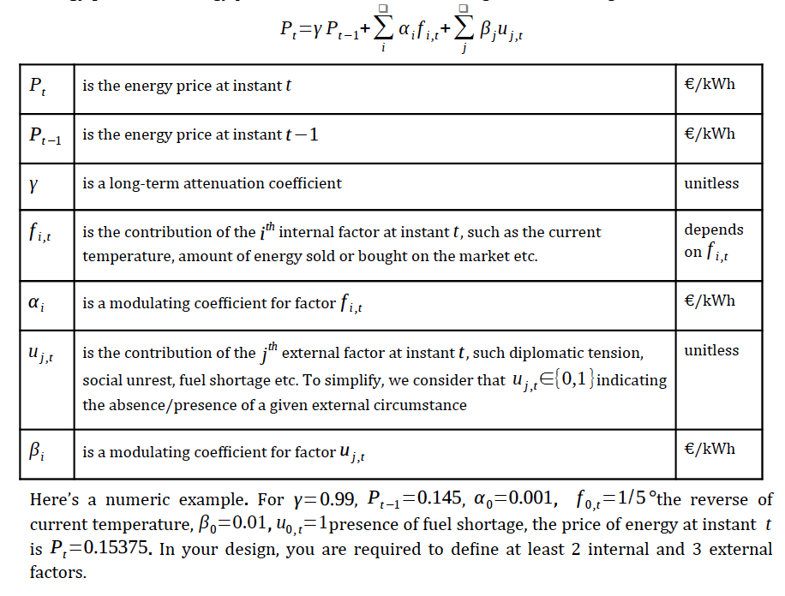

3. Solution

3.1. Design

Start with a diagram to better visualize the interactions between processes. The following
points need to be deFined:

● relationships between processes (parent-child or unrelated)
● messages exchanged between processes along with their types
● data structures stored in shared memory and how they are accessed
● synchronization primitives to protect access to shared resources or to count resources
● signals exchanged between processes, if any, and their types
● tubes involved in pairwise process communication, if any, and their types
Write down a Python-like pseudo-code of main algorithms for each process.

Relationships between processes :
messages exchanged between processes along with their types :

The market process is multi-threaded and carries out transactions with homes in separate
threads.

Process : politics
Political events parameters impacting energy consumption
(diplomatic tension, wars)
Process : market
Current energy price

Process : economics
Economic parameters
Process : weather
Weather parameters impacting energy consumption
Temperature(t)

Child / Impact

Child / Impact

Parent

Parent

Weather conditions

Transactions (message queues)

Shared memory

Process : home
initial production
consumption rates

Weather :
Politics : embargo, diplomatic tension, wars
Economics : inflation du prix (+/-)

Une action politique implique des restrictions sur la consommation des maisons. Il faudra veiller à rendre possible un apport insuffisant d’énergie lors d’un problème politique ou économique.
(Energie = taux de conso – production initiale)

